September 2, 2021

Dear Colleagues:

We have new resources to share this week. We hope you find them helpful.
New Trusted Sources Video for Back to School
As students return to school, we have recruited physicians including Dr. Frinny Polanco Walters of Boston Children’s Hospital to encourage 12+ vaccination. Please share this video with your networks.

New FDA Pfizer Approval Outreach Tools
Full FDA approval of the Pfizer COVID-19 vaccine presents an opportunity to further emphasize the safety and effectiveness of vaccination. Tools from the Public Health Communications Collaborative can help you field questions about FDA approval and boost confidence among those vaccinated and unvaccinated.

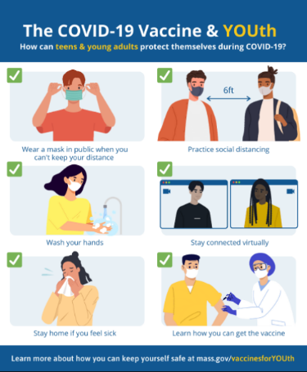
Reminder Teen and Young Adult Related Graphics
Download our youth-related graphics on topics such as: how teens can get the COVID-19 vaccine; how teens can protect themselves during COVID-19, and how to cope with pandemic stress.

New Archive of these Communications
Trying to find one of these previous weekly emails? Check the new archive.

Thank you for all you are doing to promote vaccine safety and confidence!

