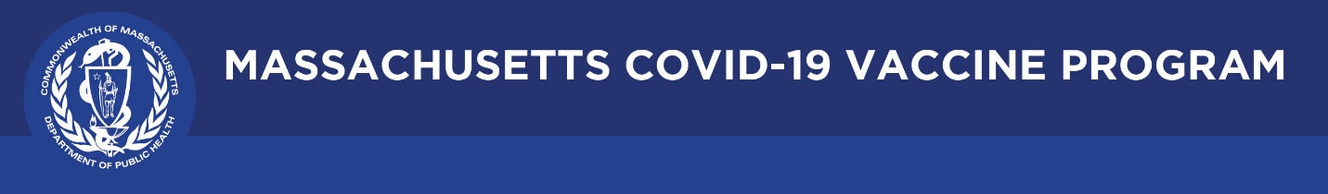

September 9, 2021

Dear Colleagues:

We have new resources to share this week. We hope you find them helpful.
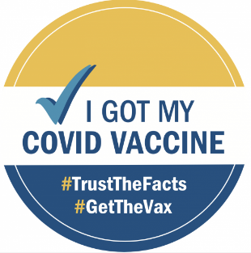
New Requesting a Copy of Your COVID-19 Vaccination Record
Individuals who have misplaced their COVID-19 vaccination card can learn how to obtain a copy of their vaccination record by visiting a new webpage: www.mass.gov/myvaxrecord.

New Factsheet in 10 languages: Answering Vaccine Questions
This factsheet includes responses to some of the most frequently asked questions about the safety and effectiveness of the COVID-19 vaccine. It is available in multiple languages including Albanian, Arabic, Cape Verdean, Khmer, Russian, Somali, and more. Please use it in your outreach.

New CDC ChatBot
Having trouble locating info on the CDC website? The new CDC SmartFind COVID-19 Vaccine ChatBot (scroll down) helps individuals and providers quickly locate information about COVID-19 vaccines.

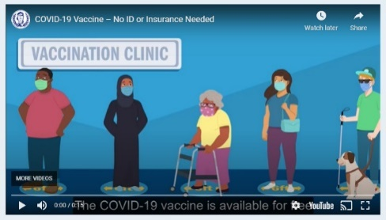
Reminder Video - No ID or Insurance Needed
Use this video to spread the word. Flyers can also be downloaded from mass.gov and posters can be ordered from the Public Health Clearinghouse at no cost.

Reminder Request a DPH Vaccine Ambassador
DPH ambassadors can attend community forums or meetings to share information and answer questions about the COVID-19 vaccine. Ambassadors speak 12 languages. To invite a DPH ambassador to your forum, please complete this form.

Thank you for all you are doing to promote vaccine safety and confidence!

