LOOKING TO GET YOUR UPDATED COVID-19 VACCINE?
As of September, the CDC now recommends that everyone ages 6 months and older get one updated COVID-19 vaccine dose.
The updated COVID-19 vaccine is currently being shipped to vaccination locations. Not all locations have it in stock yet, and some locations do not yet have doses for all age groups. To make sure the dose you need is in stock, please contact the location before you go!
When you search Vaccines.gov for vaccinators near you, the results will show:

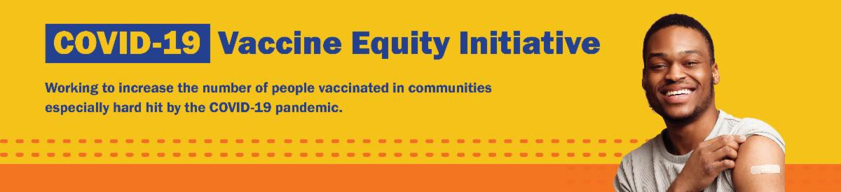
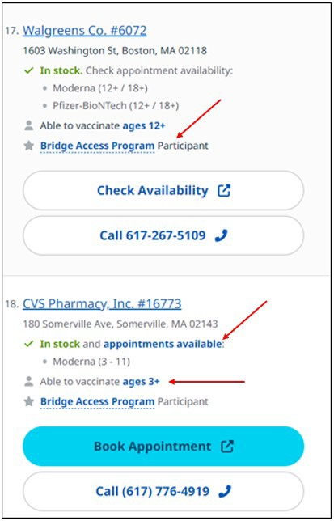
If they have the vaccine in stock What age group they have the vaccine for
October 13, 2023
Here are the latest resources for promoting COVID-19 vaccination to share with your colleagues
and networks across Massachusetts. If you received this from a colleague, subscribe today.
View this email online.
What's New
If they are participating in the Bridge Access Program (which offers free vaccines for those without health insurance)
Clicking on a vaccination location will show you many more details, including if you need an appointment or if you can simply

Search results on Vaccines.gov show if a location has the vaccine in stock, what ages are available, and if they participate in the Bridge Access

drop in. Program.
Looking for an updated vaccine but not sure where to start? For help with finding or making an appointment, call 2-1-1 (or 877-211-6277) and press
1. Calls are answered Monday through Friday, 9 a.m. to 5 p.m.
Reminders

DON'T FORGET: THE COMMUNITY HEALTH EQUITY SURVEY CLOSES OCTOBER 31!
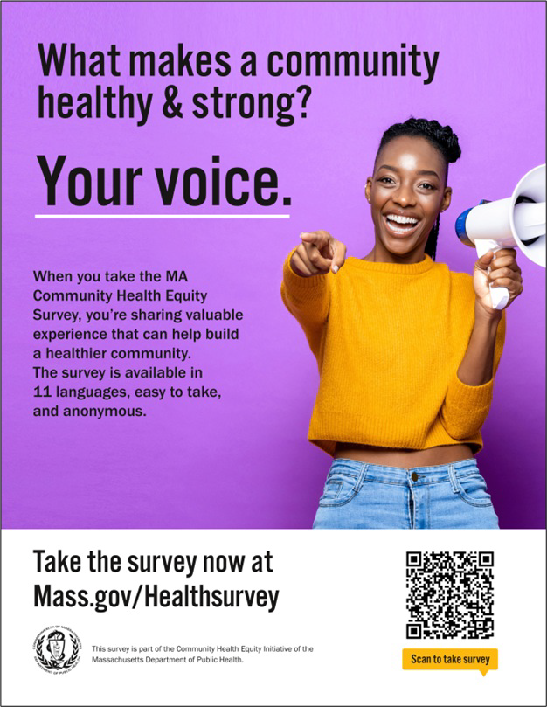
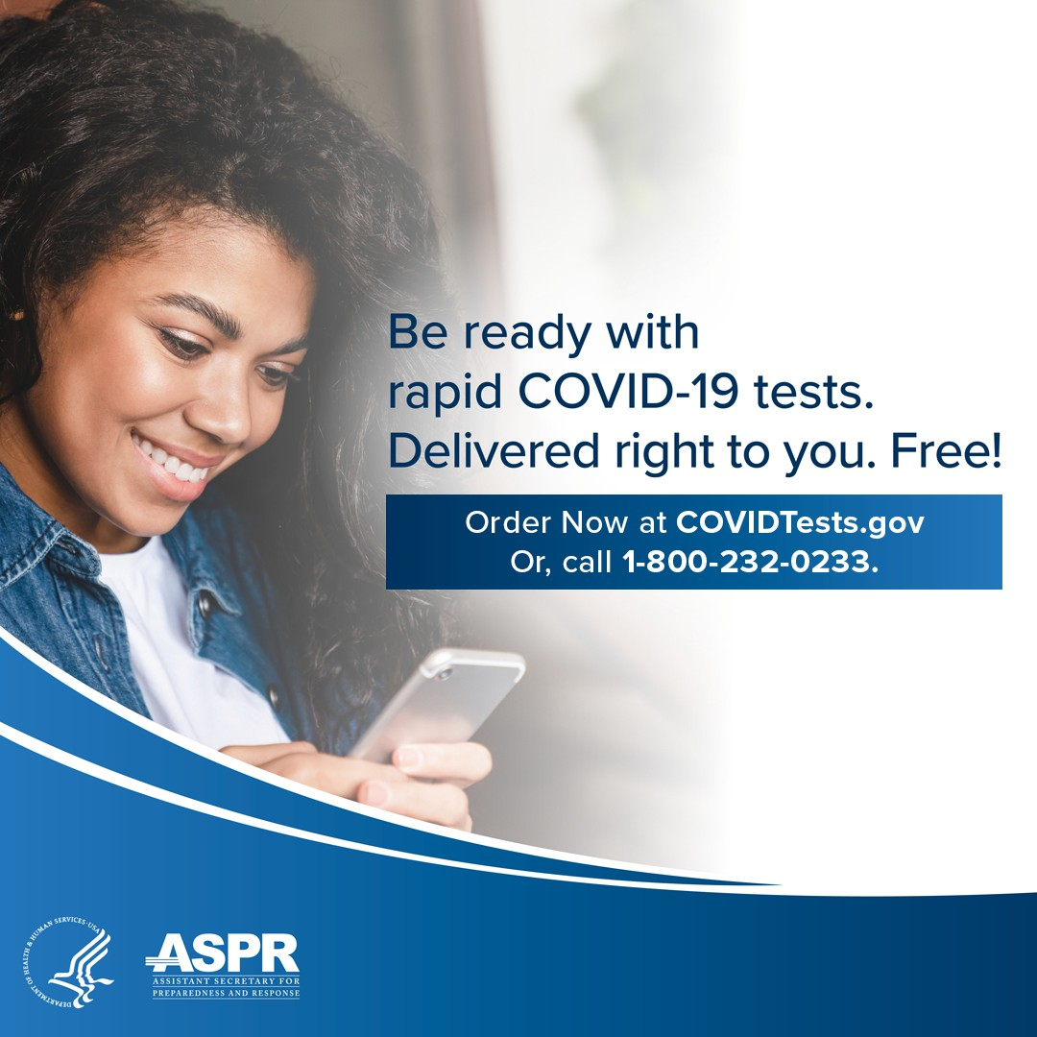
There's still time to take the Community Health Equity Survey, which is open for Massachusetts residents through the end of October!
Results will help DPH improve programs, make decisions about funding and resources, and support policies to improve health inequities.
The survey is available in 11 languages and is anonymous. It is open to anyone ages 14 and older. Get started
at mass.gov/HealthSurvey.
Help get the word out! Find talking points, flyers, and other materials to help promote the survey in this toolkit.

ALL U.S. HOUSEHOLDS CAN ORDER FOUR FREE COVID RAPID TESTS
Every U.S. household can once again order four free COVID-19 rapid tests. Tests will be delivered directly to recipients' homes.
To order tests, visit COVID.gov/Tests.
Accessible COVID test kits are also available.
Don't forget: Many at-home COVID tests have had their expiration dates extended. Check updated expiration dates on the FDA's website.

Key Resources

100+ GATHER FOR FIRST-EVER MASSACHUSETTS TRIBAL AND INDIGENOUS HEALTH SUMMIT
Congratulations to the Community Engagement Unit for the success of the first- ever Tribal and Indigenous Health Summit! The event was led by Cheryl Cromwell, the unit’s Tribal and Indigenous Health Equity Strategist, along with a robust team comprised of Department of Public Health staff and Tribal members from various communities. The event was held at the University of Massachusetts Boston on September 28.

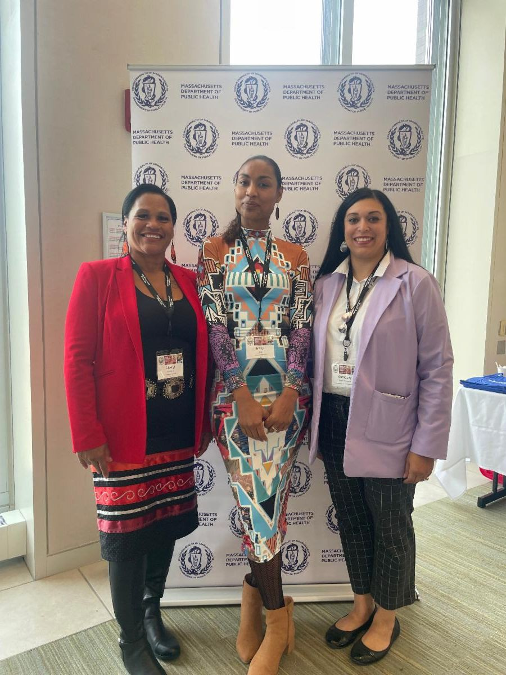
Among the 150 attendees were Tribal leaders and community members from Tribes in Massachusetts, Rhode Island, and New York, Tribal and Indigenous People Serving Organization (TIPSOs), and federal and state- wide agencies who gathered to learn and discuss Tribal and Indigenous culture, health priorities, and best practices to the COVID-19 pandemic. The summit focused on the sharing of strategies and resources to culturally enhance and strengthen partnerships in the state. Specific breakout sessions on Tribal data sovereignty, substance use, the social determinants of health, and mental health allowed panelists and participants to share potential resources and strategies for issues that critically impact these communities.
OUTREACH AND EDUCATION MATERIALS
COVID-19 Vaccine FAQs
COVID-19 Therapeutic Information (including telehealth) Archive of Weekly Provider Bulletins
Archive of COVID-19 Vaccine Communications Updates (past editions of VEI Roundup)
FIND A COVID-19 VACCINE DOSE
Use Vaccines.gov to sign up for a COVID-19 vaccine appointment Find a community COVID-19 vaccination clinic near you
Learn about the COVID-19 In-Home Vaccination Program and request a visit Request a copy of your vaccine card
Highlights

Cheryl Cromwell (left) poses alongside two Summit participants.

Goals and outcomes of the event included:
Establishing and enhancing federal, state, local, regional and Tribal relationships and partnerships
Improving understanding of the history of Tribes and Indigenous people in Massachusetts, New England, and beyond
Gaining knowledge of Tribal sovereignty, consultation, meaningful engagement, and health systems that serve Tribal and Indigenous people
Learning about Tribal and Indigenous pre-, current and post-COVID priorities and challenges, and social determinants of health disparities
Strengthening, engaging, and coordinating resources and best practices that will support Tribal and Indigenous communities
Discussing policy development to address effective access to resources for Tribal and Indigenous communities

Read More Highlights

Visit the VEI Website
Share This Email
Share This Email
Share This Email

Vaccine Equity Initiative | 250 Washington Street, Boston, MA 02108 Unsubscribe vaccineequityinitiative@mass.gov
Constant Contact Data Notice
Sent by vaccineequityinitiative@mass.gov powered by

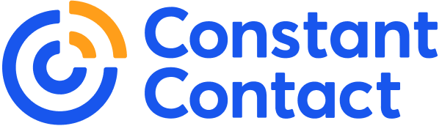

Try email marketing for free today!

