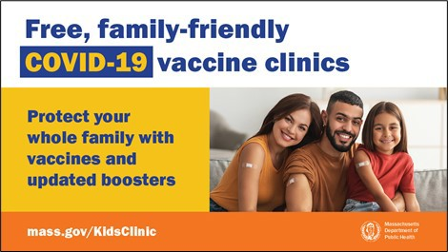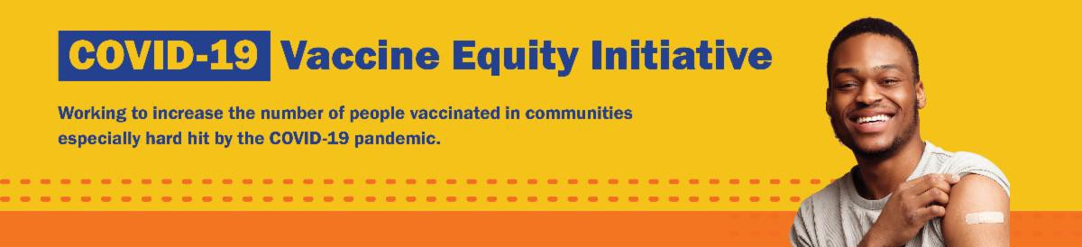
UPDATED BOOSTERS AVAILABLE FOR CHILDREN AGE 5 AND OLDER

Updated COVID-19 boosters for children age 5 and older are available in Massachusetts beginning October
13. Learn more about booster eligibility.

Booster appointments will become available as shipments arrive in Massachusetts. Find a clinic near you.
FREE, FAMILY-FRIENDLY VACCINATION CLINICS — NEW SOCIAL MEDIA
GRAPHIC!

DPH is offering free COVID vaccinations for everyone 6 months and older – and boosters for everyone 5 years and older – at community-based clinics across MA this fall. No appointment needed! Find a clinic near you.

Help get the word out by retweeting DPH
or sharing this new social media graphic.
October 14, 2022
Here are the latest resources for promoting COVID-19 vaccination to share with your colleagues
and networks across Massachusetts. If you received this from a colleague, subscribe today.

View this email online.
What's New

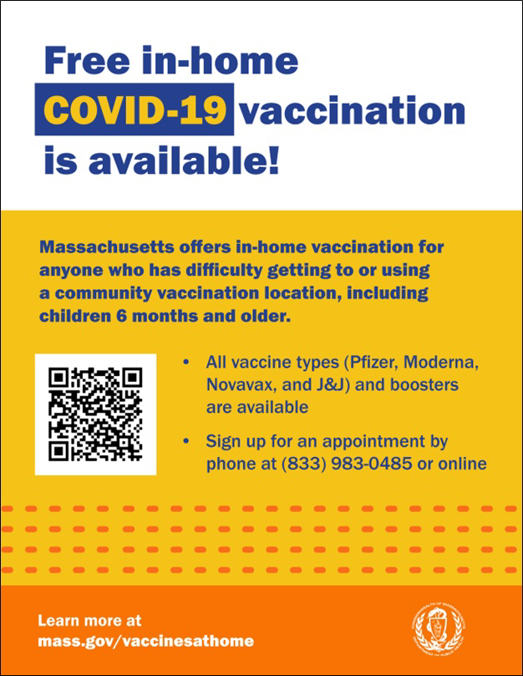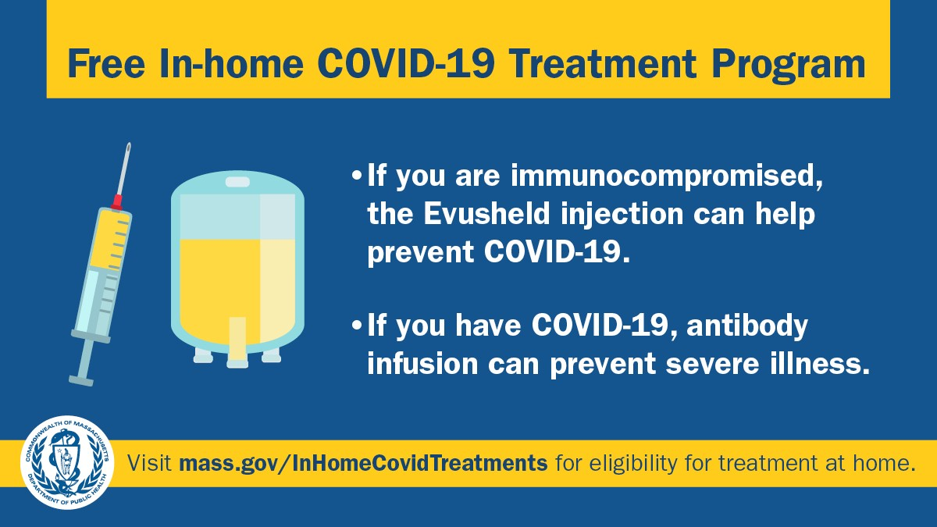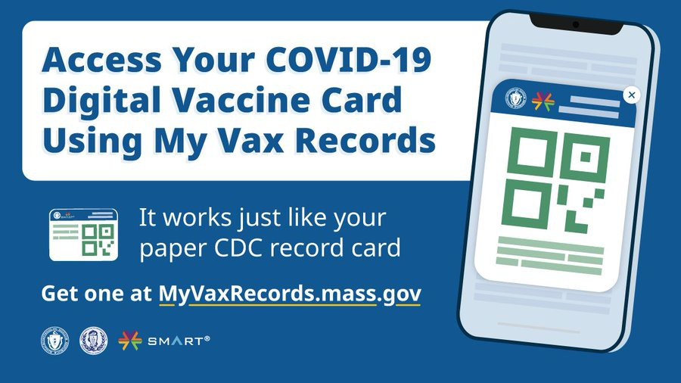Reminders

IN-HOME VACCINATION PROGRAM — NEW FLYER AND GRAPHIC AVAILABLE

Massachusetts offers in-home COVID-19 vaccinations for anyone who has difficulty getting to or using a community clinic, including young children. Learn more,
or call 833-983-0485 to sign up for an appointment.

Help spread the word with this new flyer
and social media graphic!

FREE COVID-19 IN-HOME TREATMENT PROGRAM

In Massachusetts, treatments like Evusheld (to prevent COVID-19) and monoclonal antibody infusion (to prevent severe illness) can be administered at home.
Check if you are eligible for our at-home COVID-19 treatment program.

Learn more about free, safe, and effective treatments for COVID-19.

DO YOU USE MY VAX RECORDS? IT'S A DIGITAL VACCINE CARD FOR MA RESIDENTS

Need a copy of your COVID-19 vaccination record? MA residents can use My Vax Records to get a digital vaccine card to show they’ve been vaccinated against COVID-19, if they choose. Learn more.

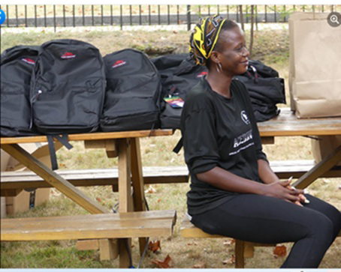Key Resources
Boston

In September, the African Community Economic Development of New England (ACEDONE) hosted two back-to-school vaccine clinics, where students and families were able to receive school supplies and PPE (see photo). Over 140 people visited the first clinic, held at First Church Roxbury, and 12 children between the ages of 12 and 17 were vaccinated.
Over 50 people visited the second clinic, held at Nueva Vida Church. In total, 7 adults received boosters and 8 children were vaccinated.
Read More Highlights
Recent Highlights

OUTREACH AND EDUCATION MATERIALS

COVID-19 Vaccine FAQs
COVID-19 Therapeutic Information (including telehealth) Weekly Provider Bulletin (latest edition published 10/13/22)
Trust the Facts, Get the Vax Campaign Materials (organized by audience, including general, parents and pregnant people, youth, young adults; available in 12 languages) Multilingual COVID-19 Materials (videos and printables; organized by language) COVID-19 Funeral Assistance from FEMA (including one-pager with key info available in multiple languages)
COVID-19 Vaccination Tools for Employers
Archive of COVID-19 Vaccine Communications Updates (past editions of VEI Roundup)

FIND A COVID-19 VACCINE OR BOOSTER

Mass.gov/KidsClinic (family-friendly clinics throughout the fall)
Vaccine Finder
Find, Schedule, or Sign Up for a Mobile COVID-19 Vaccination COVID-19 In-Home Vaccination Program
Request a Copy of Your Vaccine Card

Share This Email
Share This Email
Share This Email

Visit the VEI Website

Vaccine Equity Initiative | 250 Washington Street, Boston, MA 02108 Unsubscribe vaccineequityinitiative@mass.gov
Constant Contact Data Notice
Sent by vaccineequityinitiative@mass.gov in collaboration with
Try email marketing for free today!

