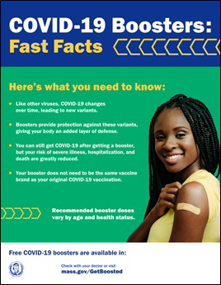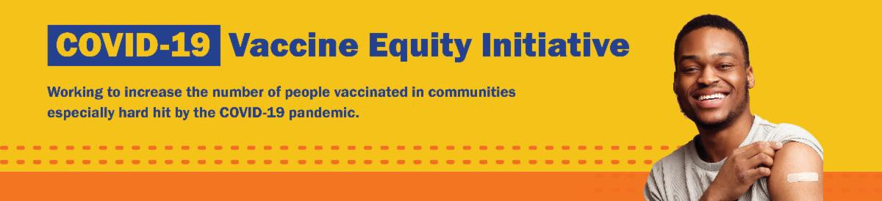

**October 24, 2022**

Here are the latest resources for promoting COVID-19 vaccination to share with your colleagues

and networks across Massachusetts. If you received this from a colleague, [**subscribe today**](https://lp.constantcontactpages.com/su/9wFTcRU/VEIWeeklyRoundup?source_id=04ebdcac-5947-42ca-aaba-bc8174b71e8c&source_type=em&c)**.**

[**View this email online**](https://campaignlp.constantcontact.com/em/1138003900342/04ebdcac-5947-42ca-aaba-bc8174b71e8c)**.**

**What's New**

# LAUNCHING OUR FALL COVID VACCINATION CAMPAIGN: $75 GIFT CARDS FOR THOSE VACCINATED AT SELECT CLINICS!

Beginning today, the Massachusetts Department of Public Health (DPH) is launching a campaign to increase COVID- 19 vaccination in communities hardest hit by the pandemic.

DPH is partnering on over 200 free COVID- 19 vaccination clinics that will offer an enhanced incentive for getting protected.

A $75 gift card for area retailers will be offered at select clinics to any MA resident (all ages) who gets vaccinated (first dose, second dose, or booster) at those clinics.

See participating clinics at [**mass.gov/GetBoosted**](https://www.mass.gov/info-details/free-family-friendly-covid-19-vaccination-clinics).

Help spread the word! Share this [**customizable flyer**](https://files.constantcontact.com/6b77156f801/5b6894a8-1c1c-43bc-afbf-dcceaf3847e3.pdf). Click in the flyer's footer to add your organization's logo and/or clinic details.

[Find more resources in this **COVID-19 vaccination promotion toolkit**.](https://www.mass.gov/info-details/covid-19-vaccine-promotion-toolkit)

# UPDATED BOOSTERS AVAILABLE FOR CHILDREN AGE 5 AND OLDER

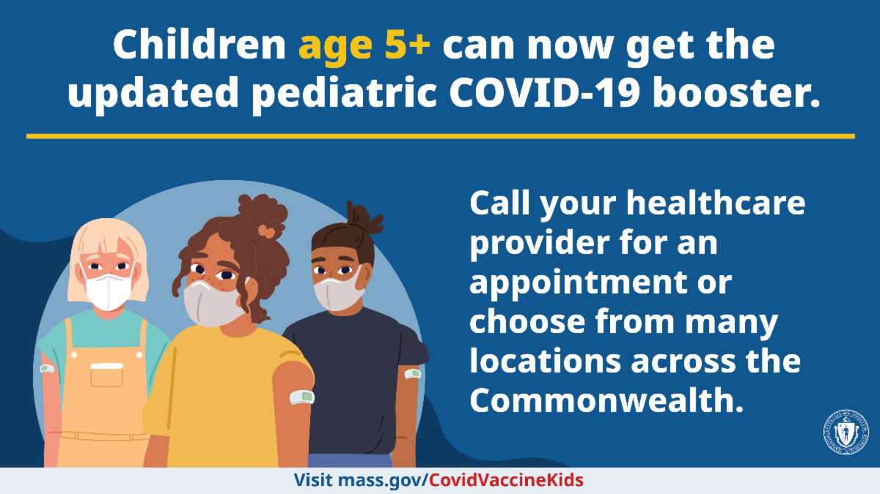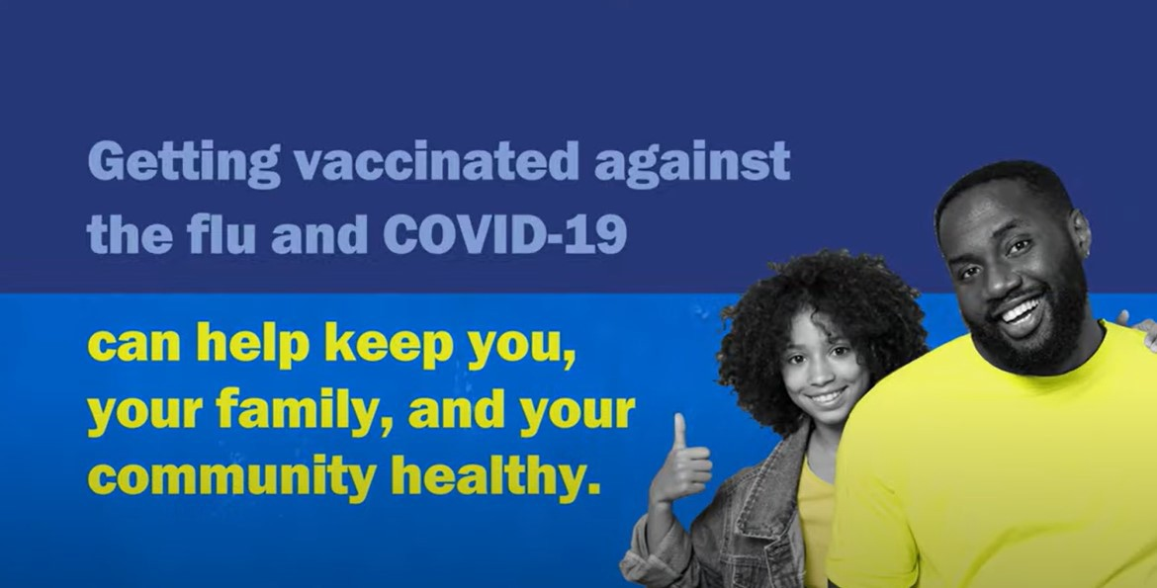

The COVID-19 booster helps protect against new variants. Now kids 5 years and older can get the updated pediatric [booster. **Learn more about booster eligibility.**](https://www.mass.gov/info-details/covid-19-booster-frequently-asked-questions)

Call your child’s health care provider for [an appointment, or **find a vaccination location near you**.](https://vaxfinder.mass.gov/)

# GET VACCINATED AGAINST THE FLU AND COVID-19

The best way to prevent illness this year? Get vaccinated against the flu and COVID- 19.

[Protect yourself and your family. **Learn more.**](http://mass.gov/flushot)

# CDC APPROVES NOVAVAX BOOSTERS FOR ADULTS AGES 18 AND UP

The CDC has allowed a Novavax monovalent COVID-19 booster for people ages 18 years and older.

These boosters are available for adults if they have completed their primary series vaccination but have not previously received a COVID-19 booster—and if they cannot or do not wish to receive an updated mRNA booster. [**Learn more.**](https://www.cdc.gov/coronavirus/2019-ncov/vaccines/stay-up-to-date.html)

# IN-HOME VACCINATION PROGRAM — FLYER NOW IN 12 LANGUAGES!

Massachusetts offers in-home COVID-19 vaccinations for anyone who has difficulty getting to or using a community clinic, including young children. [**Learn more**](https://mass.gov/info-details/covid-19-in-home-vaccination-program),

or call 833-983-0485 to sign up for an appointment.

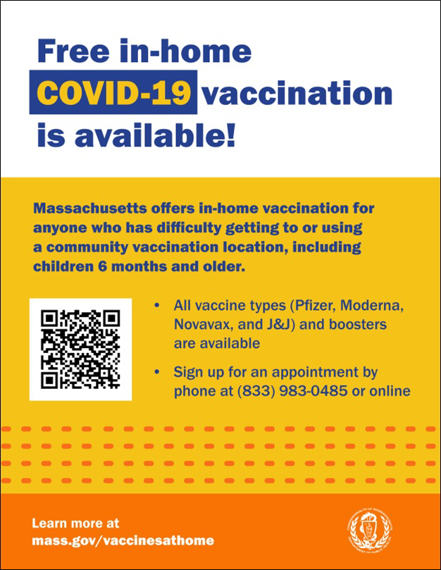

Help spread the word with this flyer , now

[**available in 12 languages**](https://www.mass.gov/info-details/covid-19-in-home-vaccination-program#download-in-home-vaccination-flyer-) !

**Key Resources**

# OUTREACH AND EDUCATION MATERIALS

[**COVID-19 Vaccine FAQs**](https://www.mass.gov/info-details/covid-19-vaccine-frequently-asked-questions)

[**COVID-19 Therapeutic Information**](https://www.mass.gov/get-treated-for-covid-19)(including [**telehealth**](https://www.mass.gov/info-details/free-telehealth-for-covid-19-treatment-with-paxlovid)) [**Weekly Provider Bulletin**](https://www.mass.gov/info-details/massachusetts-covid-19-vaccine-program-mcvp-guidance-for-vaccine-providers-and-organizations#weekly-provider-bulletins-)(latest edition published 10/18/22)

[**Trust the Facts, Get the Vax Campaign Materials**](https://www.mass.gov/resource/trust-the-facts-get-the-vax-campaign-materials)(organized by audience, including general, parents and pregnant people, youth, young adults; available in 12 languages) [**Multilingual COVID-19 Materials**](https://www.mass.gov/resource/multilingual-covid-19-materials)(videos and printables; organized by language) [**COVID-19 Funeral Assistance from FEMA**](https://www.mass.gov/info-details/covid-19-funeral-assistance)(including [**one-pager with key info**](https://www.mass.gov/info-details/covid-19-funeral-assistance#fema-funeral-assistance-website-%26-faq-)available in multiple languages)

[**COVID-19 Vaccination Tools for Employers**](https://www.mass.gov/doc/covid-19-vaccination-tools-for-employers)

[**Archive of COVID-19 Vaccine Communications Updates**](https://www.mass.gov/lists/archive-of-covid-19-vaccine-communications-updates)(past editions of VEI Roundup)

# FIND A COVID-19 VACCINE OR BOOSTER

[**Mass.gov/KidsClinic**](https://www.mass.gov/info-details/prepare-for-back-to-school-with-free-covid-19-vaccination-clinics#clinic-schedule-)(family-friendly clinics throughout the fall)

[**Vaccine Finder**](https://vaxfinder.mass.gov/)

[**Find, Schedule, or Sign Up for a Mobile COVID-19 Vaccination**](https://www.mass.gov/covid-19-mobile-vaccinations)[**COVID-19 In-Home Vaccination Program**](https://www.mass.gov/info-details/covid-19-in-home-vaccination-program)

[**Request a Copy of Your Vaccine Card**](https://www.mass.gov/info-details/requesting-a-copy-of-your-covid-19-vaccination-record)

**Recent Highlights**

**Revere and Everett**

In September, [**Women Encouraging Empowerment**](https://www.weerevere.org/), a trusted organization in the immigrant community of Revere, and the [**Joint Committee for Children's Health Care**](https://jcchce.org/)in Everett formed a partnership to offer weekly COVID-19 vaccine clinics while also providing health insurance enrollment (*see photos*). The organizations saw an opportunity to support new

immigrant families arriving in Revere by combining these health-related services. A win-win!

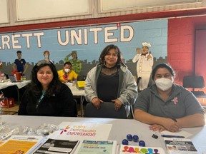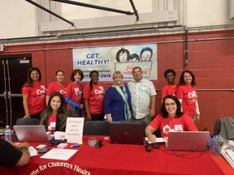

[**Read More Highlights**](https://www.mass.gov/info-details/covid-19-vaccine-equity-initiative-highlights)



[Share This Email](https://www.facebook.com/sharer/sharer.php?u=https%3A//campaignlp.constantcontact.com/em/1138003900342/04ebdcac-5947-42ca-aaba-bc8174b71e8c)

[Share This Email](https://twitter.com/intent/tweet?text=VEI%2BWeekly%2BRoundup%3A%2Bhttps%3A//campaignlp.constantcontact.com/em/1138003900342/04ebdcac-5947-42ca-aaba-bc8174b71e8c)

[Share This Email](https://www.linkedin.com/sharing/share-offsite/?url=https%3A//campaignlp.constantcontact.com/em/1138003900342/04ebdcac-5947-42ca-aaba-bc8174b71e8c)

[**Visit the VEI Website**](https://www.mass.gov/info-details/covid-19-vaccine-equity-initiative)

Vaccine Equity Initiative | 250 Washington Street, Boston, MA 02108 [Unsubscribe vaccineequityinitiative@mass.gov](mailto:Unsubscribevaccineequityinitiative@mass.gov)

[Constant Contact Data Notice](http://www.constantcontact.com/legal/about-constant-contact)

Sent by [vaccineequityinitiative@mass.gov](mailto:vaccineequityinitiative@mass.gov) in collaboration with



[Try email marketing for free today](http://www.constantcontact.com/index.jsp?cc=nge&rmc=VF21_CPE&nav=04ebdcac-5947-42ca-aaba-bc8174b71e8c)!