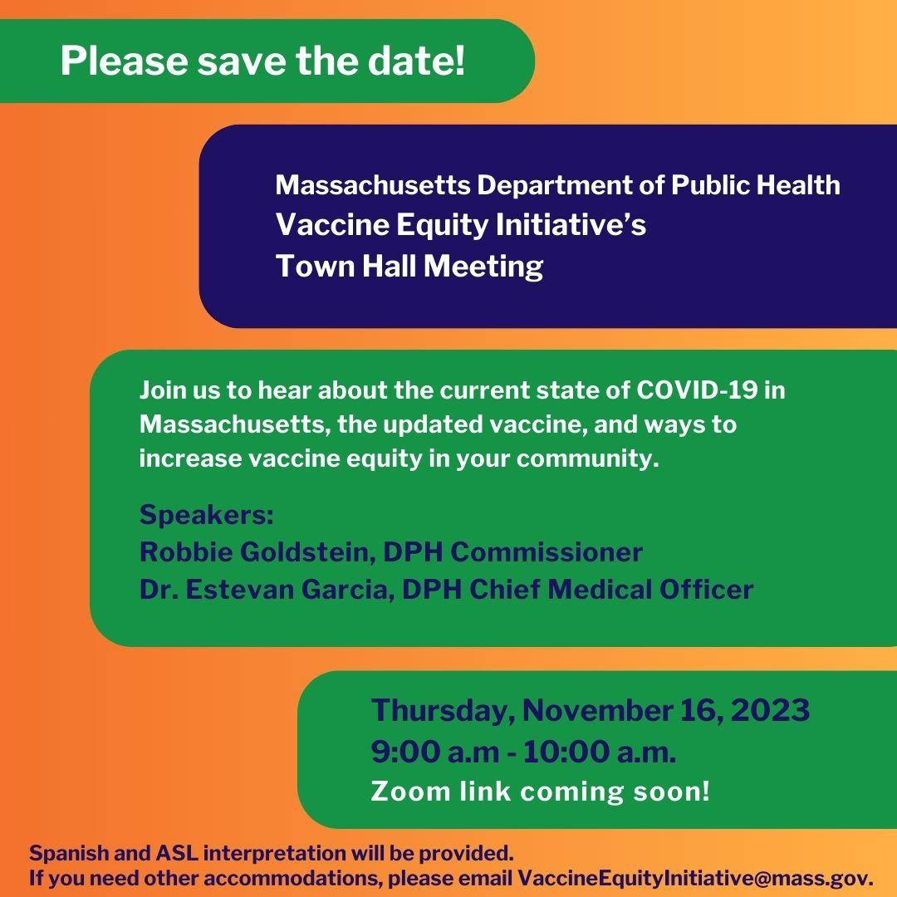
October 27, 2023
Here are the latest resources for promoting COVID-19 vaccination to share with your colleagues
and networks across Massachusetts. If you received this from a colleague, subscribe today.
View this email online.
What's New

SAVE THE DATE: VEI TOWN HALL ON NOVEMBER 16 AT 9 A.M.
Join the Vaccine Equity Initiative Town Hall on Thursday, November 16 from 9:00 to 10:00 a.m.!
During this time, we will hear about the current state of COVID-19 in Massachusetts, learn about the updated vaccine, and hear about ways to increase vaccine equity in communities.
A registration link will be shared closer to the event date. The registration form will include the opportunity to ask questions you’d like answered at the event.

Join the VEI Town Hall on November 16! Have questions or need accommodations to join? Email us!

ARE YOU DUE FOR AN UPDATED COVID VACCINE? HERE'S HOW TO TELL
Everyone 6 months and older should get an updated COVID-19 vaccine if they have not had one since September 12, 2023.
What does this mean?

Everyone aged 5 years and

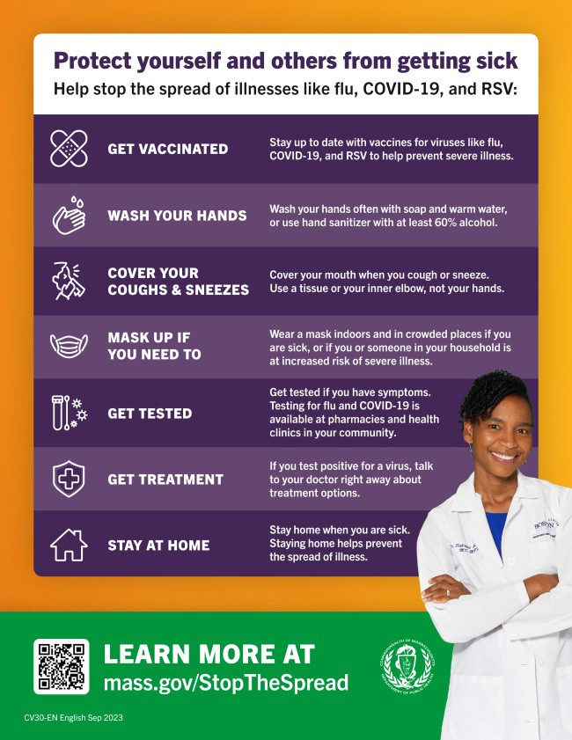
older should get 1 dose of an
updated COVID-19 vaccine — even if you've never been vaccinated before!
Children aged 6 months to 4 years need 1-3 doses, depending on the number and brand of doses they got in the past.

Recommended doses may vary by age and immune status. Learn more at mass.gov/CovidVaccine.

NEW FLYER: PROTECT YOURSELF AND OTHERS FROM GETTING SICK
Getting the updated COVID-19 vaccine is just one way that you can help protect yourself and others from getting sick during respiratory illness season!
This flyer offers a checklist of ways to help stop the spread of COVID, flu, and RSV. It's available in 13 languages !

Have questions about the COVID, flu, or RSV vaccines? Need to find a vaccine? Visit mass.gov/StopTheSpread.

Reminders

LOOKING TO GET YOUR UPDATED COVID-19 VACCINE?
As of September, the CDC now recommends that everyone ages 6 months and older get one updated COVID-19 vaccine dose.

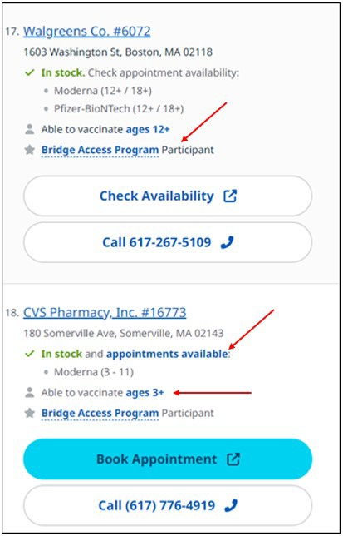
The updated COVID-19 vaccine is
currently being shipped to vaccination locations. Not all locations have it in stock yet, and some locations do not yet have doses for all age groups. To make sure the dose you need is in stock, please contact the location before you go!

When you search Vaccines.gov for vaccinators near you, the results will show:
If they have the vaccine in stock What age group they have the
vaccine for
If they are participating in the Bridge Access Program (which offers free vaccines for those without health insurance)
Clicking on a vaccination location will show you many more details, including if you need an appointment or if you can simply drop in.

Search results on Vaccines.gov show if a location has the vaccine in stock, what ages are available, and if they participate in the Bridge Access Program.
Looking for an updated vaccine but not sure where to start? For help with finding or making an appointment, call 2-1-1 (or 877-211-6277) and press
1. Calls are answered Monday through Friday, 9 a.m. to 5 p.m.

DON'T FORGET: THE COMMUNITY HEALTH EQUITY SURVEY CLOSES OCTOBER 31!
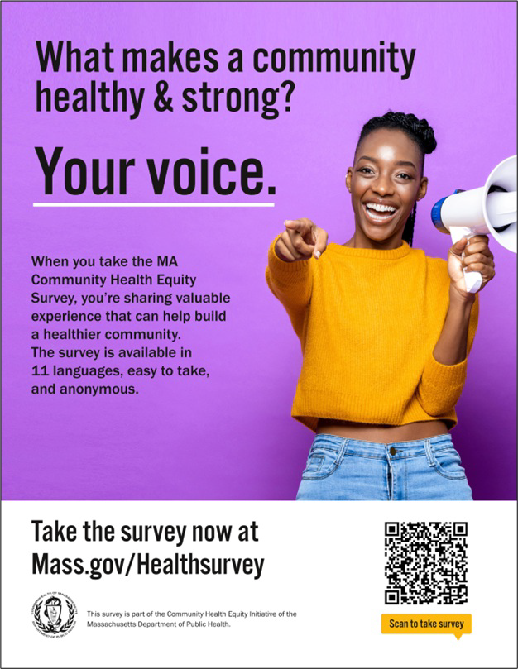
There's still time to take the Community Health Equity Survey, which is open for Massachusetts residents through the end of October!
Results will help DPH improve programs, make decisions about funding and resources, and support policies to improve health inequities.
The survey is available in 11 languages and is anonymous. It is open to anyone ages 14 and older. Get started

at mass.gov/HealthSurvey.
Help get the word out! Find talking points, flyers, and other materials to help promote the survey in this toolkit.

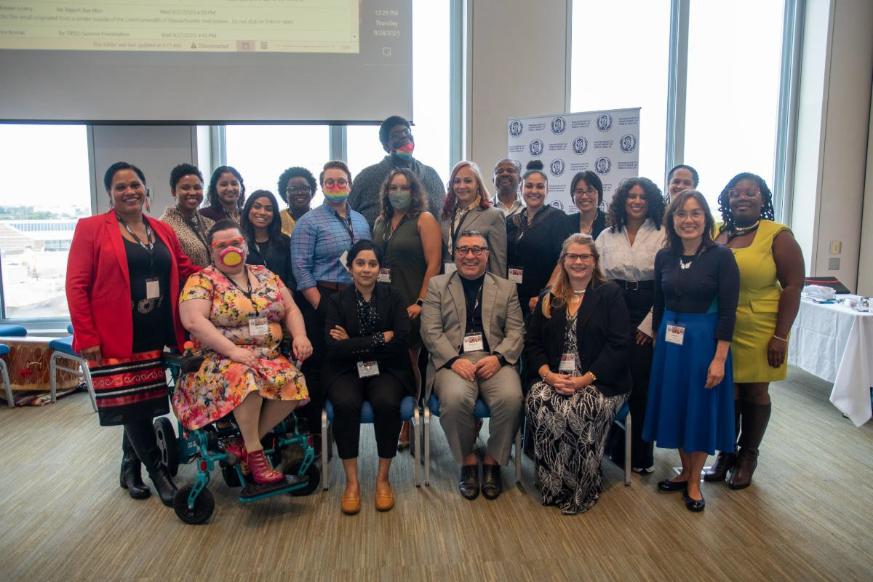
FIRST-EVER MASSACHUSETTS TRIBAL AND INDIGENOUS HEALTH SUMMIT:
VIEW THE PHOTOS!
Over 100 attendees — including
Tribal leaders and community members from Tribes in Massachusetts, Rhode Island, and New York; Tribal and Indigenous people serving organizations (TIPSOs); and leaders from federal and statewide agencies — joined together for the Commonwealth's first-ever Tribal and Indigenous Health Summit held on September 28. Check out some of the photos!
Congratulations to the Community Engagement Unit and
Cheryl Cromwell, the unit’s Tribal and Indigenous Health Equity Strategist, on the success of the summit!
Read More Highlights
OUTREACH AND EDUCATION MATERIALS
COVID-19 Vaccine FAQs
COVID-19 Therapeutic Information (including telehealth) Archive of Weekly Provider Bulletins
Archive of COVID-19 Vaccine Communications Updates (past editions of VEI Roundup)
FIND A COVID-19 VACCINE DOSE
Use Vaccines.gov to sign up for a COVID-19 vaccine appointment Find a community COVID-19 vaccination clinic near you
Learn about the COVID-19 In-Home Vaccination Program and request a visit Request a copy of your vaccine card
Highlights
Key Resources

Share This Email
Share This Email
Share This Email

Visit the VEI Website

Vaccine Equity Initiative | 250 Washington Street, Boston, MA 02108 Unsubscribe vaccineequityinitiative@mass.gov
Constant Contact Data Notice
Sent by vaccineequityinitiative@mass.gov powered by
Try email marketing for free today!

