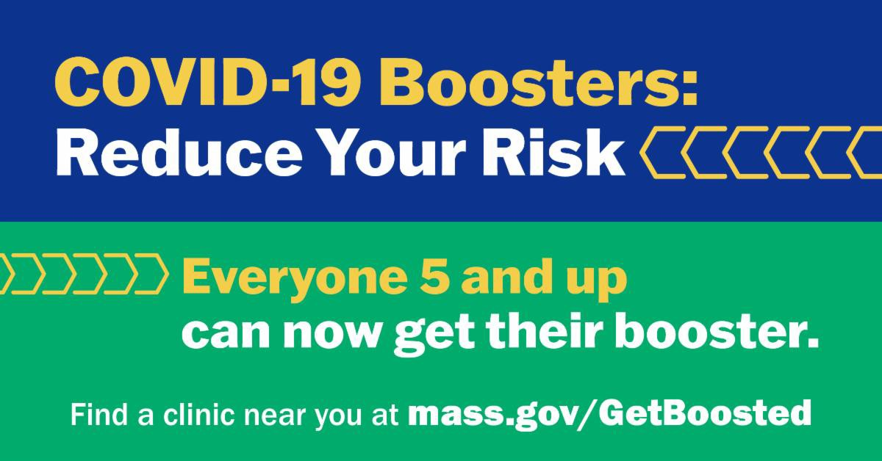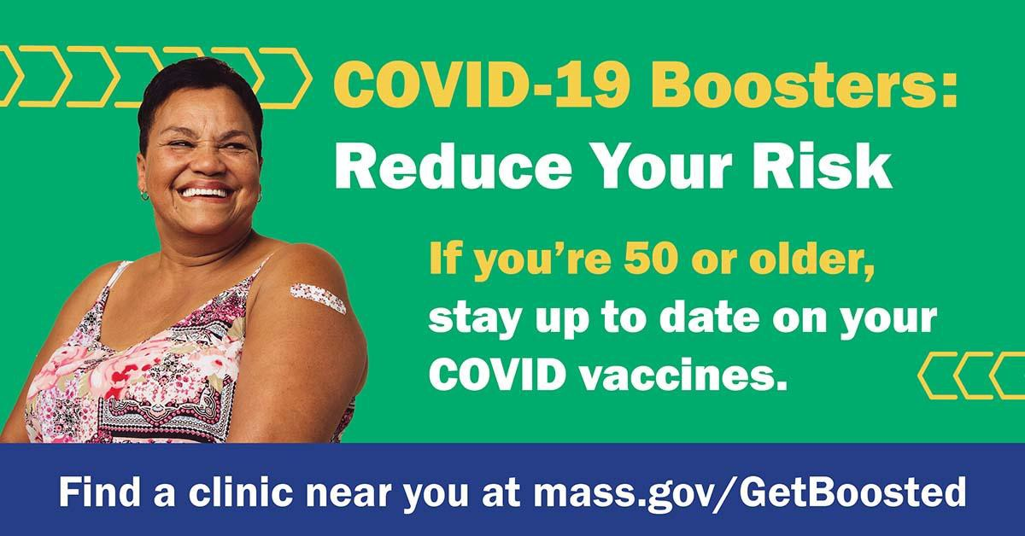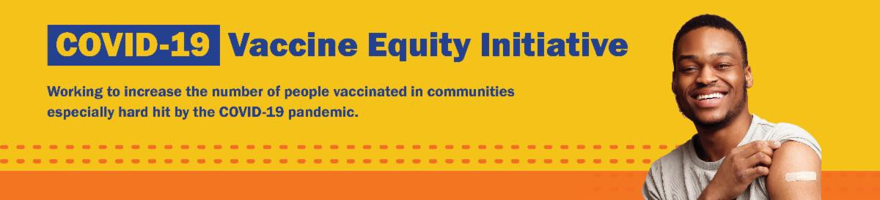
October 28, 2022
Here are the latest resources for promoting COVID-19 vaccination to share with your colleagues
and networks across Massachusetts. If you received this from a colleague, subscribe today.

View this email online.
What's New

PLEASE SHARE: FALL COVID VACCINATION CLINICS OFFERS $75 GIFT CARDS FOR THOSE VACCINATED AT ONE OF 200+ CLINICS!

DPH is partnering on over 200 free COVID-19 vaccination clinics that will offer an enhanced incentive for getting protected through the end of 2022.

A $75 gift card for area retailers will be offered to any MA resident (all ages) who gets vaccinated (first dose, second dose, or booster) at the clinics listed on mass.gov/GetBoosted.

Resources are available to help spread the word about these clinics, including:
Customizable booster flyer
Social media graphics (option 1 & option 2) Newsletter article (also available in multiple languages)
Press release template

Find more resources in this COVID-19 vaccination promotion toolkit!

A big thank you to all of the community partners supporting these clinics!

An October 26 clinic at the Fall River Public Library, held in partnership with SER Jobs

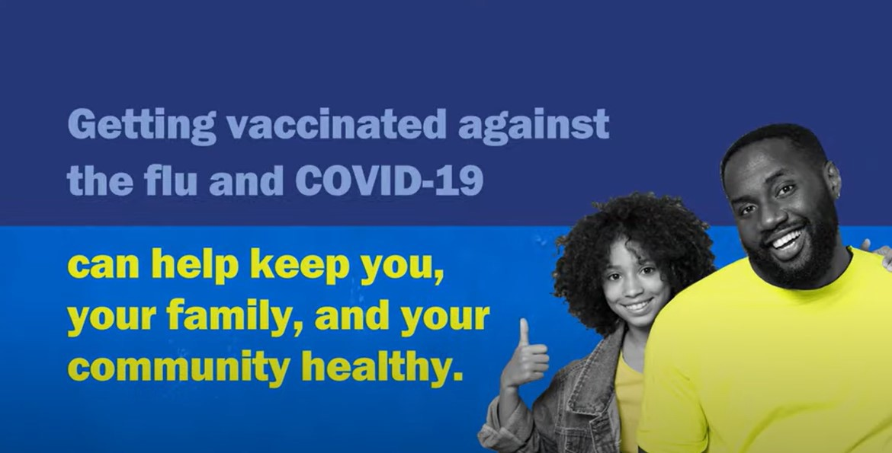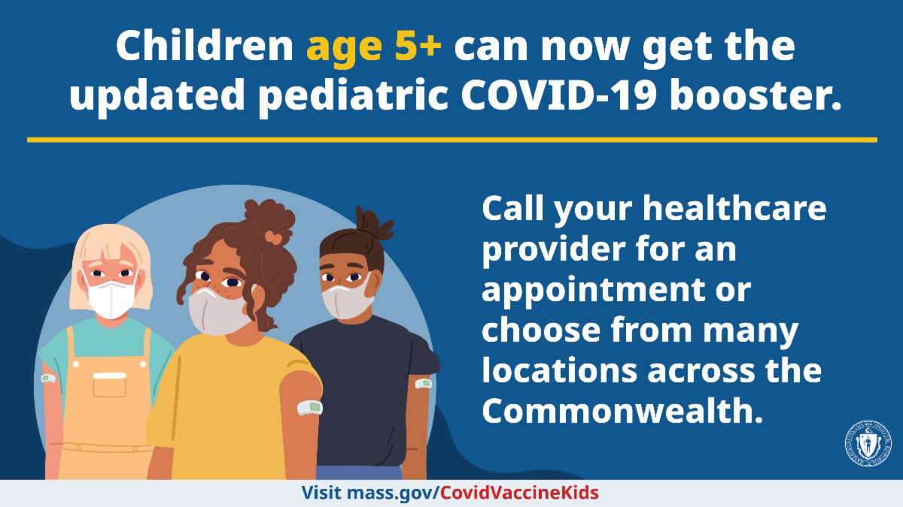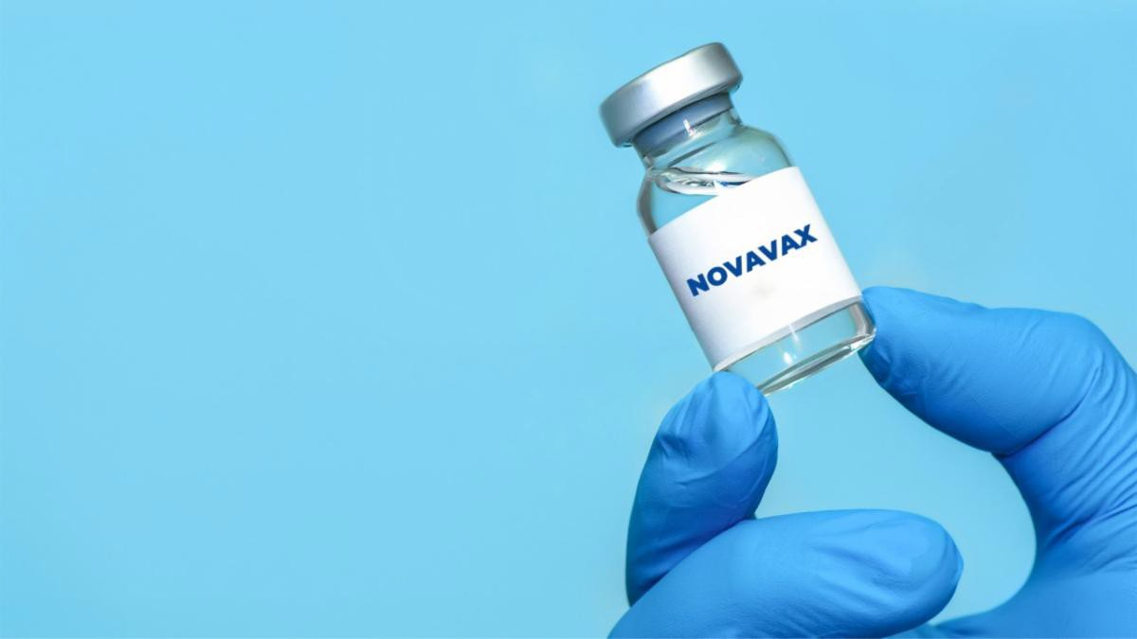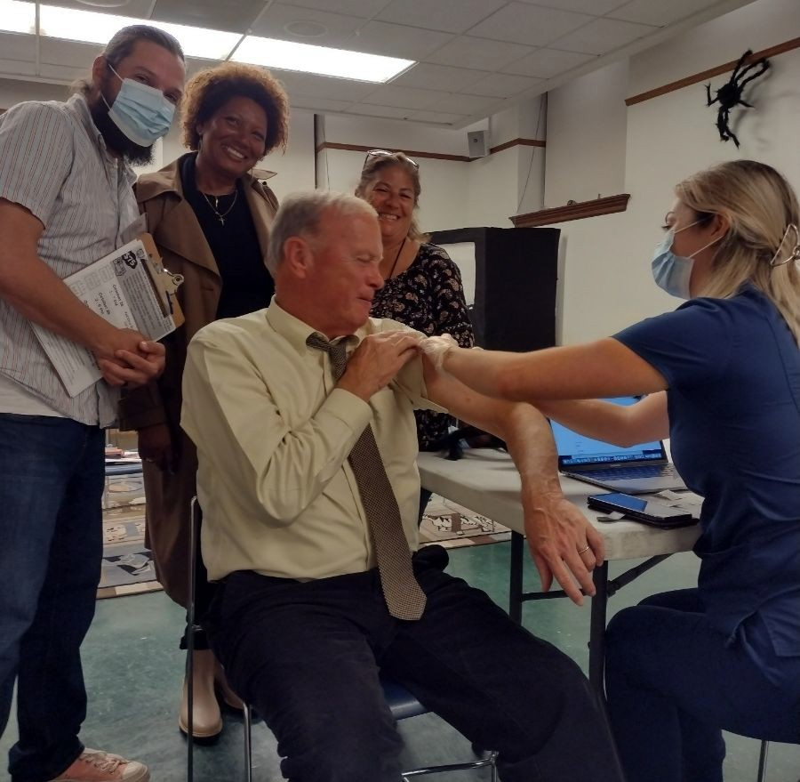
for Progress, resulted in 66 vaccinations.
Mayor Paul Coogan stopped by to get an updated COVID-19 booster (see photo)!
Above: Mayor Paul Coogan receives an updated
COVID-19 booster at a recent Fall River clinic.
Reminders

GET VACCINATED AGAINST THE FLU AND COVID-19

The best way to prevent getting sick?
Get vaccinated against the flu and COVID-
19. Protect yourself and your family. Learn more.

Help spread the word! Share a short video, which can be found here along with links to fact sheets and clinic lists.

UPDATED BOOSTERS AVAILABLE FOR CHILDREN AGE 5 AND OLDER

The COVID-19 booster helps protect against new variants. Now kids 5 years and older can get the updated pediatric booster. Learn more about booster eligibility.

Call your child’s health care provider for an appointment, or find a vaccination location near you.

CDC APPROVES NOVAVAX BOOSTERS FOR ADULTS AGES 18 AND UP

The CDC has appproved a Novavax monovalent COVID-19 booster for people ages 18 years and older.

These boosters are available for adults if they have completed their primary series vaccination but have not previously received a COVID-19 booster — and if they

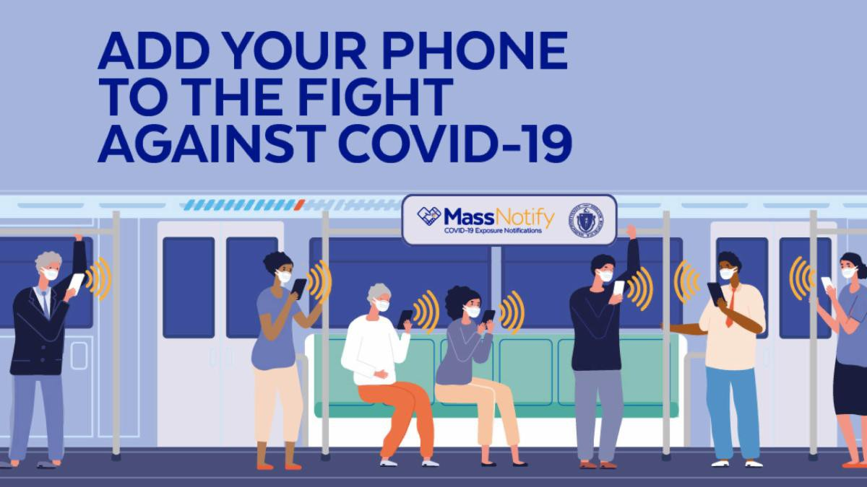
cannot or do not wish to receive an
updated mRNA booster. Learn more.
ENABLE MASSNOTIFY ON YOUR SMARTPHONE

More than 2 million MA residents now use MassNotify, a tool that works through smartphones — with a focus on
privacy — to alert users who may have been exposed to COVID-19. Learn more.
Key Resources

OUTREACH AND EDUCATION MATERIALS

COVID-19 Vaccine FAQs
COVID-19 Therapeutic Information (including telehealth) Weekly Provider Bulletin (latest edition published 10/18/22)
Trust the Facts, Get the Vax Campaign Materials (organized by audience, including general, parents and pregnant people, youth, young adults; available in 12 languages) Multilingual COVID-19 Materials (videos and printables; organized by language) COVID-19 Funeral Assistance from FEMA (including one-pager with key info available in multiple languages)
COVID-19 Vaccination Tools for Employers
Archive of COVID-19 Vaccine Communications Updates (past editions of VEI Roundup)

FIND A COVID-19 VACCINE OR BOOSTER

Mass.gov/KidsClinic (family-friendly clinics throughout the fall)
Vaccine Finder
Find, Schedule, or Sign Up for a Mobile COVID-19 Vaccination COVID-19 In-Home Vaccination Program
Request a Copy of Your Vaccine Card

Recent Highlights

Everett
Latinos Unidos de Massachusetts (LUMA) hosted two events that included COVID-19 vaccine clinics. On August 28, LUMA hosted their 15th Annual Multicultural

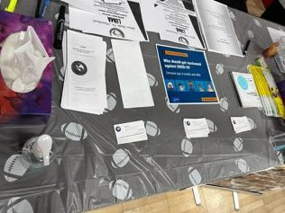
Festival at Glendale Park. The event brings
together community members from 27 different Latin American countries. At the event, 42 people received a vaccine dose. On September 17, LUMA joined with Cambridge Health Alliance and other partners to host a Community Health and Resource Fair, where 64 people received COVID shots.

Read More Highlights

Share This Email
Share This Email
Share This Email

Visit the VEI Website

Vaccine Equity Initiative | 250 Washington Street, Boston, MA 02108

Unsubscribe vaccineequityinitiative@mass.gov Constant Contact Data Notice
Sent by vaccineequityinitiative@mass.gov in collaboration with
Try email marketing for free today!

