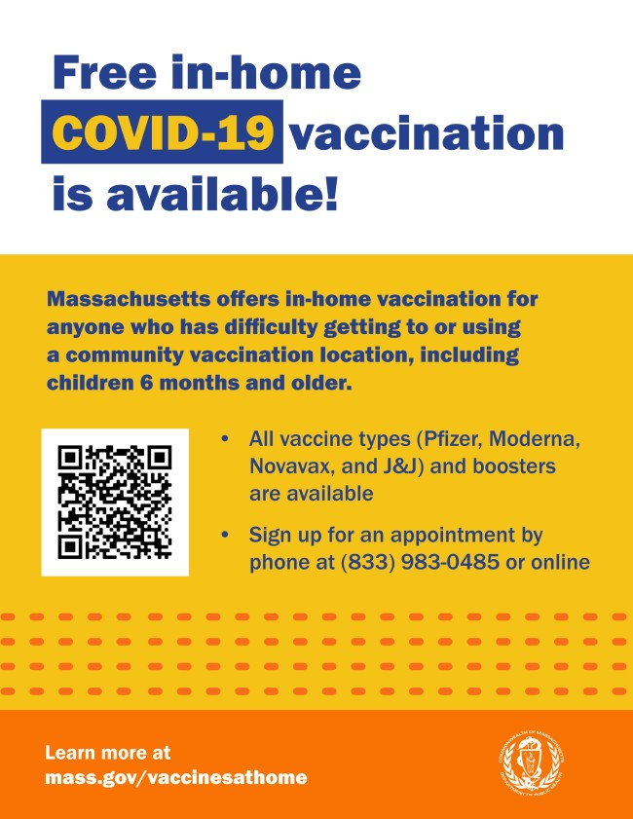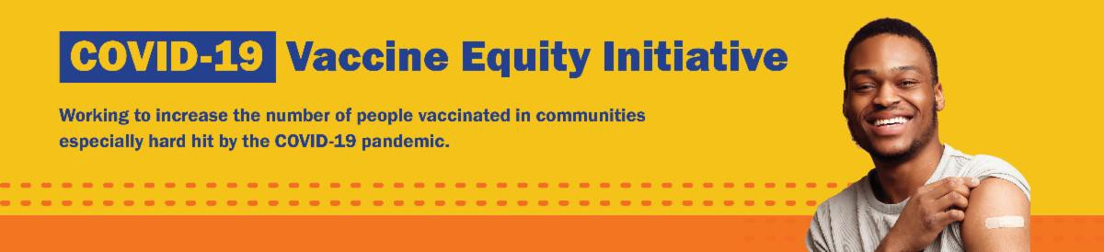
IN-HOME VACCINATION PROGRAM — NEW FLYER AND GRAPHIC
AVAILABLE

Massachusetts offers in-home COVID-19 vaccinations for anyone who has difficulty getting to or using a community clinic, including young children. Learn more,
or call 833-983-0485 to sign up for an appointment.

Help spread the word with this new flyer
and social media graphic!
FREE, FAMILY-FRIENDLY VACCINATION CLINICS — SCHEDULE UPDATED!

DPH is providing free COVID-19 vaccination clinics throughout fall 2022.

Anyone ages 5 years and older can get a COVID-19 vaccination or booster. Anyone ages 6 months to 4 years can get a COVID- 19 vaccination at these clinics.
October 7, 2022
Here are the latest resources for promoting COVID-19 vaccination to share with your colleagues
and networks across Massachusetts. If you received this from a colleague, subscribe today.

View this email online.
What's New

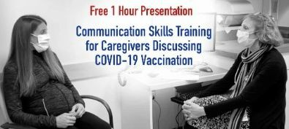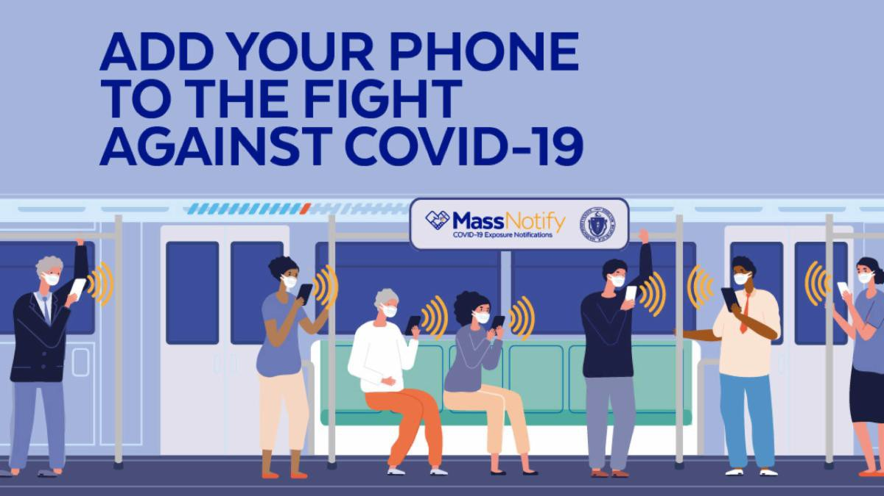
You do not need an appointment at these
clinics, although some may encourage pre- registration. Find a clinic near you.
Reminders

COMMUNICATION SKILLS TRAINING FOR CAREGIVERS DISCUSSING COVID- 19 VACCINATION DURING PREGNANCY AND POST-PARTUM

Offered by the UMass Chan Medical School's Center for Integrated Primary Care, this free, one-hour presentation focuses on practical strategies to adapt conversations about COVID19 vaccinations to meet the needs of people from a diversity of backgrounds. CMEs and CEs available. Although the presentation focuses on pregnant persons, it will be of interest to anyone counseling clients or patients about vaccination. Learn more.

ENABLE MASSNOTIFY ON YOUR SMARTPHONE

More than 2 million MA residents now use MassNotify, a tool that works through smartphones — with a focus on
privacy — to alert users who may have been exposed to COVID-19. Learn more.

FOLLOW THESE SEVEN STEPS

There are a number of steps that you can take to help protect yourself, your family, and your community from COVID-19.

Available in multiple languages, this flyer features a checklist with these
steps. Please share it with your networks.

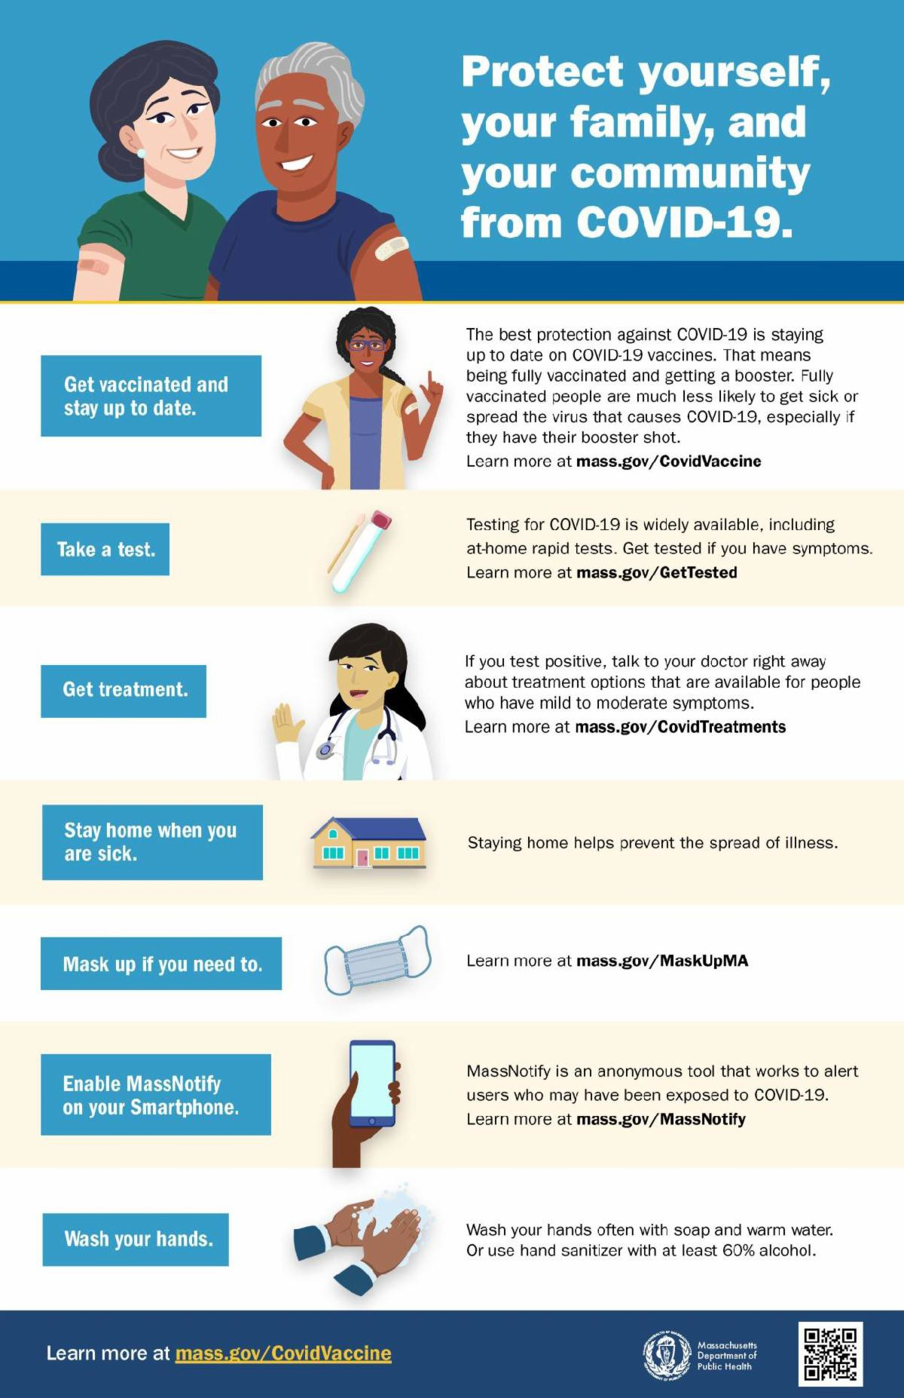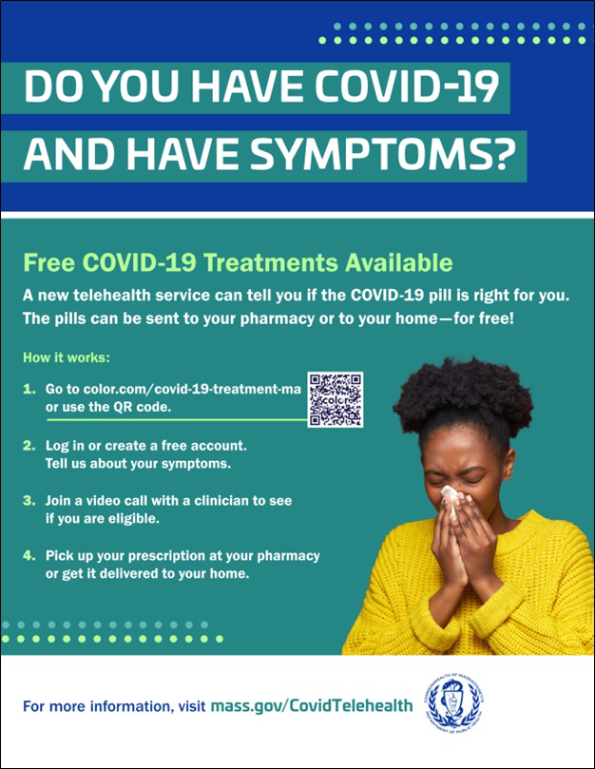
OUTREACH AND EDUCATION MATERIALS

COVID-19 Vaccine FAQs
COVID-19 Therapeutic Information (including telehealth) Weekly Provider Bulletin
Trust the Facts, Get the Vax Campaign Materials (organized by audience, including general, parents and pregnant people, youth, young adults; available in 12 languages) Multilingual COVID-19 Materials (videos and printables; organized by language)
Key Resources

FREE TELEHEALTH FOR COVID-19 TREATMENT

Free, safe, and effective treatments for COVID-19 are available across MA. They can help prevent hospitalizations and reduce the risk of severe disease.

Telehealth consultations are now available via phone, in addition to video, once you’ve requested a
consultation online. Consultations can be accessed in 10+ languages.

Help spread the word with a customizable flyer. Click in the flyer's footer to add your organization's logo. Other flyers in additional languages are also available.

Please also share this new video about free COVID treatments.

Learn more about how to access treatment, including in-home options.

COVID-19 Funeral Assistance from FEMA (including one-pager with key info
available in multiple languages)
COVID-19 Vaccination Tools for Employers
Archive of COVID-19 Vaccine Communications Updates (past editions of VEI Roundup)
FIND A COVID-19 VACCINE OR BOOSTER

Mass.gov/KidsClinic (family-friendly clinics throughout the fall)
Vaccine Finder
Find, Schedule, or Sign Up for a Mobile COVID-19 Vaccination COVID-19 In-Home Vaccination Program
Request a Copy of Your Vaccine Card
Recent Highlights

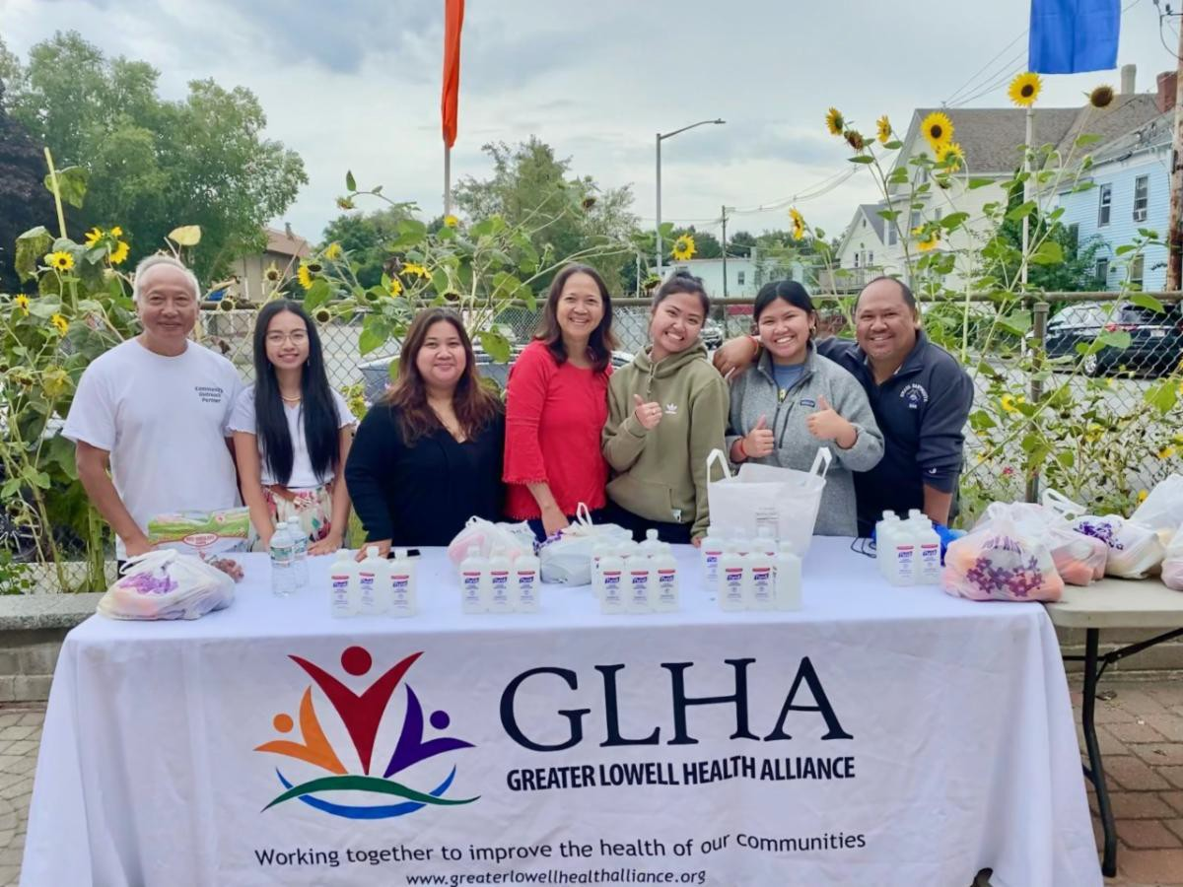Lowell

VEI recently partnered with Greater Lowell Health Alliance and several other community organizations to hold two clinics at local temples. Both clinics were held on September 25, which is one of the biggest Khmer religious events of the year, after Khmer New Year. Cataldo Ambulance provided COVID vaccinations at the events, and outreach workers tabled and provided educational resources, COVID test kits, and PPE (see photo). At the Glory Buddhist Temple, 160 people were vaccinated (159 boosters), while at the Wat Khmer Samaki Santikaram Temple, 88 people got vaccinated (87 boosters).

Read More Highlights

Share This Email
Share This Email
Share This Email

Visit the VEI Website

Vaccine Equity Initiative | 250 Washington Street, Boston, MA 02108

Unsubscribe vaccineequityinitiative@mass.gov Constant Contact Data Notice
Sent by vaccineequityinitiative@mass.gov in collaboration with
Try email marketing for free today!

