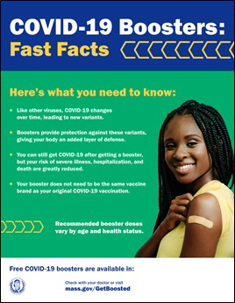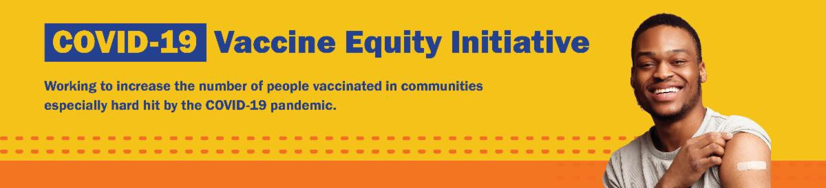
November 10, 2022
Here are the latest resources for promoting COVID-19 vaccination to share with your colleagues
and networks across Massachusetts. If you received this from a colleague, subscribe today.

View this email online.
What's New

UPDATED COVID-19 BOOSTER AND $75 GIFT CARD: TWO MORE REASONS TO GET VACCINATED NOW!

More than 7,000 doses of COVID vaccine have been administered in just the first two weeks of this program. These free, family- friendly clinics enable anyone ages 6 months and up to get a COVID-19 vaccine and anyone ages 5 and up can get a COVID-19 vaccine or booster.

As part of a special promotion, Massachusetts residents of all ages who get vaccinated (first dose, second dose, or booster) at participating clinics will receive a
$75 gift card, while supplies last. Offer runs through December 31, 2022.

New clinics continue to be added! View a list of the clinics at mass.gov/GetBoosted.

Resources are available to help spread the word about these clinics, including:
Customizable booster flyer Social media graphics Newsletter article
Press release template

Find these resources and more in our vaccine promotion toolkit!

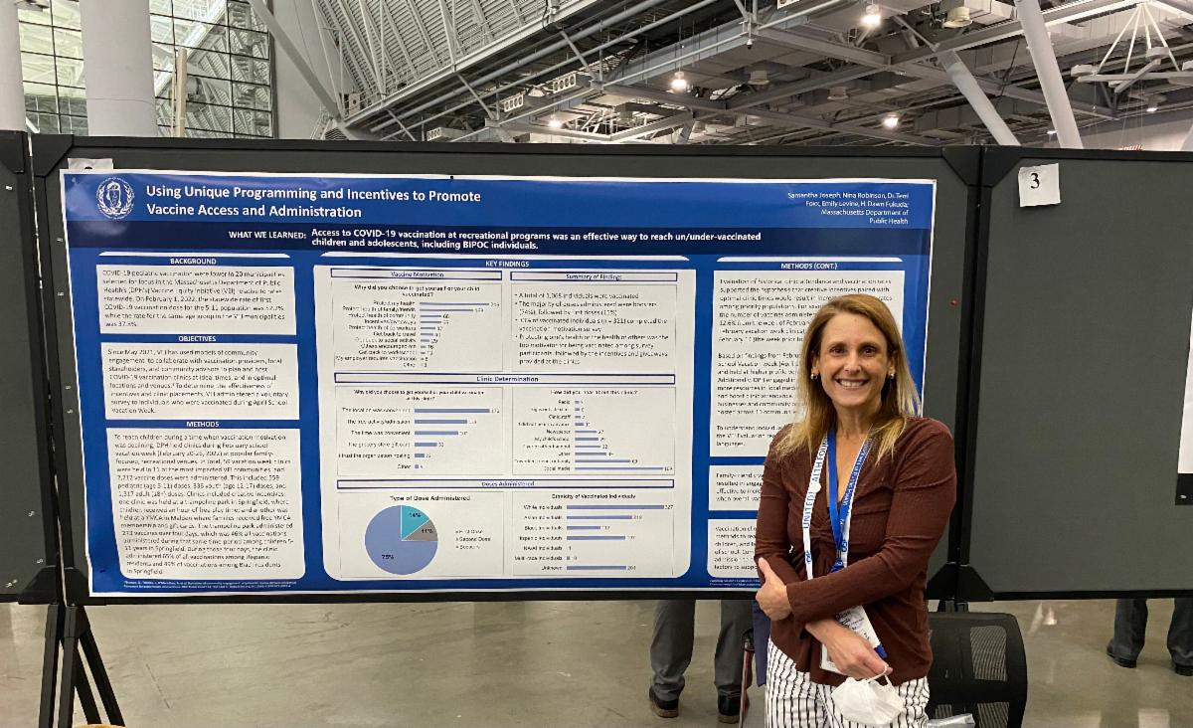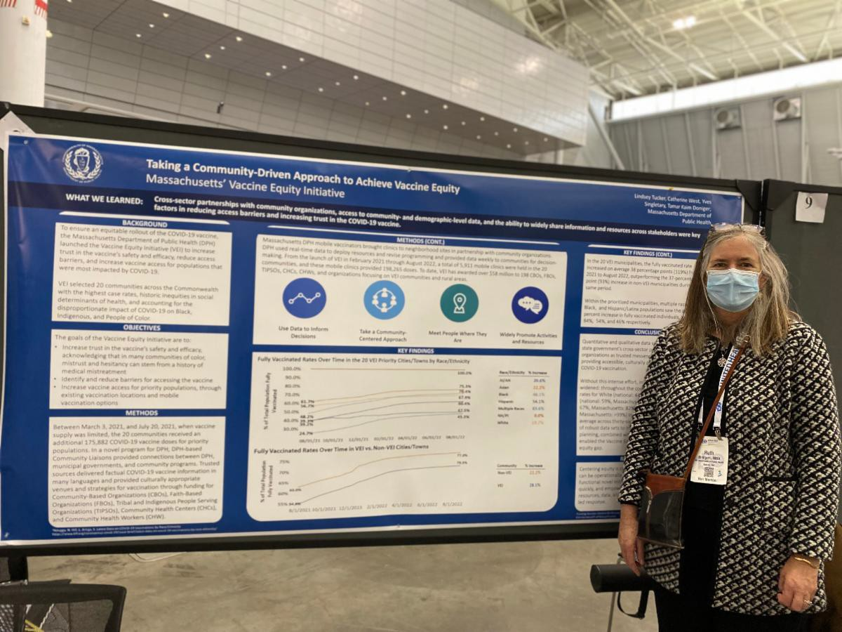
VACCINE EQUITY INITIATIVE (VEI) PRESENTS FINDINGS AT AMERICAN PUBLIC HEALTH ASSOCIATION MEETING IN BOSTON

Above: Dawn Fukuda (Director, Office of HIV/AIDS) and Ruth Blodgett (Director, Bureau of Community Health and Prevention) present VEI posters at the 2022 APHA meeting.

At the American Public Health Association (APHA) 2022 annual meeting in Boston on November 6-9, our VEI team discussed best practices for supporting COVID-19 vaccine equity. VEI presentations included:

Using Unique Programming and Incentives to Promote Vaccine Access and Administration
(Dawn Fukuda, Emily Levine, Samantha Joseph, Nina Robinson, Terri Foxx)

Taking a Community-Driven Approach to Achieve Vaccine Equity: Massachusetts’ Vaccine Equity Initiative
(Lindsey Tucker, Catherine West, Yves Singletary, Ruth Blodgett, Tamar Kaim Doniger)

A Data Driven Approach to COVID-19 Vaccine Equity Initiatives
(Abigail Averbach, Amy Bettano, Arielle Coq, Kevin Harlen, Michelle Reid)

Massachusetts Vaccine Equity Initiative’s Census Block Group Data Dashboard – Helping Communities Use Data to Determine Areas in Need of Vaccine Administration
(Arielle Coq, Amy Bettano, Michelle Reid, Braden Miller, Dana Bernson, Abigail Averbach, Kevin Harlen, Rachel Allen, Samya Pasha, Sam Chanen, Sean Burpoe)

Congratulations to all of the authors, presenters, and team members who supported this work!

Reminders

DO YOU USE MY VAX RECORDS? IT'S A DIGITAL VACCINE CARD FOR MA RESIDENTS

Need a copy of your COVID-19 vaccination record? MA residents can use My Vax Records to get a digital vaccine card to show they’ve been vaccinated against COVID-19, if they choose. Learn more.

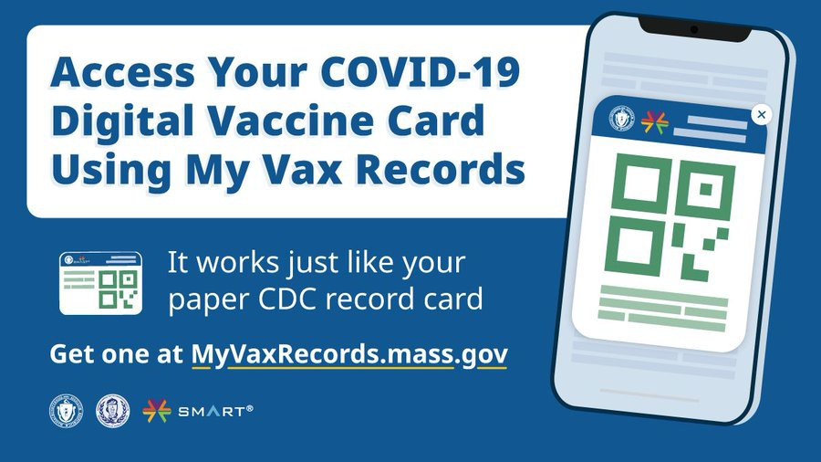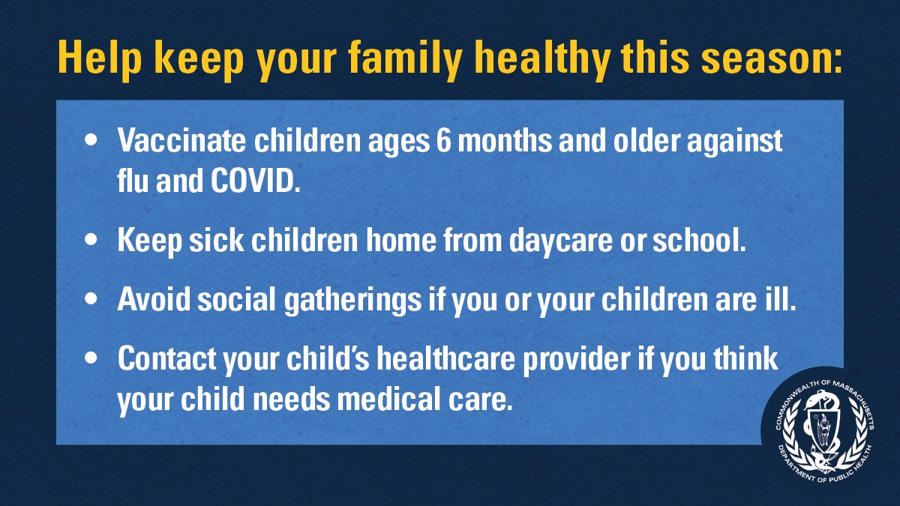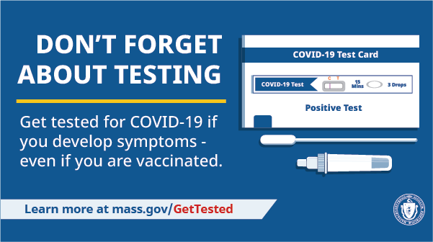
OUTREACH AND EDUCATION MATERIALS

COVID-19 Vaccine FAQs
COVID-19 Therapeutic Information (including telehealth) Weekly Provider Bulletin (latest edition published 11/8/22)
Trust the Facts, Get the Vax Campaign Materials (organized by audience, including general, parents and pregnant people, youth, young adults; available in 12 languages) Multilingual COVID-19 Materials (videos and printables; organized by language) COVID-19 Funeral Assistance from FEMA (including one-pager with key info available in multiple languages)
COVID-19 Vaccination Tools for Employers
Archive of COVID-19 Vaccine Communications Updates (past editions of VEI Roundup)
Key Resources

GET VACCINATED AGAINST THE FLU AND COVID-19

Rates of respiratory illness in infants and children are on the rise in Massachusetts and across much of the U.S. Take steps to keep your family healthy this season by getting vaccinated against the flu and COVID-19 and taking other precautions.

Protect yourself and your family. Learn more.

DON'T FORGET ABOUT TESTING

Testing is a critical tool in the fight against COVID-19. Get tested if you develop symptoms — even if you're vaccinated.
Visit mass.gov/GetTested.

FIND A COVID-19 VACCINE OR BOOSTER

Mass.gov/GetBoosted (family-friendly clinics through the end of 2022)
Vaccine Finder
Find, Schedule, or Sign Up for a Mobile COVID-19 Vaccination COVID-19 In-Home Vaccination Program
Request a Copy of Your Vaccine Card
Recent Highlights

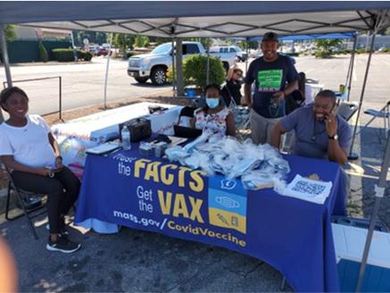Boston
Authentic Caribbean Foundation, Inc. (ACF) has hosted a number of events and vaccine clinics in recent months, including eight vaccine clinics at community events in Brockton, Springfield, and Hyde Park in July, and four clinics in Brockton, Mattapan, and Hyde Park in August (see photo). ACF engaged with over 1,000 people over the course of these clinics and related outreach, during which they also distributed flyers, hand sanitizer, masks, and other resources. The clinics also provided important opportunities for parents to speak with nurses and vaccine providers about their questions regarding pediatric COVID vaccines.

Read More Highlights

Share This Email
Share This Email
Share This Email

Visit the VEI Website

Vaccine Equity Initiative | 250 Washington Street, Boston, MA 02108 Unsubscribe vaccineequityinitiative@mass.gov
Constant Contact Data Notice
Sent by vaccineequityinitiative@mass.gov in collaboration with

Try email marketing for free today!

