REGISTER NOW! VEI TOWN HALL ON NOVEMBER 16 AT 9 A.M.
Register to join the Vaccine Equity Initiative Town Hall on Thursday, November 16, from 9:00 to 10:00 a.m.!
During this time, we will hear about the current state of COVID-19 in Massachusetts, learn about the updated vaccine, and hear about ways to increase vaccine equity in communities.
Register now at tinyurl.com/VEI- TownHall!

Have questions you’d like answered at the event? Please write them in the space on the registration form!
We look forward to seeing you there!

Join the VEI Town Hall on November 16! Have questions or need accommodations to join? Email us!

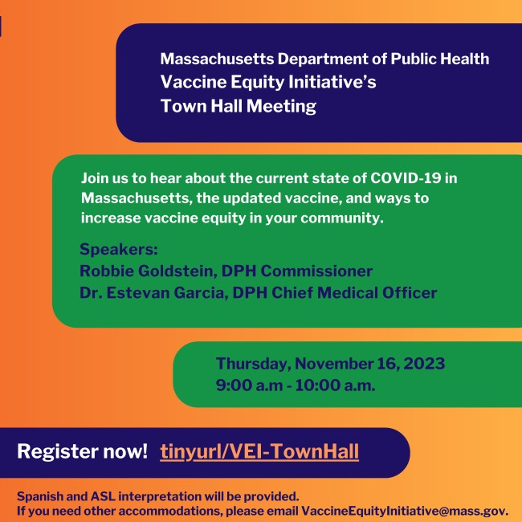
November 10, 2023
Here are the latest resources for promoting COVID-19 vaccination to share with your colleagues
and networks across Massachusetts. If you received this from a colleague, subscribe today.
View this email online.
What's New

EMERGENCY ASSISTANCE UPDATE: FAQS ON SHELTER CAPACITY AND MORE
Last month, Governor Healey announced that the state's emergency family shelter system was expected to soon reach capacity.
Have questions about what this means?

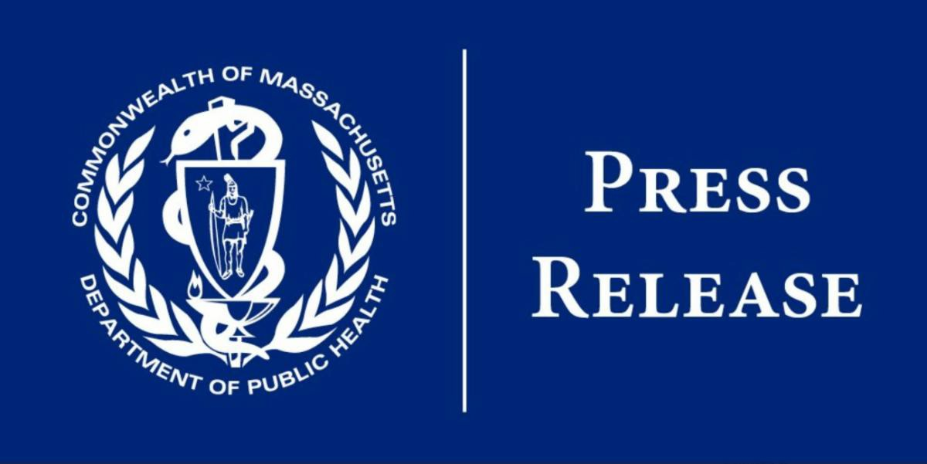
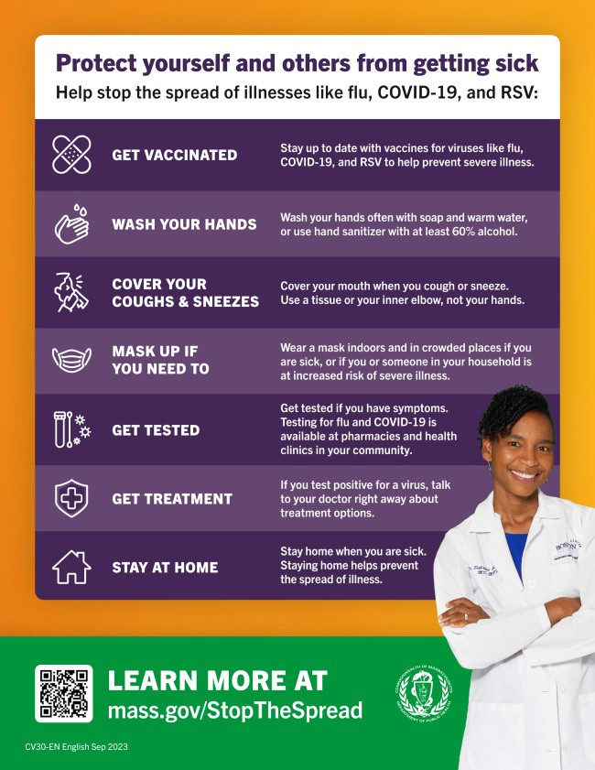
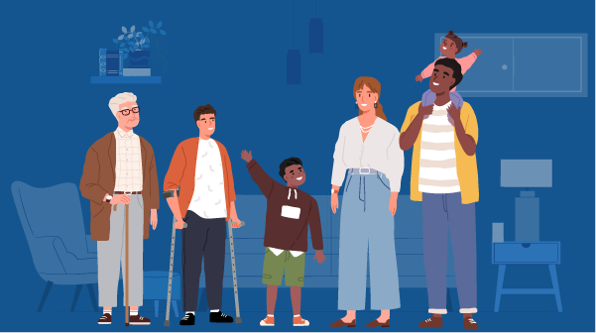
This FAQ offers answers to questions about shelter capacity, waiting lists, the right to shelter, and more.
Reminders

NEW FLYER: PROTECT YOURSELF AND OTHERS FROM GETTING SICK
Getting the updated COVID-19 vaccine is just one way that you can help protect yourself and others from getting sick during respiratory illness season!
This flyer offers a checklist of ways to help stop the spread of COVID, flu, and RSV. It's available in 13 languages !
Have questions about the COVID, flu, or RSV vaccines? Need to find a vaccine? Visit mass.gov/StopTheSpread.

IN-HOME COVID-19 VACCINATION AVAILABLE
Massachusetts offers in-home COVID-19 vaccination for anyone who has difficulty getting to or using a community clinic, including children.
Learn more, or call 833-983-0485 to sign up for an appointment.
This info is also available in ASL (thanks to The Learning Center for the Deaf!).
Key Resources

OUTREACH AND EDUCATION MATERIALS

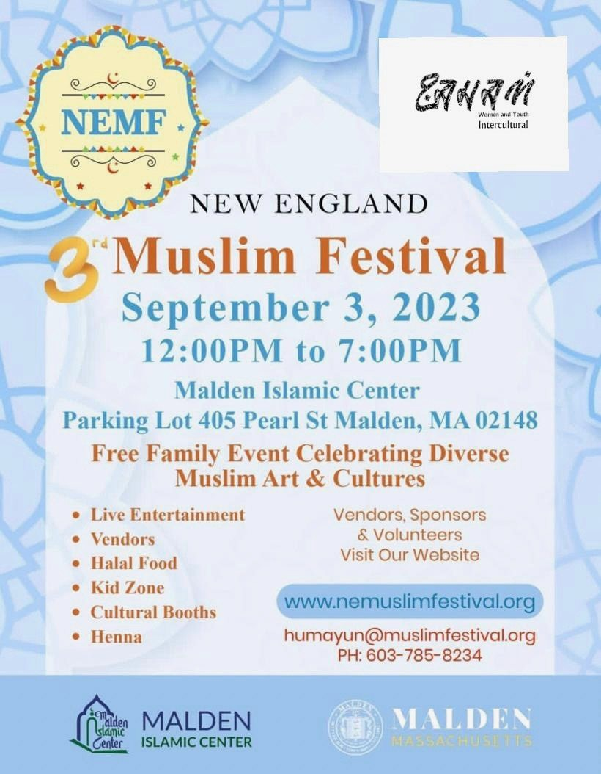
COVID-19 Vaccine FAQs
COVID-19 Therapeutic Information (including telehealth) Archive of Weekly Provider Bulletins
Archive of COVID-19 Vaccine Communications Updates (past editions of VEI Roundup)
FIND A COVID-19 VACCINE DOSE
Use Vaccines.gov to sign up for a COVID-19 vaccine appointment Find a community COVID-19 vaccination clinic near you
Learn about the COVID-19 In-Home Vaccination Program and request a visit Request a copy of your vaccine card
Highlights

Earlier this fall, JAHAN Women and Youth Intercultural partnered with the Malden Islamic Center to host the New England Muslim Festival on September 3 (see flyer). This annual cultural event, which aims to foster inclusivity, drew over 300 attendees and included live entertainment, vendors, halal food, henna, and more. For the event, JAHAN partnered with Charles River Community Health to host an on- site clinic, which provided flu and COVID-19 vaccines. They also administered blood pressure screenings and distributed COVID-19 flyers.

Read More Highlights

Share This Email
Share This Email
Share This Email

Visit the VEI Website

Vaccine Equity Initiative | 250 Washington Street, Boston, MA 02108

Unsubscribe vaccineequityinitiative@mass.gov Constant Contact Data Notice
Sent by vaccineequityinitiative@mass.gov powered by
Try email marketing for free today!

