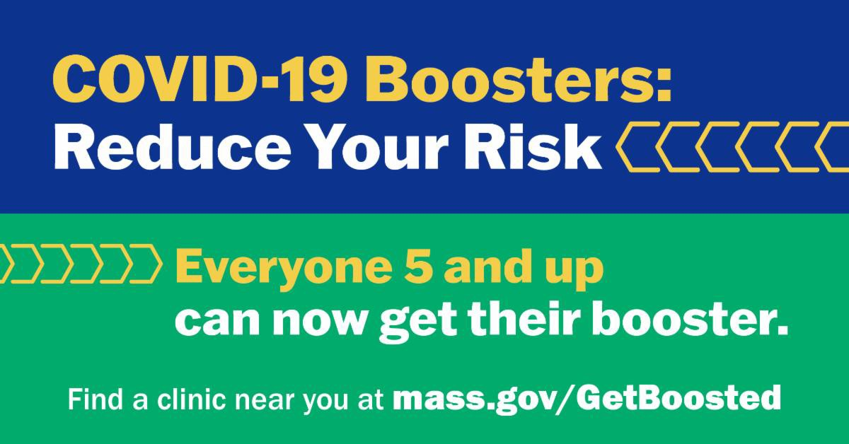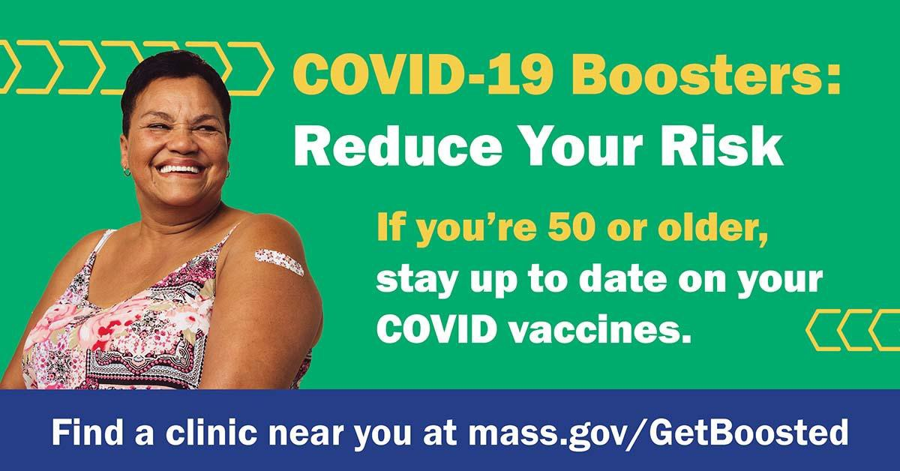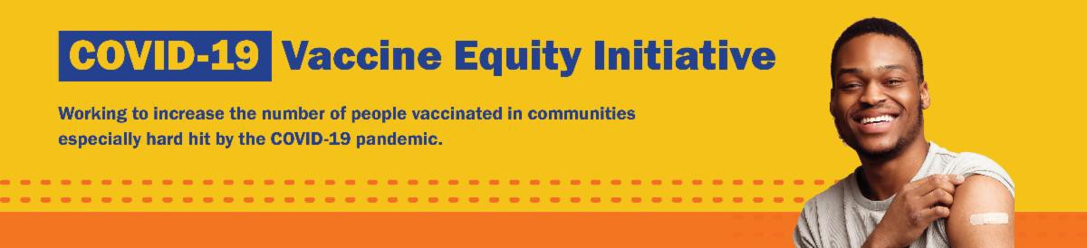
November 18, 2022
Here are the latest resources for promoting COVID-19 vaccination to share with your colleagues
and networks across Massachusetts. If you received this from a colleague, subscribe today.

View this email online.

Please note: There will be no VEI Roundup next week. Wishing everyone a happy and safe holiday!
What's New

UPDATED COVID-19 BOOSTER AND $75 GIFT CARD: TWO MORE REASONS TO GET VACCINATED NOW!

As part of its Get Boosted campaign, the Massachusetts Department of Public Health is offering a $75 gift card to residents of all ages who get vaccinated (first dose, second dose, or booster) at participating clinics, while supplies last. Offer runs through December 31, 2022.

Clinics are family-friendly and free to all. No ID or health insurance needed. Anyone ages 6 months and up can get a COVID-19 vaccine
and anyone ages 5 and up can get a COVID-19 vaccine or booster.

New clinics continue to be added! View a list of participating clinics at mass.gov/GetBoosted.

Resources are available to help spread the word about these clinics, including this customizable booster flyer, social media graphics, and more. Find these resources in our vaccine promotion toolkit!

OUTREACH AND EDUCATION MATERIALS

COVID-19 Vaccine FAQs
COVID-19 Therapeutic Information (including telehealth) Weekly Provider Bulletin
Trust the Facts, Get the Vax Campaign Materials (organized by audience, including
Key Resources
Watch our media coverage of Get Boosted clinics, including this clip from CBS Boston.
Reminders

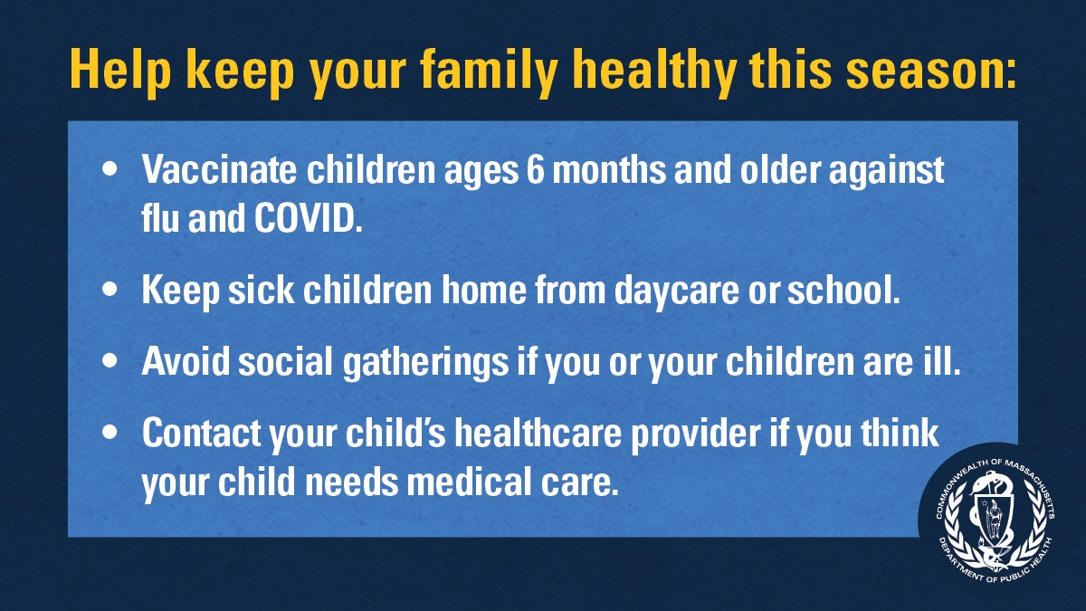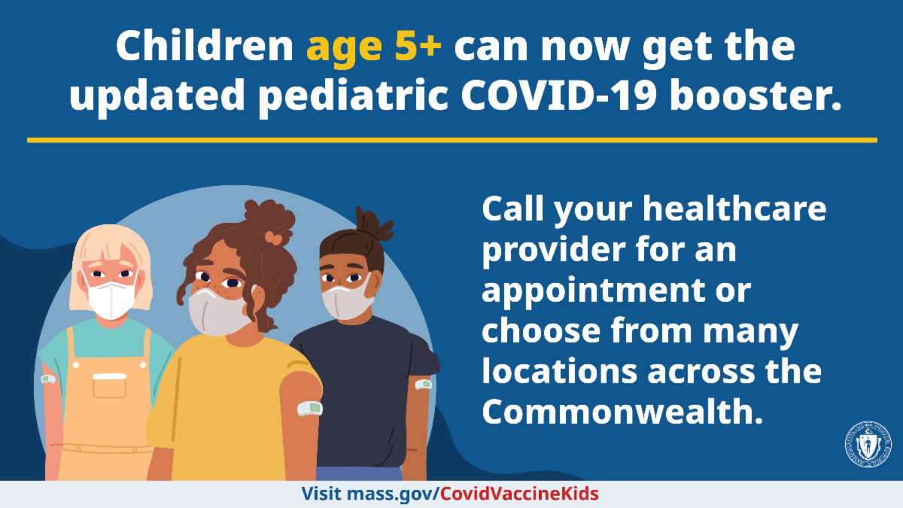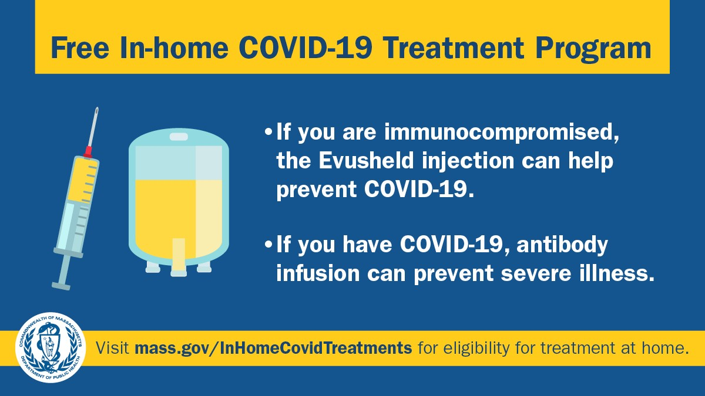GET VACCINATED AGAINST THE FLU AND COVID-19

Rates of respiratory illness in infants and children are on the rise in Massachusetts and across much of the U.S. Take steps to keep your family healthy this season by getting vaccinated against the flu and COVID-19 and taking other precautions.

Protect yourself and your family. Learn more.

UPDATED BOOSTERS FOR CHILDREN AGES 5 AND OLDER

The COVID-19 booster helps protect against new variants. Now kids 5 years and older can get the updated pediatric booster. Learn more about booster eligibility.

FREE IN-HOME COVID-19 TREATMENT PROGRAM AVAILABLE

In Massachusetts, treatments like Evusheld to prevent COVID-19, and monoclonal antibody infusion to prevent severe illness, can be administered at home. Check to see if you are eligible.

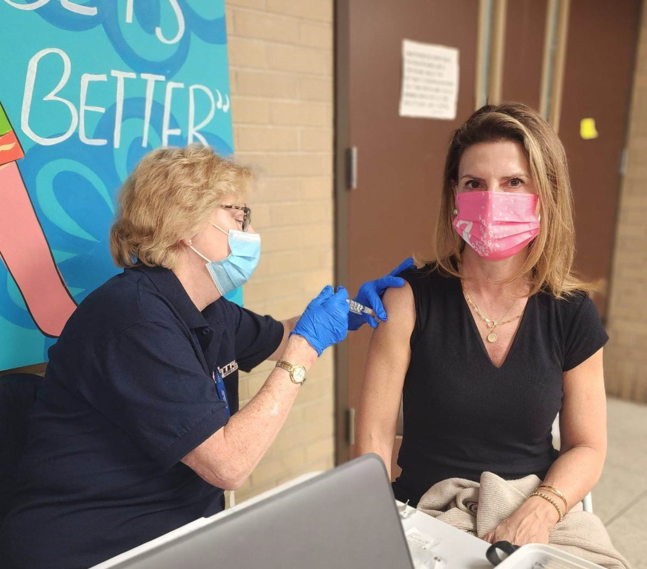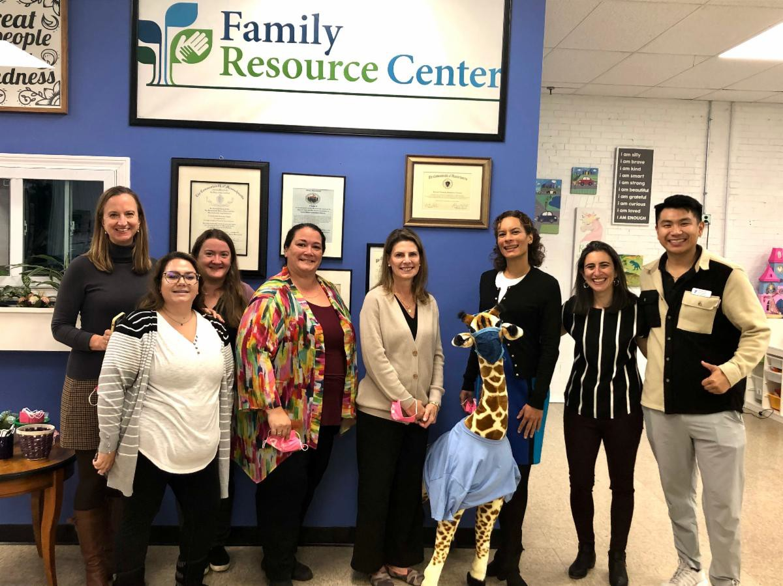
general, parents and pregnant people, youth, young adults; available in 12 languages)
Multilingual COVID-19 Materials (videos and printables; organized by language) COVID-19 Funeral Assistance from FEMA (including one-pager with key info available in multiple languages)
COVID-19 Vaccination Tools for Employers
Archive of COVID-19 Vaccine Communications Updates (past editions of VEI Roundup)
FIND A COVID-19 VACCINE OR BOOSTER

Mass.gov/GetBoosted (family-friendly clinics through the end of 2022)
Vaccine Finder
Find, Schedule, or Sign Up for a Mobile COVID-19 Vaccination COVID-19 In-Home Vaccination Program
Request a Copy of Your Vaccine Card
Recent Highlights

Get Boosted campaign sees over 13,000 COVID-19 vaccinations in first three weeks

The Vaccine Equity Initiative's Get Boosted campaign is well underway, with more than 13,000 doses of COVID-19 vaccine administered in just the first three weeks of the program! DPH Commissioner Margret Cooke recently visited one of our Get Boosted clinics at the Eliot Family Resource Center in Everett, getting her updated booster and thanking the team for their efforts (see photos). Get Boosted clinics continue through the end of the year — click here to find a clinic near you .

Read More Highlights

Share This Email
Share This Email
Share This Email

Visit the VEI Website

Vaccine Equity Initiative | 250 Washington Street, Boston, MA 02108

Unsubscribe vaccineequityinitiative@mass.gov Constant Contact Data Notice
Sent by vaccineequityinitiative@mass.gov in collaboration with
Try email marketing for free today!

