GET BOOSTED CLINICS EXTENDED THROUGH MARCH 2023!

The Get Boosted program has been extended through March 31, 2023, for all participating communities!

Over 51,000 doses of COVID vaccine have been administered since the Get Boosted effort began October 24.

Residents of all ages who get vaccinated (any dose) at participating clinics can receive a $75 gift card to local retailers, while supplies last. Find participating clinics at mass.gov/GetBoosted.

If you have questions about Get Boosted clinics, please call 211 (or 877- 211-6277) and press 1. Calls are answered Monday through Friday, from 9 a.m. to 5 p.m.

Help spread the word about these clinics on Facebook and Instagram, or by using a customizable flyer!

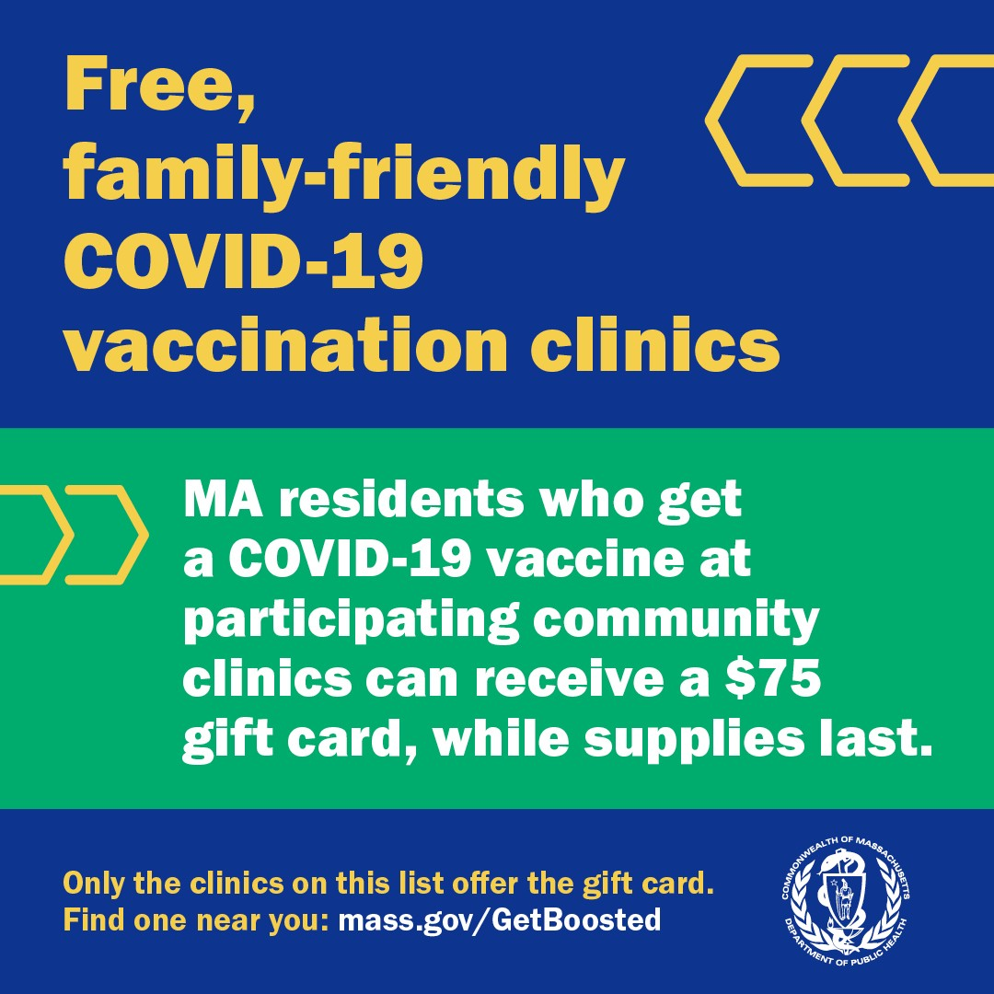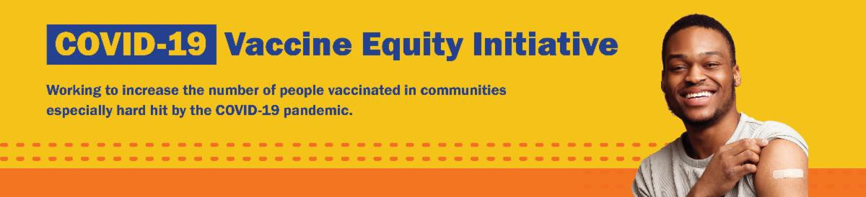
January 13, 2023
Here are the latest resources for promoting COVID-19 vaccination to share with your colleagues
and networks across Massachusetts. If you received this from a colleague, subscribe today.

View this email online.
What's New

FREE COVID-19 TESTS AND PPE AVAILABLE

Community organizations can order free at-home rapid antigen COVID-19 tests, KN95 masks, surgical masks, goggles, face

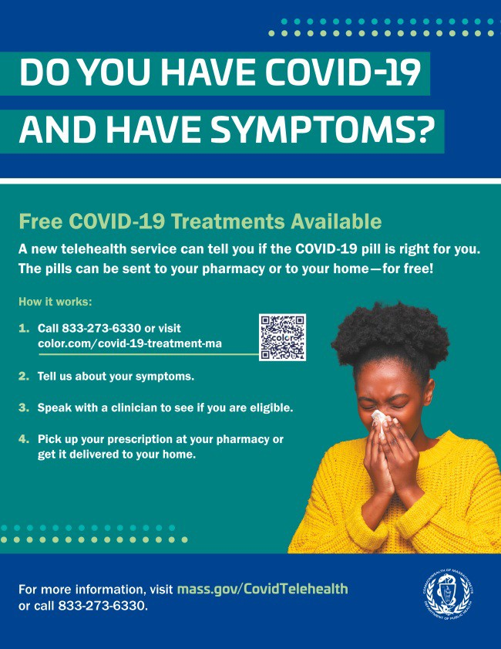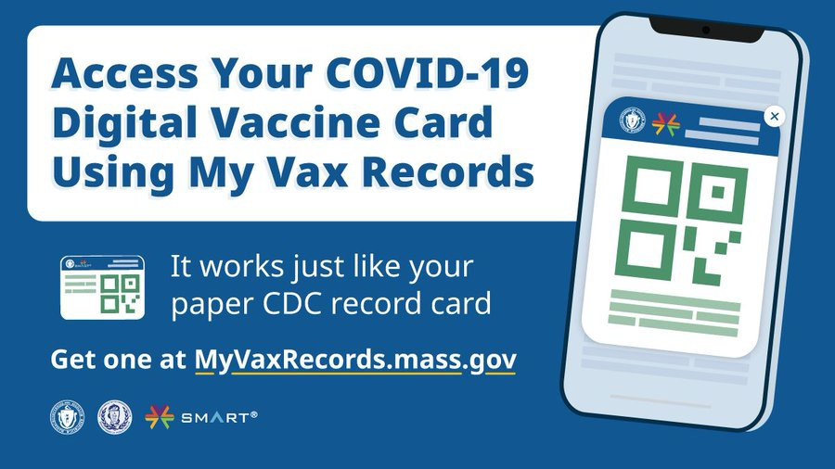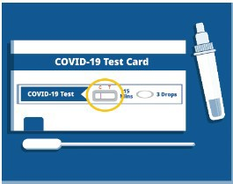
shields, and nitrile gloves—while supplies
last.

Organizations that are interested in ordering supplies must complete this short form: bit.ly/COVIDTestRequestMA.

Please note: You may need to copy and paste the link into your browser.
Reminders

FREE COVID TREATMENT — FLYERS NOW AVAILABLE IN 12 LANGUAGES

Free, safe, and effective treatments for COVID-19 are available across MA. They can help prevent hospitalizations and reduce the risk of severe disease.

Telehealth consultations are now available via phone, in addition to online.
Consultations can be accessed in 10+ languages.

Please share: Flyers are now available in 12 languages!

DO YOU USE MY VAX RECORDS? IT'S A DIGITAL VACCINE CARD FOR MASSACHUSETTS RESIDENTS

Need a copy of your COVID-19 vaccination record? Massachusetts residents can use My Vax Records to get a digital vaccine card to show they’ve been vaccinated against COVID-19, if they choose. Learn more.

IT'S NOT TOO LATE FOR A FLU SHOT! GET VACCINATED AGAINST THE FLU AND COVID-19

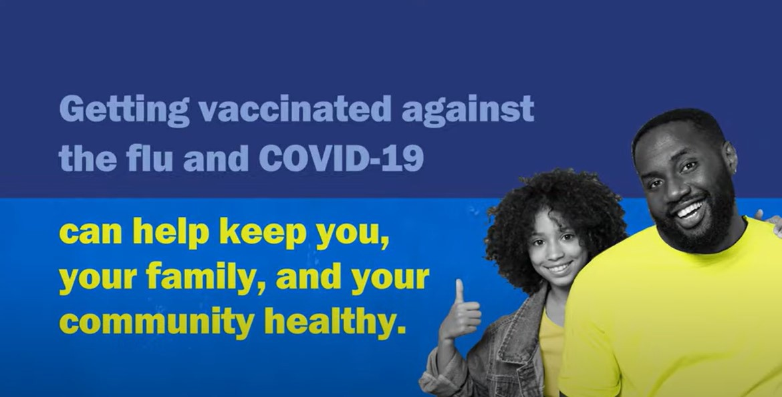
Rates of respiratory illness in infants and children are on the rise in Massachusetts and across much of the U.S. Keep your family healthy this season with several key steps. Learn more.
Key Resources

OUTREACH AND EDUCATION MATERIALS

COVID-19 Vaccine FAQs
COVID-19 Therapeutic Information (including telehealth) Weekly Provider Bulletin
Trust the Facts, Get the Vax Campaign Materials (organized by audience, including general, parents and pregnant people, youth, young adults; available in 12 languages) Multilingual COVID-19 Materials (videos and printables; organized by language) COVID-19 Funeral Assistance from FEMA (including one-pager with key info available in multiple languages)
COVID-19 Vaccination Tools for Employers
Archive of COVID-19 Vaccine Communications Updates (past editions of VEI Roundup)

FIND A COVID-19 VACCINE OR BOOSTER

Mass.gov/GetBoosted (family-friendly clinics through March 2023)
Vaccine Finder
Find, Schedule, or Sign Up for a Mobile COVID-19 Vaccination COVID-19 In-Home Vaccination Program
Request a Copy of Your Vaccine Card

Recent Highlights

Everett

This past fall, the Joint Committee for Children’s Health Care hosted various events in which they distributed COVID-19 vaccine education materials. One such event, put on in collaboration with the City of Everett, had over 1,000 attendees and included vaccine education materials distributed as part of treat bags (see photo). The Joint Committee has also launched a friends and family COVID-19 vaccine campaign, in which they offer a gift

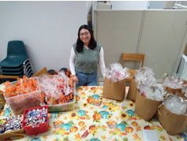
card to individuals who are able to help
their friends or families get vaccinated.

Read More Highlights

Visit the VEI Website

Share This Email
Share This Email
Share This Email

Vaccine Equity Initiative | 250 Washington Street, Boston, MA 02108

Unsubscribe vaccineequityinitiative@mass.gov Constant Contact Data Notice
Sent by vaccineequityinitiative@mass.gov in collaboration with
Try email marketing for free today!

