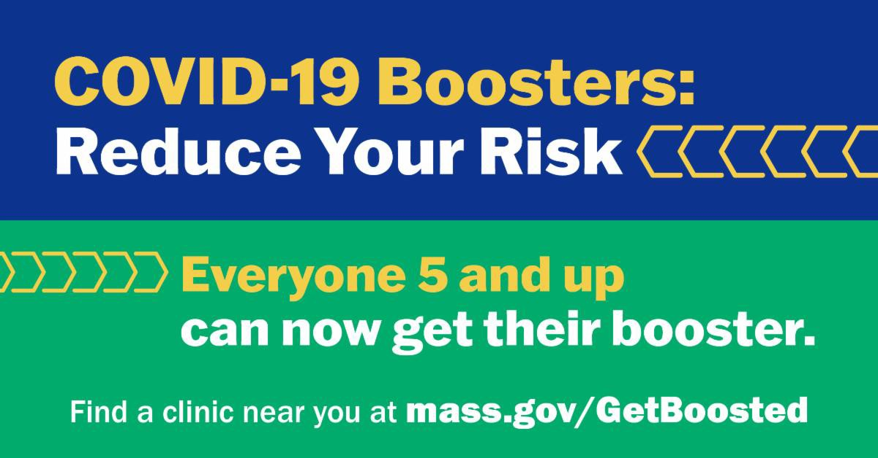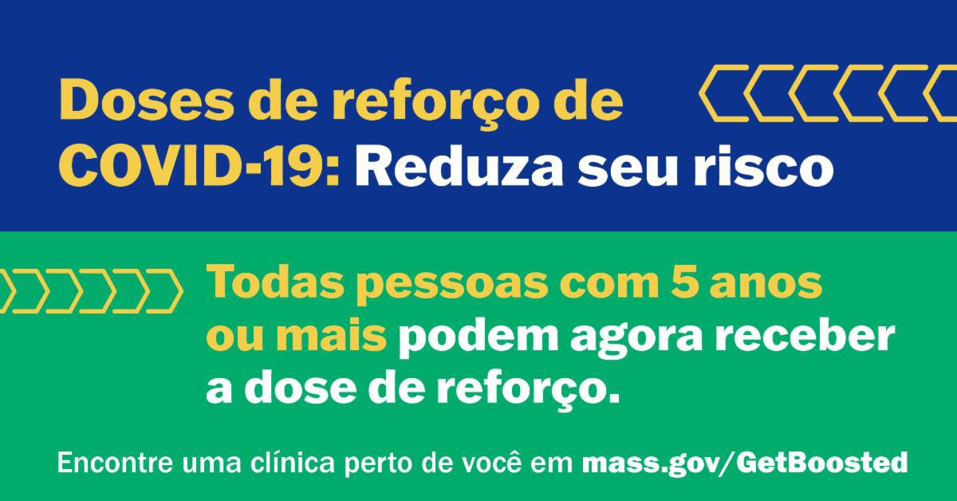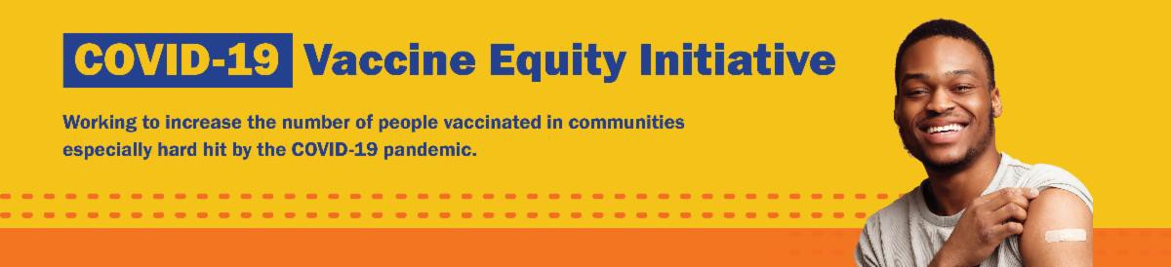
November 4, 2022
Here are the latest resources for promoting COVID-19 vaccination to share with your colleagues
and networks across Massachusetts. If you received this from a colleague, subscribe today.

View this email online.
What's New

PLEASE SHARE: UPDATED COVID-19 BOOSTER AND $75 GIFT CARD: TWO MORE REASONS TO GET VACCINATED NOW!

The Department of Public Health is offering free, family-friendly clinics where anyone ages 6 months and up can get a COVID-19 vaccine and anyone ages 5 and up can get a COVID-19 vaccine or booster.

As part of a special promotion, Massachusetts residents of all ages who get vaccinated (first dose, second dose, or booster) at participating clinics will receive a
$75 gift card, while supplies last. Find a list of the clinics at mass.gov/GetBoosted. Offer runs through December 31, 2022.

NEW — now in multiple languages! Resources are available to help spread the word about these clinics, including:
Customizable booster flyer Social media graphics Newsletter article
Press release template

Find these and more in our vaccine promotion toolkit!

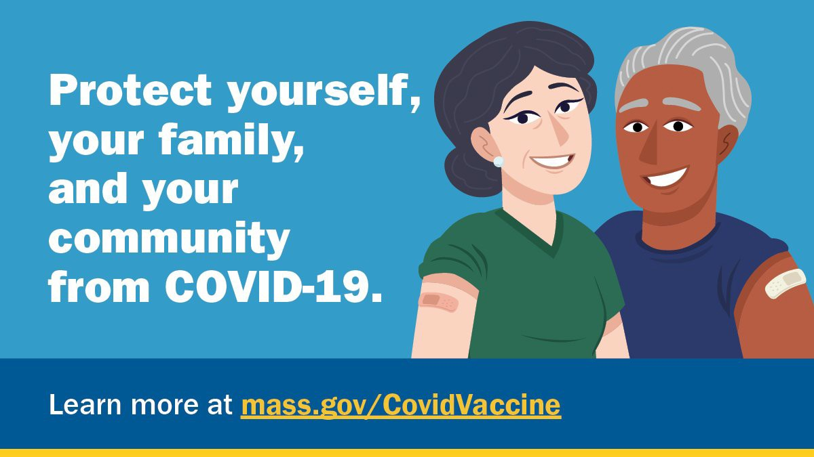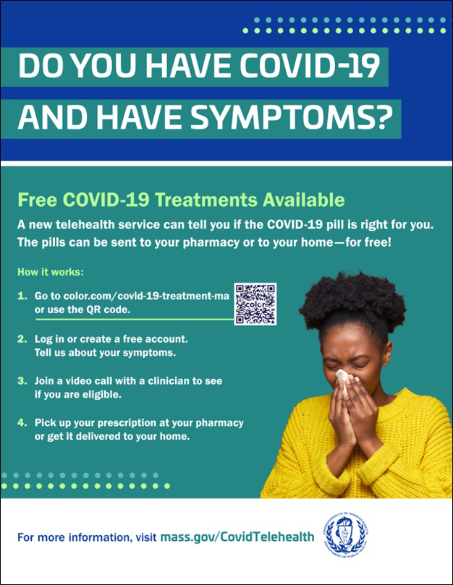
Read our media coverage of the Get Boosted clinics in Western Mass News and
WWLP in Springfield!
Reminders

IN-HOME COVID-19 VACCINATION AVAILABLE

Massachusetts offers in-home COVID-19 vaccinations for anyone who has difficulty getting to or using a community clinic, including young children. Learn more, or call 833-983-0485 to sign up for an in- home appointment.

Help spread the word with this
informational flyer (in 12 languages)!

FOLLOW THESE SEVEN STEPS

There are a number of steps that you can take to help protect yourself, your family, and your community from COVID-19.

Available in multiple languages, this flyer features a checklist with these
steps. Please share it with your networks.

FREE COVID TREATMENT AVAILABLE

Free, safe, and effective treatments for COVID-19 are available across MA. They can help prevent hospitalizations and reduce the risk of severe disease.

Telehealth consultations are now available via phone, in addition to video, once you’ve requested a consultation online.
Consultations can be accessed in 10+ languages.

Please use this customizable flyer to help share this information! Other flyers in additional languages are also available.

Please also share this video about free COVID treatments.

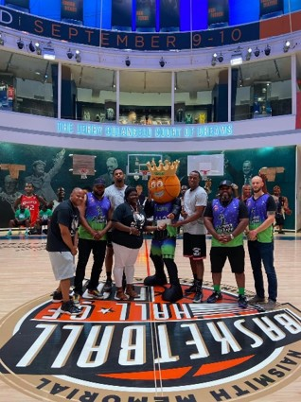
Key Resources

OUTREACH AND EDUCATION MATERIALS

COVID-19 Vaccine FAQs
COVID-19 Therapeutic Information (including telehealth) Weekly Provider Bulletin (latest edition published 10/26/22)
Trust the Facts, Get the Vax Campaign Materials (organized by audience, including general, parents and pregnant people, youth, young adults; available in 12 languages) Multilingual COVID-19 Materials (videos and printables; organized by language) COVID-19 Funeral Assistance from FEMA (including one-pager with key info available in multiple languages)
COVID-19 Vaccination Tools for Employers
Archive of COVID-19 Vaccine Communications Updates (past editions of VEI Roundup)

FIND A COVID-19 VACCINE OR BOOSTER

Mass.gov/GetBoosted (family-friendly clinics through the end of 2022)
Vaccine Finder
Find, Schedule, or Sign Up for a Mobile COVID-19 Vaccination COVID-19 In-Home Vaccination Program
Request a Copy of Your Vaccine Card

Recent Highlights

Springfield
Extreme Science Kid recently established its first-ever Youth Board, which is comprised of six youth who help improve family-centered events that offer COVID- 19 vaccine clinics and resources. Thanks to COVID-19 Community Grants funding, the youth all receive stipends. This summer and fall, the Youth Board helped bring six events to Springfield , including kids' summer block parties that included COVID- 19 vaccine clinics; a city-wide basketball tournament that also featured a mental health forum and COVID-19 clinic (see photo); and an outdoor COVID-19 awareness, prevention, and mental health forum and gospel concert. The board is also helping to plan upcoming seasonal events, such as a Boston-based holiday toy giveaway and resource fair.

Read More Highlights

Share This Email
Share This Email
Share This Email

Visit the VEI Website

Vaccine Equity Initiative | 250 Washington Street, Boston, MA 02108

Unsubscribe vaccineequityinitiative@mass.gov Constant Contact Data Notice
Sent by vaccineequityinitiative@mass.gov in collaboration with
Try email marketing for free today!

