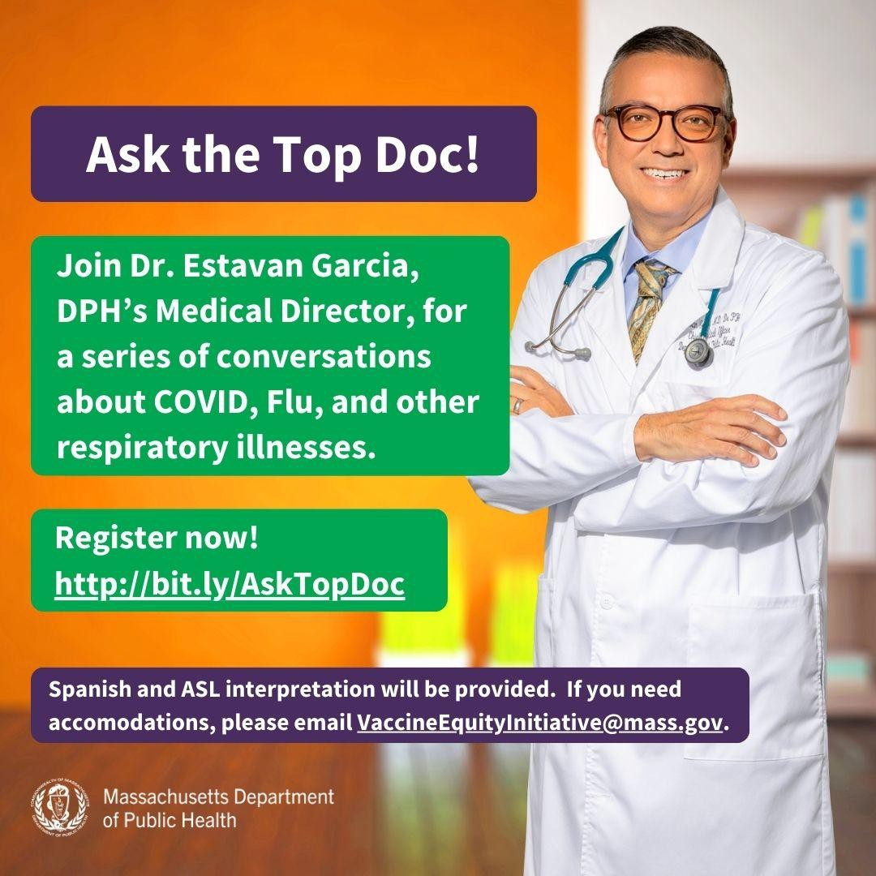
ASK THE TOP DOC: JOIN VEI FOR THE NEXT WEBINAR ON JANUARY 31!
January 19, 2024
Here are the latest resources for promoting COVID-19 vaccination to share with your colleagues
and networks across Massachusetts. If you received this from a colleague, subscribe today.
View this email online.
What's New
VEI is hosting a series of webinars with Dr. Estevan Garcia, DPH’s Medical Director, on COVID and other respiratory illnesses.
January 31: Long COVID: What we know and what we don’t.
February 21: To be determined based on feedback from community partners.

All webinars will be held from 1-2 p.m. and will include Q&A sessions. Register now!
ASL, Haitian Creole, Portuguese, and Spanish interpretation will be provided. Please email us if you need additional accommodations.

Help spread the word! The webinar invitation is available in English, Haitian Creole, Portuguese, and Spanish.
Reminders

IN-HOME COVID-19 VACCINATION AVAILABLE
Massachusetts offers in-home COVID-19 vaccination for anyone who has difficulty

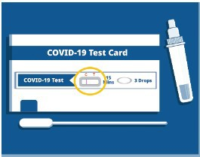
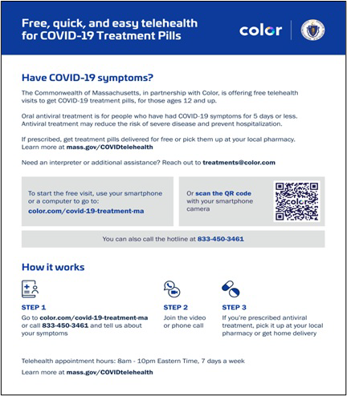
getting to or using a community clinic,
including children.
Learn more, or call 833-983-0485 to sign up for an appointment.
This info is also available in ASL (thanks to The Learning Center for the Deaf!).

Q&A: WHY DO THE EXPIRATION DATES ON COVID TESTS CHANGE?

Q: Why does the expiration date on my COVID-19 test keep changing?
A: The companies that make the tests check them to see if they still work. If they do, the FDA extends the expiration date.
Learn more about COVID-19, including what to do if you test positive,
at mass.gov/COVID.

What other questions are you hearing? Let us know!

FREE COVID TREATMENT AVAILABLE VIA PHONE OR ONLINE
Free, safe, and effective treatments for COVID-19 are available across Massachusetts. They can help prevent hospitalizations and reduce the risk of severe disease.
Telehealth consultations are available by phone at 833-273-6330, in addition
to online. Consultations can be accessed in 10+ languages.
ASL interpretation and captioning (CART or automatic) services are available online or via 833-450-3461.
Please share: Flyers are available in multiple languages.

Key Resources

OUTREACH AND EDUCATION MATERIALS

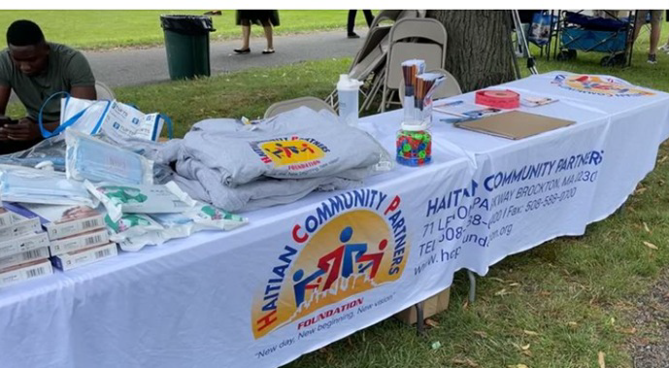
In October, Haitian Community Partners
(HCP) focused on deepening community ties by directly engaging with community members and local businesses. Their educational outreach involved distributing 170 flyers and leveraging local businesses as pivotal venues for conversation and literature distribution. These engagements, involving direct conversations with 125 individuals, addressed the community’s inquiries about accessing free annual vaccinations.
Read More Highlights
Visit the VEI Website
Share This Email
Share This Email
Share This Email
COVID-19 Vaccine Information
COVID-19 Therapeutic Information (including telehealth) Archive of Weekly Provider Bulletins
Archive of COVID-19 Vaccine Communications Updates (past editions of VEI Roundup)
FIND A COVID-19 VACCINE DOSE
Use Vaccines.gov to sign up for a COVID-19 vaccine appointment Find a community COVID-19 vaccination clinic near you
Learn about the COVID-19 In-Home Vaccination Program and request a visit Request a copy of your vaccine card
Highlights

Vaccine Equity Initiative | 250 Washington Street, Boston, MA 02108 Unsubscribe vaccineequityinitiative@mass.gov
Constant Contact Data Notice
Sent by vaccineequityinitiative@mass.gov powered by

Try email marketing for free today!

