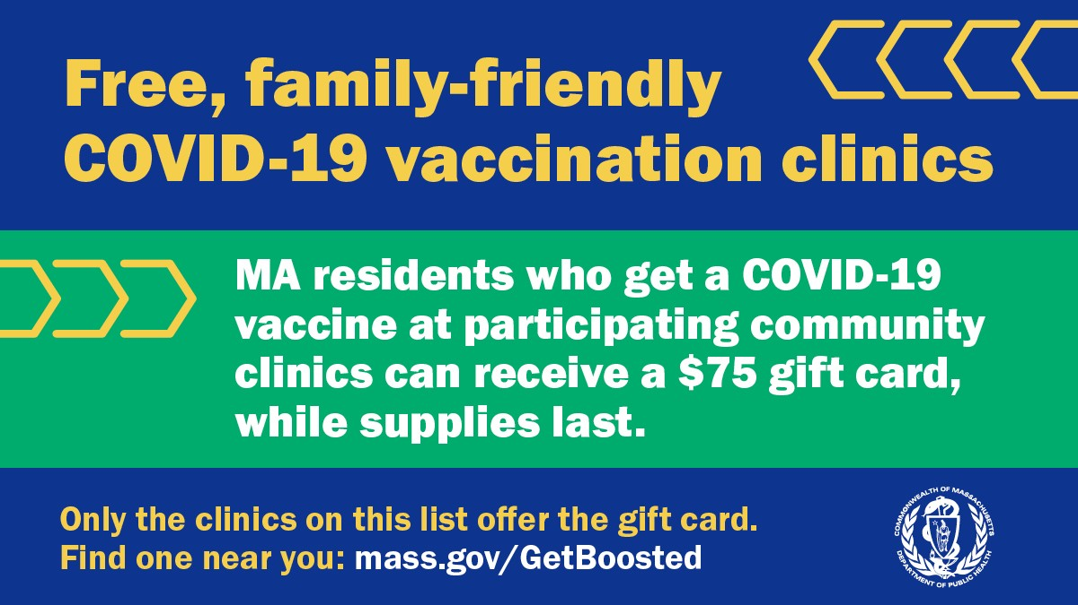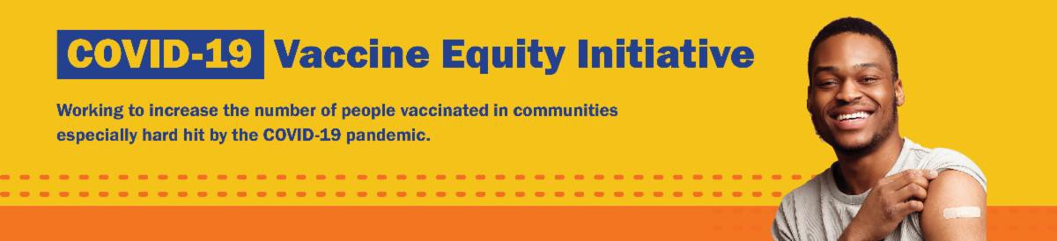GET BOOSTED CLINICS EXTENDED THROUGH MARCH 2023!
January 20, 2023
Here are the latest resources for promoting COVID-19 vaccination to share with your colleagues
and networks across Massachusetts. If you received this from a colleague, subscribe today.

View this email online.
What's New

The Get Boosted program has been extended through March 31, 2023, for all participating communities!

Over 53,000 doses of COVID vaccine have been administered since the Get Boosted effort began October 24.

Residents of all ages who get vaccinated (any dose) at participating clinics can receive a $75 gift card to local retailers, while supplies last. Find participating clinics at mass.gov/GetBoosted.

Help spread the word about these clinics on Facebook and Instagram, or by using other resources from our toolkit.

If you have questions about Get Boosted clinics, please call 211 (or 877-211-6277) and press 1. Calls are answered Monday through Friday, from 9 a.m. to 5 p.m.
Get Boosted clinics in Holyoke were recently featured by WWLP.
Reminders

FREE COVID-19 TESTS AVAILABLE FOR A LIMITED TIME!

Community organizations can order free at-home rapid antigen COVID-19 tests,

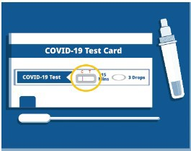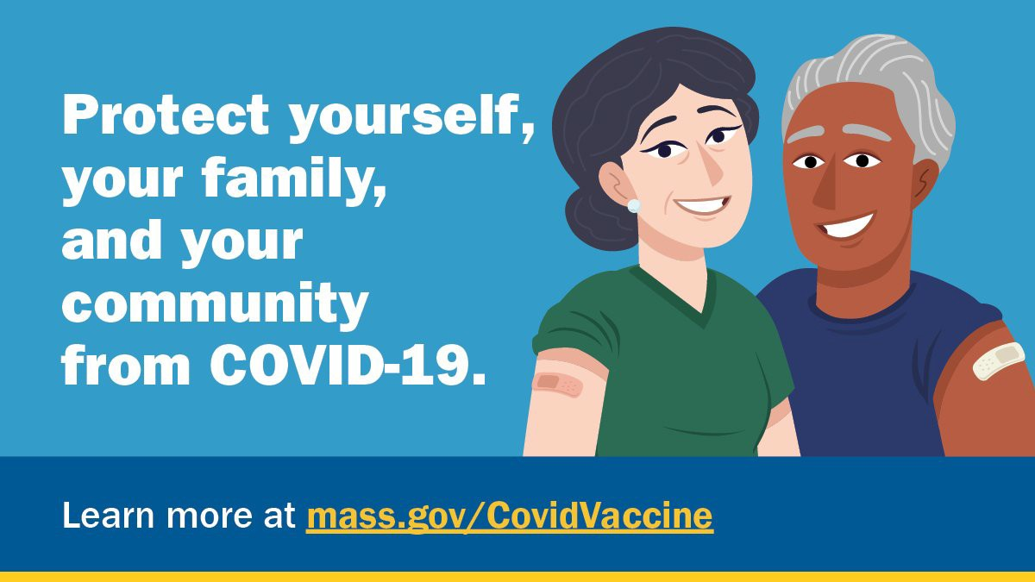while supplies last.
OUTREACH AND EDUCATION MATERIALS

COVID-19 Vaccine FAQs
COVID-19 Therapeutic Information (including telehealth) Weekly Provider Bulletin
Trust the Facts, Get the Vax Campaign Materials (organized by audience, including general, parents and pregnant people, youth, young adults; available in 12 languages) Multilingual COVID-19 Materials (videos and printables; organized by language) COVID-19 Funeral Assistance from FEMA (including one-pager with key info available in multiple languages)
COVID-19 Vaccination Tools for Employers
Archive of COVID-19 Vaccine Communications Updates (past editions of VEI
Key Resources

Organizations that are interested in ordering supplies must complete this short form: bit.ly/COVIDTestRequestMA.

Please note: You may need to copy and paste the link into your browser.

FOLLOW THESE SEVEN STEPS

There are a number of steps that you can take to help protect yourself, your family, and your community from COVID-19.

Available in multiple languages, this flyer features a checklist with these
steps. Please share it with your networks.

FREE IN-HOME COVID-19 VACCINATION AVAILABLE

Massachusetts offers in-home COVID-19 vaccinations for anyone who has difficulty getting to or using a community clinic, including young children. Learn more, or call 833-983-0485 to sign up for an in- home appointment.

Help spread the word with
this informational flyer (in 12 languages)!

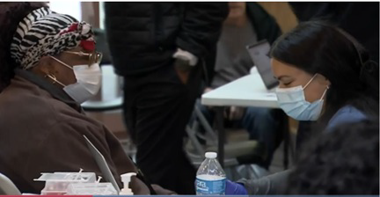
Roundup)
FIND A COVID-19 VACCINE OR BOOSTER

Mass.gov/GetBoosted (family-friendly clinics through March 2023)
Vaccine Finder
Find, Schedule, or Sign Up for a Mobile COVID-19 Vaccination COVID-19 In-Home Vaccination Program
Request a Copy of Your Vaccine Card
Recent Highlights

Brockton

In November, Pinnacle Partnerships held their Heathy for the Holidays kickoff event at the Brockton BAT Center (see photo).
The event included a clinic with COVID-19 and flu vaccines, opportunities for Pinnacle staff to talk with community members about mental health and COVID-19, and groceries, refreshments, and raffle items for attendees. Over 120 people were vaccinated, and individuals who got vaccinated against COVID-19 received $75 gift cards. Working in collaboration with PriceRite and People Affecting Community Change, Pinnacle was able to distribute 150 bags of groceries. The event also drew media attention from CBS Boston and other outlets.

Read More Highlights

Share This Email
Share This Email
Share This Email

Visit the VEI Website

Vaccine Equity Initiative | 250 Washington Street, Boston, MA 02108

Unsubscribe vaccineequityinitiative@mass.gov Constant Contact Data Notice
Sent by vaccineequityinitiative@mass.gov in collaboration with

Try email marketing for free today!

