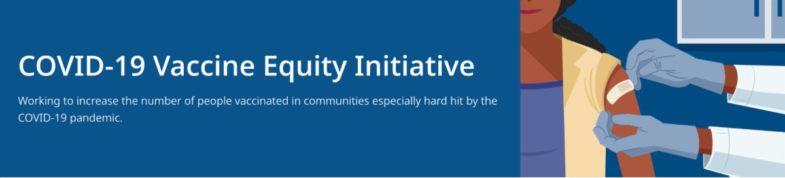
January 21, 2022
VEI Roundup is your central source for updates and materials related to vaccine promotion,
education, and access. All materials are publicly available. Each item is clickable for easy sharing.

Please forward to others who can subscribe by clicking here to submit a subscription request.
What's New

TESTING FOR CHILD CARE PROVIDERS TO KEEP CHILDREN IN CARE

News Release (1/19): Testing for Child Care Providers to Keep Children in Care

PREGNANCY AND THE COVID-19 VACCINE - FREQUENTLY ASKED QUESTIONS

Updated! - Pregnancy and the COVID-19 Vaccine: Frequently Asked Questions (now available in 12 languages)

AT-HOME TESTS FOR STUDENTS AND STAFF IN STATE TESTING PROGRAMS

News Release (1/18): Baker-Polito Administration Announces Weekly At-Home Tests Available for Students and Staff Enrolled in State’s Testing Programs

BIDEN ADMINISTRATION TO PROVIDE FREE AT-HOME TESTS

Get Free At-Home COVID Tests: The Biden Administration is offering free at-home COVID- 19 rapid tests to all U.S. households. Every home in the U.S. is eligible to order 4 tests to be delivered by the U.S. Postal Service.
DIGITAL COVID-19 VACCINE CARD, A NEW OPTION FOR MA RESIDENTS

News Release (1/10): Baker-Polito
Reminders

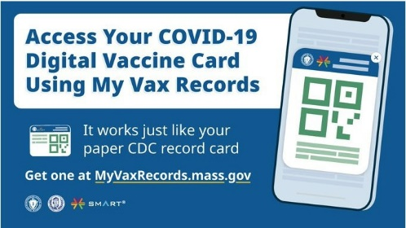
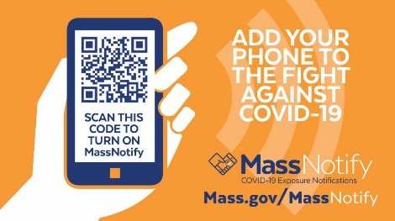
Administration Launches Tool for Residents to
Access COVID-19 Digital Vaccine Card

TRAINING OPPORTUNITIES

Communication Skills Training for Clinicians Discussing COVID-19 Vaccination(On 2/11; free webinar from DPH, PNQIN, and UMASS Chan Medical School, with a focus on pregnant and postpartum people, and parents and caregivers of young children)

MASSNOTIFY AVAILABLE ON SMARTPHONES

MassNotify is a tool that works through smartphones – with a focus on privacy – to alert users who may have been exposed to COVID-19. Enable MassNotify on your smartphone to add another tool in our fight against COVID-19. Learn more: mass.gov/MassNotify

COVID-19 TESTING RESOURCES
Webpages at Get Tested in Massachusetts, including:
What do I do if my test is positive?
What to do if you have or have been exposed to COVID-19 How to use a COVID-19 self-test
OUTREACH AND EDUCATION MATERIALS

COVID-19 Vaccine FAQs COVID-19 Booster FAQs
Weekly Provider Bulletin (published 1/19)
Trust the Facts, Get the Vax Campaign Materials
Trust the Facts, Get the Vax Creative Materials Toolkit (toolkit will continue to be updated as the situation evolves, including pediatric eligibility)
Additional Education and Outreach Materials (includes social media graphics, vaccine updates, guides to hosting a forum, and more)
Multilingual COVID-19 Materials (videos and some printables)
DPH Vaccine Ambassador Program (request a DPH employee to attend community meetings to share info about the vaccine)
COVID-19 Funeral Assistance from FEMA (assistance is available for COVID-19-related funeral expenses; 1-pager with key info is available in multiple languages)
FIND A COVID-19 VACCINE OR BOOSTER
Key Resources

Vaccine Equity Initiative | 250 Washington Street, Boston, MA 02108 Unsubscribe vaccineequityinitiative@mass.gov
About Constant Contact
Sent byvaccineequityinitiative@mass.govin collaboration with
Vaccine Finder
Find, Schedule, or Sign Up for a Mobile COVID-19 Vaccination COVID-19 Booster Eligibility Checker
Request a Copy of Your Vaccine Card
Recent Highlights

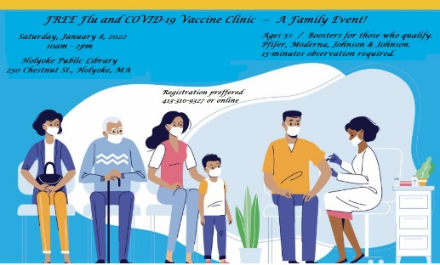
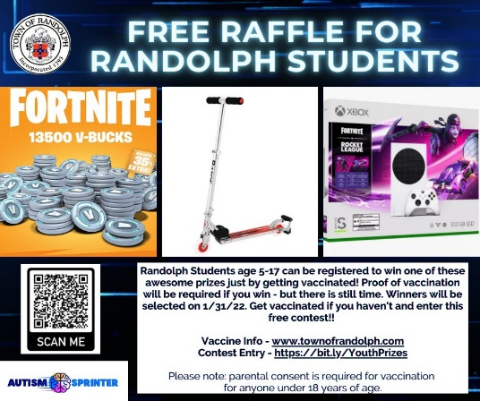
From Holyoke:

Holyoke is partnering with Behavioral Health Network to hold vaccination clinics at public libraries on Saturdays in January. Recently, 56 individuals were vaccinated in a single weekend (flyer, right).

From Randolph:

Randolph is encouraging young people to get the COVID vaccine. The city is sponsoring a raffle to encourage vaccination among residents ages 5-17. Prizes include Fortnite currency, an Xbox, and a scooter. So far, over 500 youth have signed up (flyer, right).

Read More Highlights

Visit the VEI Website

Share This Email
Share This Email
Share This Email

