THERE'S STILL TIME: GET BOOSTED CLINICS CONTINUE THROUGH DEC. 31

There's still time to get vaccinated and receive a $75 gift card!

Nearly 36,000 doses of COVID vaccine have been administered since the Get Boosted effort began this fall, with clinics running through December 31, 2022.

Residents of all ages who get vaccinated (any dose) at participating clinics can receive a $75 gift card to local retailers, while supplies last. Find participating clinics at mass.gov/GetBoosted.

Help spread the word about these clinics on Facebook and Instagram, or by using a customizable flyer!

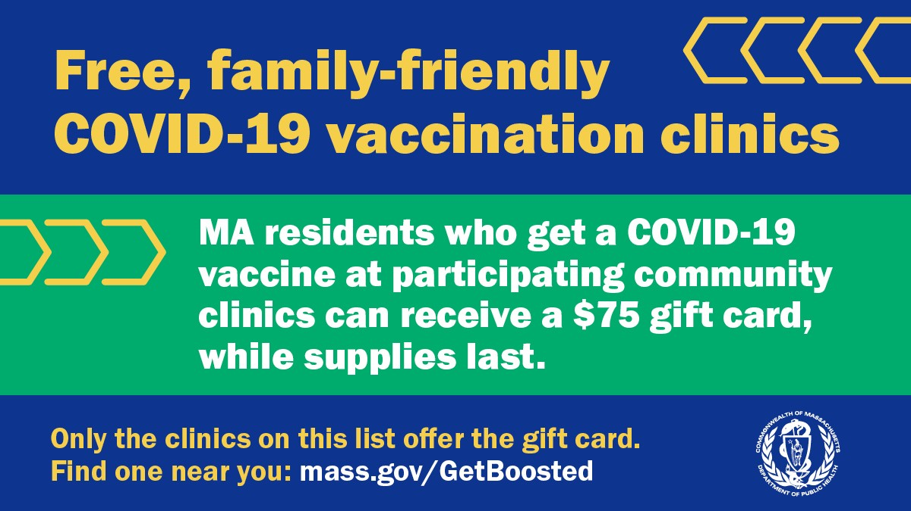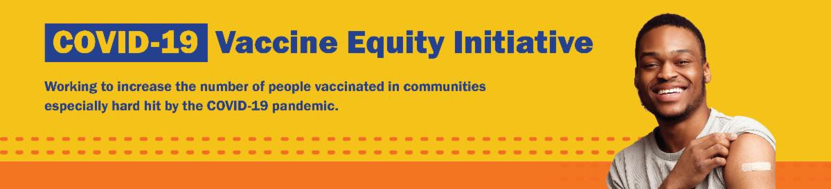
December 16, 2022
Here are the latest resources for promoting COVID-19 vaccination to share with your colleagues
and networks across Massachusetts. If you received this from a colleague, subscribe today.

View this email online.
What's New
Get Boosted clinics were recently featured by Spectrum 1 News (Worcester) and
WWLP (West Springfield).

UPDATED COVID-19 BOOSTERS APPROVED FOR CHILDREN AGES 6 MONTHS AND OLDER

Updated bivalent COVID-19 boosters for children ages 6 months and older have now been approved by the CDC.

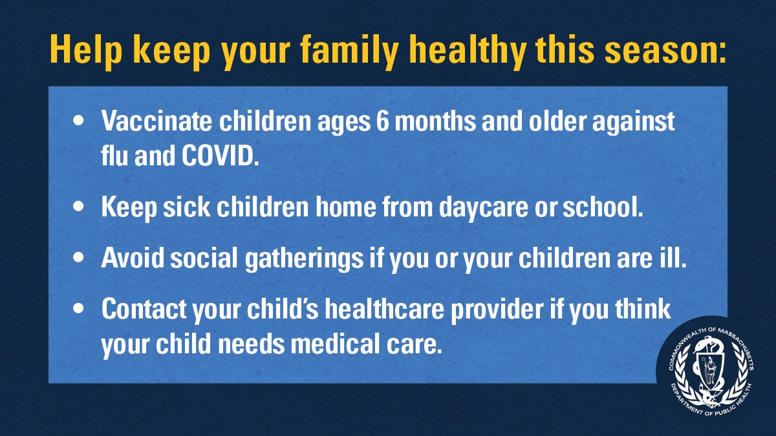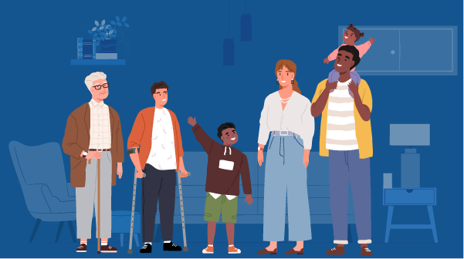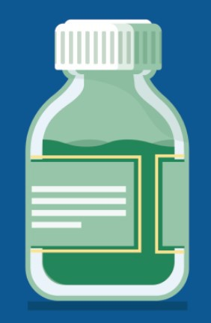
Pediatric booster recommendations differ
by age and vaccine type. Learn more, or use the CDC's guide to find out when you can get a booster.
Reminders

GET VACCINATED AGAINST THE FLU AND COVID-19

Rates of respiratory illness in infants and children are on the rise in Massachusetts and across much of the U.S. Keep your family healthy this season with these four steps. Learn more.

FREE IN-HOME COVID-19 VACCINATION AVAILABLE

Massachusetts offers in-home COVID-19 vaccinations for anyone who has difficulty getting to or using a community clinic, including young children. Learn more, or call 833-983-0485 to sign up for an in- home appointment.

Help spread the word with
this informational flyer (in 12 languages)!

FOLLOW THESE SEVEN STEPS

There are a number of steps that you can take to help protect yourself, your family, and your community from COVID-19.

Available in multiple languages, this flyer features a checklist with these
steps. Please share it with your networks.

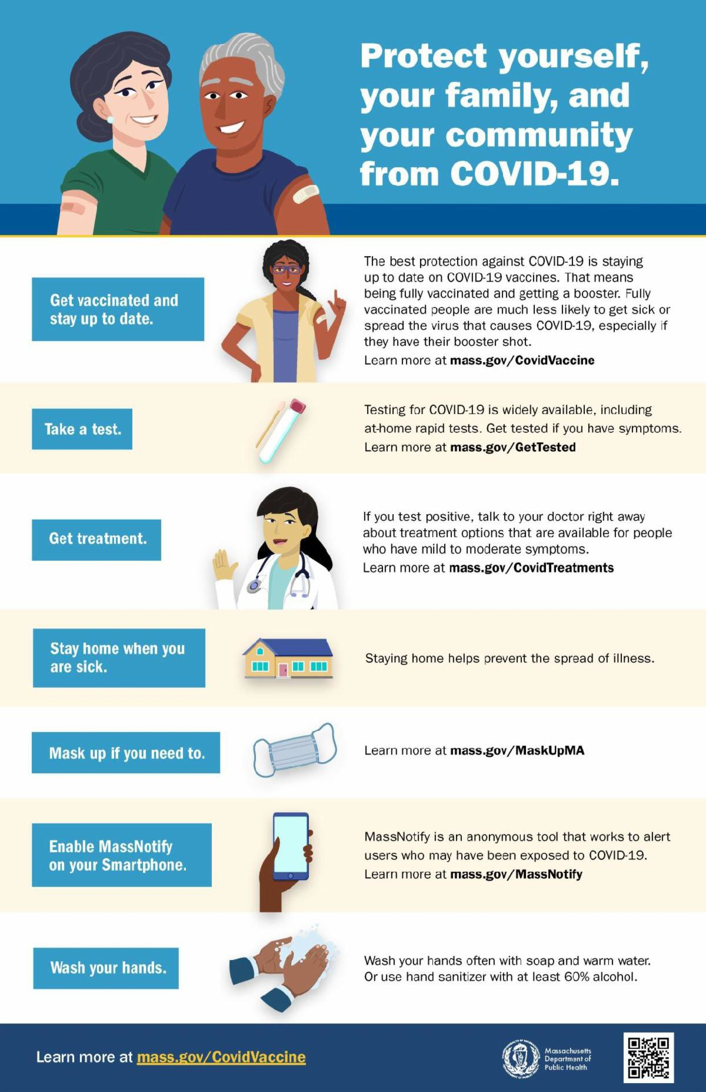
Key Resources

OUTREACH AND EDUCATION MATERIALS

COVID-19 Vaccine FAQs
COVID-19 Therapeutic Information (including telehealth) Weekly Provider Bulletin
Trust the Facts, Get the Vax Campaign Materials (organized by audience, including general, parents and pregnant people, youth, young adults; available in 12 languages) Multilingual COVID-19 Materials (videos and printables; organized by language) COVID-19 Funeral Assistance from FEMA (including one-pager with key info available in multiple languages)
COVID-19 Vaccination Tools for Employers
Archive of COVID-19 Vaccine Communications Updates (past editions of VEI Roundup)

FIND A COVID-19 VACCINE OR BOOSTER

Mass.gov/GetBoosted (family-friendly clinics through the end of 2022)
Vaccine Finder
Find, Schedule, or Sign Up for a Mobile COVID-19 Vaccination COVID-19 In-Home Vaccination Program
Request a Copy of Your Vaccine Card

Recent Highlights

Lowell

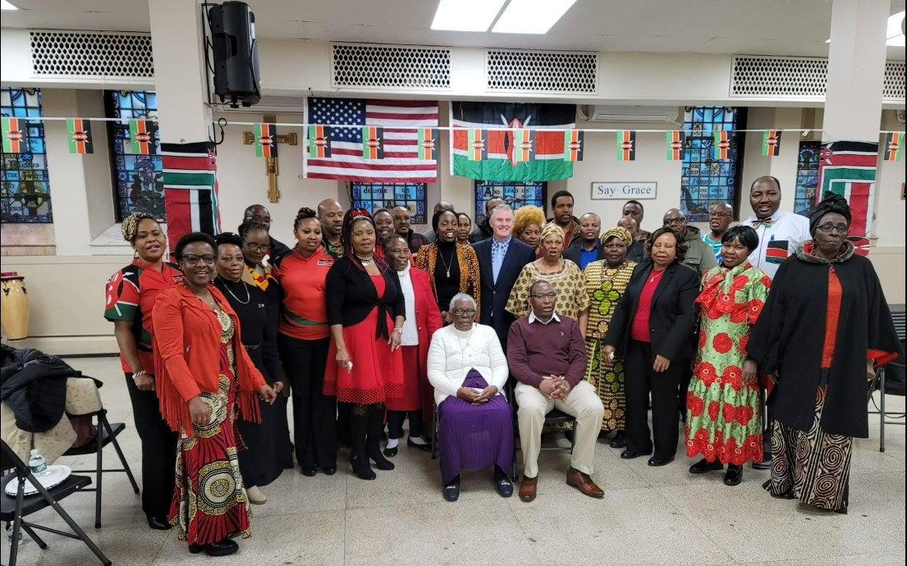
On December 11, REACH LoWELL, Lowell
Community Health Center, Greater Lowell Health Alliance, and DPH partnered to host a Get Boosted COVID-19 vaccine clinic at Saint Michael Parish Church (see photo). Over 80 community members were vaccinated at the event, which also offered an opportunity for community members to celebrate Kenyan Independence Day.

Read More Highlights

Visit the VEI Website

Share This Email
Share This Email
Share This Email

Vaccine Equity Initiative | 250 Washington Street, Boston, MA 02108

Unsubscribe vaccineequityinitiative@mass.gov Constant Contact Data Notice
Sent by vaccineequityinitiative@mass.gov in collaboration with
Try email marketing for free today!

