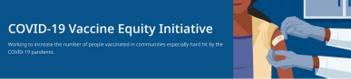December 17, 2021
Welcome to VEI Roundup, your centralized source for timely information and materials related to vaccine promotion, education, and access. All materials are publicly available. Each item is clickable, so do share widely.
Please forward to others who can subscribe by clicking here to submit a subscription request.
What's New
WAYS TO INCREASE COVID-19 VACCINATION
- Updated! - Ways to Increase COVID-19 Vaccination (1-pg factsheet with flexible clinic options, education materials and supports; available in multiple languages)
2.1M COVID SELF TESTS FOR MA PRIORITY COMMUNITIES
- News Release (12/13): Baker-Polito Administration Announces 2.1 Million At-Home COVID Tests for 102 High-Need Communities
VACCINE RESOURCE HUB
- New! - Vaccine Resource Hub (From CDC Foundation as part of the Partnering for Vaccine Equity program. Includes Infographics, videos, digital assets, and more.)
Reminders
MONOCLONAL ANTIBODY TREATMENT FOR COVID-19
- DPH News Release (11/30): Baker-Polito Administration Announces State Supported Monoclonal Antibody Treatment Sites in Massachusetts
  - Monoclonal antibody treatment is for high-risk individuals who have been exposed to or have COVID-19. Treatment is provided at no cost to the patient and offered regardless of immigration status or health insurance. Patients should discuss with their health care providers whether monoclonal antibody treatment is right for them.

REPLACING YOUR VACCINE CARD
- Request a Copy of Your Vaccine Card
EMPLOYMENT OPENINGS
- DPH Job Opening - Health Equity Manager: DPH is seeking a Health Equity Manager to join the Office of Health Equity. Candidates who are creative thinkers, collaborators, advocates for structural change, and who bring diversity, supervisory and project management experience are encouraged to apply.
GRANT OPPORTUNITY FOR LOCAL ORGANIZATIONS
- MA COVID-19 Community Grants: Community- and faith-based organizations are invited to apply for grants of up to $50,000 to support COVID-19 responses with communities of color. Applications submitted via Health Resources in Action (HRiA). Deadline to apply is January 7, 2022.Please share!
Key Resources
OUTREACH AND EDUCATION MATERIALS
- COVID-19 Vaccine FAQs
- DPH COVID-19 Booster FAQs
- Weekly Provider Bulletin (published 12/14 - includes info about boosters for 16-17 year olds and reminders about delivery cadence for upcoming holidays)
- Trust the Facts, Get the Vax Campaign Materials
- Trust the Facts, Get the Vax Creative Toolkit (toolkit will continue to be updated as the situation evolves, including pediatric eligibility)
- Additional Outreach Materials (includes social media graphics, vaccine updates, guides to hosting a forum, and more)
- Multilingual COVID-19 Materials (Videos and some printables)
- DPH Vaccine Ambassador Program (Request a DPH employee to attend community meetings to share info about the vaccine)
FIND A COVID-19 VACCINE OR BOOSTER
- Vaccine Finder
- Find, Schedule, or Sign Up for a Mobile COVID-19 Vaccination
- COVID-19 Booster Eligibility Checker
Recent Highlights
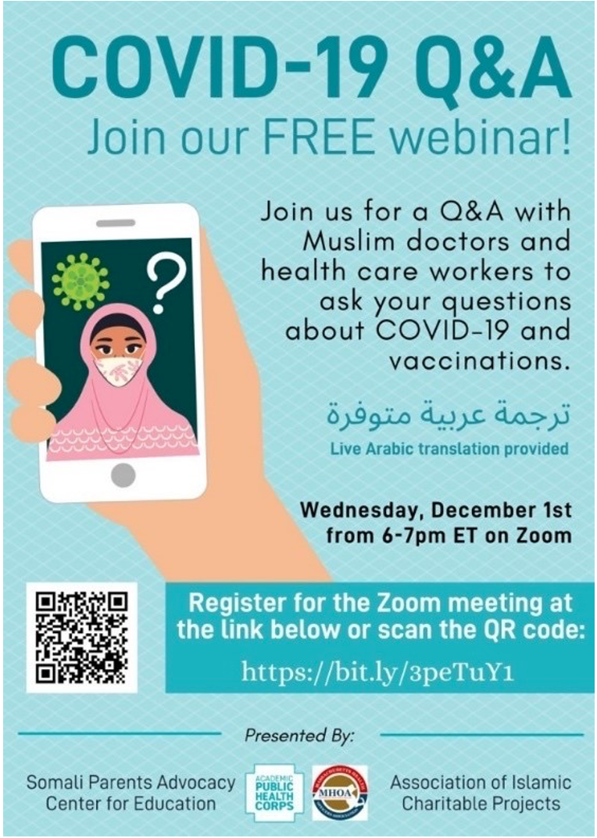
From Boston and Everett:

- Somali Parent Advocacy Center for Education (based in Boston, serving the Somali community in Boston and Everett) held a COVID-19 Q&A webinar with Muslim doctors, in collaboration with the Association of Islamic Charitable Projects the Academic Public Health Corps, and the Massachusetts Health Officers Association with about 30 people in attendance (flyer, right).

From New Bedford:
- Immigrants Assistance Center based in New Bedford has continued to reach workers at worksites to promote COVID-19 vaccines and pop-up clinics. They have visited six worksites during their lunch hours that employ up to 300 people to discuss COVID-19 vaccines boosters, those for children ages 5+, as well as registering people for future vaccine clinics. Six pop-up vaccine clinics have been held across 30 worksites in the New Bedford area to date, with at least two more clinics planned.
Read more highlights
Visit the VEI Website
Vaccine Equity Initiative | 250 Washington Street, Boston, MA 02108
Unsubscribe vaccineequityinitiative@mass.gov
About Constant Contact
Sent by vaccineequityinitiative@mass.gov in collaboration
with
Try email marketing for free today!

