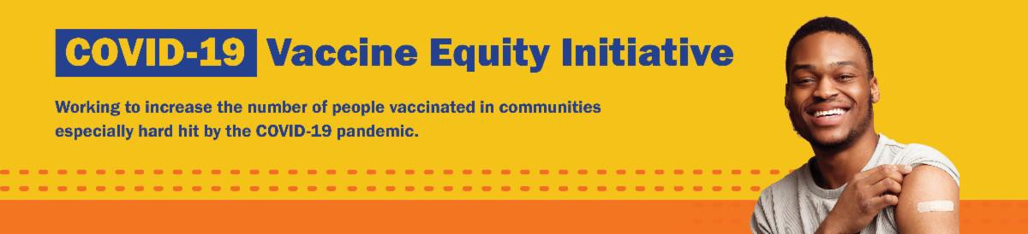
December 2, 2022
Here are the latest resources for promoting COVID-19 vaccination to share with your colleagues
and networks across Massachusetts. If you received this from a colleague, subscribe today.

View this email online.
What's New

'GET BOOSTED' CLINICS SEE NEARLY 24,000 COVID VACCINATIONS AND WILL CONTINUE THROUGH THE END OF THE YEAR

Nearly 24,000 doses of COVID vaccine have been administered since the 'Get Boosted' effort began this fall, with more than 90% booster doses. These successful clinics will continue through the end of the year.

Get Boosted clinics have been featured in media outlets statewide including WBUR, Boston Globe, and Boston.com.

Residents of all ages who get vaccinated (any dose) at participating clinics can receive a $75 gift card to local retailers, while supplies last. View a list of participating clinics at mass.gov/GetBoosted.

Get Boosted clinics were featured in the Boston Globe November 29.

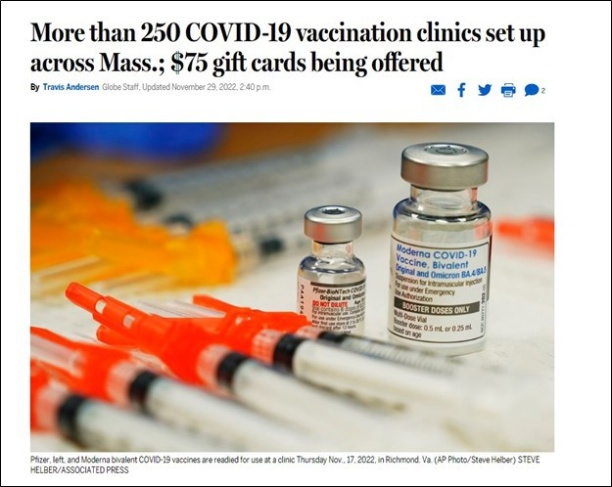
Help spread the word about these clinics! Find a customizable booster flyer, social media graphics, and more in our vaccine promotion toolkit!

BECOME A VACCINE CHAMPION: LEARN STRATEGIES FOR RESPONDING TO COVID-19, FLU, AND RSV
DPH and its partners will offer a virtual

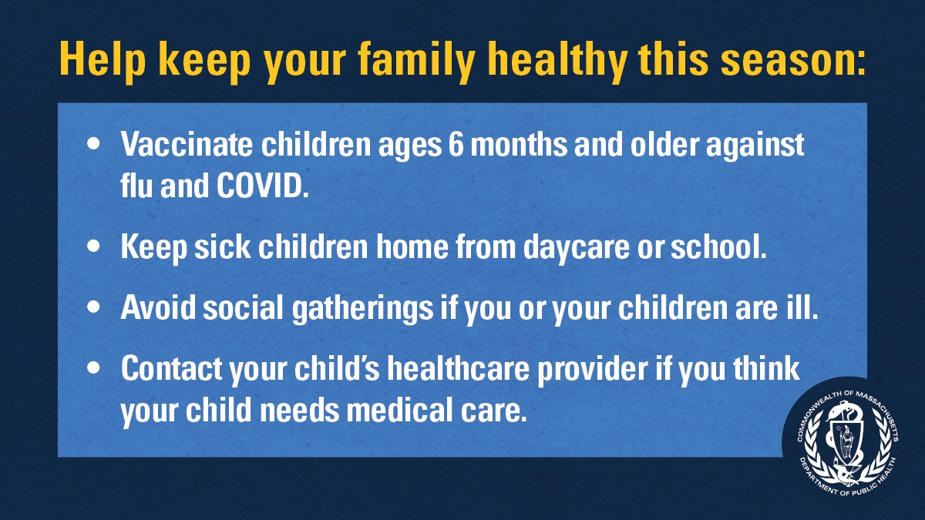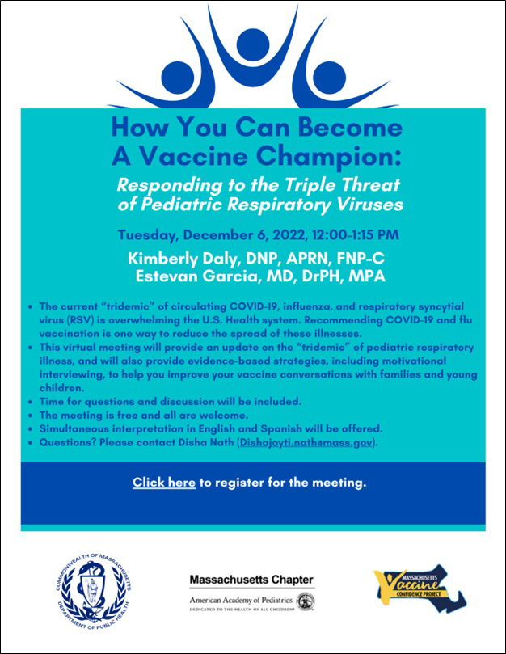training on December 6 to provide an update on the "triple-demic" of pediatric respiratory illness (COVID, flu, and RSV). This training will also help you improve confidence in COVID-19 vaccines among families and young children.
FREE IN-HOME COVID-19 VACCINATION AVAILABLE

Massachusetts offers in-home COVID-19 vaccinations for anyone who has difficulty getting to or using a community clinic, including young children. Learn more, or call 833-983-0485 to sign up for an in- home appointment.

Help spread the word with
this informational flyer (in 12 languages)!
GET VACCINATED AGAINST THE FLU AND COVID-19

Rates of respiratory illness in infants and children are on the rise in Massachusetts and across much of the U.S. Take steps to keep your family healthy this season by getting vaccinated against the flu and COVID-19 and taking other precautions.
Protect yourself and your family. Learn
more.
FOLLOW THESE SEVEN STEPS
Reminders

More than 250 people attended similar trainings in the spring and fall, which covered topics like vaccine safety, co- administration of COVID and flu vaccines, the science behind mRNA vaccines, navigating COVID vaccination after COVID infection, pediatric (0-5) COVID vaccination, and more.

All are welcome at this free event.

Register for December 6.

Please share! Flyers available
in English, Spanish, and Portuguese.

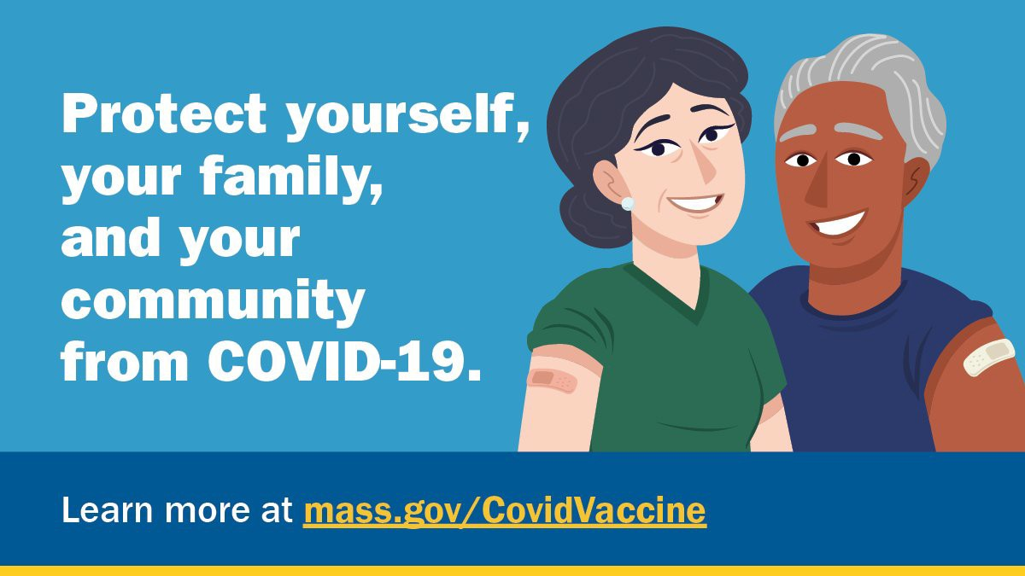
There are a number of steps that you can take to help protect yourself, your family, and your community from COVID-19.

Available in multiple languages, this flyer features a checklist with these
steps. Please share it with your networks.
Key Resources

OUTREACH AND EDUCATION MATERIALS

COVID-19 Vaccine FAQs
COVID-19 Therapeutic Information (including telehealth) Weekly Provider Bulletin
Trust the Facts, Get the Vax Campaign Materials (organized by audience, including general, parents and pregnant people, youth, young adults; available in 12 languages) Multilingual COVID-19 Materials (videos and printables; organized by language) COVID-19 Funeral Assistance from FEMA (including one-pager with key info available in multiple languages)

COVID-19 Vaccination Tools for Employers
Archive of COVID-19 Vaccine Communications Updates (past editions of VEI Roundup)

FIND A COVID-19 VACCINE OR BOOSTER

Mass.gov/GetBoosted (family-friendly clinics through the end of 2022)
Vaccine Finder
Find, Schedule, or Sign Up for a Mobile COVID-19 Vaccination COVID-19 In-Home Vaccination Program
Request a Copy of Your Vaccine Card

Recent Highlights

Chicopee

Lorraine’s Soup Kitchen and Pantry in Chicopee hosted a recent Get Boosted clinic where 44 people were vaccinated, including 3 who received their first vaccine dose. The clinic was featured on MassLive (see photo). Another Chicopee Get Boosted clinic will be held December 20 as part of the Council on Aging's Holiday Dinner. Get Boosted clinics continue statewide through the end of the year —

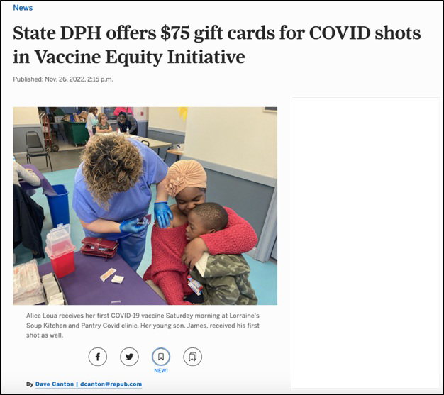click here to find a clinic near you .

A Get Boosted clinic at Lorraine's Soup Kitchen and Pantry featured on MassLive November 26.

Read More Highlights

Share This Email
Share This Email
Share This Email

Visit the VEI Website

Vaccine Equity Initiative | 250 Washington Street, Boston, MA 02108 Unsubscribe vaccineequityinitiative@mass.gov
Constant Contact Data Notice
Sent by vaccineequityinitiative@mass.gov in collaboration with
Try email marketing for free today!

