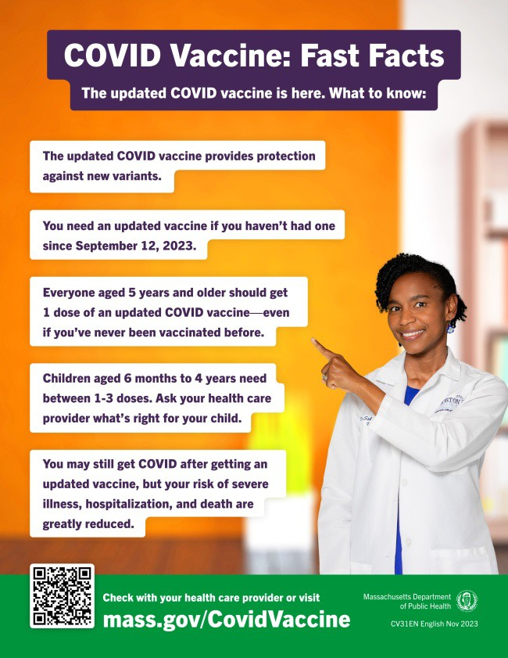
GEAR UP FOR NEW YEAR'S RESOLUTIONS: SHARE MATERIALS FROM THE
VAX PROMOTION TOOLKIT!
New materials have been added to VEI's
Vaccine Promotion Toolkit!
These include:
COVID Vaccine: Fast Facts flyer in 12 languages
Social media graphics and copy in 4 languages
Customizable clinic promotion flyers (in English and Spanish)
And more!
Don't see something you need? Email us and let us know!
ALL U.S. HOUSEHOLDS CAN ORDER FOUR MORE FREE COVID RAPID TESTS
As of November 20, every U.S. household can once again order four free COVID-19 rapid tests, and some may be eligible to receive eight tests. Tests will be delivered
December 22, 2023
Here are the latest resources for promoting COVID-19 vaccination to share with your colleagues
and networks across Massachusetts. If you received this from a colleague, subscribe today.
View this email online.
What's New

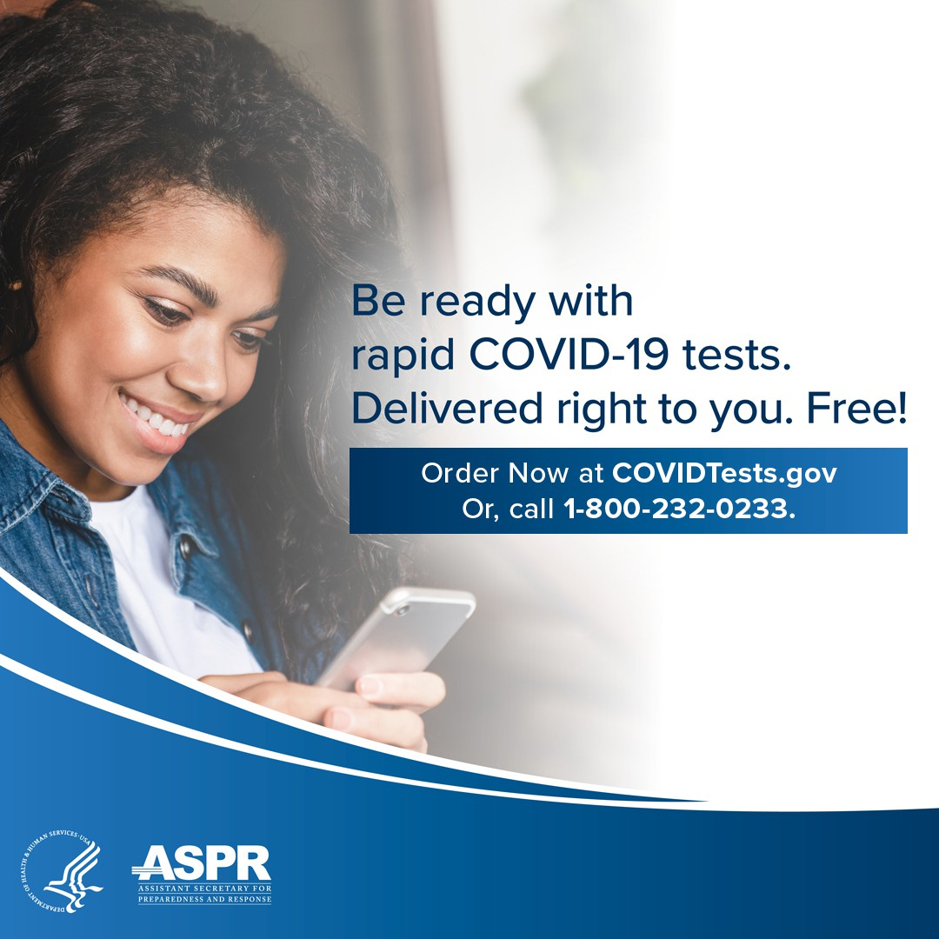
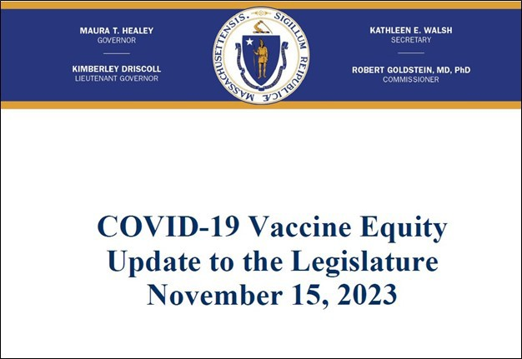
directly to recipients' homes.
To order tests, visit COVID.gov/Tests.
Accessible COVID test kits are also available for people who are blind or have low vision.
Don't forget: Many at-home COVID tests have had their expiration dates extended. Check updated expiration dates on the FDA's website.

HAVE QUESTIONS ABOUT COVID? WE'VE GOT ANSWERS!
You can get up to date on the latest COVID information with:
Presentation slides on the state of COVID, updated vaccine guidelines, and more
Answers to questions your colleagues asked
Recordings of presentations on the following topics: Commissioner remarks, current status of COVID- 19, commercialization of the COVID-19 vaccine, options for community vaccination
Have questions of your own? Email us!

COVID-19 VACCINE EQUITY PLAN: 60-DAY UPDATE

DPH submits a Vaccine Equity report to the Legislature every 60 days that outlines the progress and results made through the Vaccine Equity Initiative.

Read the most recent report, submitted on November 15.

Key Resources

The Latino Health Insurance Program (LHIP) administered over 200 COVID vaccines in October (see photo). LHIP's patient navigators have been invaluable to this work, conducting outreach, providing resources, and assisting patients to register for vaccinations and/or for Medicare, MassHealth, and SNAP. The patient navigators are multilingual and are trained to communicate important information and build trust. LHIP has also hired a Haitian Creole speaking patient navigator to better support recent migrants from Haiti.

LHIP administered over 200 COVID vaccines in October.

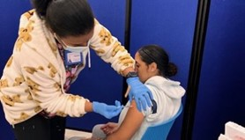
OUTREACH AND EDUCATION MATERIALS
COVID-19 Vaccine Information
COVID-19 Therapeutic Information (including telehealth) Archive of Weekly Provider Bulletins
Archive of COVID-19 Vaccine Communications Updates (past editions of VEI Roundup)
FIND A COVID-19 VACCINE DOSE
Use Vaccines.gov to sign up for a COVID-19 vaccine appointment Find a community COVID-19 vaccination clinic near you
Learn about the COVID-19 In-Home Vaccination Program and request a visit Request a copy of your vaccine card
Highlights

Read More Highlights

Share This Email
Share This Email
Share This Email

Visit the VEI Website

Vaccine Equity Initiative | 250 Washington Street, Boston, MA 02108

Unsubscribe vaccineequityinitiative@mass.gov Constant Contact Data Notice
Sent by vaccineequityinitiative@mass.gov powered by
Try email marketing for free today!

