GET BOOSTED CLINICS CONTINUE THROUGH DECEMBER 31!

Over 40,000 doses of COVID vaccine have been administered since the Get Boosted effort began October 24th.

There's still time to get vaccinated and receive a $75 gift card! Clinics run through December 31, 2022.

Residents of all ages who get vaccinated (any dose) at participating clinics can receive a $75 gift card to local retailers, while supplies last. Find participating clinics at mass.gov/GetBoosted.

If you have questions about Get Boosted clinics, please call 211 (or 1- 877-211-6277) and press 1. Calls are answered Monday through Friday, from 9am to 5pm.

Help spread the word about these clinics on Facebook and Instagram, or by using a customizable flyer!
Get Boosted clinics were recently featured by the Sun Chronicle (Attleboro) and This Week in Worcester.

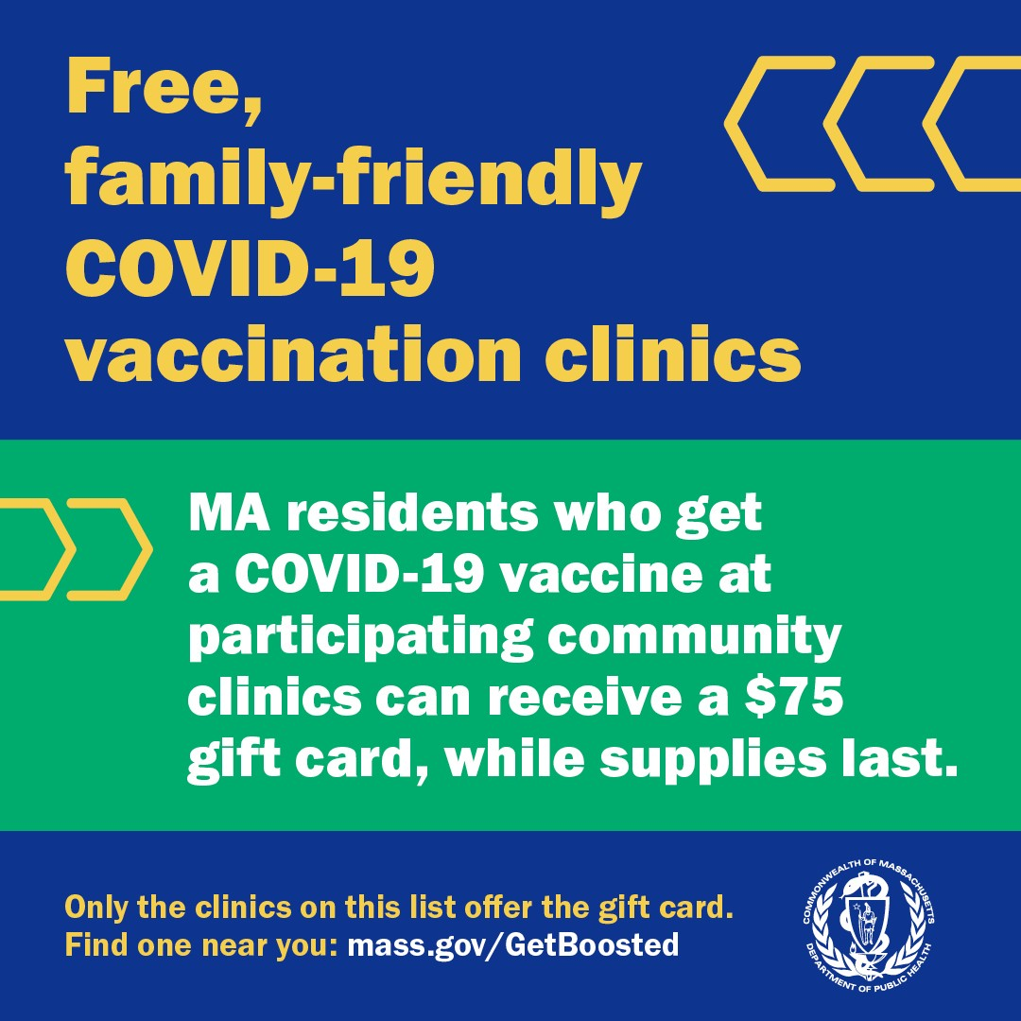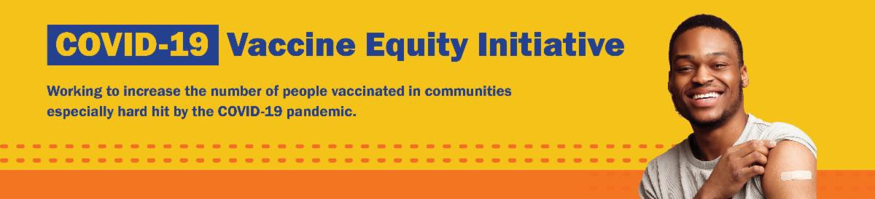
December 23, 2022
Here are the latest resources for promoting COVID-19 vaccination to share with your colleagues
and networks across Massachusetts. If you received this from a colleague, subscribe today.

View this email online.
Please note: There will be no VEI Roundup next week. Wishing everyone a happy and safe New
Year!
What's New

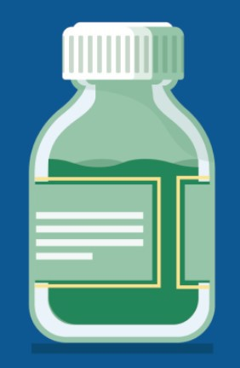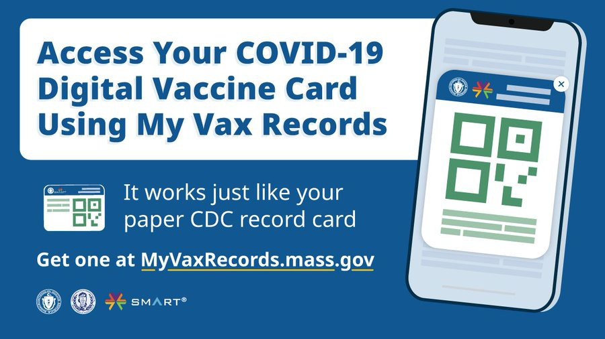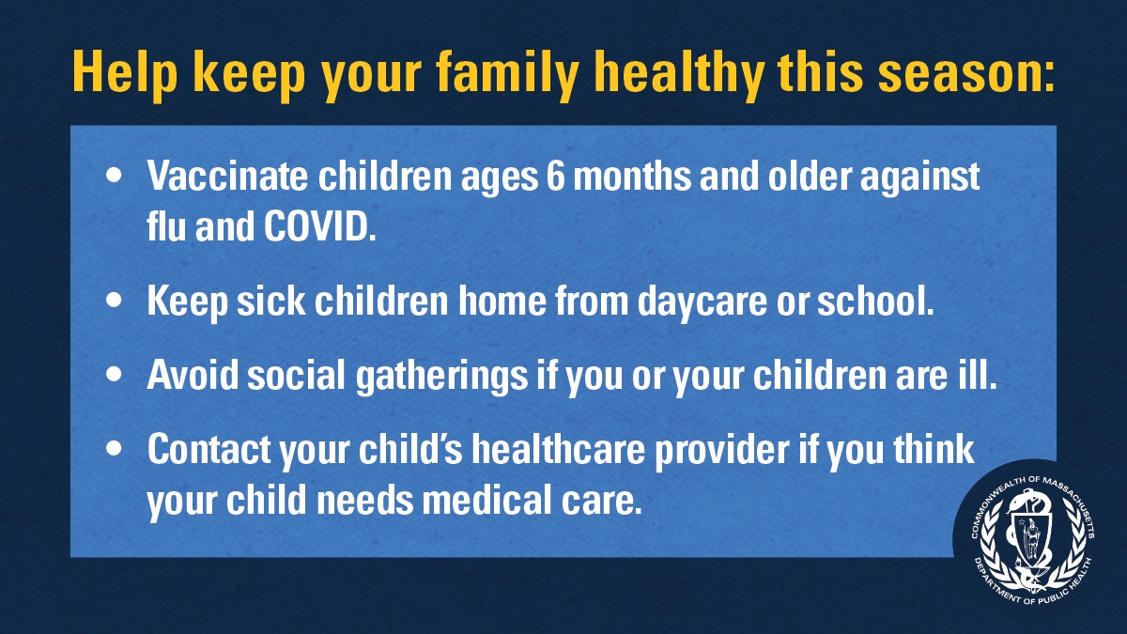
Reminders

UPDATED COVID-19 BOOSTERS APPROVED FOR CHILDREN AGES 6 MONTHS AND OLDER

Updated bivalent COVID-19 boosters for children ages 6 months and older have now been approved by the CDC.

Pediatric booster recommendations differ by age and vaccine type. Learn more, or use the CDC's guide to find out when you can get a booster.

DO YOU USE MY VAX RECORDS? IT'S A DIGITAL VACCINE CARD FOR MA RESIDENTS

Need a copy of your COVID-19 vaccination record? MA residents can use My Vax Records to get a digital vaccine card to show they’ve been vaccinated against COVID-19, if they choose. Learn more.

IT'S NOT TOO LATE FOR A FLU SHOT! GET VACCINATED AGAINST THE FLU AND COVID-19

Rates of respiratory illness in infants and children are on the rise in Massachusetts and across much of the U.S. Keep your family healthy this season with these four steps. Learn more.

FREE COVID TREATMENT AVAILABLE

Free, safe, and effective treatments for COVID-19 are available across MA. They can help prevent hospitalizations and

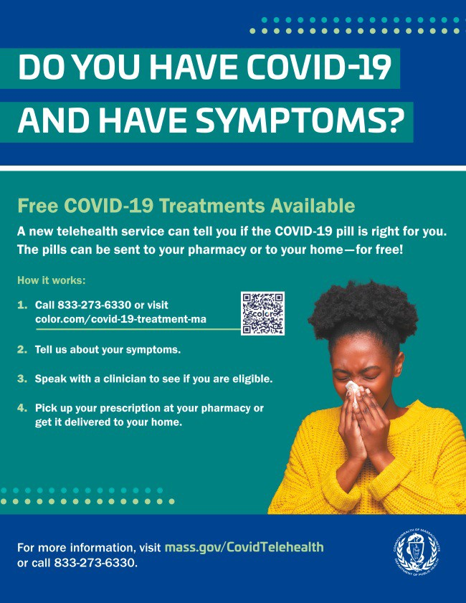
reduce the risk of severe disease.

Telehealth consultations are now available via phone, in addition to online.
Consultations can be accessed in 10+ languages.

Please use this flyer to help share this information!

Please also share this video about free COVID treatments.
Key Resources

OUTREACH AND EDUCATION MATERIALS

COVID-19 Vaccine FAQs
COVID-19 Therapeutic Information (including telehealth) Weekly Provider Bulletin
Trust the Facts, Get the Vax Campaign Materials (organized by audience, including general, parents and pregnant people, youth, young adults; available in 12 languages) Multilingual COVID-19 Materials (videos and printables; organized by language) COVID-19 Funeral Assistance from FEMA (including one-pager with key info available in multiple languages)
COVID-19 Vaccination Tools for Employers
Archive of COVID-19 Vaccine Communications Updates (past editions of VEI Roundup)

FIND A COVID-19 VACCINE OR BOOSTER

Mass.gov/GetBoosted Vaccine Finder
Find, Schedule, or Sign Up for a Mobile COVID-19 Vaccination COVID-19 In-Home Vaccination Program
Request a Copy of Your Vaccine Card

Recent Highlights

Boston

The South Asian Workers’ Center (SAWC) has been engaging community members at their bimonthly Chai Adda (conversational meetings over chai tea) to discuss physical and mental health, well-being, COVID-19 vaccines, and the anti-Asian racism they are facing. Throughout the fall, SAWC organized three mobile COVID-19 vaccine clinics, resulting in 90 people getting vaccinated. They also continue to do COVID-19 outreach as part of DPH's Get Boosted campaign.

Read More Highlights

Visit the VEI Website
Share This Email
Share This Email
Share This Email

Vaccine Equity Initiative | 250 Washington Street, Boston, MA 02108

Unsubscribe vaccineequityinitiative@mass.gov Constant Contact Data Notice
Sent by vaccineequityinitiative@mass.gov in collaboration with
Try email marketing for free today!

