GET BOOSTED CLINICS EXTENDED THROUGH MARCH 2023!

The Get Boosted program has been extended through March 31, 2023, for all participating communities!

Over 55,000 doses of COVID vaccine have been administered since the Get Boosted effort began October 24.

Residents of all ages who get vaccinated (any dose) at participating clinics can receive a $75 gift card to local retailers, while supplies last. Find participating clinics at mass.gov/GetBoosted.

Help spread the word about these clinics on Facebook and Instagram, or by using other resources from our toolkit.

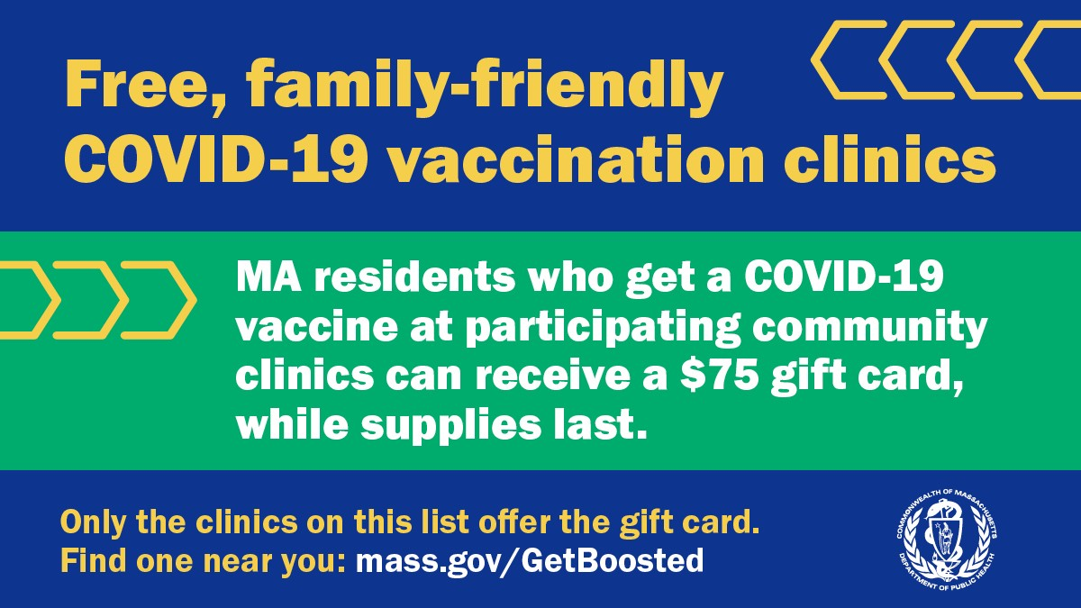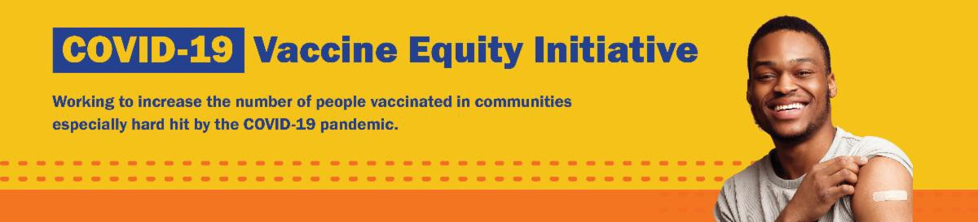
January 27, 2023
Here are the latest resources for promoting COVID-19 vaccination to share with your colleagues
and networks across Massachusetts. If you received this from a colleague, subscribe today.

View this email online.
What's New
If you have questions about Get Boosted clinics, please call 2-1-1 (or 877-211-6277) and press 1. Calls are answered Monday through Friday, from 9 a.m. to 5 p.m.
Get Boosted clinics were recently featured by Gardner News and the Lowell Sun.

LOST YOUR COVID-19 VACCINE CARD? HERE'S HOW TO GET A NEW ONE

There are a few ways to get a copy of your COVID-19 vaccine record:

If you were vaccinated at a health care center or by your primary care provider: contact the

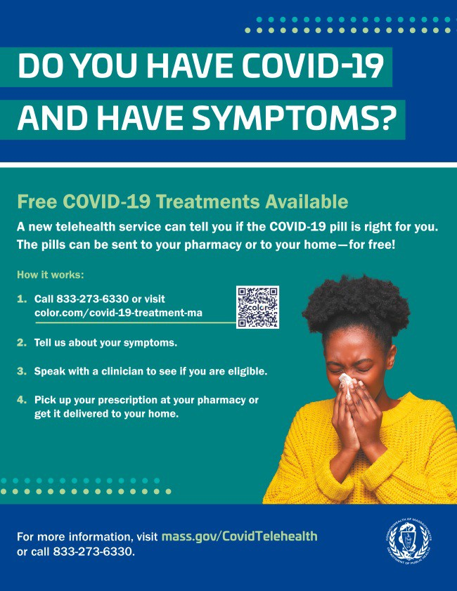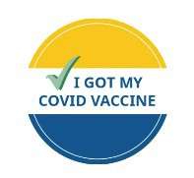
location where you got vaccinated.
If you were vaccinated at a pop-up clinic: contact your primary care provider, or explore the other options below.
If you were vaccinated at a retail pharmacy: you may be able to access your record online, or contact a pharmacist (varies by pharmacy). If you were vaccinated at a state mass vaccination site: follow these instructions.
You can also:
Get a digital copy from My Vax Records .
Find your record in v-safe (if you already enrolled).
Fill out a state immunization record request form. This will provide a record of all vaccines you've gotten. It may take several weeks to process.

Learn more, or call 2-1-1 with any questions.
Reminders

FREE COVID TREATMENT AVAILABLE VIA PHONE OR ONLINE

Free, safe, and effective treatments for COVID-19 are available across Massachusetts. They can help prevent hospitalizations and reduce the risk of severe disease.

Telehealth consultations are now available via phone, in addition to online.
Consultations can be accessed in 10+ languages.

Please share: Flyers are now available in 12 languages!

FREE COVID-19 TESTS AVAILABLE FOR A LIMITED TIME!

Community organizations can order free at-home rapid antigen COVID-19 tests, while supplies last.

Organizations that are interested in ordering supplies must complete this short form: bit.ly/COVIDTestRequestMA.

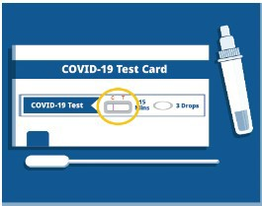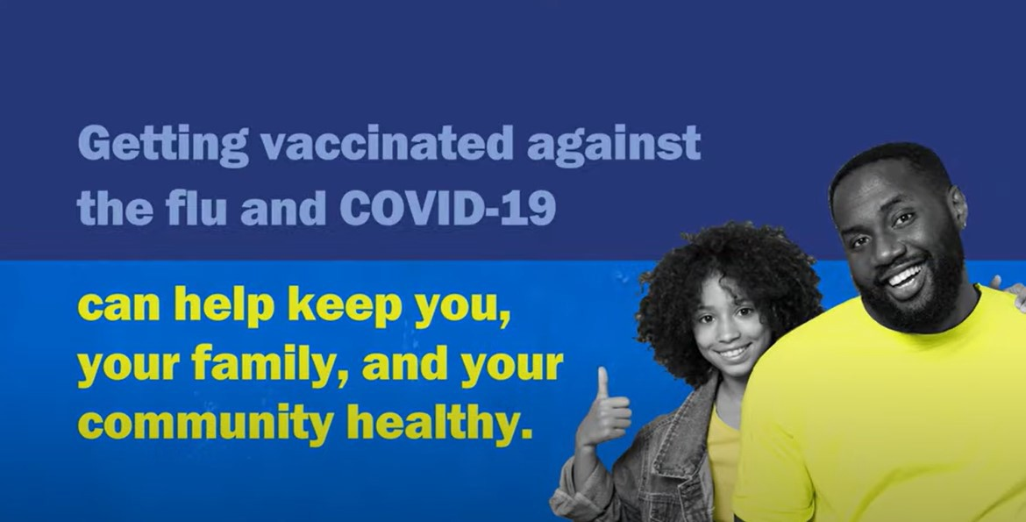
Please note: You may need to copy and
paste the link into your browser.
IT'S NOT TOO LATE FOR A FLU SHOT! GET VACCINATED AGAINST COVID-19
AND THE FLU

It’s not too late to get a flu shot – and you can even get a flu shot and your COVID vaccine at the same time. Both vaccinations can help keep you, your family, and your community healthy. Learn more.
Key Resources

OUTREACH AND EDUCATION MATERIALS

COVID-19 Vaccine FAQs
COVID-19 Therapeutic Information (including telehealth) Weekly Provider Bulletin
Trust the Facts, Get the Vax Campaign Materials (organized by audience, including general, parents and pregnant people, youth, young adults; available in 12 languages) Multilingual COVID-19 Materials (videos and printables; organized by language) COVID-19 Funeral Assistance from FEMA (including one-pager with key info available in multiple languages)
COVID-19 Vaccination Tools for Employers
Archive of COVID-19 Vaccine Communications Updates (past editions of VEI Roundup)

FIND A COVID-19 VACCINE OR BOOSTER

Mass.gov/GetBoosted (family-friendly clinics through March 2023)
Vaccine Finder
Find, Schedule, or Sign Up for a Mobile COVID-19 Vaccination COVID-19 In-Home Vaccination Program
Request a Copy of Your Vaccine Card

Recent Highlights

Chelsea and Revere

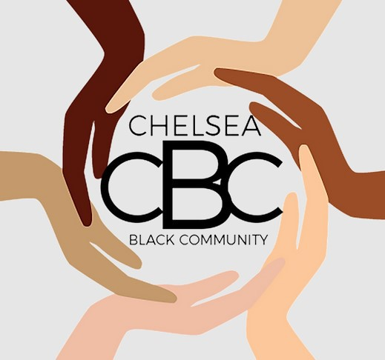Chelsea Black Community (CBC) and Women Encouraging Empowerment (WEE) held Get Boosted COVID-19 vaccine clinics at the Chelsea Senior Center and WEE’s Revere office, respectively, throughout December. To accommodate high turnout and help individuals get vaccinated ahead of the holidays, CBC held extra weekend clinics and clinics on Christmas Eve and New Year's Eve. WEE offered clinics in the afternoons and evenings. Clinic attendees also had opportunities to get connected with resources like food or rental assistance, and WEE offered flu and mpox vaccines.
Each of WEE's and CBC’s weekly clinics
vaccinated between 100-200 people per clinic.

Read More Highlights

Share This Email
Share This Email
Share This Email

Visit the VEI Website

Vaccine Equity Initiative | 250 Washington Street, Boston, MA 02108 Unsubscribe vaccineequityinitiative@mass.gov
Constant Contact Data Notice
Sent by vaccineequityinitiative@mass.gov in collaboration with
Try email marketing for free today!

