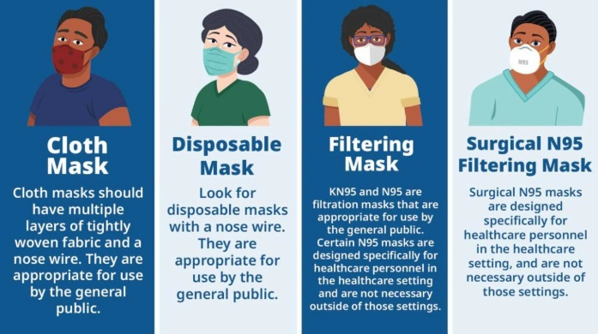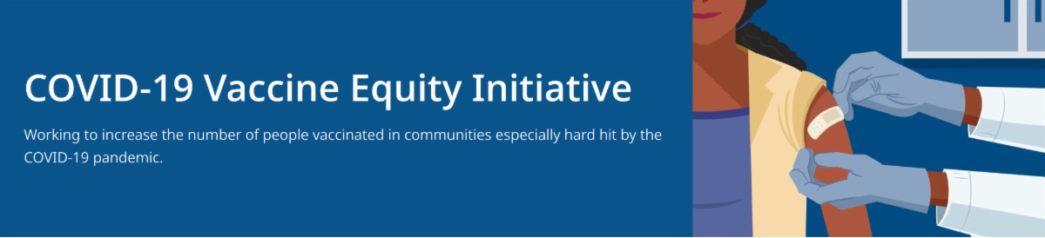

**January 28, 2022**

VEI Roundup is your central source for updates and materials related to vaccine promotion,

education, and access. All materials are publicly available. Each item is clickable for easy sharing.

Please forward to others who can subscribe by [**clicking here to submit a subscription reques**](mailto:VaccineEquityInitiative@mass.gov)**t**.

**What's New**

# COVID-19 MASK INFORMATION

[**COVID-19 Mask Information**](https://www.mass.gov/info-details/covid-19-mask-information) (Now on mass.gov – how to select and wear a mask)

[**Types of Masks and Respirator**](https://www.cdc.gov/coronavirus/2019-ncov/prevent-getting-sick/types-of-masks.html)**s** (detailed info from the CDC regarding types of masks and levels of protection offered)

# COVID-19 ISOLATION AND QUARANTINE GUIDANCE

[**COVID-19 Isolation and Quarantine Guidance for the General Publi**](https://www.mass.gov/info-details/covid-19-isolation-and-quarantine-guidance-for-the-general-public)**c** (updates on mass.gov to reflect changes in isolation and quarantine guidance from the CDC)

# MASSHEALTH NOW COVERING AT-HOME COVID TESTS FOR MEMBERS

Over-the-counter COVID-19 self-test kits are now covered through MassHealth. Up to 8 test kits per member per month will be covered without the need for a prescription or prior authorization. More in the [**MassHealth Provider Bulleti**](https://www.mass.gov/doc/all-provider-bulletin-337-masshealth-pharmacy-coverage-of-over-the-counter-diagnostic-antigen-tests-for-sars-cov-2-0/download)**n**.

# ADDITIONAL TESTING OPTIONS

The Biden Administration is offering free at-home COVID-19 rapid tests to all U.S. households. Every home in the U.S. is eligible to order 4 tests to be delivered by the U.S. Postal Service: [**Get Free At-Home COVID Test**](https://www.covidtests.gov/)**s**

More than 1,000 testing sites are available to MA residents. Find locations at

[**www.mass.gov/gettested**](http://www.mass.gov/gettested)

**Reminders**

# IN-HOME VACCINATIONS AVAILABLE

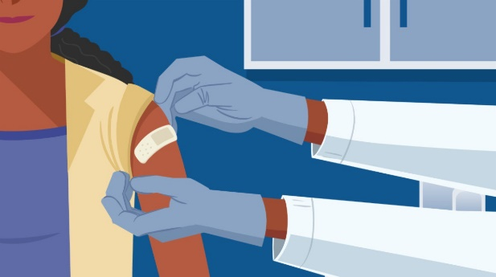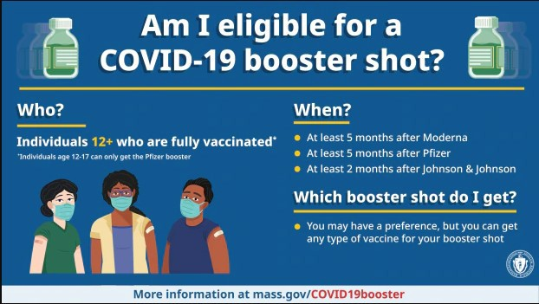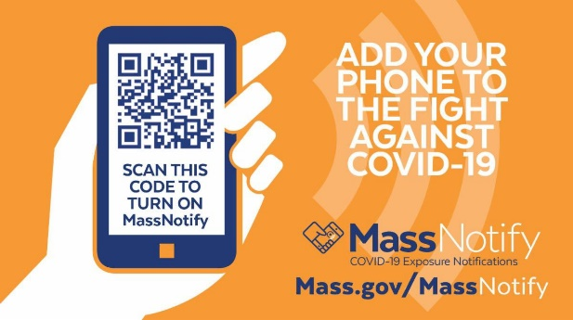

[**COVID-19 In-Home Vaccination Program**](https://www.mass.gov/info-details/covid-19-in-home-vaccination-program)**:** In-home vaccinations are available for anyone who has difficulty getting to or using a community vaccination location

# COVID-19 BOOSTER SHOT FAQ

[**COVID-19 Booster FAQ**](https://www.mass.gov/info-details/covid-19-booster-frequently-asked-questions)**s** (addresses questions about booster eligibility, how to find a booster, and more)

# TRAINING OPPORTUNITIES

[**Communication Skills Training for Clinicians Discussing COVID-19 Vaccinatio**](https://www.pnqinma.org/_files/ugd/fdc477_92ee38fd7e654af4a32c4609b66df30e.pdf)**n** (On Feb. 11; free webinar from DPH, UMASS Chan Medical School, and other partners, with a focus on pregnant and postpartum people, and parents and caregivers of young children)

# ENABLE MASSNOTIFY ON YOUR SMARTPHONE

MassNotify is a tool that works through smartphones – with a focus on privacy – to alert users who may have been exposed to COVID-19. Enable MassNotify on your smartphone to add another tool in our fight against COVID-19. Learn more: [**mass.gov/MassNotify**](http://mass.gov/MassNotify)

**Key Resources**

# OUTREACH AND EDUCATION MATERIALS

[**COVID-19 Vaccine FAQ**](https://www.mass.gov/info-details/covid-19-vaccine-frequently-asked-questions)**s**

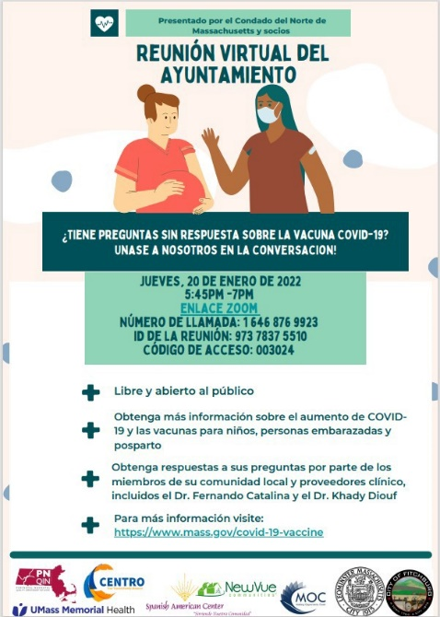

**From Fitchburg and Leominster:**

Fitchburg and Leominster hosted a virtual town hall on Jan. 20 where attendees learned about vaccinations for children and pregnant and postpartum people and had a Q&A with community advocates and clinical providers. Spanish translation was available for the Q&A, and a recorded version of the webinar will be translated into Spanish for dissemination (flyer, right).

**From Revere:**

A recent clinic in Revere resulted in 215 vaccinations, including 55 pediatric doses. During the clinic, MD students engaged with breastfeeding mothers and parents about vaccine safety.

[**Read More Highlights**](https://www.mass.gov/info-details/covid-19-vaccine-equity-initiative-highlights)

[**Visit the VEI Website**](https://www.mass.gov/info-details/covid-19-vaccine-equity-initiative)

**Recent Highlights**

[**Weekly Provider Bulletin**](https://www.mass.gov/info-details/massachusetts-covid-19-vaccine-program-mcvp-guidance-for-vaccine-providers-and-organizations#weekly-provider-bulletins-) (updated 1/26)

[**Trust the Facts, Get the Vax Campaign Material**](https://www.mass.gov/resource/trust-the-facts-get-the-vax-campaign-materials)**s** (organized by audience, including general, parents and pregnant people, youth, young adults; available in 12 languages)

[**Trust the Facts, Get the Vax Creative Materials Toolki**](https://www.mass.gov/doc/creative-materials-toolkit-trust-the-facts-get-the-vax/download)**t** (updates ongoing, including pediatric eligibility)

[**Additional Education and Outreach Material**](https://www.mass.gov/info-details/stop-covid-19-vaccine-education-and-outreach-materials)**s** (includes social media graphics, vaccine updates, guides to hosting a forum, and more)

[**Multilingual COVID-19 Material**](https://www.mass.gov/resource/multilingual-covid-19-materials)**s** (videos and some printables)

[**DPH Vaccine Ambassador Program**](https://www.mass.gov/info-details/covid-19-vaccine-equity-initiative-dph-vaccine-ambassador-program) (request a DPH employee to attend community meetings to share info about the vaccine)

[**COVID-19 Funeral Assistance from FEM**](https://www.mass.gov/info-details/covid-19-funeral-assistance)**A** (including [**1-pager with key inf**](https://www.mass.gov/info-details/covid-19-funeral-assistance#fema-funeral-assistance-website-%26-faq-)**o** available in multiple languages)

# FIND A COVID-19 VACCINE OR BOOSTER

[**Vaccine Finde**](https://vaxfinder.mass.gov/)**r**

[**Find, Schedule, or Sign Up for a Mobile COVID-19 Vaccinatio**](https://www.mass.gov/covid-19-mobile-vaccinations)**n** [**COVID-19 Booster Eligibility Checker**](https://www.mass.gov/covid-19-vaccine)

[**Request a Copy of Your Vaccine Car**](https://www.mass.gov/info-details/requesting-a-copy-of-your-covid-19-vaccination-record)**d**



Share This Email

Share This Email

Share This Email

Vaccine Equity Initiative | 250 Washington Street, Boston, MA 02108 [Unsubscribe vaccineequityinitiative@mass.gov](mailto:Unsubscribevaccineequityinitiative@mass.gov)

[About Constant Contac](http://www.constantcontact.com/legal/about-constant-contact)t

Sent by[vaccineequityinitiative@mass.gov](mailto:vaccineequityinitiative@mass.gov)in collaboration with



[Try email marketing for free today](http://www.constantcontact.com/index.jsp?cc=nge&rmc=VF21_CPE&nav=b2d48009-83c7-4436-9e4d-cf384c19c01c)!