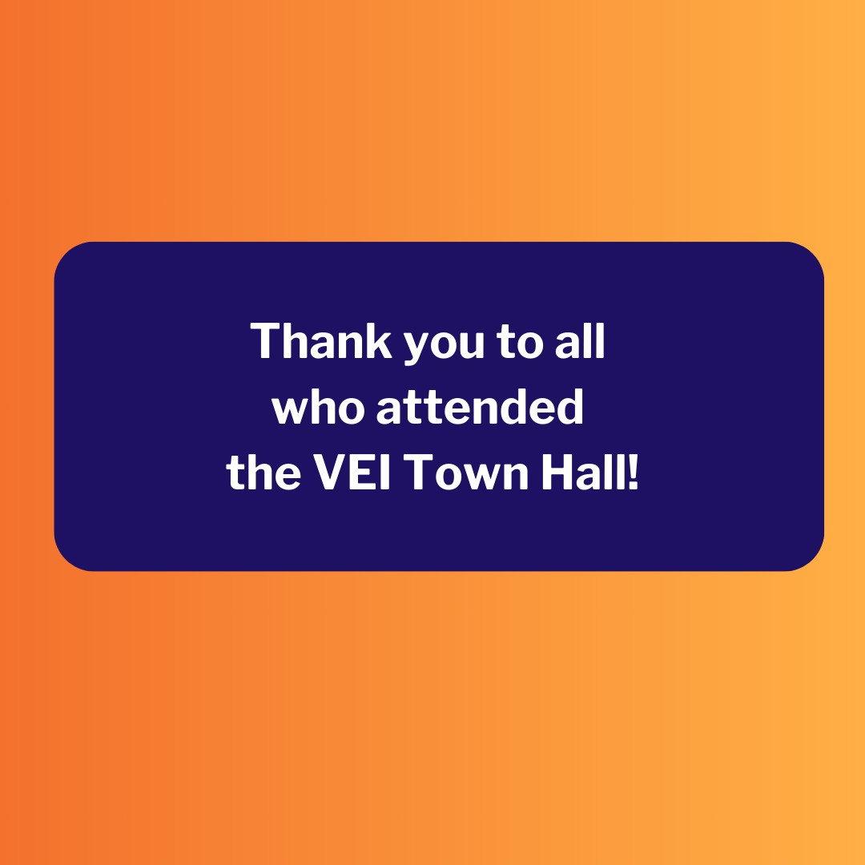
December 8, 2023
Here are the latest resources for promoting COVID-19 vaccination to share with your colleagues
and networks across Massachusetts. If you received this from a colleague, subscribe today.
View this email online.
What's New

THANK YOU TO THE 130+ ATTENDEES WHO JOINED VEI'S TOWN HALL!
Thank you to all who joined the VEI Town Hall on November 16!
Over 130 attendees tuned in to hear the latest about the updated COVID vaccine, statewide case and vaccination rates, and more.
Follow-up information from the meeting is ready for sharing, including:
Presentation slides
Answers to FAQs from the meeting Recordings of presentations (Commissioner remarks, current status of COVID-19, commercialization of the COVID-19 vaccine, options for community vaccination)

Have questions or feedback about the town hall? Email us!

COVID VAX PROMOTION TOOLKIT: NEW MATERIALS ADDED!
New materials have been added to VEI's Vaccine Promotion Toolkit!
These include:
COVID Vaccine: Fast Facts flyer in 12

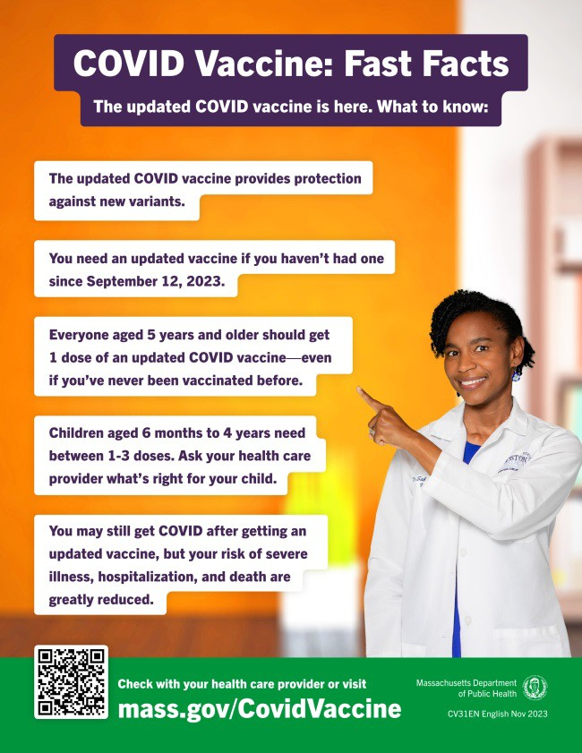
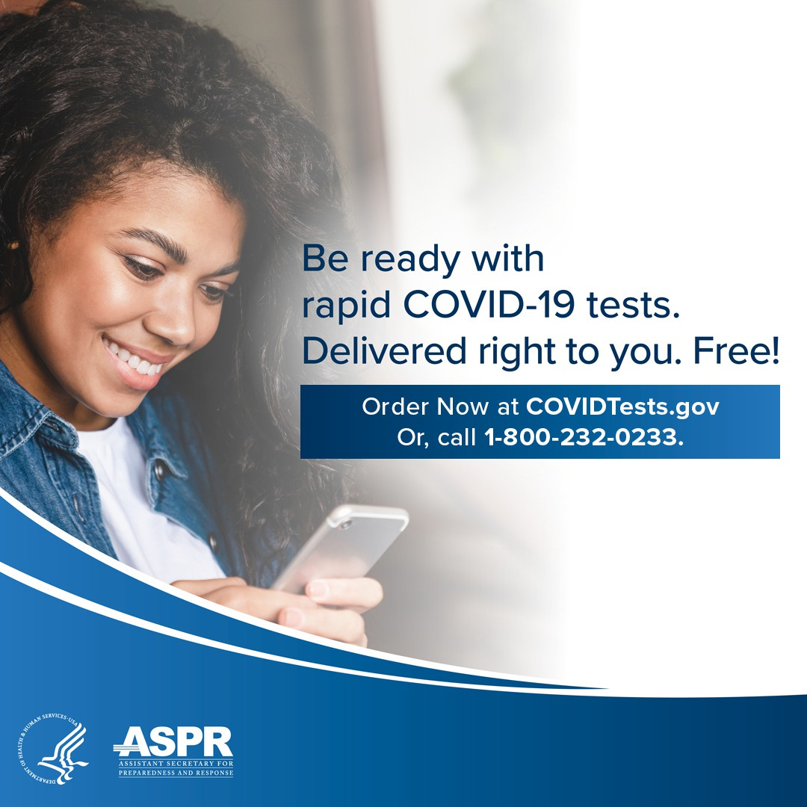
languages
Social media graphics and copy in 4 languages
Customizable clinic promotion flyers (in English and Spanish)
And more!
Don't see something you need? Email us and let us know!

ALL U.S. HOUSEHOLDS CAN ORDER FOUR MORE FREE COVID RAPID TESTS
As of November 20, every U.S. household can once again order four free COVID-19 rapid tests, and some may be eligible to receive eight tests. Tests will be delivered directly to recipients' homes.
To order tests, visit COVID.gov/Tests.
Accessible COVID test kits are also available for people who are blind or have low vision.
Don't forget: Many at-home COVID tests have had their expiration dates extended. Check updated expiration dates on the FDA's website.
Reminders

EMERGENCY ASSISTANCE UPDATE: FAQS ON SHELTER CAPACITY AND MORE
In late October, Emergency Assistance Director Lt. General Scott Rice gave an update on next steps for the state’s emergency family shelter system as it approaches its capacity limit.
Have questions about what this means?
This FAQ offers answers to questions

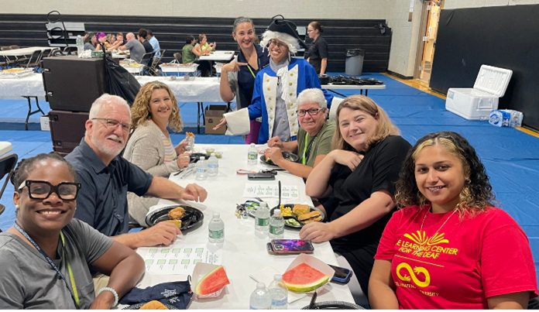
In October, The Learning Center for
the Deaf (TLC) engaged over 200 people through event booths and staff meetings (see photo). TLC addressed community concerns regarding compatibility of the updated COVID vaccine and flu vaccine, and they bolstered outreach efforts by distributing accessible materials in ASL, Spanish, and Portuguese. TLC also released a newsletter and a press release to keep the community informed about
TLC staff meeting event in October
Highlights
OUTREACH AND EDUCATION MATERIALS
COVID-19 Vaccine Information
COVID-19 Therapeutic Information (including telehealth) Archive of Weekly Provider Bulletins
Archive of COVID-19 Vaccine Communications Updates (past editions of VEI Roundup)
FIND A COVID-19 VACCINE DOSE
Use Vaccines.gov to sign up for a COVID-19 vaccine appointment Find a community COVID-19 vaccination clinic near you
Learn about the COVID-19 In-Home Vaccination Program and request a visit Request a copy of your vaccine card
about shelter capacity, waiting lists, the
right to shelter, and more.
Key Resources

ongoing COVID-19 educational
initiatives. The October newsletter
was viewed by over 100 people.

Read More Highlights

Visit the VEI Website
Share This Email
Share This Email
Share This Email

Vaccine Equity Initiative | 250 Washington Street, Boston, MA 02108 Unsubscribe vaccineequityinitiative@mass.gov
Constant Contact Data Notice
Sent by vaccineequityinitiative@mass.gov powered by

Try email marketing for free today!

