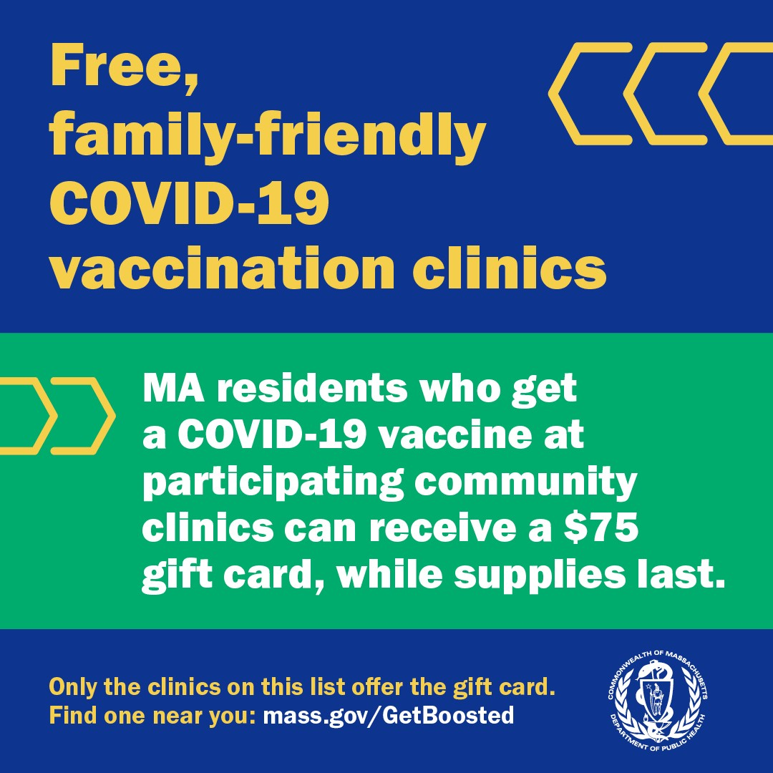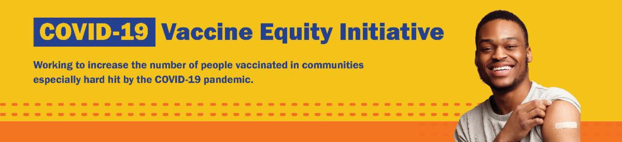
December 9, 2022
Here are the latest resources for promoting COVID-19 vaccination to share with your colleagues
and networks across Massachusetts. If you received this from a colleague, subscribe today.

View this email online.
A NOTE ON UPDATED COVID-19 BOOSTERS FOR CHILDREN 5 AND YOUNGER

The CDC is expected to approve updated COVID-19 boosters for children 6 months and older soon. After this happens, we’ll share resources about pediatric COVID-19 vaccines and boosters in the VEI Roundup.
What's New

'GET BOOSTED' CLINICS CONTINUE THROUGH THE END OF THE YEAR

Nearly 29,000 doses of COVID vaccine have been administered since the "Get Boosted" effort began this fall, with more than 90% booster doses. These successful clinics will continue through the end of the year.

Residents of all ages who get vaccinated (any dose) at participating clinics can receive a $75 gift card to local retailers, while supplies last. View a list of participating clinics at mass.gov/GetBoosted.

Help spread the word about these clinics! New social media graphics for Facebook and Instagram are now available. Find more in our vaccine promotion toolkit!

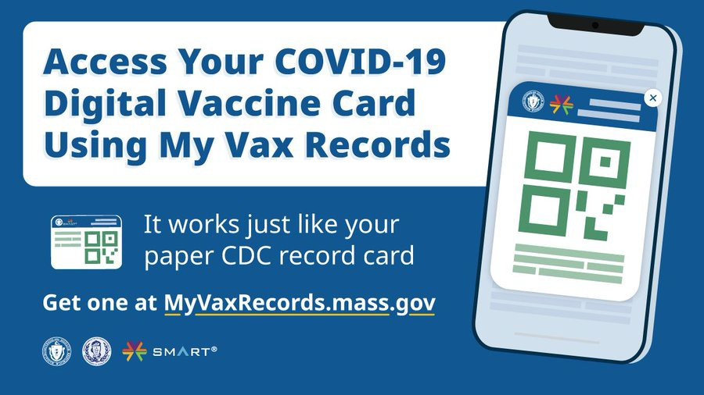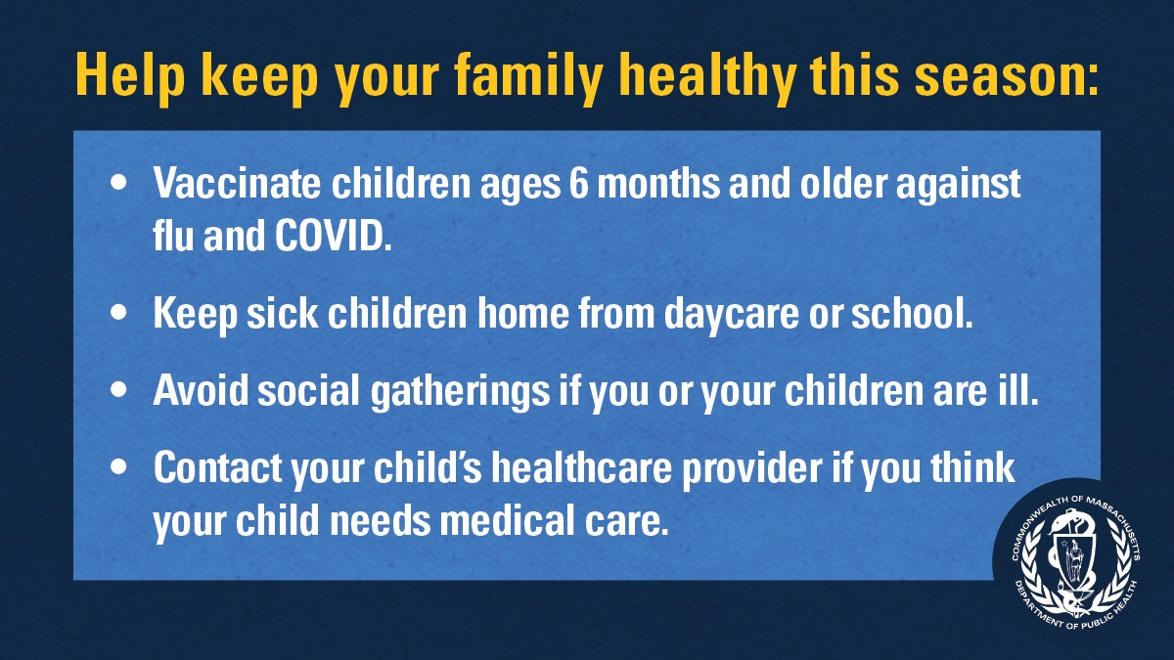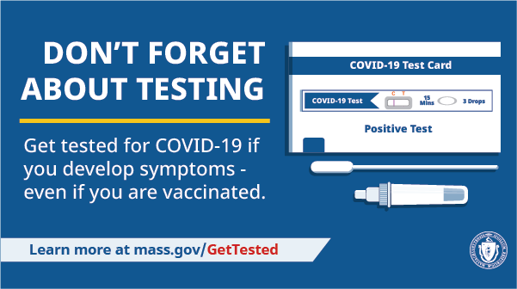
"Get Boosted" clinics have recently been featured in the media, including stories from
WWLP in Amherst and Western Mass News .
Reminders

DO YOU USE MY VAX RECORDS? IT'S A DIGITAL VACCINE CARD FOR MA RESIDENTS

Need a copy of your COVID-19 vaccination record? MA residents can use My Vax Records to get a digital vaccine card to show they’ve been vaccinated against COVID-19, if they choose. Learn more.

GET VACCINATED AGAINST THE FLU AND COVID-19

Rates of respiratory illness in infants and children are on the rise in Massachusetts and across much of the U.S. Keep your family healthy this season with these four steps. Learn more.

DON'T FORGET ABOUT TESTING

Testing is a critical tool in the fight against COVID-19. Get tested if you develop symptoms — even if you're vaccinated.
Visit mass.gov/GetTested.

FREE COVID TREATMENT AVAILABLE

Free, safe, and effective treatments for COVID-19 are available across MA. They can help prevent hospitalizations and reduce the risk of severe disease.
Telehealth consultations are now available

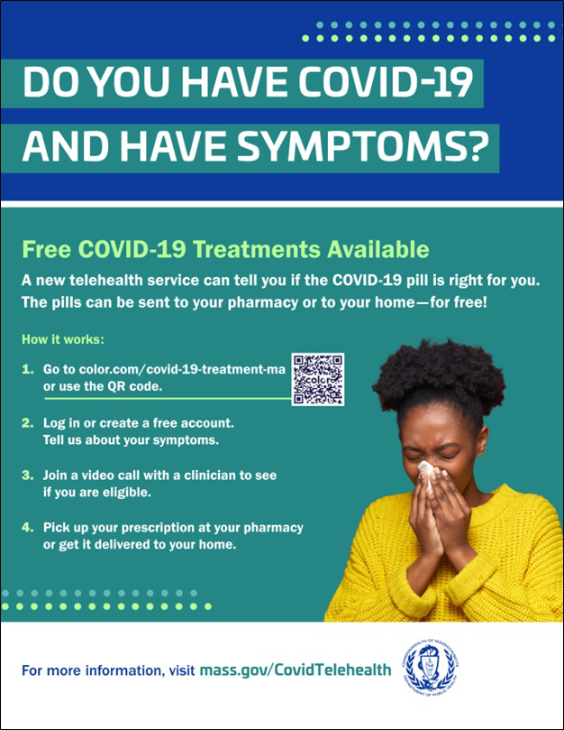
via phone, in addition to video, once you’ve requested a consultation online. Consultations can be accessed in 10+ languages.

Please use this customizable flyer to help share this information! Other flyers in additional languages are also available.

Please also share this video about free COVID treatments.
Key Resources

OUTREACH AND EDUCATION MATERIALS

COVID-19 Vaccine FAQs
COVID-19 Therapeutic Information (including telehealth) Weekly Provider Bulletin
Trust the Facts, Get the Vax Campaign Materials (organized by audience, including general, parents and pregnant people, youth, young adults; available in 12 languages) Multilingual COVID-19 Materials (videos and printables; organized by language) COVID-19 Funeral Assistance from FEMA (including one-pager with key info available in multiple languages)
COVID-19 Vaccination Tools for Employers
Archive of COVID-19 Vaccine Communications Updates (past editions of VEI Roundup)

FIND A COVID-19 VACCINE OR BOOSTER

Mass.gov/GetBoosted (family-friendly clinics through the end of 2022)
Vaccine Finder
Find, Schedule, or Sign Up for a Mobile COVID-19 Vaccination COVID-19 In-Home Vaccination Program
Request a Copy of Your Vaccine Card

Recent Highlights

Springfield

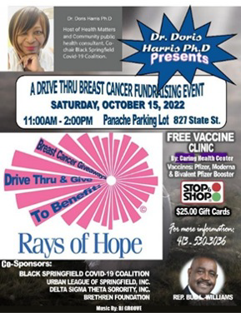In October, the Black Springfield COVID-19 Coalition hosted “Rays of Hope," a drive- through fundraising event for equipment, breast health programs, and outreach and education throughout Baystate Health (see flyer). The event also featured a mobile vaccine clinic, at which 45 people received COVID-19 vaccines.

Read More Highlights

Share This Email
Share This Email
Share This Email

Visit the VEI Website

Vaccine Equity Initiative | 250 Washington Street, Boston, MA 02108 Unsubscribe vaccineequityinitiative@mass.gov
Constant Contact Data Notice
Sent by vaccineequityinitiative@mass.gov in collaboration with
Try email marketing for free today!

