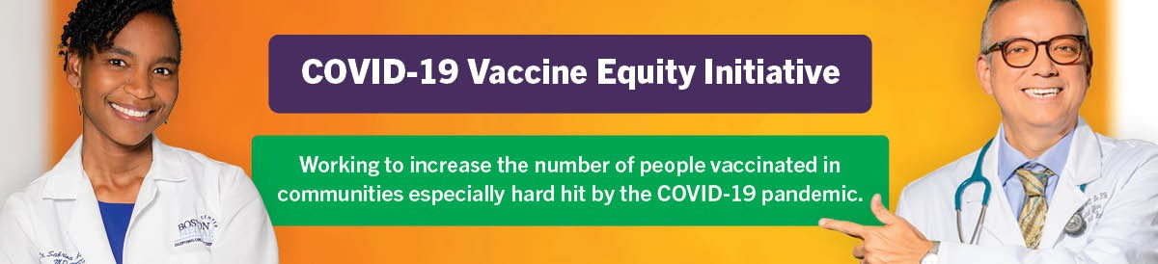
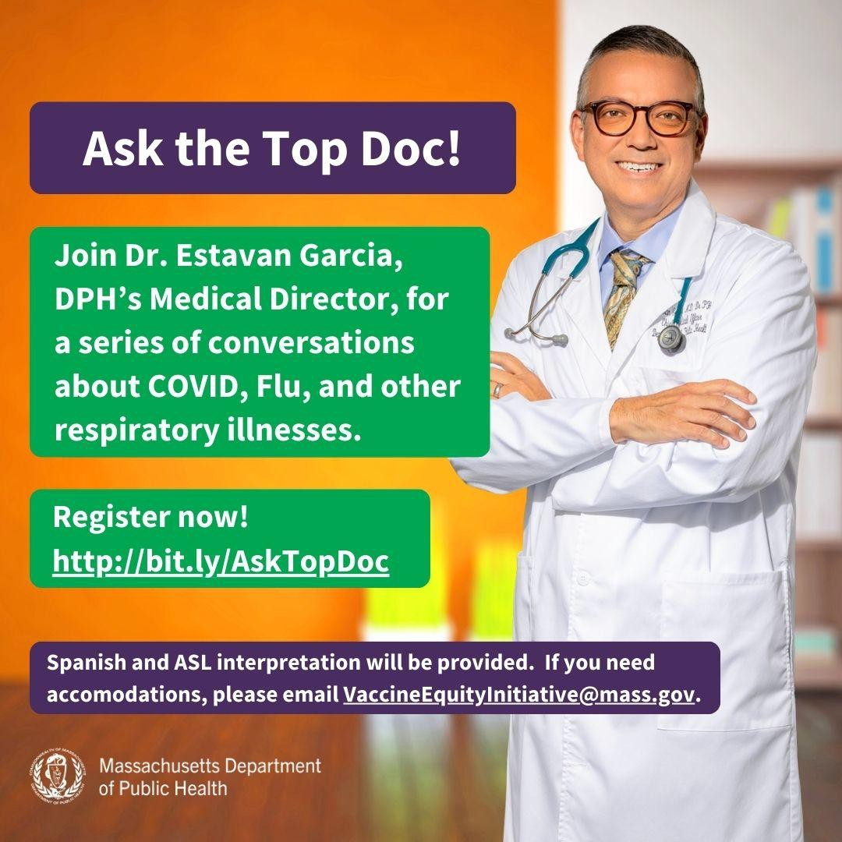
ASK THE TOP DOC: VEI WEBINAR SERIES STARTS JANUARY 17!
January 5, 2023
Here are the latest resources for promoting COVID-19 vaccination to share with your colleagues
and networks across Massachusetts. If you received this from a colleague, subscribe today.
View this email online.
What's New
VEI is hosting a series of webinars with Dr. Estevan Garcia, DPH’s Medical Director, on COVID and other respiratory illnesses.
January 17: Current data on respiratory illnesses in Massachusetts and an explanation of the basic science of Flu, COVID, RSV, and TB.
January 31: Long COVID: What we know and what we don’t.
February 21: To be determined based on feedback from community partners.

All webinars will be held from 1-2pm and will include Q&A sessions. Register now!

ASL and Spanish interpretation will be provided. Please email us if you need additional accommodations.
Reminders

KICK OFF 2024 BY SHARING MATERIALS FROM THE VAX PROMOTION TOOLKIT!
New materials have been added to VEI's

Vaccine Promotion Toolkit!

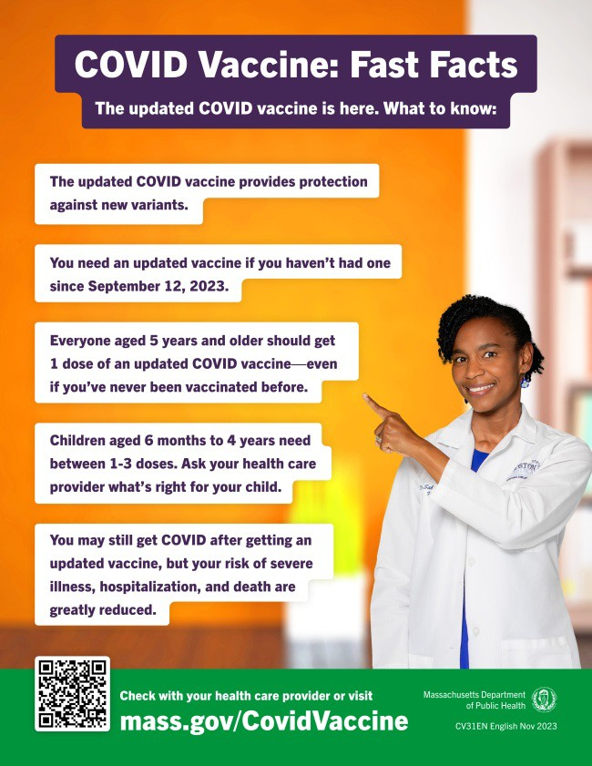
These include:
COVID Vaccine: Fast Facts flyer in 12 languages
Social media graphics and copy in 4 languages
Customizable clinic promotion flyers (in English and Spanish)
And more!
Don't see something you need? Email us and let us know!

FREE COVID TREATMENT AVAILABLE VIA PHONE OR ONLINE
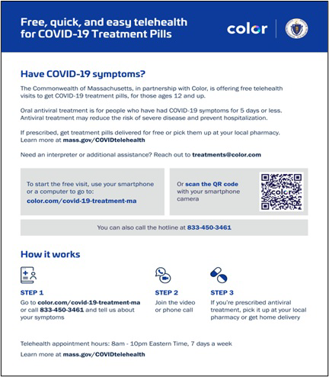
Free, safe, and effective treatments for COVID-19 are available across Massachusetts. They can help prevent hospitalizations and reduce the risk of severe disease.
Telehealth consultations are available via phone at 833-273-6330, in addition
to online. Consultations can be accessed in 10+ languages.
ASL interpretation and captioning (CART or automatic) services are available online or via 833-450-3461.
Please share: Flyers are available in multiple languages.

ALL U.S. HOUSEHOLDS CAN ORDER FOUR MORE FREE COVID RAPID TESTS
As of November 20, every U.S. household can once again order four free COVID-19 rapid tests, and some may be eligible to receive eight tests. Tests will be delivered directly to recipients' homes.
To order tests, visit COVID.gov/Tests.
Accessible COVID test kits are also available for people who are blind or have

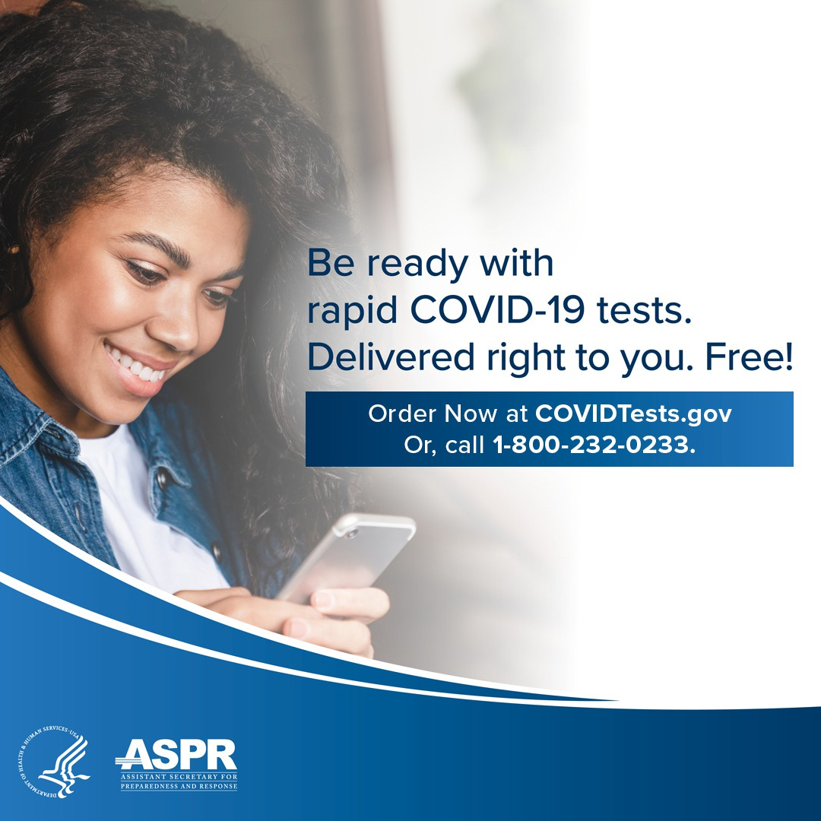
OUTREACH AND EDUCATION MATERIALS
COVID-19 Vaccine Information
COVID-19 Therapeutic Information (including telehealth) Archive of Weekly Provider Bulletins
Archive of COVID-19 Vaccine Communications Updates (past editions of VEI Roundup)
FIND A COVID-19 VACCINE DOSE
Use Vaccines.gov to sign up for a COVID-19 vaccine appointment Find a community COVID-19 vaccination clinic near you
Learn about the COVID-19 In-Home Vaccination Program and request a visit Request a copy of your vaccine card
Highlights
low vision.
Don't forget: Many at-home COVID tests have had their expiration dates extended. Check updated expiration dates on the FDA's website.
Key Resources

In October, Ohketeau Cultural Center hosted a Fall Harvest Health Fair in partnership with Native American Lifelines, UMass Amherst School of Public Health and Health Sciences, Mass General Brigham, Amherst Public Health, and DPH. The festival included free COVID vaccinations, fall foods and activities, and a free sweatshirt for anyone that received a vaccination.

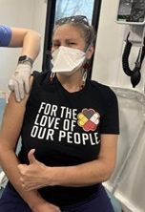

Read More Highlights

Visit the VEI Website
Share This Email
Share This Email
Share This Email

Vaccine Equity Initiative | 250 Washington Street, Boston, MA 02108 Unsubscribe vaccineequityinitiative@mass.gov
Constant Contact Data Notice
Sent by vaccineequityinitiative@mass.gov powered by

Try email marketing for free today!

