GET BOOSTED CLINICS EXTENDED THROUGH MARCH 2023!

The Get Boosted program has been extended through March 31, 2023, for all participating communities!

Over 40,000 doses of COVID vaccine have been administered since the Get Boosted effort began October 24.

Residents of all ages who get vaccinated (any dose) at participating clinics can receive a $75 gift card to local retailers, while supplies last. Find participating clinics at mass.gov/GetBoosted.

Help spread the word about these clinics on Facebook and Instagram, or by using a customizable flyer!

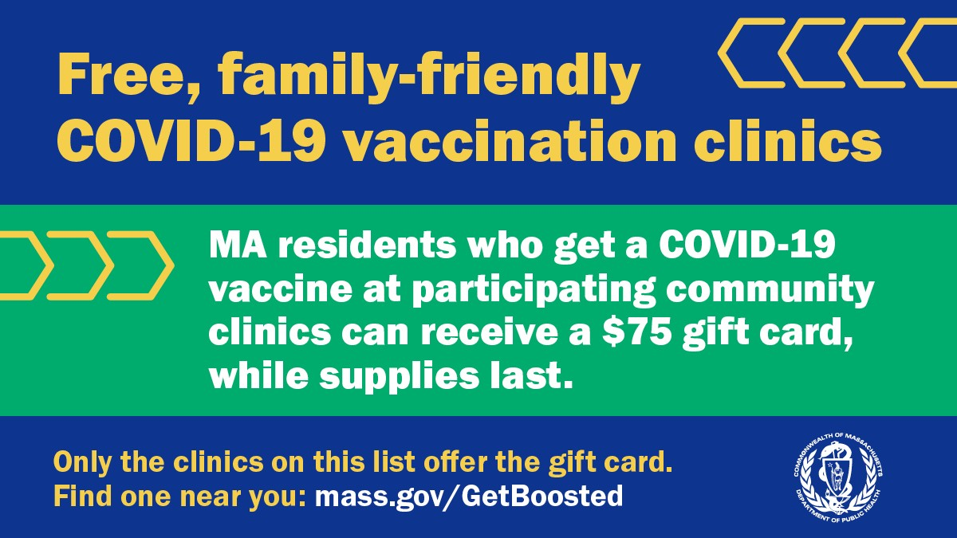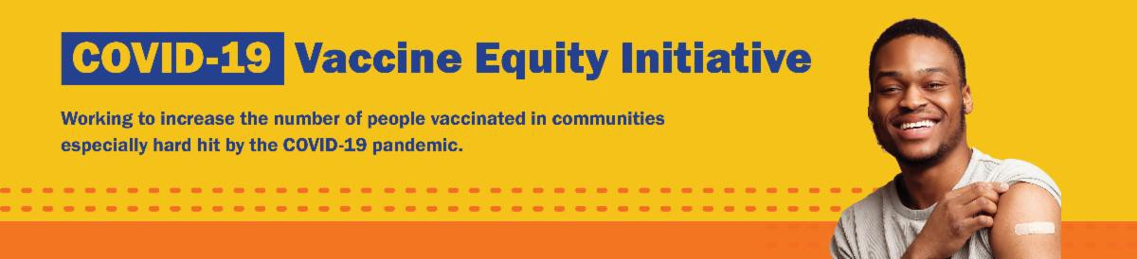
January 6, 2023
Here are the latest resources for promoting COVID-19 vaccination to share with your colleagues
and networks across Massachusetts. If you received this from a colleague, subscribe today.

View this email online.
What's New
If you have questions about Get Boosted clinics, please call 211 (or 877-211-6277) and press
1. Calls are answered Monday through Friday, from 9 a.m. to 5 p.m.
Get Boosted clinics were recently featured by the Sun Chronicle (Attleboro) and
WWLP Springfield.

FREE COVID TREATMENT — FLYERS NOW AVAILABLE IN 12 LANGUAGES

Free, safe, and effective treatments for COVID-19 are available across MA. They can help prevent hospitalizations and

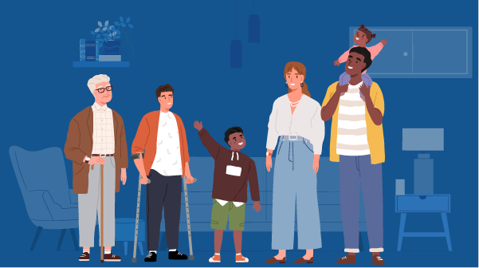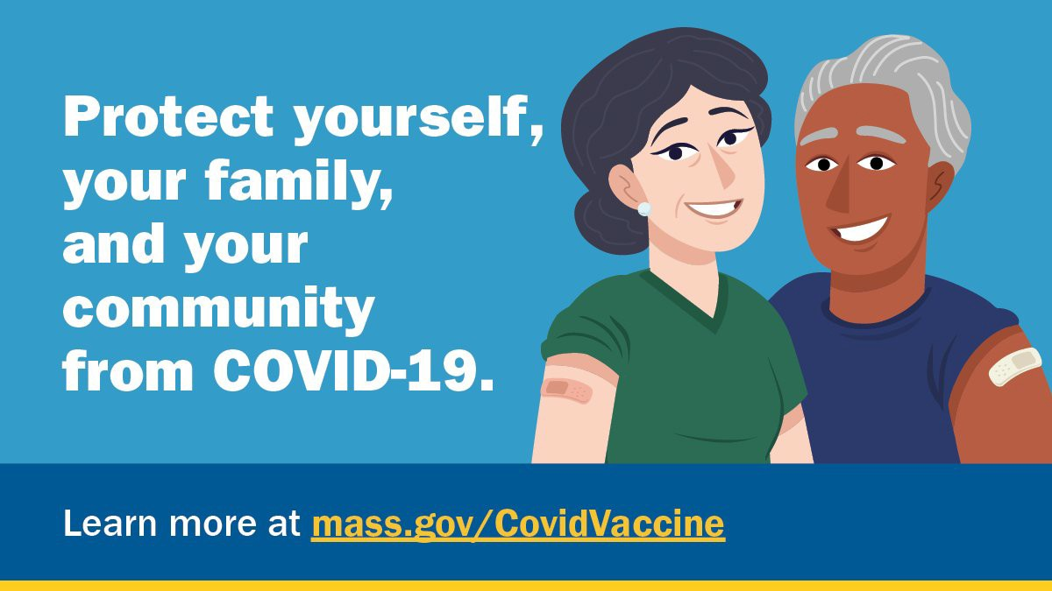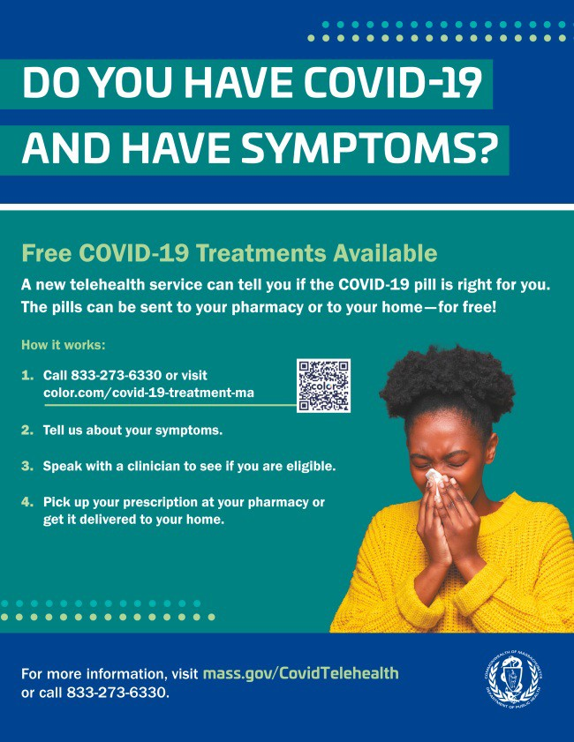
reduce the risk of severe disease.

Telehealth consultations are now available via phone, in addition to online.
Consultations can be accessed in 10+ languages.

Please share: Flyers are now available in 12 languages!
Reminders

FREE IN-HOME COVID-19 VACCINATION AVAILABLE

Massachusetts offers in-home COVID-19 vaccinations for anyone who has difficulty getting to or using a community clinic, including young children. Learn more, or call 833-983-0485 to sign up for an in- home appointment.

Help spread the word with
this informational flyer (in 12 languages)!

FOLLOW THESE SEVEN STEPS

There are a number of steps that you can take to help protect yourself, your family, and your community from COVID-19.

Available in multiple languages, this flyer features a checklist with these
steps. Please share it with your networks.

IN-HOME COVID-19 TREATMENT PROGRAM

In Massachusetts, treatments like Evusheld (to prevent COVID-19) and monoclonal antibody infusion (to prevent severe illness), can be administered at

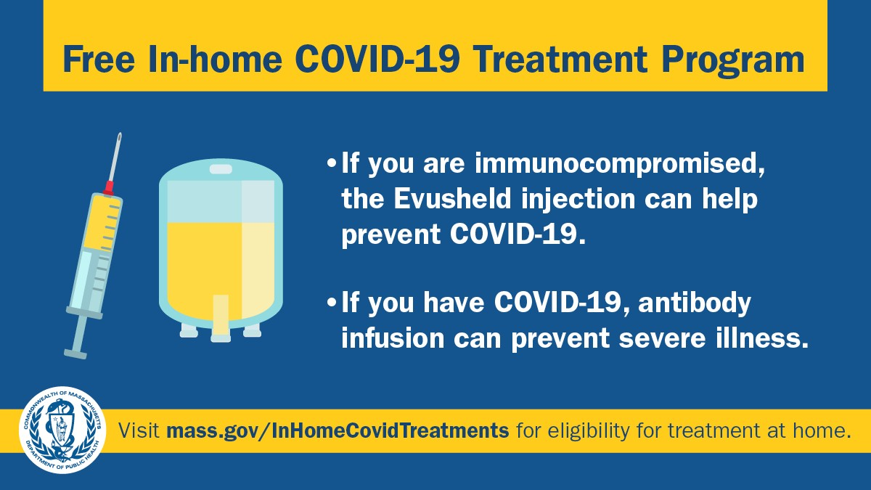

Springfield

Late last fall, the Springfield Boys and Girls Club partnered with MOCHA (Men of Color Health Awareness) to hold a COVID- 19 vaccine drive at the Boys and Girls Club, which served as a polling location on Election Day. The vaccine drive provided voters with vaccines and any vaccine- related information they requested. In total, 28 vaccines were given, with gift cards provided by MA DPH.
Recent Highlights
home. Check to see if you are eligible.
Key Resources

OUTREACH AND EDUCATION MATERIALS

COVID-19 Vaccine FAQs
COVID-19 Therapeutic Information (including telehealth) Weekly Provider Bulletin
Trust the Facts, Get the Vax Campaign Materials (organized by audience, including general, parents and pregnant people, youth, young adults; available in 12 languages) Multilingual COVID-19 Materials (videos and printables; organized by language) COVID-19 Funeral Assistance from FEMA (including one-pager with key info available in multiple languages)
COVID-19 Vaccination Tools for Employers
Archive of COVID-19 Vaccine Communications Updates (past editions of VEI Roundup)

FIND A COVID-19 VACCINE OR BOOSTER

Mass.gov/GetBoosted (family-friendly clinics through March 2023)
Vaccine Finder
Find, Schedule, or Sign Up for a Mobile COVID-19 Vaccination COVID-19 In-Home Vaccination Program
Request a Copy of Your Vaccine Card

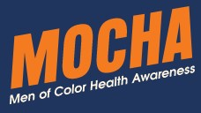

Read More Highlights

Visit the VEI Website

Share This Email
Share This Email
Share This Email

Vaccine Equity Initiative | 250 Washington Street, Boston, MA 02108

Unsubscribe vaccineequityinitiative@mass.gov Constant Contact Data Notice
Sent by vaccineequityinitiative@mass.gov in collaboration with
Try email marketing for free today!

