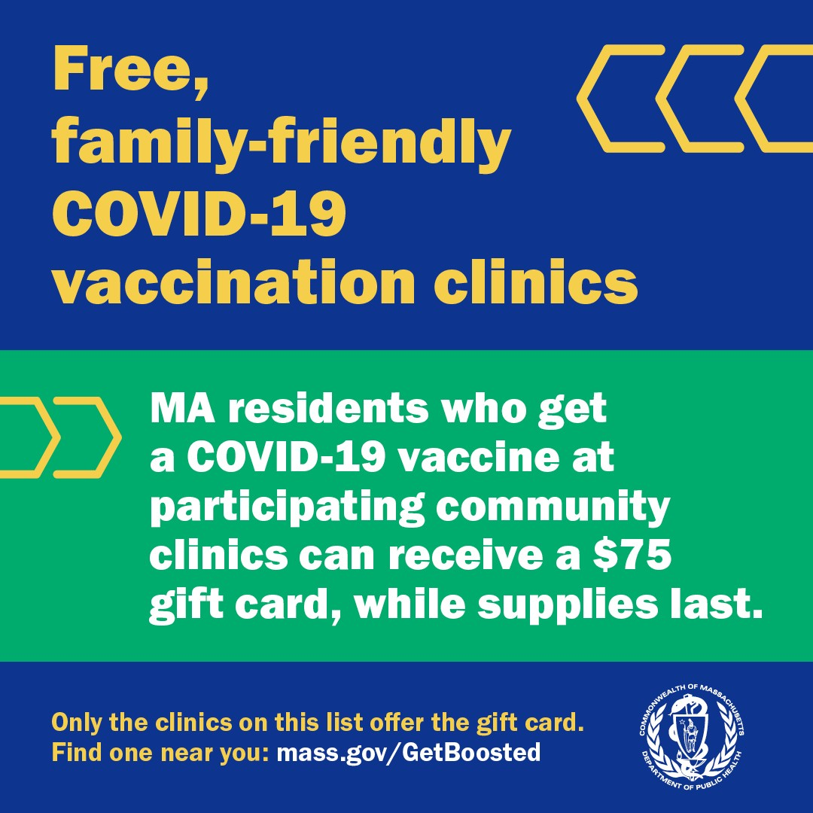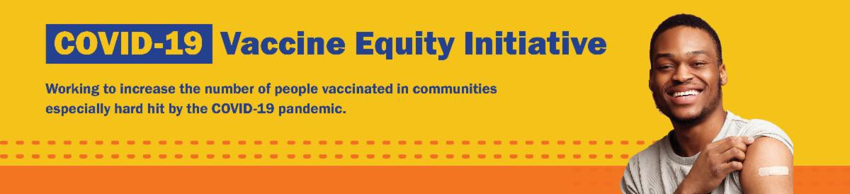
GET BOOSTED CLINICS CONTINUE THROUGH MARCH 31!

The Get Boosted program has been extended through March 31, 2023, for all participating communities!

Over 61,000 doses of COVID vaccine have been administered since the Get Boosted effort began October 24.

Residents of all ages who get vaccinated (any dose) at participating clinics can receive a $75 gift card to local retailers, while supplies last. Find participating clinics at mass.gov/GetBoosted.
If you have questions about Get
Boosted clinics, please call 2-1-1 (or 877-211-6277) and press 1. Calls are answered Monday through Friday, from 9 a.m. to 5 p.m.
Get Boosted clinics were recently featured in
the Haverhill Gazette and the Attleboro Sun Chronicle.
Help spread the word: Get Boosted clinics will be held during the upcoming February school vacation week! Flyers, email templates, and more resources are available in multiple languages in our toolkit.
February 10, 2023
Here are the latest resources for promoting COVID-19 vaccination to share with your colleagues
and networks across Massachusetts. If you received this from a colleague, subscribe today.

View this email online.
What's New

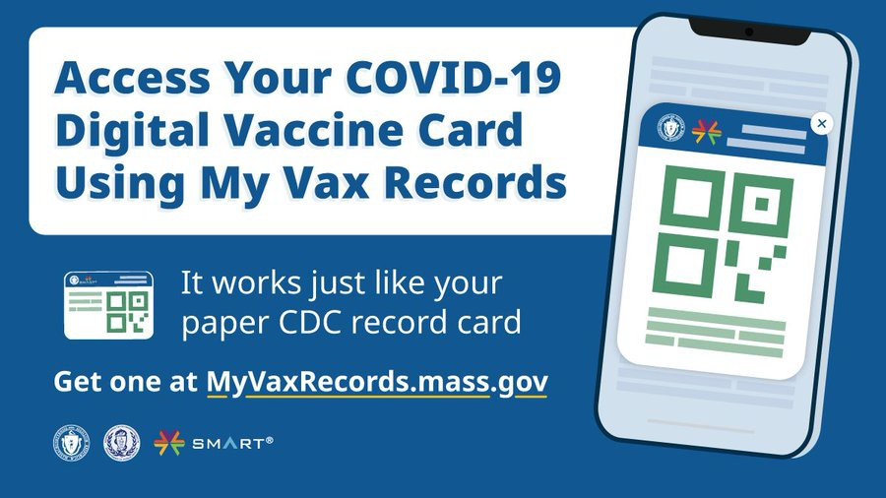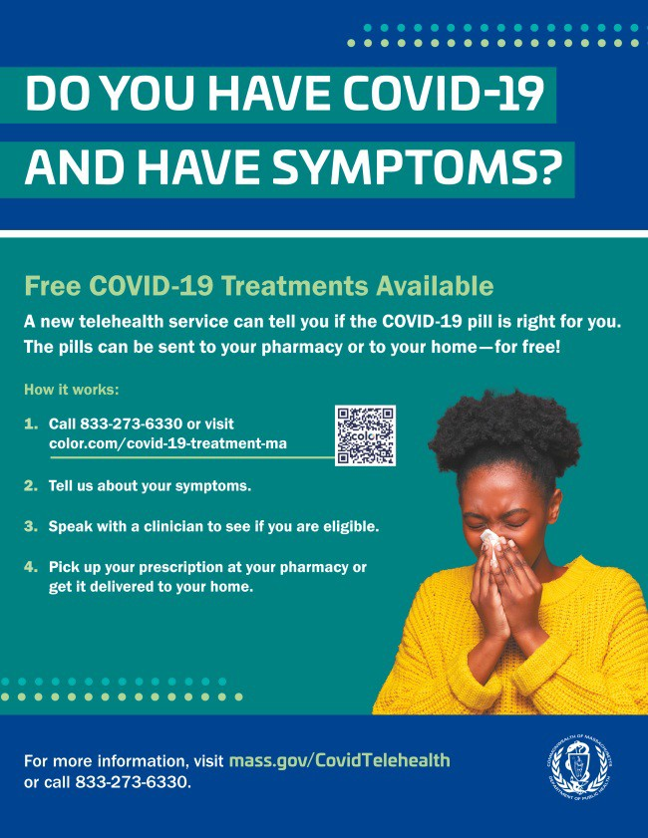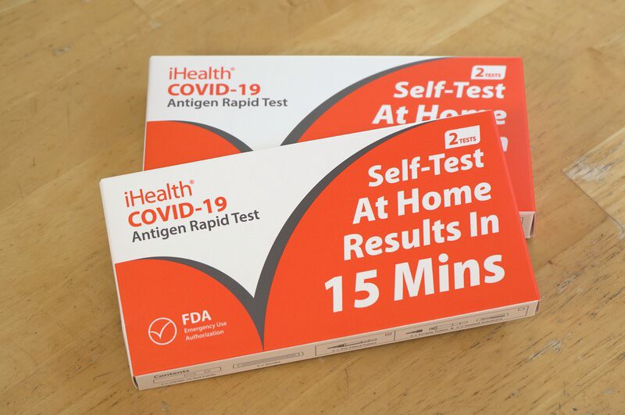
iHEALTH COVID-19 RAPID TESTS RECEIVE EXTENDED EXPIRATION DATE

The FDA recently extended the expiration date of iHealth COVID-19 Rapid Tests to 15 months after their manufacture date (three more months than was previously granted). Learn more about updated expiration dates.
Reminders

DO YOU USE MY VAX RECORDS? IT'S A DIGITAL VACCINE CARD FOR MASSACHUSETTS RESIDENTS

Need a copy of your COVID-19 vaccination record? Massachusetts residents can use My Vax Records to get a digital vaccine card to show they’ve been vaccinated against COVID-19, if they choose. Learn more.

FREE COVID TREATMENT AVAILABLE VIA PHONE OR ONLINE

Free, safe, and effective treatments for COVID-19 are available across Massachusetts. They can help prevent hospitalizations and reduce the risk of severe disease.

Telehealth consultations are now available via phone, in addition to online.
Consultations can be accessed in 10+ languages.

Please share: Flyers are now available in 12 languages!

FREE COVID-19 TESTS AVAILABLE FOR A LIMITED TIME!

Community organizations can order free at-home rapid antigen COVID-19 tests, while supplies last.

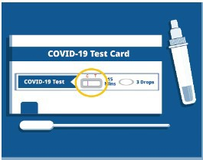
Organizations that are interested in
ordering supplies must complete this short form: bit.ly/COVIDTestRequestMA.

Please note: You may need to copy and paste the link into your browser.
Key Resources

OUTREACH AND EDUCATION MATERIALS

COVID-19 Vaccine FAQs
COVID-19 Therapeutic Information (including telehealth) Weekly Provider Bulletin
Trust the Facts, Get the Vax Campaign Materials (organized by audience, including general, parents and pregnant people, youth, young adults; available in 12 languages) Multilingual COVID-19 Materials (videos and printables; organized by language) COVID-19 Funeral Assistance from FEMA (including one-pager with key info available in multiple languages)
COVID-19 Vaccination Tools for Employers
Archive of COVID-19 Vaccine Communications Updates (past editions of VEI Roundup)

FIND A COVID-19 VACCINE OR BOOSTER

Mass.gov/GetBoosted (family-friendly clinics through March 2023)
Vaccine Finder
Find, Schedule, or Sign Up for a Mobile COVID-19 Vaccination COVID-19 In-Home Vaccination Program
Request a Copy of Your Vaccine Card

Recent Highlights

Boston

The South Asian Workers' Center hosted several well-being sessions in late 2022, including two in November and a holiday celebration in December (see photo). At each event, they shared information about how community members could protect themselves from COVID-19, flu, and RSV,

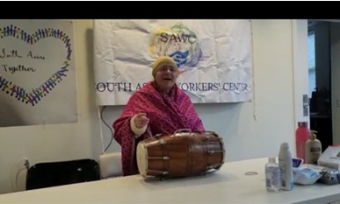
including getting vaccinated at Get
Boosted vaccine clinics. At the holiday event, every member took a pledge to talk to at least 10 families in their network about the Get Boosted clinics.

Read More Highlights

Visit the VEI Website

Share This Email
Share This Email
Share This Email

Vaccine Equity Initiative | 250 Washington Street, Boston, MA 02108 Unsubscribe vaccineequityinitiative@mass.gov
Constant Contact Data Notice
Sent by vaccineequityinitiative@mass.gov in collaboration with
Try email marketing for free today!

