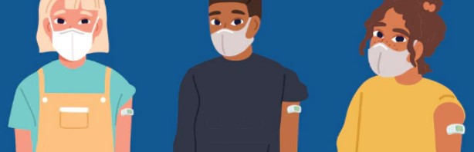
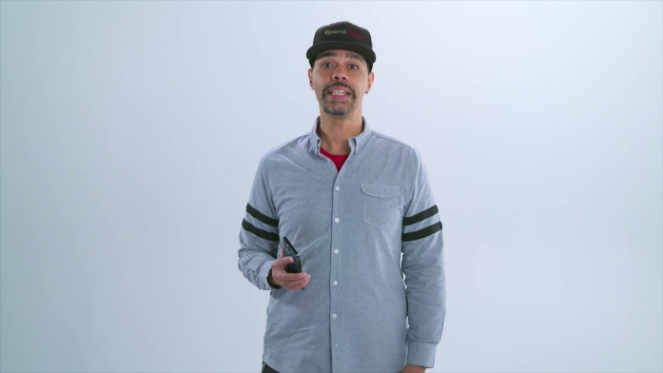
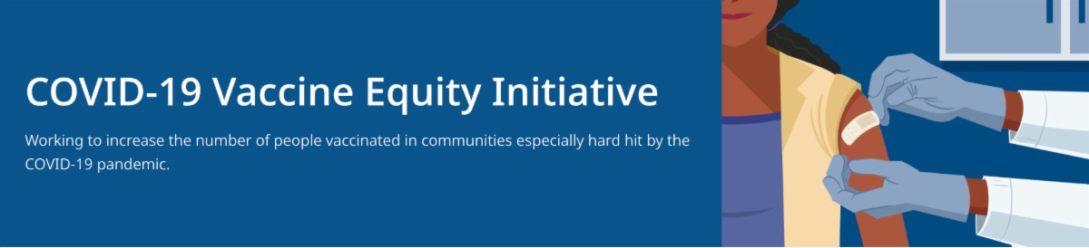
February 11, 2022
This newsletter is your central source for COVID-19 vaccination updates. Materials are publicly
available and clickable for easy sharing. Others may subscribe by clicking here.
What's New

SCHOOL VACATION WEEK (FEBRUARY 20-26) VACCINATION CLINICS

DPH is providing COVID-19 vaccination clinics in several communities during school vacation week, Feb. 20–26, 2022.
Families are welcome! $25 gift cards available while supplies last. View the schedule.

ENABLE MASSNOTIFY ON YOUR SMARTPHONE - NEW VIDEO FROM JAVA JIMMY AND REV. DR. WHITE-HAMMOND

More than 2 million MA residents now use MassNotify. Share the video with radio personality Java Jimmy and faith leader Rev. Dr. White-Hammond about this phone app that alerts users who may have been exposed to COVID-19. Enable MassNotify on your smartphone.
Learn more: mass.gov/MassNotify.

Above: James Hills (Java Jimmy) explains how easy it is to enable MassNotify.

MY COVID-19 VACCINE STORY - NEW VIDEOS FROM COMMUNITY INFLUENCERS

New My Vaccine Story videos

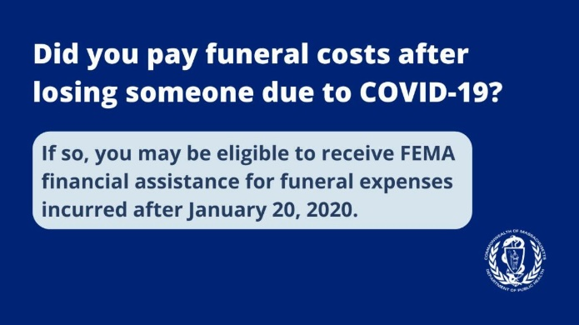
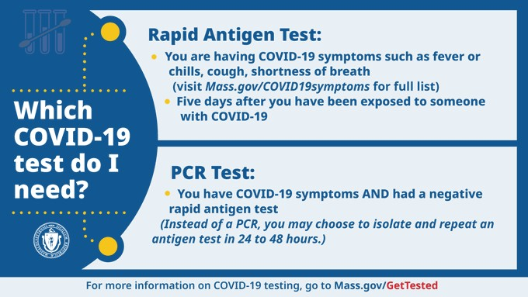
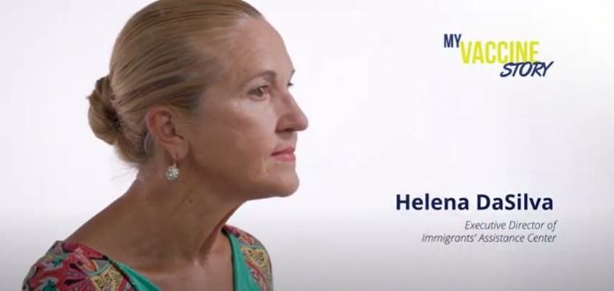
feature community influencers
speaking about their decisions to receive the COVID-19 vaccine. Many videos are available in multiple languages. View the full playlist on the DPH YouTube Channel.
Above: Helena DaSilva shares her vaccine story.
Reminders

EMPLOYERS: WAYS TO INCREASE COVID-19 VACCINATION AMONG EMPLOYEES

COVID-19 Vaccination Tools for Employers (includes info on hosting a free mobile clinic, helping employees locate a vaccine, offering paid sick leave for vaccination, and more)

COVID-19 FUNERAL ASSISTANCE AVAILABLE

If you or someone you know lost a loved one to COVID-19, you may be eligible for financial assistance or reimbursement for funeral expenses from FEMA. More information is available in multiple languages.

CHOOSE THE RIGHT COVID-19 TEST FOR YOU

There are various types of COVID- 19 tests available. New posted guidance outlines which test might be right for you. Learn more about the types of COVID- 19 tests available.

FIND A BOOSTER APPOINTMENT NEAR YOU

Boosters are available at state- managed locations in Boston, Barnstable, Brockton, Danvers, Lynn, Lowell, Springfield, and Taunton – plus hundreds of other locations in MA. Find your appointment or walk-in location.

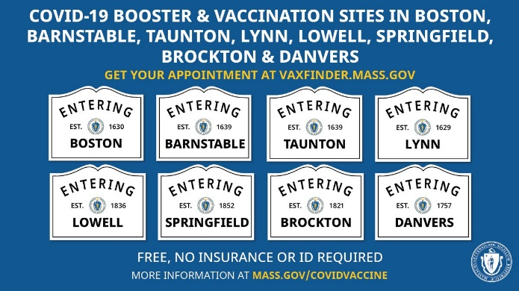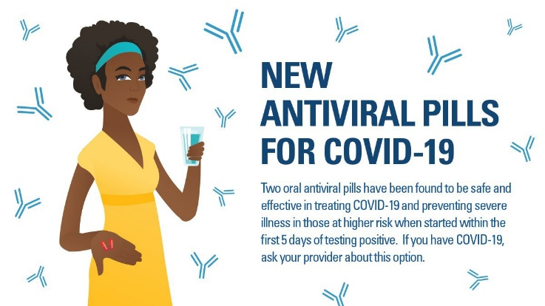

THERAPEUTIC TREATMENTS FOR COVID-19

If you test positive for COVID-19, have risk factors and any symptoms, you may want to pursue new therapeutic treatments which can keep you from getting severely ill. They're safe, effective, and free – no insurance needed. Learn more.
Key Resources

OUTREACH AND EDUCATION MATERIALS

COVID-19 Vaccine FAQs COVID-19 Booster FAQs
Weekly Provider Bulletin (published Feb. 9; includes ordering info for the Pfizer under 5) Trust the Facts, Get the Vax Campaign Materials (organized by audience, including general, parents and pregnant people, youth, young adults; available in 12 languages)
Trust the Facts, Get the Vax Creative Materials Toolkit (updates ongoing, including pediatric eligibility)
Additional Education and Outreach Materials (includes social media graphics, vaccine updates, guides to hosting a forum, and more)
Multilingual COVID-19 Materials (videos and some printables)
DPH Vaccine Ambassador Program (request a DPH employee to attend community meetings to share info about the vaccine)
COVID-19 Funeral Assistance from FEMA (including 1-pager with key info available in multiple languages)

FIND A COVID-19 VACCINE OR BOOSTER

Vaccine Finder
Find, Schedule, or Sign Up for a Mobile COVID-19 Vaccination COVID-19 In-Home Vaccination Program
Request a Copy of Your Vaccine Card

Recent Highlights

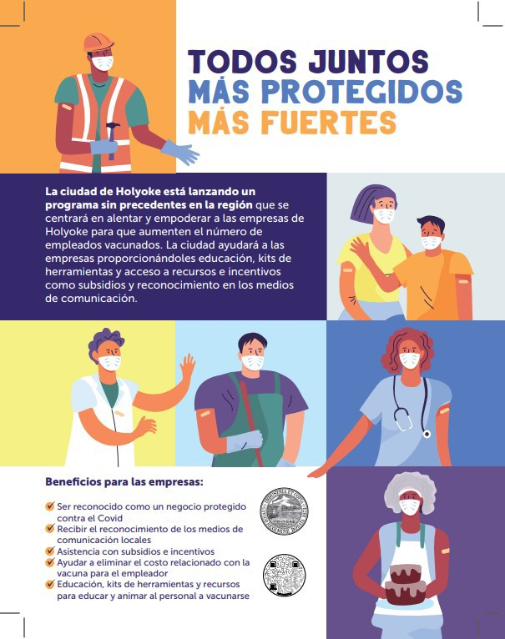
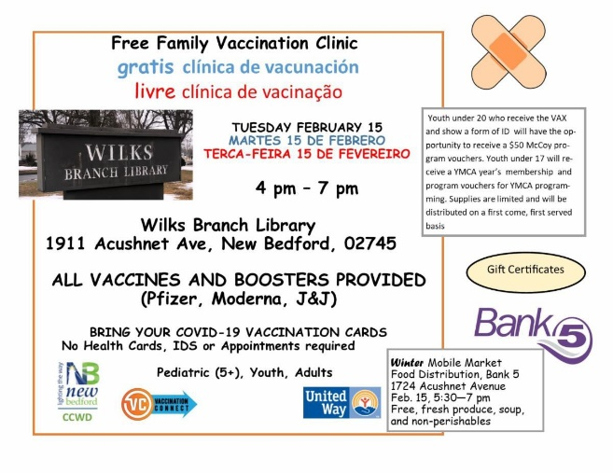

Holyoke:

The City of Holyoke is launching a new 6- week program to encourage Holyoke businesses to increase the number of vaccinated employees. The city will assist businesses by providing education, toolkits, and access to resources and incentives such as grants and media recognition.

More than 200 businesses have been contacted. All outreach and education materials are bilingual (see flyer, right).

New Bedford:

On Feb. 15, New Bedford will be hosting a vaccine clinic at a new location, the Wilks Branch Library. The City will offer incentives for youth, such as YMCA memberships and program vouchers, and outreach will be done at a nearby mobile food market (see flyer, right).

Read More Highlights

Visit the VEI Website

Share This Email
Share This Email
Share This Email

Vaccine Equity Initiative | 250 Washington Street, Boston, MA 02108 Unsubscribe vaccineequityinitiative@mass.gov
About Constant Contact

