
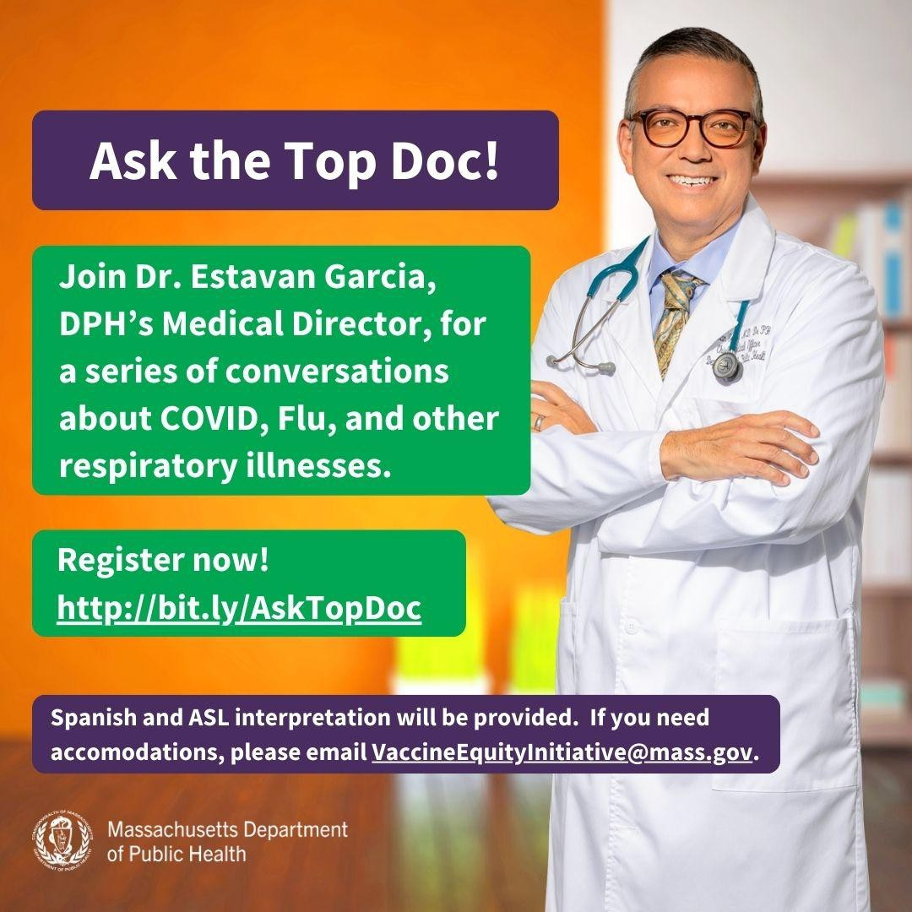
February 16, 2024
Here are the latest resources for promoting COVID-19 vaccination to share with your colleagues
and networks across Massachusetts. If you received this from a colleague, subscribe today.X
View this email online.X
What's New

ASK THE TOP DOC: JOIN VEI FOR THE NEXT WEBINAR ON FEBRUARY 21!
VEI is hosting a series of webinars with Dr. Estevan Garcia, DPH’s Medical Director, on COVID and other respiratory illnesses.
The final webinar will be held on February 21, 1-2 p.m. Register now!
The topic will be decided based on feedback from community partners.
ASL, Haitian Creole, Portuguese, and Spanish interpretation will be provided. Please email us if you need additional accommodations.

Help spread the word! The webinar invitation is available in English, Haitian Creole, Portuguese, and Spanish.

RESOURCES FROM PREVIOUS TOP DOC WEBINARS NOW AVAILABLE!
Slides, recordings, and other resources from the first two Ask the Top Doc webinars are now available!
This includes:
Compilation of all Q&As
Webinar on respiratory illnesses:

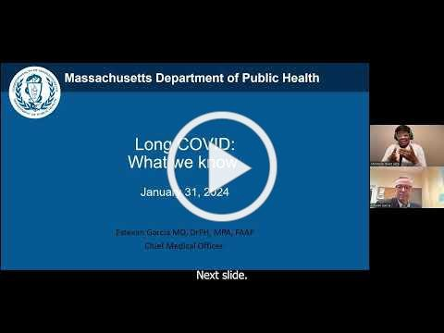
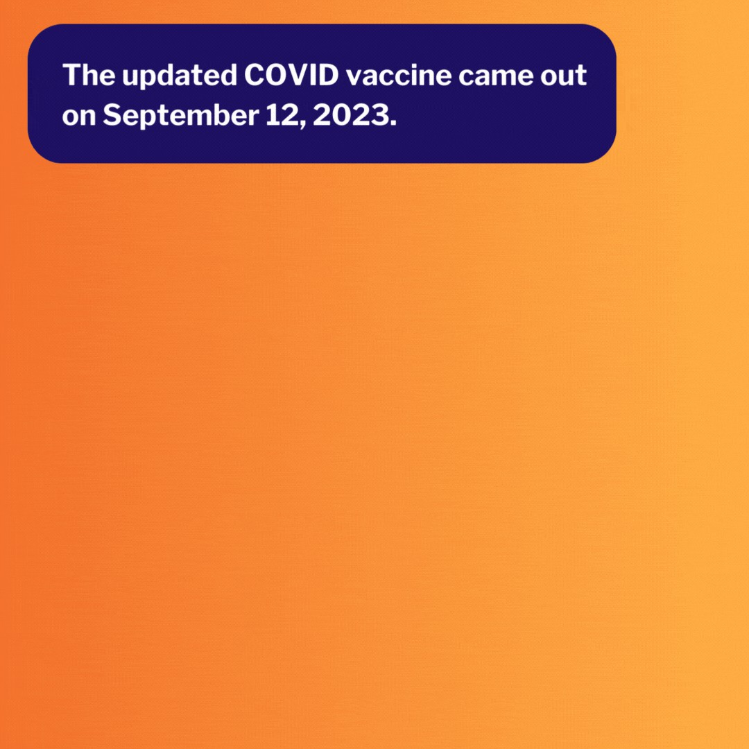

Presentation slidesX
Presentation recordingX
Webinar on long COVID:
Presentation slides Presentation recordingX
Presentation recordings are currently available in English/ASL; other languages will be
available soon!
Reminders

DON'T FORGET: VAX PROMOTION TOOLKIT OFFERS FREE MATERIALS
Free materials to promote COVID-19 vaccine education and clinics are available in VEI's Vaccine Promotion Toolkit!
These include:
COVID Vaccine: Fast Facts flyer in 12 languages
Social media graphics and copy in 4 languages
Customizable clinic promotion flyers (in English and Spanish)
And more!
Don't see something you need? Email us and let us know!

IN-HOME COVID-19 VACCINATION AVAILABLE
Respiratory illness season is not over just yet! Having trouble making it to a clinic or pharmacy?
In-home COVID-19 vaccination is available for anyone who has difficulty getting to or using a community clinic, including children.
Learn more, or call (833) 983-0485 to sign up for an appointment.

This info is also available in ASL (thanks to The Learning Center for the Deaf!).
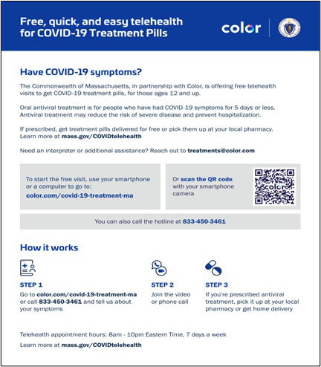
OUTREACH AND EDUCATION MATERIALS
COVID-19 Vaccine InformationX
COVID-19 Therapeutic Information (including telehealth)X
Archive of COVID-19 Vaccine Communications Updates (past editions of VEI Roundup)X
FIND A COVID-19 VACCINE DOSE
Use Vaccines.gov to sign up for a COVID-19 vaccine appointment Find a community COVID-19 vaccination clinic near youX
Learn about the COVID-19 In-Home Vaccination Program and request a visit Request a copy of your vaccine cardX
Highlights
Key Resources
FREE COVID TREATMENT AVAILABLE VIA PHONE OR ONLINE
Free, safe, and effective treatments for COVID-19 are available across Massachusetts. They can help prevent hospitalizations and reduce the risk of severe disease.X
Telehealth consultations are available via phone at 833-273-6330, in addition
to online. Consultations can be accessed in 10+ languages.X
ASL interpretation and captioning (CART or automatic) services are available online or via (833) 450-3461.
Please share: Flyers are available in multiple languages.X

On December 19, ACEDONE hosted a health clinic in Roxbury in partnership with Equity Now and Beyond, an immigrant health equity cohort (see photos). The health clinic provided a variety of services and resources, including COVID-19 vaccinations and test kits, blood pressure screenings, health insurance enrollment assistance, and immigration support. In



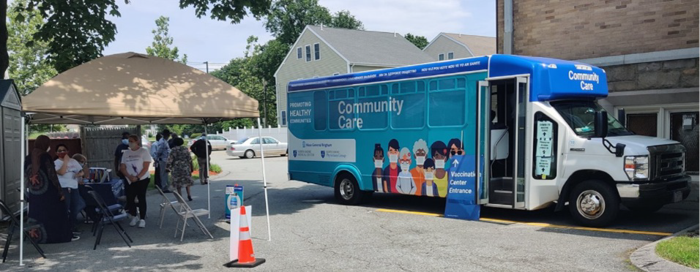

total, 16 people were vaccinated. This
approach is a key part of ACEDONE's continuous effort to provide vital health services to the community by providing multiple services in one clinic.

Read More HighlightsX

Visit the VEI WebsiteX
Share This EmailX
Share This EmailX
Share This EmailX

Vaccine Equity Initiative | 250 Washington Street, Boston, MA 02108 Unsubscribe vaccineequityinitiative@mass.gov
Constant Contact Data Notice
Sent by vei@vaccineequityinitiative.ccsend.com powered by



Try email marketing for free today!

