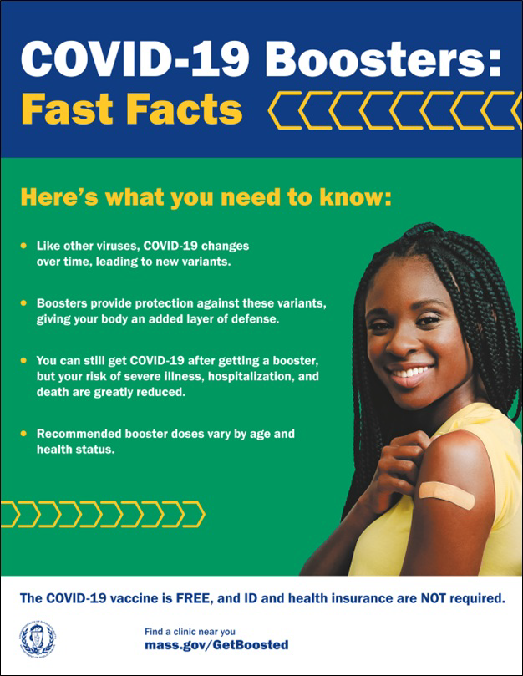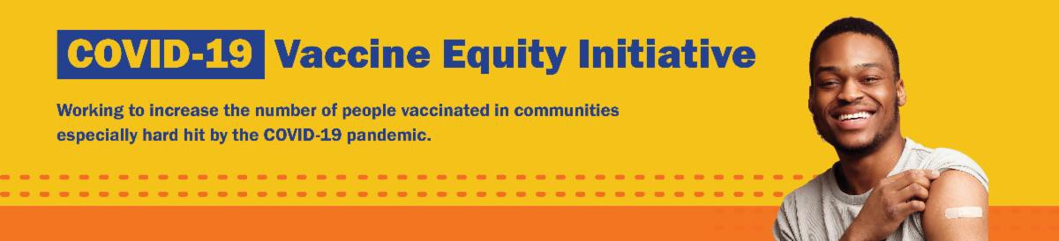
GET YOUR UPDATED COVID-19 BOOSTER OR VAX DURING FEBRUARY SCHOOL VACATION WEEK — AND A $75 GIFT CARD!

Now is the time! Protect your whole family with free COVID-19 vaccines and updated boosters, available at Get Boosted clinics happening during February School Vacation Week.

Residents of all ages who get vaccinated (any dose) at participating clinics can receive a $75 gift card, while supplies last. Find participating clinics
at mass.gov/GetBoosted.

If you have questions about Get Boosted clinics, please call 2-1-1 (or 877-211-6277) and press 1. Calls are answered Monday through Friday, from 9 a.m. to 5 p.m.

Help spread the word: Flyers, email templates, and more resources are available in multiple languages in our vacation week toolkit.
February Vacation Week clinics were recently featured by CBS Boston, the Eagle- Tribune, Framingham SOURCE, and Worcester Patch.
February 17, 2023
Here are the latest resources for promoting COVID-19 vaccination to share with your colleagues
and networks across Massachusetts. If you received this from a colleague, subscribe today.

View this email online.
What's New

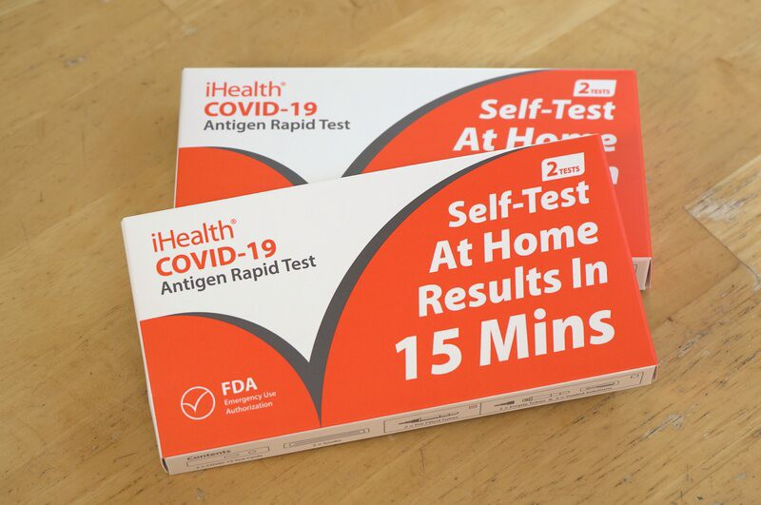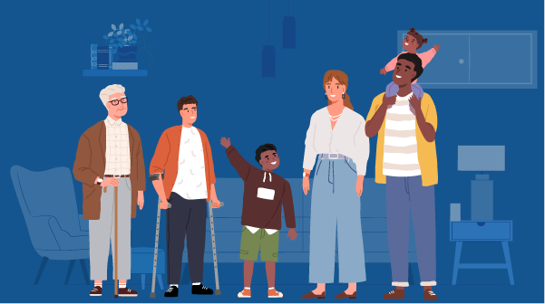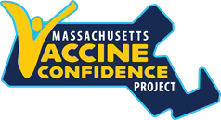

NOW LIVE: MASSACHUSETTS VACCINE CONFIDENCE PROJECT WEBSITE

The Massachusetts Vaccine Confidence Project aims to support vaccine confidence and ensure that all residents are fully protected against serious, vaccine- preventable disease. Find more information about the project, including resources and trainings, on their new website.
Reminders

iHEALTH COVID-19 RAPID TESTS RECEIVE EXTENDED EXPIRATION DATE

The FDA recently extended the expiration date of iHealth COVID-19 Rapid Tests to 15 months after their manufacture date (three more months than was previously granted). Learn more about updated expiration dates.

FREE IN-HOME COVID-19 VACCINATION AVAILABLE

Massachusetts offers in-home COVID-19 vaccinations for anyone who has difficulty getting to or using a community clinic, including young children. Learn more, or call 833-983-0485 to sign up for an in- home appointment.

Help spread the word with
this informational flyer (in 12 languages)!

FREE COVID-19 TESTS AVAILABLE FOR A LIMITED TIME!

Community organizations can order free at-home rapid antigen COVID-19 tests, while supplies last.

Organizations that are interested in ordering supplies must complete this short form: bit.ly/COVIDTestRequestMA.

Please note: You may need to copy and paste the link into your browser.

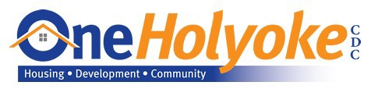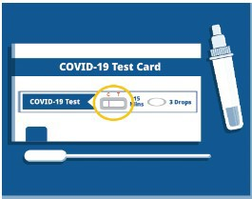

Holyoke

In November, OneHolyoke hosted three focus groups with parents in the Holyoke area. One essential theme that emerged was parents’ concern for their children’s mental and behavioral health due to COVID. OneHolyoke is addressing this concern by hosting several long-COVID
Recent Highlights
Key Resources

OUTREACH AND EDUCATION MATERIALS

COVID-19 Vaccine FAQs
COVID-19 Therapeutic Information (including telehealth) Weekly Provider Bulletin
Trust the Facts, Get the Vax Campaign Materials (organized by audience, including general, parents and pregnant people, youth, young adults; available in 12 languages) Multilingual COVID-19 Materials (videos and printables; organized by language) COVID-19 Funeral Assistance from FEMA (including one-pager with key info available in multiple languages)
COVID-19 Vaccination Tools for Employers
Archive of COVID-19 Vaccine Communications Updates (past editions of VEI Roundup)

FIND A COVID-19 VACCINE OR BOOSTER

Mass.gov/GetBoosted (family-friendly clinics through March 2023)
Vaccine Finder
Find, Schedule, or Sign Up for a Mobile COVID-19 Vaccination COVID-19 In-Home Vaccination Program
Request a Copy of Your Vaccine Card

support groups, including health care
professionals who offer information and resources to parents and residents about children’s health needs.

Read More Highlights

Visit the VEI Website

Share This Email
Share This Email
Share This Email

Vaccine Equity Initiative | 250 Washington Street, Boston, MA 02108

Unsubscribe vaccineequityinitiative@mass.gov Constant Contact Data Notice
Sent by vaccineequityinitiative@mass.gov in collaboration with
Try email marketing for free today!

