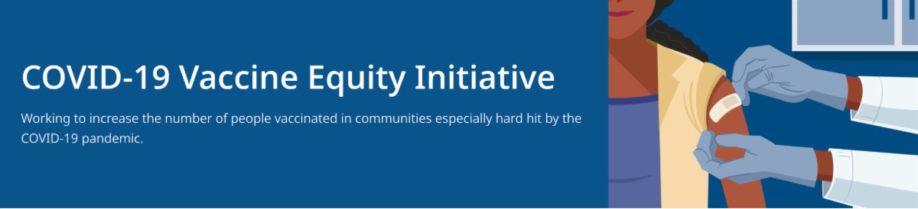
February 18, 2022
This newsletter is your central source for COVID-19 vaccination updates. Materials are publicly
available and clickable for easy sharing. Others may subscribe by clicking here.
What's New

NEW TREATMENT OPTIONS FOR COVID-19

Patients recently diagnosed with COVID-19 have treatment options – monoclonal antibodies and oral antivirals – which can prevent hospitalization and severe illness.
They're available at no cost to the patient, no insurance needed, at sites across MA. Listen to Dr. Estevan Garcia (Chief Medical Officer at MA DPH) describe new treatments for COVID.

More info available at mass.gov/CovidTreatments and on this flyer.

Above: Dr. Garcia describes new treatments for COVID-19, including the COVID pill.

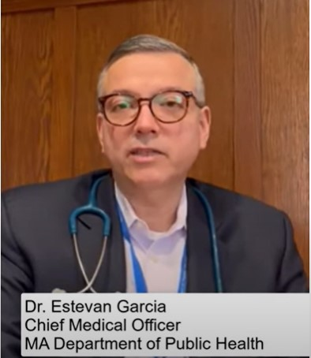

STRATEGIES TO ADDRESS VACCINE ACCEPTANCE THROUGH LOCAL PTAS

Highlights from National PTA's virtual roundtable discussion with Surgeon General Dr. Vivek Murthy. Includes practical strategies and resources to help overcome vaccine hesitancy.
Read more.

DR. SABRINA ASSOUMOU FEATURED IN PANEL ON RACE AND COVID-19 VACCINATION FROM NBC BOSTON

Dr. Sabrina Assoumou (Boston Medical

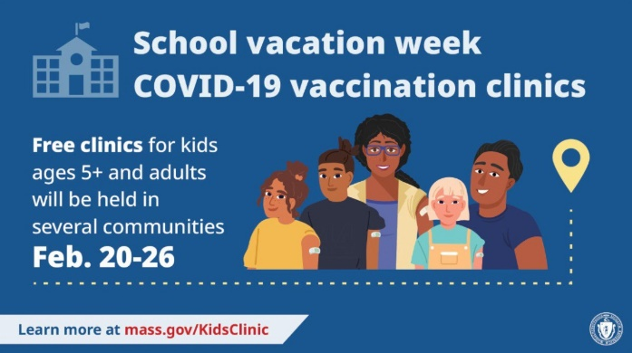
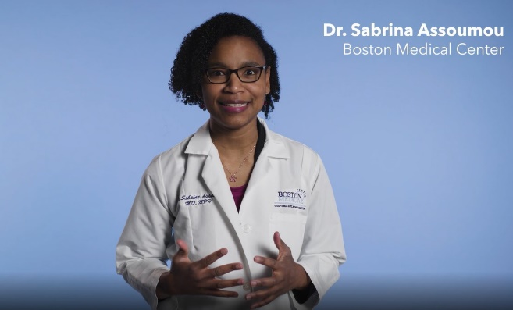
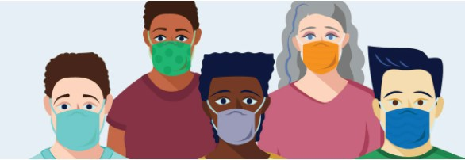
Center), featured in our Trust the
SCHOOL VACATION WEEK (FEBRUARY 20-26) VACCINATION CLINICS

DPH is providing COVID-19 vaccination clinics in several communities during school vacation week, Feb. 20–26, 2022. Families are welcome! $25 gift cards available while supplies last. View the schedule.
MULTILINGUAL VACCINE RESOURCES FROM DPH

Resources to support COVID-19 vaccine promotion and education,
Reminders
Facts. Get the Vax. campaign video, recently participated in an NBC Boston panel on closing the racial gap in COVID-19 vaccination. Watch the discussion here.

Above: Dr. Assoumou discusses COVID-19 vaccine safety and efficacy.

LEARNING OPPORTUNITY: CRUSH COVID COMMUNITY OF PRACTICE

DPH, the Department of Elementary and Secondary Education (DESE), and Pinnacle Partnerships are offering an opportunity for school and community leaders to come together monthly to learn from one another and navigate challenges related to vaccine equity and more. Learn more here.

UPDATED FACE COVERING ADVISORY FROM MA DPH

News Release (2/15) - Massachusetts Department of Public Health Releases Updated Face Covering Advisory

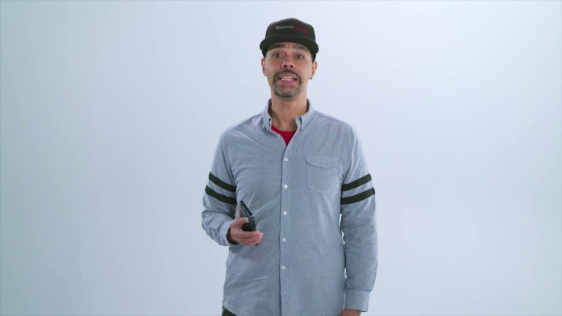
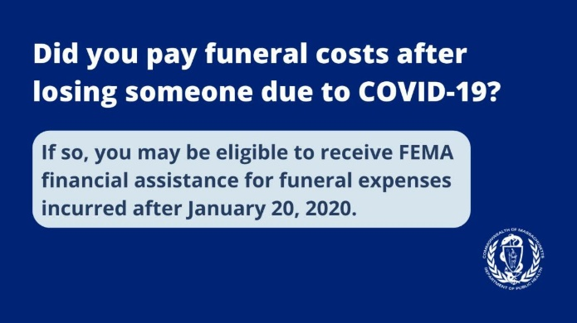
organized by language. Includes
OUTREACH AND EDUCATION MATERIALS

COVID-19 Vaccine FAQs COVID-19 Booster FAQs
Weekly Provider Bulletin (published Feb. 16)
Trust the Facts, Get the Vax Campaign Materials (organized by audience, including general, parents and pregnant people, youth, young adults; available in 12 languages)
Trust the Facts, Get the Vax Creative Materials Toolkit (updates ongoing, including pediatric eligibility)
Additional Education and Outreach Materials (includes social media graphics, vaccine updates, guides to hosting a forum, and more)
DPH Vaccine Ambassador Program (request a DPH employee to attend community meetings to share info about the vaccine)
COVID-19 Funeral Assistance from FEMA (including 1-pager with key info available in multiple languages)
Key Resources
videos and printables on topics like vaccine safety, pregnancy and the vaccine, and FAQs.

ENABLE MASSNOTIFY ON YOUR SMARTPHONE - NEW VIDEO FROM JAVA JIMMY AND REV. DR. WHITE-HAMMOND

More than 2 million MA residents now use MassNotify. Share the video with radio personality Java Jimmy and faith leader Rev. Dr. White-Hammond about this phone app that alerts users who may have been exposed to COVID-19. Enable MassNotify on your smartphone.
Learn more: mass.gov/MassNotify.

Above: James Hills (Java Jimmy) explains how easy it is to enable MassNotify.

COVID-19 FUNERAL ASSISTANCE AVAILABLE

If you or someone you know lost a loved one to COVID-19, you may be eligible for financial assistance or reimbursement for funeral expenses from FEMA. More information is available in multiple languages.

COVID-19 Vaccination Tools for Employers
FIND A COVID-19 VACCINE OR BOOSTER

Vaccine Finder
Find, Schedule, or Sign Up for a Mobile COVID-19 Vaccination COVID-19 In-Home Vaccination Program
Request a Copy of Your Vaccine Card
COVID-19 VACCINE STANDING ORDERS (FROM CDC)

Pfizer
5-11 (updated 2/7/22)
12 + Gray Cap (updated 1/12/22)
12 + Purple Cap (updated 1/12/22)
Moderna (updated 2/15/22)
Janssen (updated 2/15/22)
Recent Highlights

Leominster:

Leominster's monthly COVID-19 vaccination clinics at the Spanish American Center were prominently featured in a story by the Sentinel & Enterprise. The Center hosts clinics on the last Wednesday of the month, with the next clinic on Feb. 23. The Center also provides vaccine education and promotion, and a virtual townhall was held last month. Read the full article here.

Randolph:

In Randolph, the clinics coordinator and charge nurse and her team have been partnering with the public schools to distribute test kits and flyers with info about upcoming vaccine clinics. The clinics team has also set up "Public Health tables" at day cares, high school basketball games, banks, the local library, and more. At the tables, staff offer free testing kits, provide information on the COVID vaccine and answer any questions that people have.

Read More Highlights

Visit the VEI Website

Share This Email
Share This Email
Share This Email

Vaccine Equity Initiative | 250 Washington Street, Boston, MA 02108

