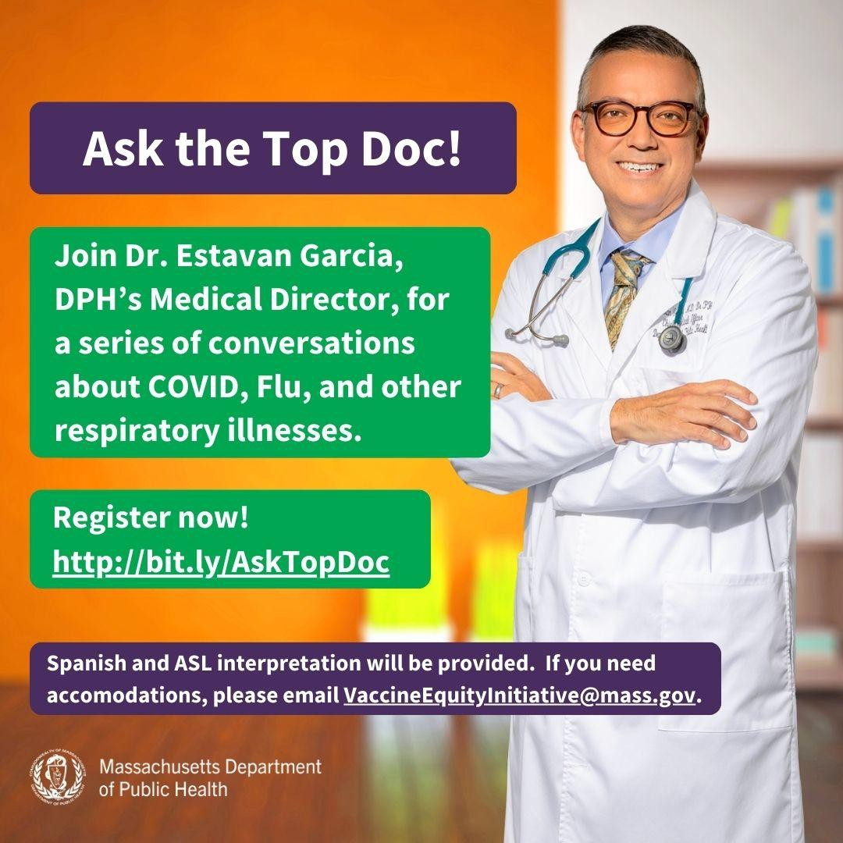
ASK THE TOP DOC: JOIN VEI FOR THE NEXT WEBINAR ON FEBRUARY 21!
February 2, 2024
Here are the latest resources for promoting COVID-19 vaccination to share with your colleagues
and networks across Massachusetts. If you received this from a colleague, subscribe today.
View this email online.
What's New
VEI is hosting a series of webinars with Dr. Estevan Garcia, DPH’s Medical Director, on COVID and other respiratory illnesses.
The final webinar will be held on February 21 from 1-2 p.m. Register now!
The topic will be decided based on feedback from community partners. Have a COVID-related topic you'd like to see addressed? Let us know!
ASL, Haitian Creole, Portuguese, and Spanish interpretation will be provided. Please email us if you need additional accommodations.

Help spread the word! The webinar invitation is available in English, Haitian Creole, Portuguese, and Spanish.
Reminders

IT'S STILL RESPIRATORY ILLNESS SEASON: HELP PROTECT YOURSELF AND OTHERS
Respiratory illness season is not over just yet! Getting the updated COVID-19 vaccine is just one way that you can help protect

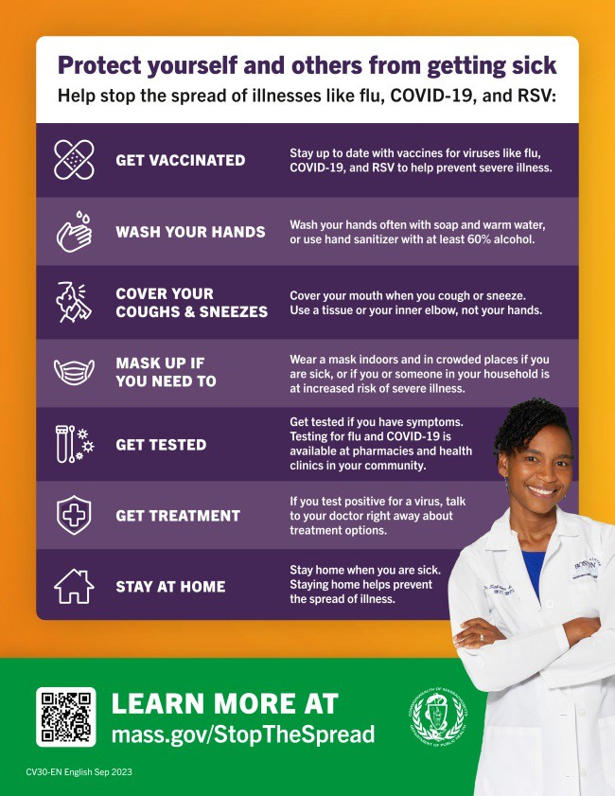
yourself and others from getting sick
during this time.
This flyer offers a checklist of ways to help stop the spread of COVID, flu, and RSV. It's available in 13 languages !
Have questions about the COVID, flu, or RSV vaccines? Need to find a vaccine? Visit mass.gov/StopTheSpread.

NEED AN UPDATED COVID-19 VACCINE? HERE'S HOW TO FIND ONE
Free COVID-19 vaccine clinics are still being held throughout Massachusetts!
To find COVID-19 vaccination opportunities, you can:
Search vaccines.gov for appointments
Find a local mobile clinic near you Learn more about in-home

vaccination
If you have questions, please call 211 or (877)-211-6277 and press 1. Calls are answered Monday through Friday, 9 a.m. to 5 p.m.

FREE COVID TESTS AVAILABLE TO ALL U.S. HOUSEHOLDS
All U.S. household can order four free COVID-19 rapid tests, and some may be eligible to receive eight tests. Tests will be delivered directly to recipients' homes.
To order tests, visit COVID.gov/Tests.
Accessible COVID test kits are also available for people who are blind or have low vision.

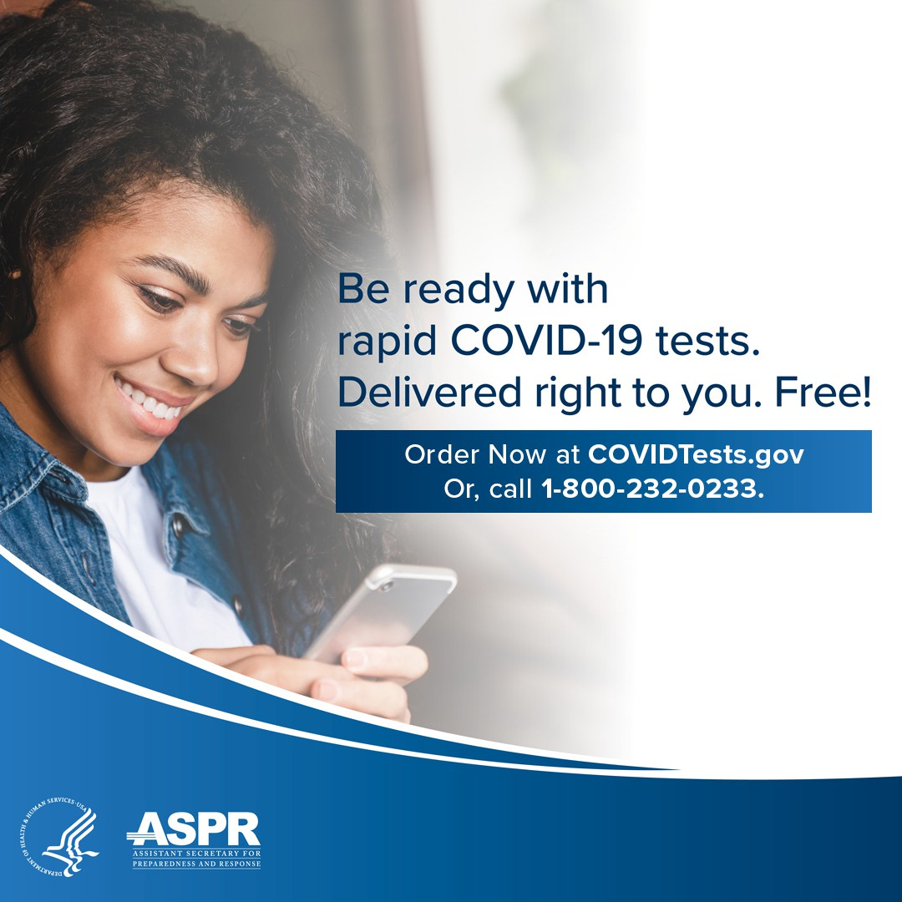
OUTREACH AND EDUCATION MATERIALS
COVID-19 Vaccine Information
COVID-19 Therapeutic Information (including telehealth) Archive of Weekly Provider Bulletins
Archive of COVID-19 Vaccine Communications Updates (past editions of VEI Roundup)
FIND A COVID-19 VACCINE DOSE
Use Vaccines.gov to sign up for a COVID-19 vaccine appointment Find a community COVID-19 vaccination clinic near you
Learn about the COVID-19 In-Home Vaccination Program and request a visit Request a copy of your vaccine card
Highlights
Don't forget: Many at-home COVID tests have had their expiration dates
extended. Check updated expiration dates on the FDA's website.
Key Resources

Late last year, Extreme Science Kid, Inc. partnered with the Springfield Technical Community College radio station, MOCHA, the Springfield Urban League, Inc., Black Springfield COVID-19 Coalition, and other local organizations for a community Christmas party. The Springfield Technical Community College radio station held a live broadcast of the event to promote it in real time. Other organizations also donated items to give away to attendees, such as bikes and turkeys and other food

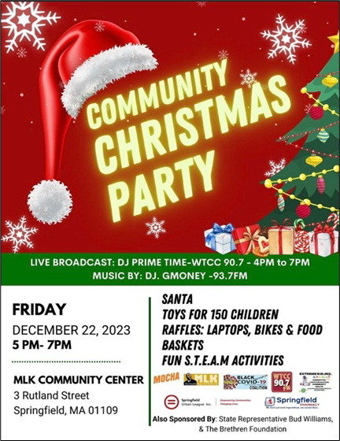
products. Attendees were also offered flu,
COVID, and RSV vaccines.

Read More Highlights

Share This Email
Share This Email
Share This Email

Visit the VEI Website

Vaccine Equity Initiative | 250 Washington Street, Boston, MA 02108 Unsubscribe vaccineequityinitiative@mass.gov
Constant Contact Data Notice
Sent by vei@vaccineequityinitiative.ccsend.com powered by

Try email marketing for free today!

