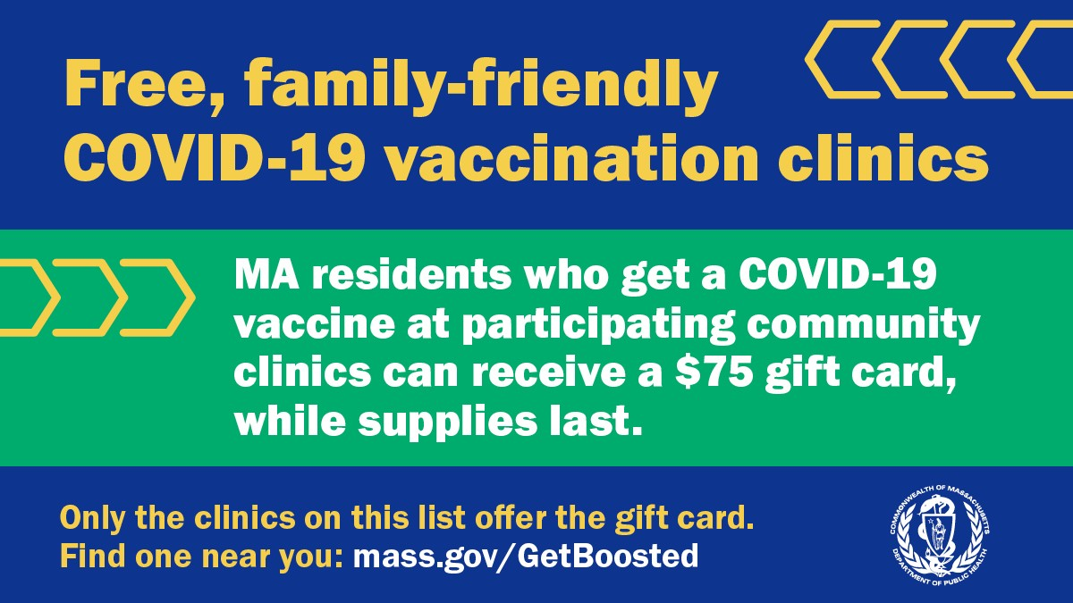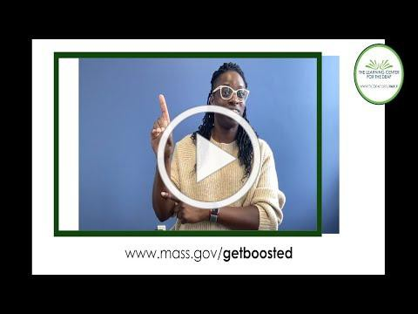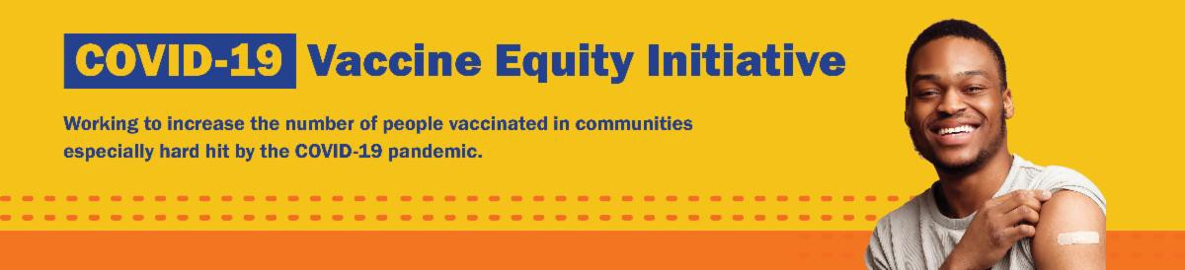

**February 24, 2023**

Here are the latest resources for promoting COVID-19 vaccination to share with your colleagues

and networks across Massachusetts. If you received this from a colleague, [**subscribe today**](https://lp.constantcontactpages.com/su/9wFTcRU/VEIWeeklyRoundup?source_id=963bb56c-4a6c-4882-a0fa-fdcf6c8c1b30&source_type=em&c)**.**

[**View this email online**](https://campaignlp.constantcontact.com/em/1138003900342/963bb56c-4a6c-4882-a0fa-fdcf6c8c1b30)**.**

**What's New**

# FEBRUARY VACATION WEEK CLINICS CONTINUE THROUGH THE WEEKEND — GET YOUR UPDATED COVID-19 BOOSTER OR VAX AND A $75 GIFT CARD!

Now is the time! Protect your whole family with free COVID-19 vaccines and updated boosters, available at Get Boosted clinics happening during February School Vacation Week.

Residents of all ages who get vaccinated (any dose) at participating clinics can receive a $75 gift card, while supplies last. Find participating clinics at [**mass.gov/GetBoosted**](http://mass.gov/getboosted).

**Help spread the word:** Flyers, email templates, and more resources are available in multiple languages in our vacation week [**toolkit**](https://www.mass.gov/info-details/covid-19-vaccine-promotion-toolkit#promoting-february-vacation-week-clinics-).

**If you have questions about Get Boosted clinics,** please call 2-1-1 (or 877-211-6277) and press 1. Calls are answered Monday through Friday,

from 9 a.m. to 5 p.m. With thanks to the Learning Center for the Deaf, info. about Get Boosted clinics is also [**available in ASL**](https://www.youtube.com/watch?v=ZrPP3JrHLBo&list=PLvnoFLZbhENOvK_6ZvQDcDQjSO_S5hT7g&index=8).

[*February Vacation Week clinics were recently featured by* ***El Rumbo****, the* ***Everett Advocate****, and the*](https://advocatenews.net/everett/news/get-updated-covid-19-booster-or-vaccination-and-75-gift-card-during-school-vacation-week/)[***Athol Daily News***](https://www.atholdailynews.com/North-Quabbin-Notes-Feb-15-49920473)[*.*](https://advocatenews.net/everett/news/get-updated-covid-19-booster-or-vaccination-and-75-gift-card-during-school-vacation-week/)

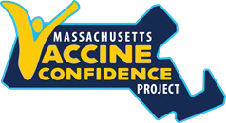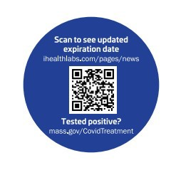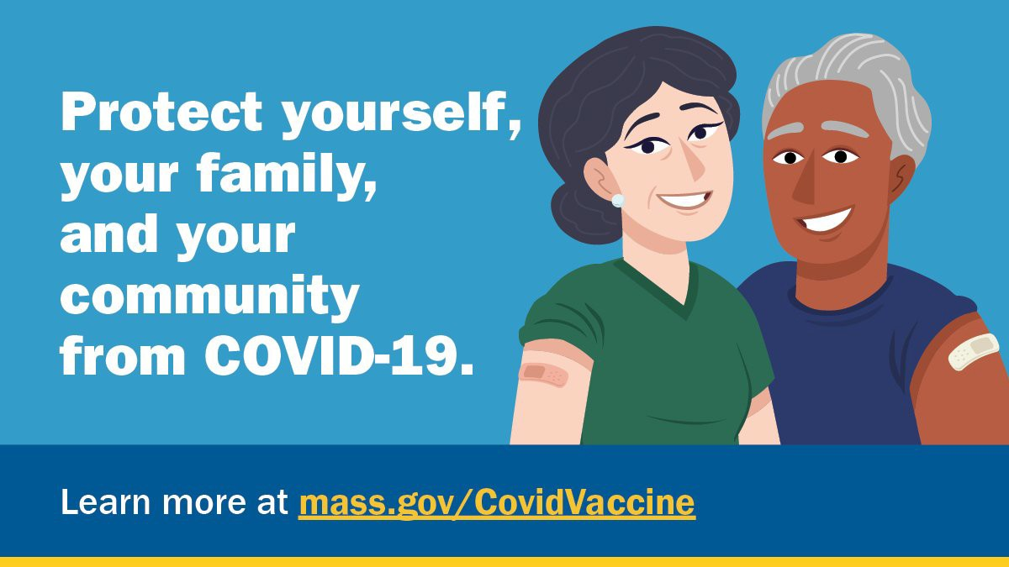

**Reminders**

# NOW LIVE: MASSACHUSETTS VACCINE CONFIDENCE PROJECT WEBSITE

The Massachusetts Vaccine Confidence Project aims to support vaccine confidence and ensure that all residents are fully protected against serious, vaccine- [preventable disease. **Find more information about the project, including resources and trainings, on their new website.**](https://massvaccineconfidenceproject.org/)

# iHEALTH COVID-19 RAPID TESTS RECEIVE EXTENDED EXPIRATION DATE

The [**FDA recently extended**](https://www.fda.gov/media/164513/download)the expiration date of iHealth COVID-19 Rapid Tests to 15 months after their manufacture date (three more months than was previously [granted). **Learn more about updated expiration dates.**](https://www.fda.gov/media/164551/download)

[**Printable stickers**](https://www.mass.gov/info-details/covid-19-vaccine-promotion-toolkit#additional-resources-(by-topic)-)that can be placed on iHealth test kits are available in multiple languages.

# FOLLOW THESE SEVEN STEPS

There are a number of steps that you can take to help protect yourself, your family, and your community from COVID-19.

[Available in multiple languages, **this flyer** features a checklist with these](https://www.mass.gov/lists/protect-yourself-your-family-and-your-community-from-covid-19-flyer)

steps. Please share it with your networks.

# FREE COVID-19 TESTS AVAILABLE FOR A LIMITED TIME!

Community organizations can order free at-home rapid antigen COVID-19 tests, while supplies last.

Organizations that are interested in



**Boston**

[Starting in October, the **Asian American Civic Association** (AACA) began hosting](https://www.aaca-boston.org/) a series of forums to address issues that have been exacerbated within the community by the COVID-19 pandemic. The forums are structured in a way that allows for discussion and input from

**Recent Highlights**

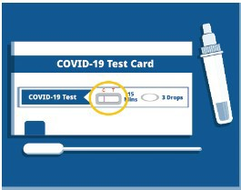

ordering supplies must complete this short

form: [**bit.ly/COVIDTestRequestMA**](http://bit.ly/COVIDTestRequestMA).

**Please note:** You may need to copy and paste the link into your browser.

**Key Resources**

# OUTREACH AND EDUCATION MATERIALS

[**COVID-19 Vaccine FAQs**](https://www.mass.gov/info-details/covid-19-vaccine-frequently-asked-questions)

[**COVID-19 Therapeutic Information**](https://www.mass.gov/get-treated-for-covid-19)(including [**telehealth**](https://www.mass.gov/info-details/free-telehealth-for-covid-19-treatment-with-paxlovid)) [**Weekly Provider Bulletin**](https://www.mass.gov/info-details/massachusetts-covid-19-vaccine-program-mcvp-guidance-for-vaccine-providers-and-organizations#weekly-provider-bulletins-)

[**Trust the Facts, Get the Vax Campaign Materials**](https://www.mass.gov/resource/trust-the-facts-get-the-vax-campaign-materials)(organized by audience, including general, parents and pregnant people, youth, young adults; available in 12 languages) [**Multilingual COVID-19 Materials**](https://www.mass.gov/resource/multilingual-covid-19-materials)(videos and printables; organized by language) [**COVID-19 Funeral Assistance from FEMA**](https://www.mass.gov/info-details/covid-19-funeral-assistance)(including [**one-pager with key info**](https://www.mass.gov/info-details/covid-19-funeral-assistance#fema-funeral-assistance-website-%26-faq-)available in multiple languages)

[**COVID-19 Vaccination Tools for Employers**](https://www.mass.gov/doc/covid-19-vaccination-tools-for-employers)

[**Archive of COVID-19 Vaccine Communications Updates**](https://www.mass.gov/lists/archive-of-covid-19-vaccine-communications-updates)(past editions of VEI Roundup)

# FIND A COVID-19 VACCINE OR BOOSTER

[**Mass.gov/GetBoosted**](http://mass.gov/getboosted)(family-friendly clinics through March 2023)

[**Vaccine Finder**](https://vaxfinder.mass.gov/)

[**Find, Schedule, or Sign Up for a Mobile COVID-19 Vaccination**](https://www.mass.gov/covid-19-mobile-vaccinations)[**COVID-19 In-Home Vaccination Program**](https://www.mass.gov/info-details/covid-19-in-home-vaccination-program)

[**Request a Copy of Your Vaccine Card**](https://www.mass.gov/info-details/requesting-a-copy-of-your-covid-19-vaccination-record)

community members, as well as for

sharing of relevant resources. The next forum is scheduled for late February. For more information, [**contact AACA**](https://www.aaca-boston.org/contact).

[**Read More Highlights**](https://www.mass.gov/info-details/covid-19-vaccine-equity-initiative-highlights)

[**Visit the VEI Website**](https://www.mass.gov/info-details/covid-19-vaccine-equity-initiative)



[Share This Email](https://www.linkedin.com/sharing/share-offsite/?url=https%3A//campaignlp.constantcontact.com/em/1138003900342/963bb56c-4a6c-4882-a0fa-fdcf6c8c1b30)

[Share This Email](https://twitter.com/intent/tweet?text=VEI%2BWeekly%2BRoundup%3A%2Bhttps%3A//campaignlp.constantcontact.com/em/1138003900342/963bb56c-4a6c-4882-a0fa-fdcf6c8c1b30)

[Share This Email](https://www.facebook.com/sharer/sharer.php?u=https%3A//campaignlp.constantcontact.com/em/1138003900342/963bb56c-4a6c-4882-a0fa-fdcf6c8c1b30)

Vaccine Equity Initiative | 250 Washington Street, Boston, MA 02108

[Unsubscribe vaccineequityinitiative@mass.gov](mailto:Unsubscribevaccineequityinitiative@mass.gov) [Constant Contact Data Notice](http://www.constantcontact.com/legal/about-constant-contact)

Sent by [vaccineequityinitiative@mass.gov](mailto:vaccineequityinitiative@mass.gov) in collaboration with



[Try email marketing for free today](http://www.constantcontact.com/index.jsp?cc=nge&rmc=VF21_CPE&nav=963bb56c-4a6c-4882-a0fa-fdcf6c8c1b30)!