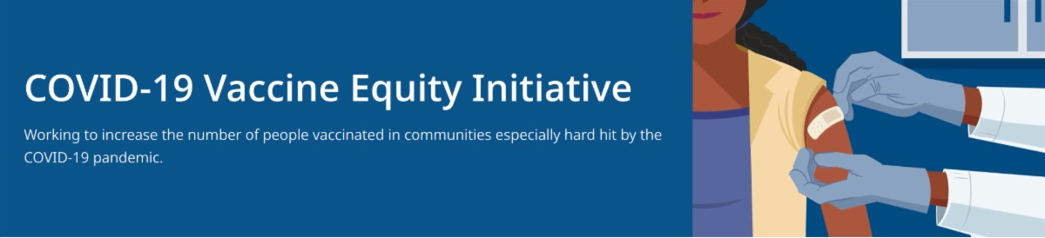
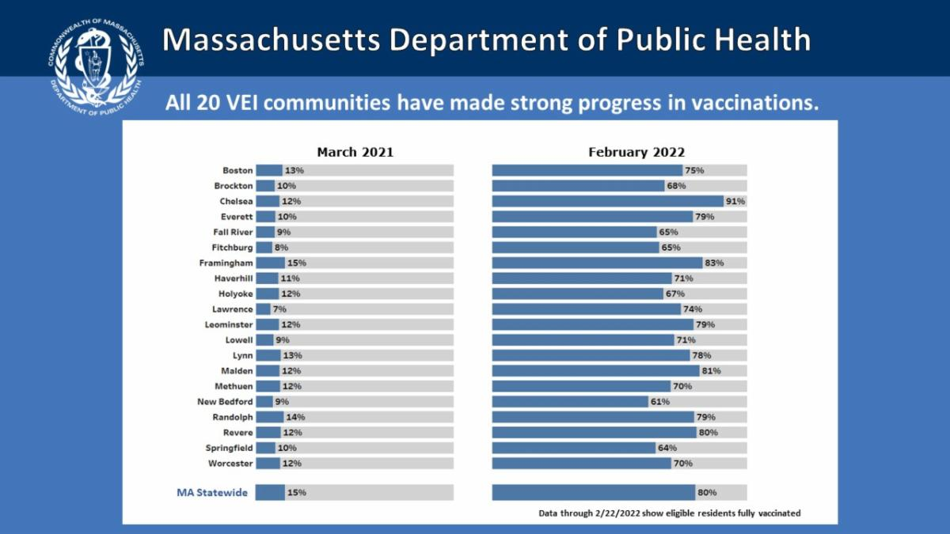

February 25, 2022

This newsletter is your central source for COVID-19 vaccination updates. Materials are publicly available and clickable for easy sharing. Others may subscribe by clicking here.

What's New

ONE-YEAR ANNIVERSARY OF THE VACCINE EQUITY INITIATIVE

This week we marked the one-year anniversary of the Vaccine Equity Initiative (VEI), our far-reaching statewide effort to increase vaccination in 20 communities hardest hit by COVID. We gathered virtually with VEI participants who shared their successful community efforts and partnerships for increasing vaccine acceptance and access. EHS Secretary Sudders and DPH Commissioner Cooke thanked municipal leaders as we marked the strong progress made in vaccinations in all 20 communities (see charts, below). Thank you to all as we continue our work together to increase COVID vaccination across the Commonwealth.

Above: Comparative charts showing the strong progress in vaccinations made in the 20 VEI communities over the last year. Data shows eligible residents fully vaccinated as of Feb. 22.
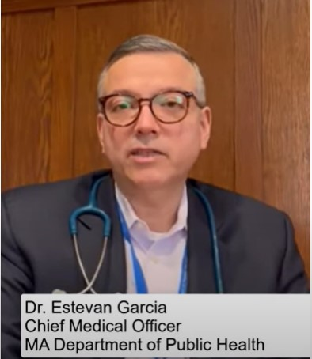
Visit the VEI Website

HOST A COVID-19 VACCINATION EVENT AT YOUR LOCAL LIBRARY

Read this conversation between MA DPH and the MA Library System to learn more about hosting a COVID-19 mobile clinic or community conversation at your local library.

COVID-19 TREATMENTS AVAILABLE FOR POSITIVE HIGHER-RISK INDIVIDUALS

News Release (2/23) - DPH reminds residents of availability of COVID-19 treatments for positive higher-risk individuals

Reminders

NEW TREATMENT OPTIONS FOR COVID-19

Patients recently diagnosed with COVID-19 have options for treatment, available at no cost at sites across MA. Listen to Dr. Estevan Garcia (Chief Medical Officer at MA DPH) describe treatment safety and effectiveness.

More info available at mass.gov/CovidTreatments and on this flyer.

Above: Dr. Garcia describes new treatments for COVID-19, including the COVID pill.

SCHOOL VACATION WEEK (FEBRUARY 20-26) VACCINATION CLINICS

DPH is partnering with
local communities to host more
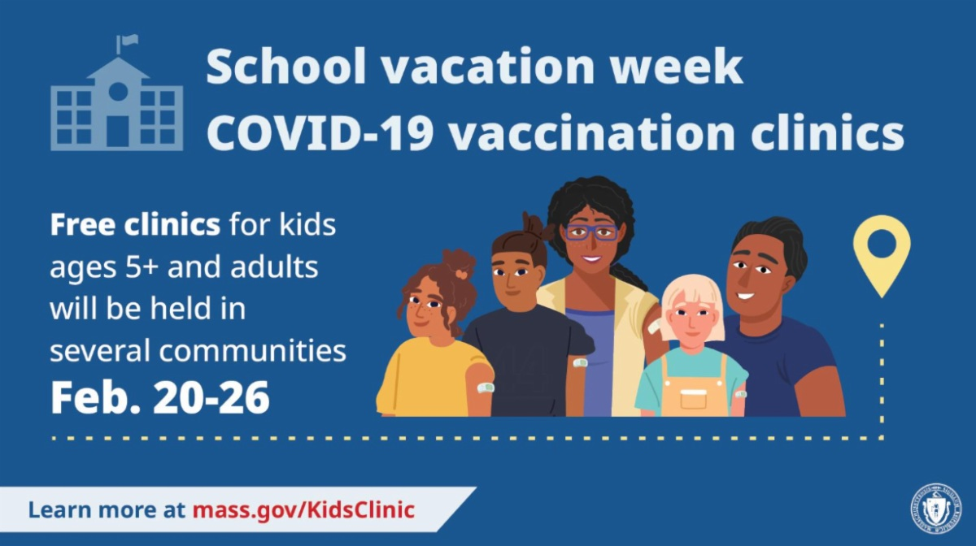
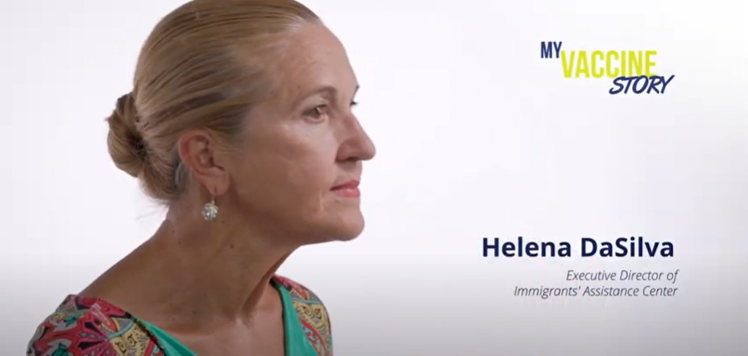
than 60 vaccination clinics during this weeklong event, which lasts through tomorrow (2/26). Families are welcome! $25 gift cards available while supplies last with thanks to Blue Cross Blue Shield and The United Way. View the schedule.

COVID-19 OUTREACH AND EDUCATION RESOURCES FROM DPH

Resources to support COVID-19 vaccine promotion and education. Includessocial media graphics, vaccine updates, guides to hosting a forum, and more.

MY COVID-19 VACCINE STORY - VIDEOS FROM COMMUNITY INFLUENCERS

My Vaccine Story videos feature community influencers speaking about their decisions to receive the COVID-19 vaccine. Many videos are available in multiple languages. View the full playlist on the DPH YouTube Channel.

Above: Helena DaSilva shares her vaccine story.

IN-HOME VACCINATIONS AVAILABLE

The COVID-19 In-Home Vaccination Program is a resource for anyone who has difficulty getting to or using a community vaccination location.

Key Resources

OUTREACH AND EDUCATION MATERIALS

COVID-19 Vaccine FAQs COVID-19 Booster FAQs
Weekly Provider Bulletin (published Feb. 23)
Trust the Facts, Get the Vax Campaign Materials (organized by audience, including general, parents and pregnant people, youth, young adults; available in 12 languages)
Trust the Facts, Get the Vax Creative Materials Toolkit (updates ongoing, including
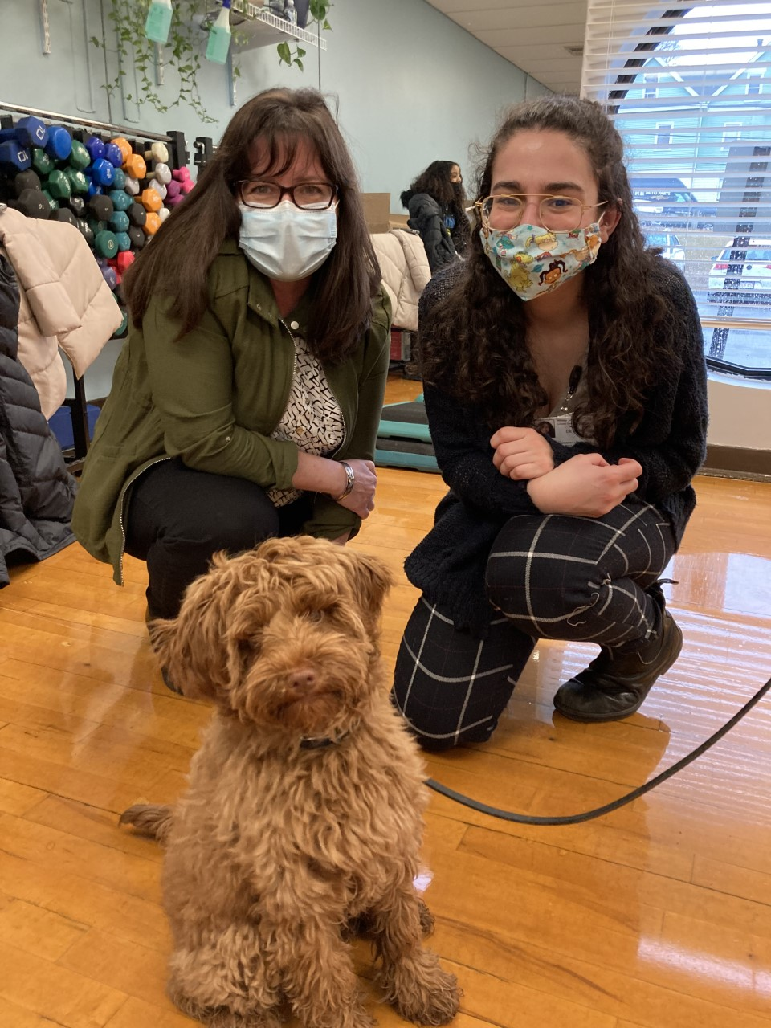
pediatric eligibility)
Additional Education and Outreach Materials(includes social media graphics, vaccine updates, guides to hosting a forum, and more)
Multilingual COVID-19 Materials (videos and printables; organized by language) DPH Vaccine Ambassador Program (request a DPH employee to attend community meetings to share info about the vaccine)
COVID-19 Funeral Assistance from FEMA (including 1-pager with key infoavailable in multiple languages)
COVID-19 Vaccination Tools for Employers

FIND A COVID-19 VACCINE OR BOOSTER

Vaccine Finder
Find, Schedule, or Sign Up for a Mobile COVID-19 Vaccination COVID-19 In-Home Vaccination Program
Request a Copy of Your Vaccine Card

COVID-19 VACCINE STANDING ORDERS (FROM CDC)

Pfizer
5-11 (updated 2/7/22)
12 + Gray Cap(updated 1/12/22) 12 + Purple Cap(updated 1/12/22)
Moderna (updated 2/22/22) Janssen (updated 2/22/22)

Recent Highlights

Lowell:

On Tuesday, comfort dog in training, Brownie McSnuggles, paid a visit to the school vacation week vaccine clinic at the Greater Lowell YMCA (photo, right). Brownie brought smiles to attendees, and those vaccinated were eligible for additional incentives, like Girl Scout Cookies and a $500 gift card raffle.

Springfield:

Springfield is hosting family-friendly school vacation week vaccination clinics at BOUNCE Trampoline Park, where kids can receive 1 hour of free play time for getting vaccinated. 80 vaccinations were administered in just one day, including 30 pediatric doses. The clinics have received media attention from WWLP, MASS Live, and other outlets.

Read More Highlights

Share This Email Share This Email Share This Email

