GET BOOSTED CLINICS EXTENDED THROUGH MARCH 2023!

The Get Boosted program has been extended through March 31, 2023, for all participating communities!

Over 59,000 doses of COVID vaccine have been administered since the Get Boosted effort began October 24.

Residents of all ages who get vaccinated (any dose) at participating clinics can receive a $75 gift card to local retailers, while supplies last. Find participating clinics at mass.gov/GetBoosted.

If you have questions about Get Boosted clinics, please call 2-1-1 (or 877-211-6277) and press 1. Calls are answered Monday through Friday, from 9 a.m. to 5 p.m.

Help spread the word about these clinics on Facebook and Instagram, or by using other resources from our toolkit.

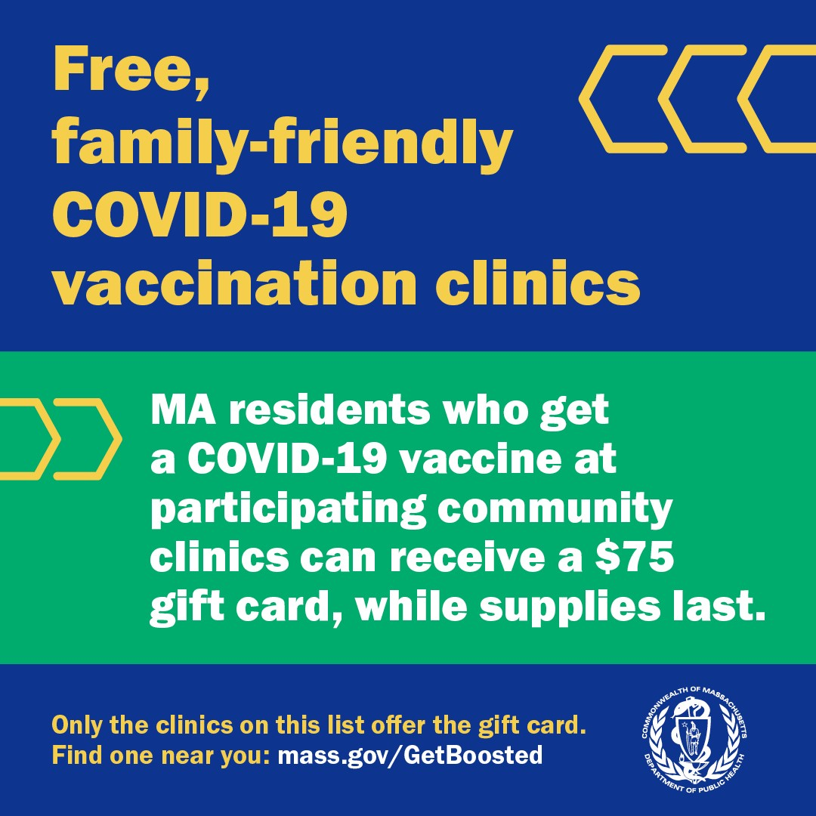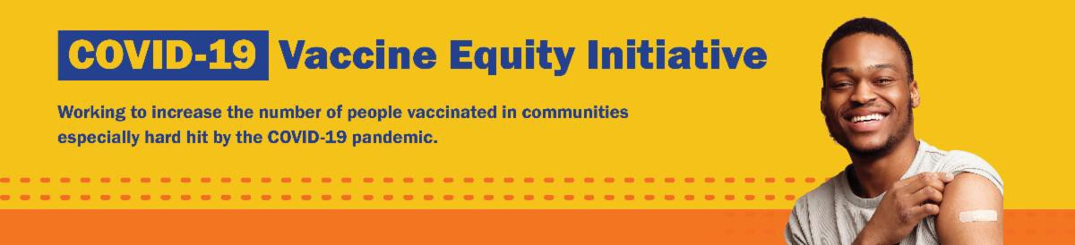
February 3, 2023
Here are the latest resources for promoting COVID-19 vaccination to share with your colleagues
and networks across Massachusetts. If you received this from a colleague, subscribe today.

View this email online.
What's New
Get Boosted clinics were recently featured by Rumbo (Lawrence) and the Sun Chronicle (Attleboro).
Reminders

LOST YOUR COVID-19 VACCINE CARD? HERE'S HOW TO GET A NEW ONE

There are a few ways to get a copy of your COVID-19 vaccine record:

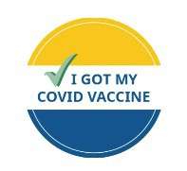
If you were vaccinated at a health care center or by your primary care provider: contact the location where you got vaccinated.
If you were vaccinated at a pop-up clinic: contact your primary care provider, or explore the other options below.
If you were vaccinated at a retail pharmacy: you may be able to access your record online, or contact a pharmacist (varies by pharmacy). If you were vaccinated at a state mass vaccination site: follow these instructions.

You can also:
Get a digital copy from My Vax Records .
Find your record in v-safe (if you already enrolled).
Fill out a state immunization record request form. This will provide a record of all vaccines you've gotten. It may take several weeks to process.

Learn more, or call 2-1-1 with any questions.

FREE IN-HOME COVID-19 VACCINATION AVAILABLE

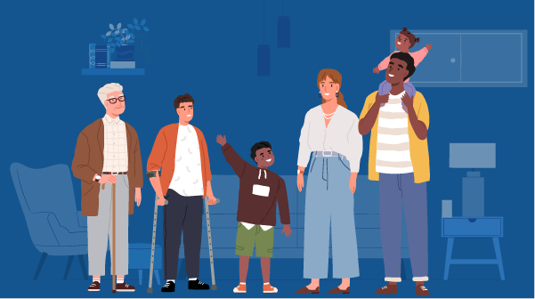
Massachusetts offers in-home COVID-19 vaccinations for anyone who has difficulty getting to or using a community clinic, including young children. Learn more, or call 833-983-0485 to sign up for an in- home appointment.

Help spread the word with
this informational flyer (in 12 languages)!

FOLLOW THESE SEVEN STEPS

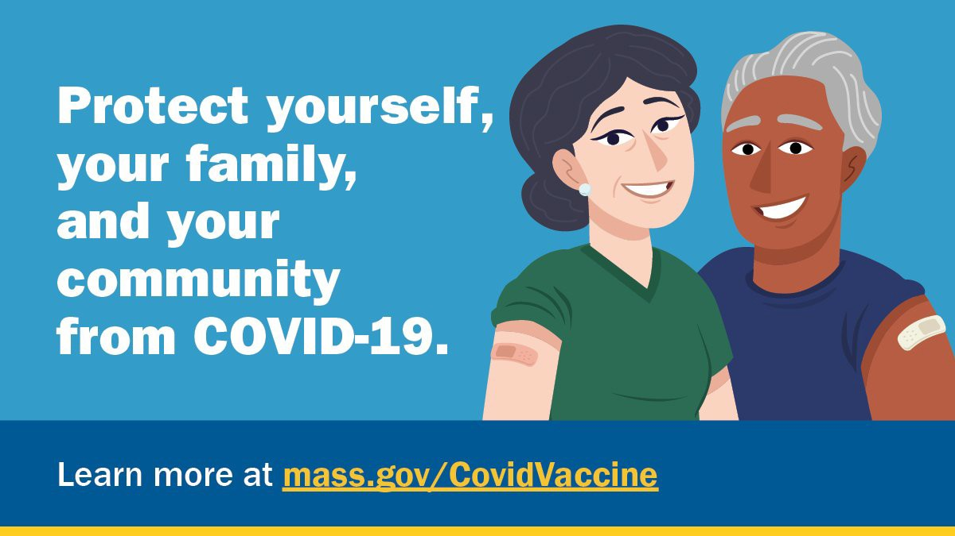
There are a number of steps that you can take to help protect yourself, your family, and your community from COVID-19.

Available in multiple languages, this flyer features a checklist with these
steps. Please share it with your networks.

FREE COVID-19 TESTS AVAILABLE FOR A LIMITED TIME!

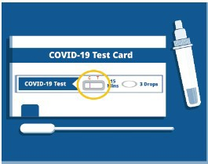
Community organizations can order free at-home rapid antigen COVID-19 tests, while supplies last.

Organizations that are interested in ordering supplies must complete this short form: bit.ly/COVIDTestRequestMA.

Please note: You may need to copy and paste the link into your browser.
Key Resources

OUTREACH AND EDUCATION MATERIALS

COVID-19 Vaccine FAQs
COVID-19 Therapeutic Information (including telehealth) Weekly Provider Bulletin
Trust the Facts, Get the Vax Campaign Materials (organized by audience, including general, parents and pregnant people, youth, young adults; available in 12 languages) Multilingual COVID-19 Materials (videos and printables; organized by language) COVID-19 Funeral Assistance from FEMA (including one-pager with key info available in multiple languages)
COVID-19 Vaccination Tools for Employers
Archive of COVID-19 Vaccine Communications Updates (past editions of VEI Roundup)

FIND A COVID-19 VACCINE OR BOOSTER

Mass.gov/GetBoosted (family-friendly clinics through March 2023)
Vaccine Finder
Find, Schedule, or Sign Up for a Mobile COVID-19 Vaccination COVID-19 In-Home Vaccination Program
Request a Copy of Your Vaccine Card

Recent Highlights

Malden

Chinese Culture Connection has been using their community events as an opportunity to host vaccine clinics in culturally relevant settings. In late November, they hosted their annual Ping- Pong Tournament, where participants ranging in age from 7 to 79 years old

competed while family and friends
cheered on the side. A Get Boosted clinic hosted during the event resulted in 83 vaccinations, including doses administered to children and 80-year-old adults. Many who got vaccinated also received language assistance from Chinese Culture Connection at the vaccine check-in.

Read More Highlights

Visit the VEI Website

Share This Email
Share This Email
Share This Email

Vaccine Equity Initiative | 250 Washington Street, Boston, MA 02108

Unsubscribe vaccineequityinitiative@mass.gov Constant Contact Data Notice
Sent byvaccineequityinitiative@mass.govin collaboration with
Try email marketing for free today!

