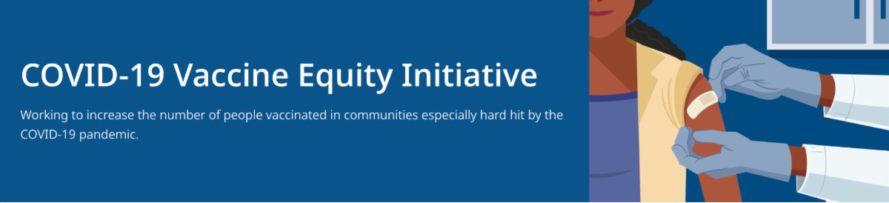
FIND A BOOSTER APPOINTMENT NEAR YOU

Boosters are available at state- managed locations in Boston, Barnstable, Brockton, Danvers, Lynn, Lowell, Springfield, and Taunton - plus hundreds of other
Reminders
February 4, 2022
VEI Roundup is your central source for updates and materials related to vaccine promotion,
education, and access. All materials are publicly available. Each item is clickable for easy sharing.

Please forward to others who can subscribe by clicking here to submit a subscription request.
What's New

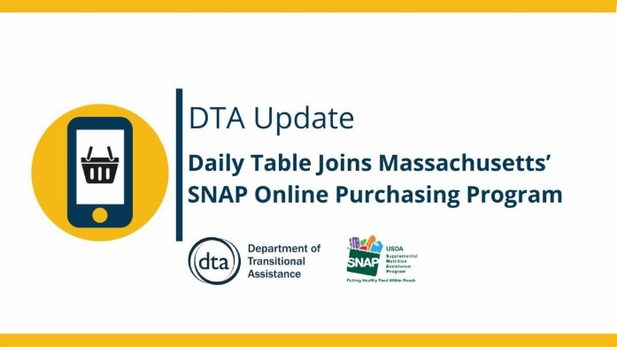
FOR EMPLOYERS: WAYS TO INCREASE COVID-19 VACCINATION AMONG EMPLOYEES

COVID-19 Vaccination Tools for Employers (includes info on hosting a free mobile clinic, helping employees locate a vaccine, offering paid sick leave for vaccination, and more)

SUPPORT SOCIAL DISTANCING: MA RESIDENTS CAN USE SNAP BENEFITS TO ORDER GROCERIES ONLINE

Daily Table Joins Massachusetts’ SNAP Online Purchasing Program: SNAP benefits can now be used to buy groceries online from Daily Table
Other SNAP online retailers: BJs, Stop & Shop, Walmart, Amazon, ALDI, Hannaford, and Price Chopper

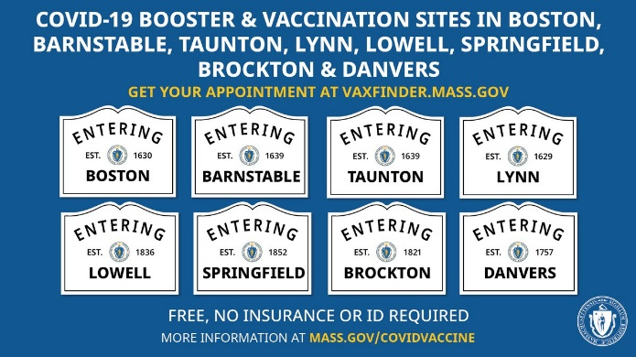
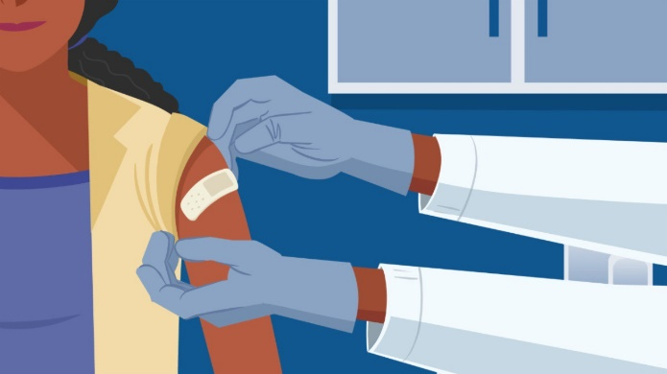
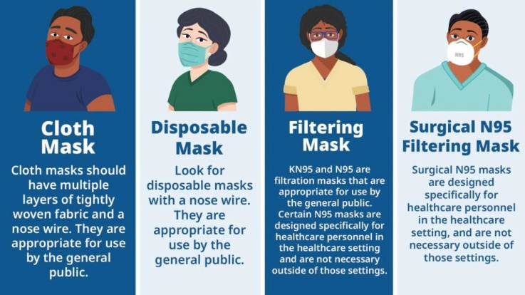
locations in MA. Find your
appointment or walk-in location.

IN-HOME VACCINATIONS AVAILABLE

COVID-19 In-Home Vaccination Program: In-home vaccinations are available for anyone who has difficulty getting to or using a community vaccination location

TRAINING OPPORTUNITIES

Communication Skills Training for Clinicians Discussing COVID-19 Vaccination (On Feb. 11; free webinar from DPH, UMASS Chan Medical School, and other partners, with a focus on pregnant and postpartum people, and parents and caregivers of young children)

COVID-19 MASK INFORMATION

COVID-19 Mask Information (Now on mass.gov – how to select and wear a mask)
Types of Masks and Respirators (from CDC: detailed info on mask types and levels of protection offered)

MASSHEALTH NOW COVERING AT-HOME COVID TESTS FOR MEMBERS

Over-the-counter COVID-19 self-test kits are now covered through MassHealth. Up to 8 test kits per member per month will be covered without the need for a prescription or prior authorization. More in the MassHealth Provider Bulletin.

ADDITIONAL TESTING OPTIONS

The Biden Administration is offering free at-home COVID-19 rapid tests to all U.S.

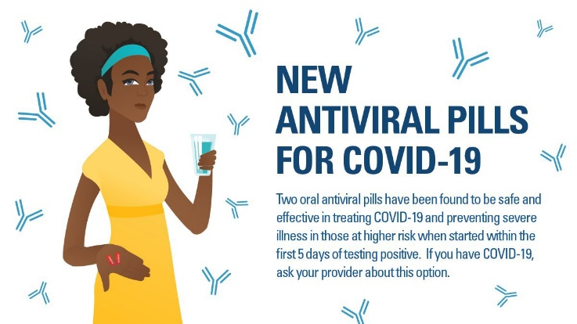
households. Every home in the U.S. is eligible to order 4 tests to be delivered by the U.S.
Postal Service: Get Free At-Home COVID Tests
More than 1000 testing sites are available to MA residents. Find locations at
www.mass.gov/gettested
THERAPEUTIC TREATMENTS FOR COVID-19

If you test positive for COVID-19, have risk factors and any symptoms, you may want to pursue new therapeutic treatments which can keep you from getting severely ill. They're safe, effective, and free – no insurance needed. Learn more.
Key Resources

OUTREACH AND EDUCATION MATERIALS

COVID-19 Vaccine FAQs COVID-19 Booster FAQs
Weekly Provider Bulletin (published Feb. 2)
Trust the Facts, Get the Vax Campaign Materials (organized by audience, including general, parents and pregnant people, youth, young adults; available in 12 languages)
Trust the Facts, Get the Vax Creative Materials Toolkit (updates ongoing, including pediatric eligibility)
Additional Education and Outreach Materials (includes social media graphics, vaccine updates, guides to hosting a forum, and more)
Multilingual COVID-19 Materials (videos and some printables)
DPH Vaccine Ambassador Program (request a DPH employee to attend community meetings to share info about the vaccine)
COVID-19 Funeral Assistance from FEMA (including 1-pager with key info available in multiple languages)

FIND A COVID-19 VACCINE OR BOOSTER

Vaccine Finder
Find, Schedule, or Sign Up for a Mobile COVID-19 Vaccination COVID-19 Booster Eligibility Checker
Request a Copy of Your Vaccine Card

Recent Highlights

Chelsea:

Chelsea partnered with the East Boston Neighborhood Health Center for an evening booster clinic on Feb. 1, with outreach to essential workers and distribution of PPE and COVID-19 test kits.

Additionally, last week at a booster clinic for students and staff at the high school, 70 people pre-
registered and 98 residents received shots (including some first doses).

Fitchburg and Leominster:

This month, additional standing clinics in Leominster/Fitchburg began. All new standing clinics offer adult and pediatric doses and are in areas easily accessible by the community. In addition, AIDS Project Worcester provides a clinic on the first Friday of every month at the Restoration and Recovery Center and Making Opportunity Count offers two clinics a week.

Randolph:

The Randolph Health Department team recently visited New Jerusalem Church, a predominantly Black church where the team previously saw success with first doses. More than 20 received the COVID-19 booster.

Read More Highlights

Visit the VEI Website

Share This Email
Share This Email
Share This Email

Vaccine Equity Initiative | 250 Washington Street, Boston, MA 02108 Unsubscribe vaccineequityinitiative@mass.gov
About Constant Contact
Sent byvaccineequityinitiative@mass.govin collaboration with
Try email marketing for free today!

