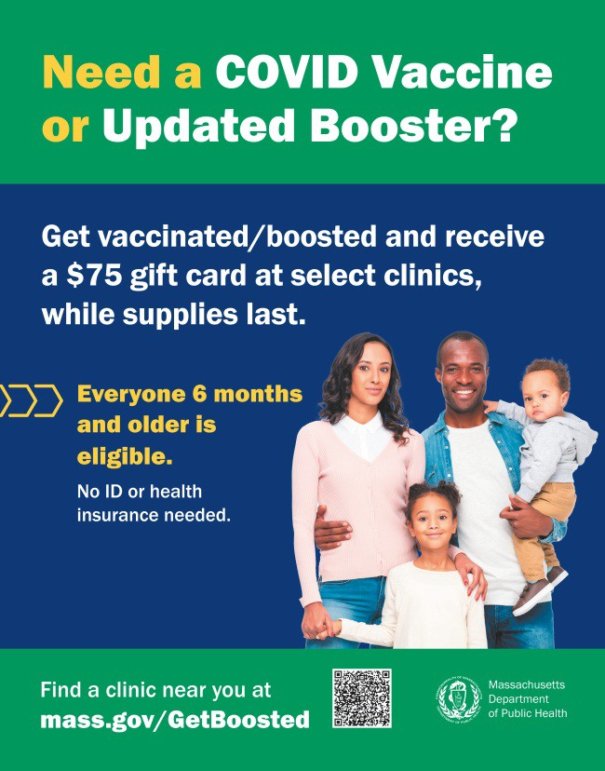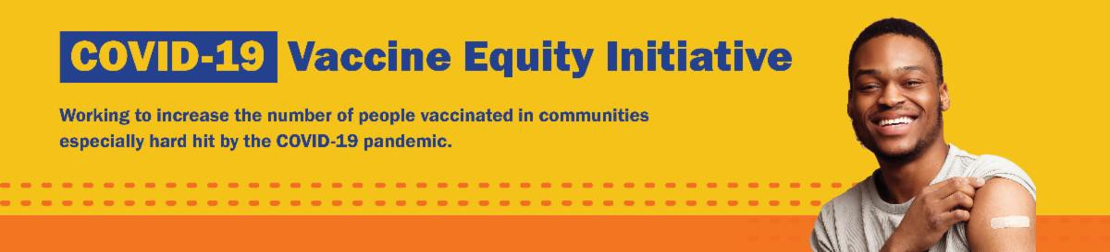
THERE'S STILL TIME: GET BOOSTED CLINICS RUN THROUGH MARCH 31!

There's still time to get vaccinated and receive a $75 gift card! Get Boosted clinics run through March 31, 2023.

Over 70,000 vaccinations have been given since the campaign launched in October 2022.

Residents of all ages who get vaccinated (any dose) at participating clinics can receive a $75 gift card, while supplies last. Find participating clinics at mass.gov/GetBoosted.

Help spread the word: Flyers and other resources are available in multiple languages in our toolkit.
If you have questions about Get
Boosted clinics, please call 2-1-1 (or 877-211-6277) and press 1. Calls are answered Monday through Friday, from 9 a.m. to 5 p.m.
With thanks to the Learning Center for the Deaf, info
about Get Boosted clinics is also available in ASL.
Get Boosted clinics were recently featured by the Attleboro Sun Chronicle.
March 10, 2023
Here are the latest resources for promoting COVID-19 vaccination to share with your colleagues
and networks across Massachusetts. If you received this from a colleague, subscribe today.

View this email online.
What's New

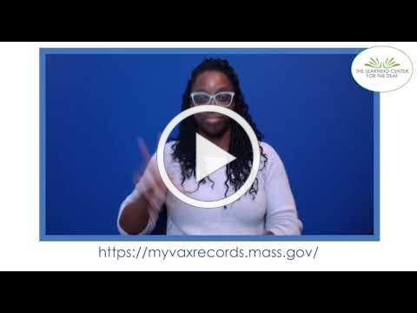MASSHEALTH REDETERMINATION BEGINS IN APRIL: HELP MEMBERS KEEP THEIR HEALTH CARE COVERAGE
MY VAX RECORDS: A DIGITAL VACCINE CARD FOR MASSACHUSETTS
RESIDENTS
Need a copy of your COVID-19 vaccination
record? Massachusetts residents can use My Vax Records to get a digital vaccine card to show they’ve been vaccinated against COVID-19, if they choose. Learn more.
Info about My Vax Records is available in ASL,
courtesy of the Learning Center for the Deaf.
FREE COVID-19 TESTS AVAILABLE FOR A LIMITED TIME!

Community organizations can order free at-home rapid antigen COVID-19 tests, while supplies last.

Organizations that are interested in ordering supplies must complete this short
Reminders

In 2023, all current MassHealth members will need to renew their health coverage to ensure they still qualify for their current benefit.

These renewals will take place over 12 months, starting in April 2023. MassHealth is working to help members maintain coverage and raise awareness about the renewal process and other coverage options, if needed.

Here's how you can help:

Remind members to update their addresses, report household changes, and read all mail from MassHealth
Share outreach materials from this toolkit (in multiple languages) Sign up for email notifications from MassHealth

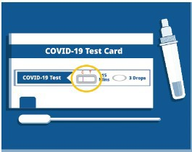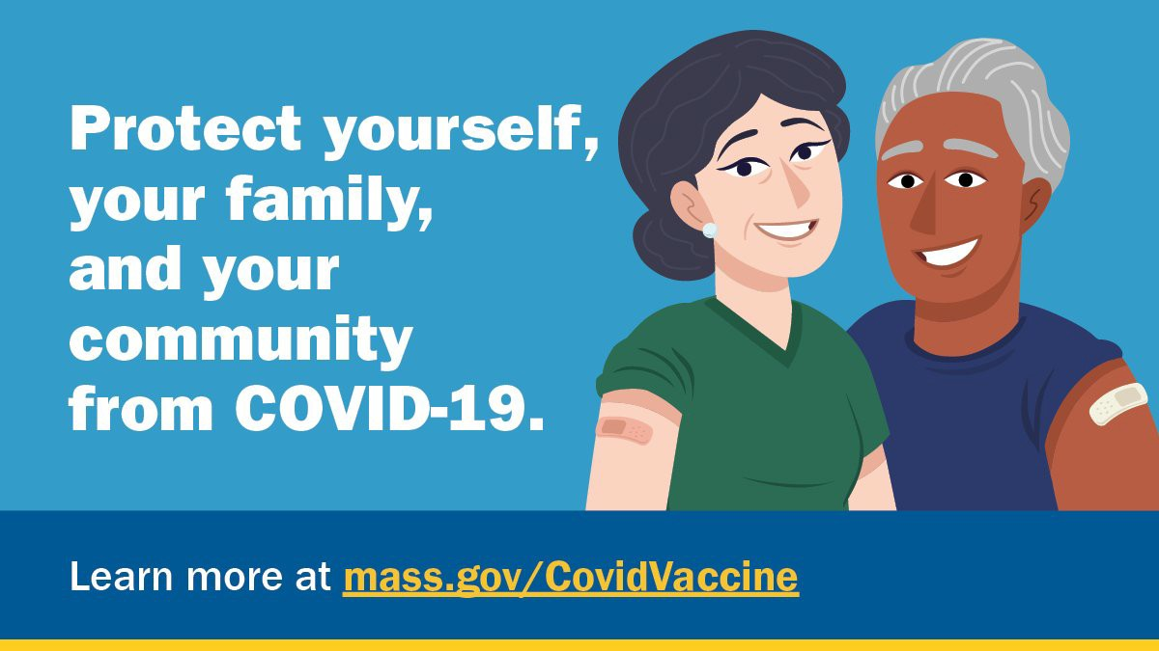
form: bit.ly/COVIDTestRequestMA.

Please note: You may need to copy and paste the link into your browser.
FOLLOW THESE SEVEN STEPS TO HELP PROTECT AGAINST COVID-19

There are a number of steps that you can take to help protect yourself, your family, and your community from COVID-19.

Available in multiple languages, this flyer features a checklist with these
steps. Please share it with your networks.
Key Resources

OUTREACH AND EDUCATION MATERIALS

COVID-19 Vaccine FAQs
COVID-19 Therapeutic Information (including telehealth) Weekly Provider Bulletin
Trust the Facts, Get the Vax Campaign Materials (organized by audience, including general, parents, youth, and young adults; available in 12 languages)
Multilingual COVID-19 Materials (videos and printables; organized by language)
COVID-19 Vaccination Tools for Employers
Archive of COVID-19 Vaccine Communications Updates (past editions of VEI Roundup)

FIND A COVID-19 VACCINE OR BOOSTER

Mass.gov/GetBoosted (family-friendly clinics through March 2023)
Vaccine Finder
Find, Schedule, or Sign Up for a Mobile COVID-19 Vaccination COVID-19 In-Home Vaccination Program
Request a Copy of Your Vaccine Card

Recent Highlights

Springfield
In February, the Black Springfield COVID- 19 Coalition partnered with Strong Young Minds for a conversation about the effect COVID-19 has had on education (see flyer). The event included a discussion with parents, teachers, and other school representatives, as well as arts and crafts, music, and refreshments. A Get Boosted clinic was also held, with six community members receiving vaccines. The Black Springfield COVID-19 Coalition has identified events connecting students and teachers as a key area to focus on for the future.

Read More Highlights

Visit the VEI Website
Share This Email
Share This Email
Share This Email

Vaccine Equity Initiative | 250 Washington Street, Boston, MA 02108

Unsubscribe vaccineequityinitiative@mass.gov Constant Contact Data Notice
Sent by vaccineequityinitiative@mass.gov in collaboration with
Try email marketing for free today!

