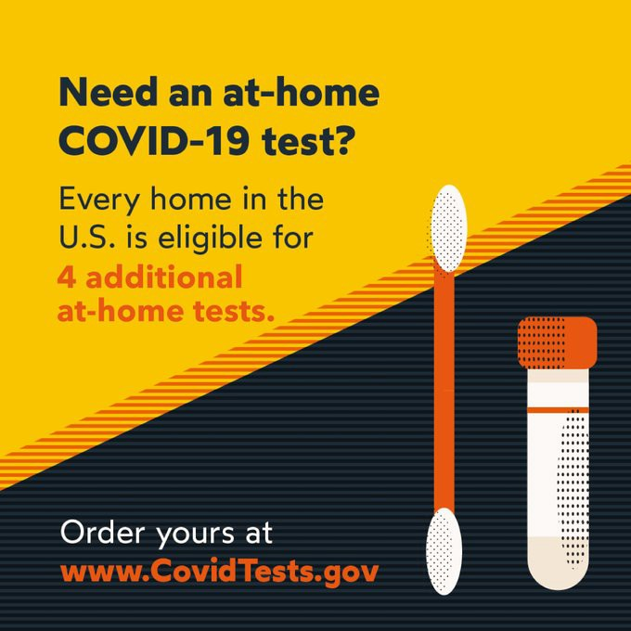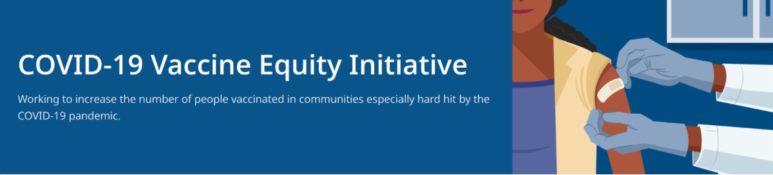
March 11, 2022
This newsletter is your central source for COVID-19 vaccination updates. Materials are publicly
available and clickable for easy sharing. Others may subscribe by clicking here.
What's New

FOUR ADDITIONAL AT-HOME COVID TESTS AVAILABLE FOR FREE!

Starting this week, every U.S. household can order an additional set of 4 at-home COVID-19 tests from the federal government. This means every home is eligible to receive a total of 8 free tests. Get Free At-Home COVID Tests

Additional info about COVID testing, including what to do if you test positive, is available at mass.gov/GetTested.

DR. SANDEEP JUBBAL DESCRIBES NEW COVID-19 TREATMENT OPTIONS

Patients recently diagnosed with COVID-19 have options for treatment, available at no cost at sites across MA. Listen to Dr. Sandeep Jubbal, Medical Director at UMass Memorial Medical Center, describe treatment safety and efficacy.

Learn more about treatment options at

mass.gov/CovidTreatment.

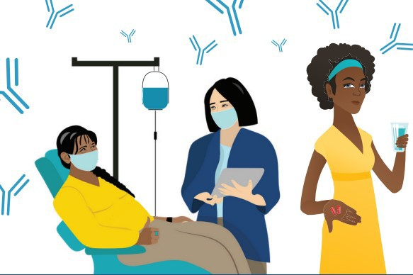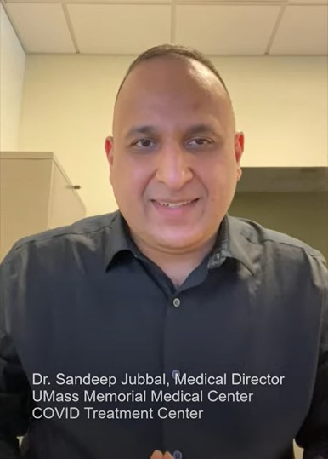
COVID-19 THERAPEUTICS FLYER - NOW IN 12 LANGUAGES

Free treatments for COVID-19 can help reduce your chance for severe disease, but they must be administered soon after diagnosis. Information for patients about these treatments is now in 12 languages.
TRUST THE FACTS. GET THE VAX. CAMPAIGN MATERIALS AVAILABLE FOR USE

Campaign materials include animations, videos, and flyers. Organized by audience, including
Reminders
Above: Dr. Jubbal discusses new COVID
treatment options.
UPDATES TO STOP THE SPREAD TESTING PROGRAM

News Release (3/4) - Baker- Polito administration announces updates to Stop the Spread testing program

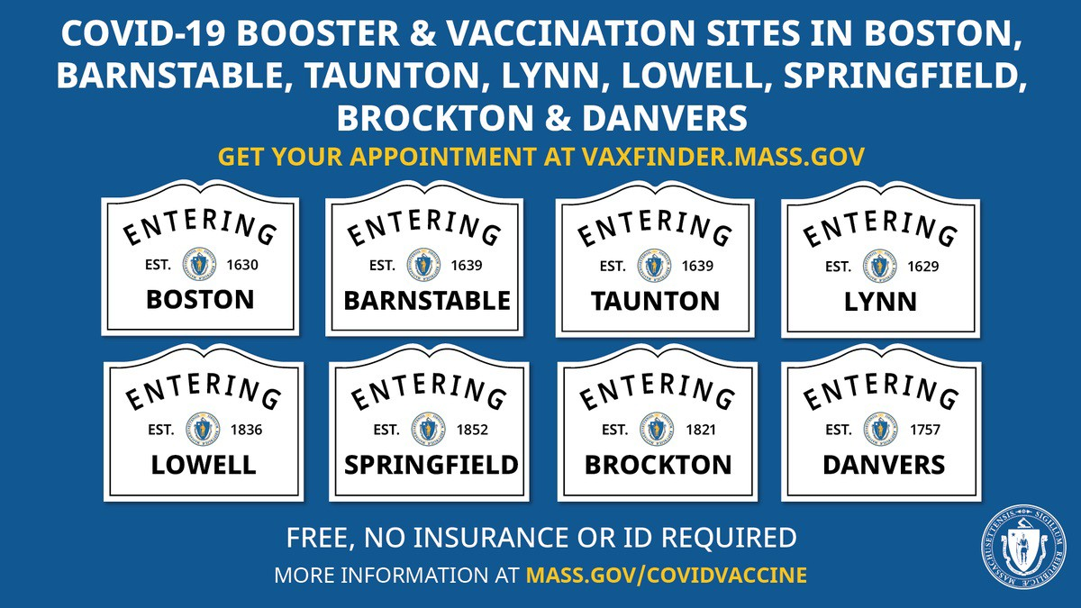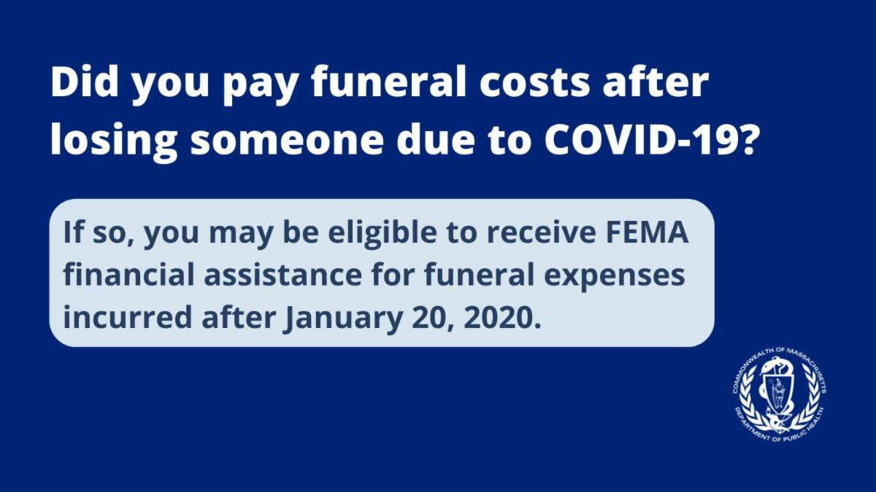general, parents and pregnant
OUTREACH AND EDUCATION MATERIALS

COVID-19 Vaccine FAQs COVID-19 Booster FAQs
Weekly Provider Bulletin (published 3/8)
Trust the Facts, Get the Vax Campaign Materials(organized by audience, including general, parents and pregnant people, youth, young adults; available in 12 languages)
Trust the Facts, Get the Vax Creative Materials Toolkit(updates ongoing, including pediatric eligibility)
Additional Education and Outreach Materials(includes social media graphics, vaccine updates, guides to hosting a forum, and more)
Multilingual COVID-19 Materials (videos and printables; organized by language) COVID-19 Funeral Assistance from FEMA(including 1-pager with key info available in multiple languages)
COVID-19 Vaccination Tools for Employers
Key Resources
people, youth, young adults; available in 12 languages. Learn more.

FIND A BOOSTER APPOINTMENT NEAR YOU

Booster vaccines continue to be available at several state- managed sites and at hundreds of other locations in MA. Find your appointment or walk-in location.

Questions about boosters? Check out the COVID-19 booster FAQ (available in 12 languages).

COVID-19 FUNERAL ASSISTANCE AVAILABLE

If you or someone you know lost a loved one to COVID-19, you may be eligible for financial assistance or reimbursement for funeral expenses from

FEMA. More information is available in multiple languages.

Archive of COVID-19 Vaccine Communications Updates (past editions of VEI Roundup)
FIND A COVID-19 VACCINE OR BOOSTER

Vaccine Finder
Find, Schedule, or Sign Up for a Mobile COVID-19 Vaccination COVID-19 In-Home Vaccination Program
Request a Copy of Your Vaccine Card
COVID-19 VACCINE STANDING ORDERS (FROM CDC)

Pfizer
5-11 (updated 2/7/22)
12 + Gray Cap(updated 2/25/22)
12 + Purple Cap (updated 2/25/22)
Moderna (updated 2/28/22)
Janssen (updated 2/22/22)
Recent Highlights

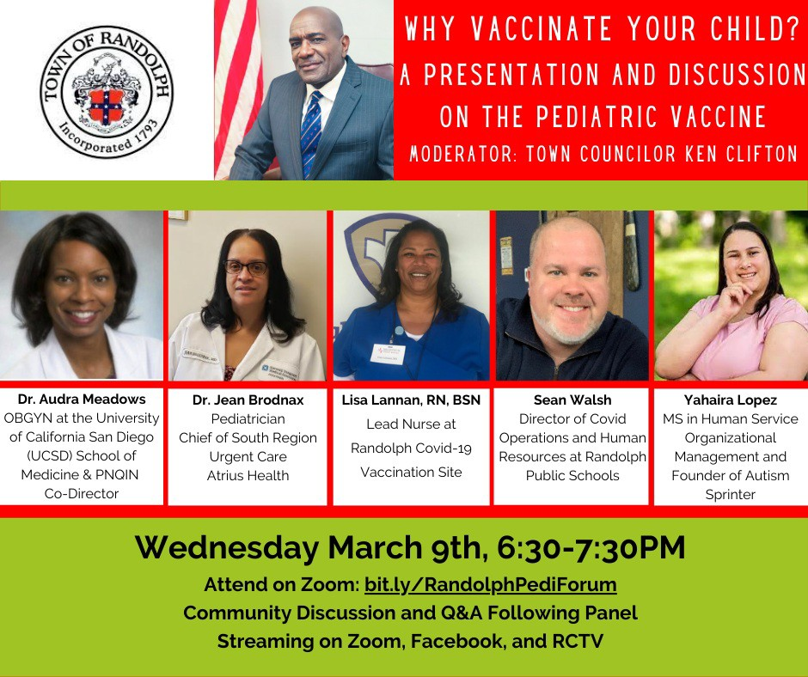
Randolph

Randolph hosted a pediatric forum on Wednesday, March 9th to discuss the COVID-19 vaccine for the pediatric population. Panelists included a pediatrician, OBGYN, and nurse, and there were opportunities for community discussion and Q&A (see flyer, right ).
Read More Highlights
Visit the VEI Website
Share This Email
Share This Email
Share This Email

Vaccine Equity Initiative | 250 Washington Street, Boston, MA 02108

Unsubscribe vaccineequityinitiative@mass.gov

About Constant Contact
Sent byvaccineequityinitiative@mass.govin collaboration with
Try email marketing for free today!

