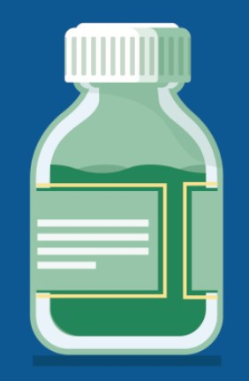
ADULTS 65+ CAN NOW RECEIVE AN ADDITIONAL COVID-19 VACCINE DOSE
This week, the CDC voted to recommend an additional COVID-19 vaccine dose for adults ages 65 and older.
Looking for a COVID-19 vaccine? You can: Search vaccines.gov for appointments
Find a local mobile clinic near you Learn more about in-home vaccination
If you have questions, please call 211 or (877) 211-6277 and press 1. Calls are answered Monday through Friday, 9 a.m. to 5 p.m.
RESOURCES FROM ALL TOP DOC WEBINARS NOW AVAILABLE!
Thank you to everyone who joined in on VEI's Ask the Top Doc webinar series!
Slides, recordings, and other resources from all of the webinars are now available!
This includes:
Compilation of all Q&As
March 1, 2024
Here are the latest resources for promoting COVID-19 vaccination to share with your colleagues
and networks across Massachusetts. If you received this from a colleague, subscribe today.
View this email online.
What's New

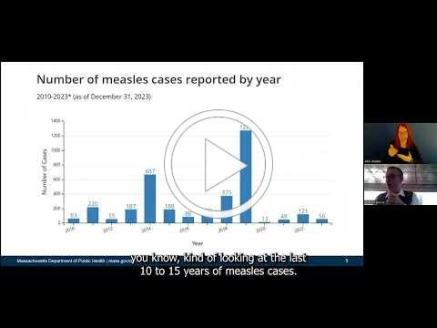
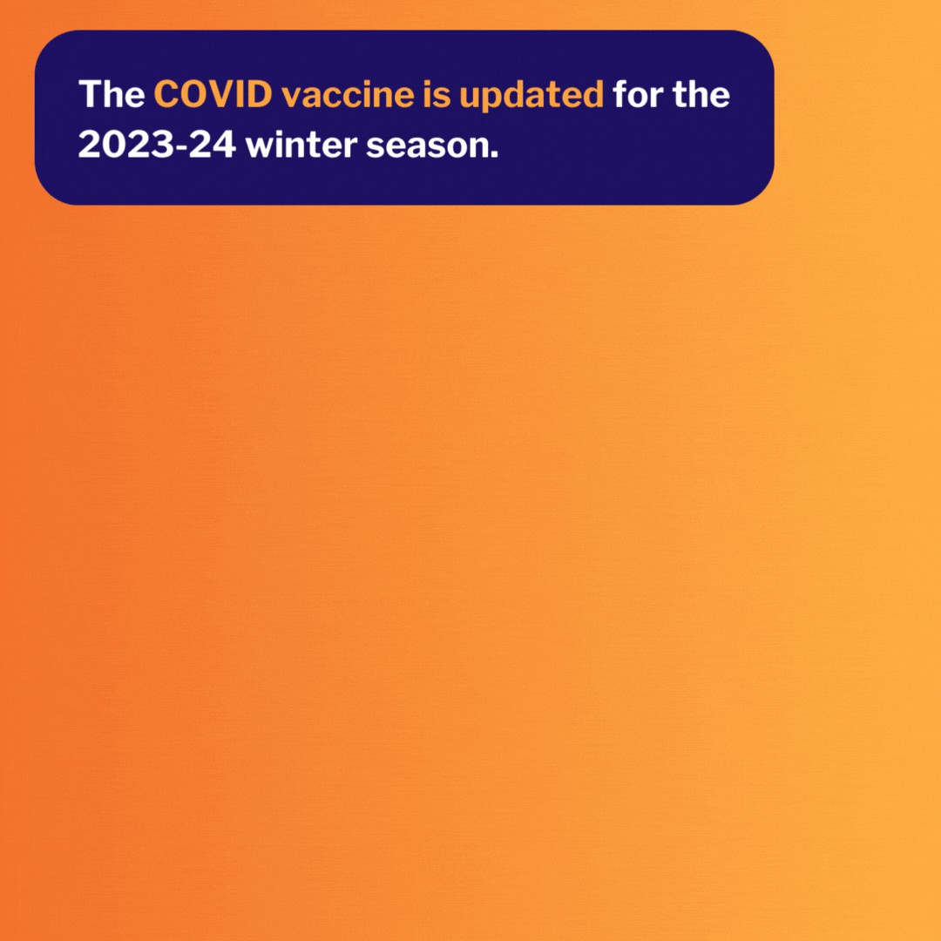
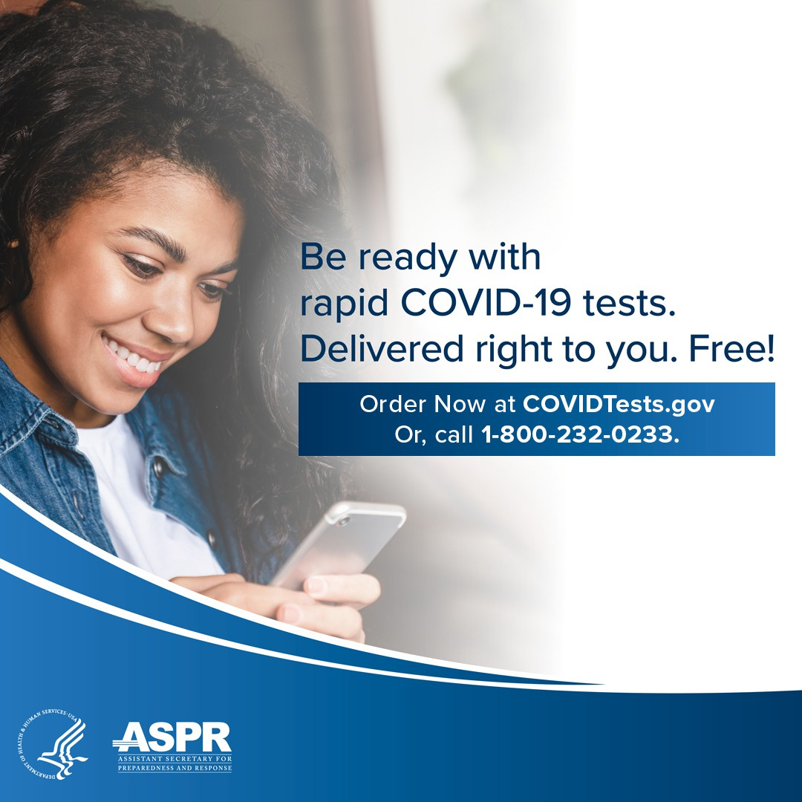
Webinar on respiratory illnesses:
FREE COVID TESTS AVAILABLE TO ALL U.S. HOUSEHOLDS
All U.S. household can order four free COVID-19 rapid tests, and some may be eligible to receive eight tests. Tests will be delivered directly to recipients' homes.
To order tests, visit COVID.gov/Tests.
Accessible COVID test kits are also available for people who are blind or have low vision.
Don't forget: Many at-home COVID tests have had their expiration dates
extended. Check updated expiration dates on the FDA's website.
Reminders

Presentation slides Presentation recording
Webinar on long COVID:

Presentation slides Presentation recording
Webinar on measles:

Presentation slides Presentation recording

Presentation recordings are currently available in English/ASL; other languages will be available soon!

NEW SOCIAL MEDIA GRAPHICS IN THE VAX PROMOTION TOOLKIT
These updated graphics give a quick overview of COVID vaccine basics and are easily shared on social media.
Now available in English, Haitian Creole, Portuguese, and Spanish.
Don't see the language you need? Let us know!

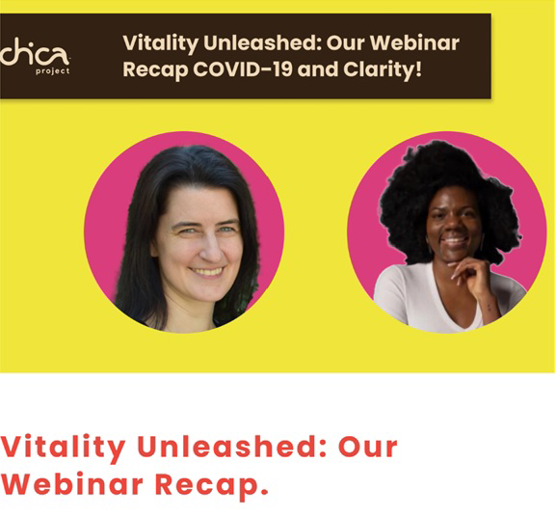
Share This Email
Visit the VEI Website
Read More Highlights
Late last year, the Chica Project planned
educational opportunities for their community, culminating in a webinar, "Vitality Unleashed: Your Path to Optimal Health." The event brought together community members from their programming (typically school-aged girls) to enhance their understanding of the current state of COVID-19, the critical importance of vaccinations, and strategies for winter preparedness and mental wellness. The webinar had 68 attendees, with participants actively engaging through hand raises, chat responses, and open discussions.
Share This Email
Share This Email
Highlights
Key Resources

OUTREACH AND EDUCATION MATERIALS

COVID-19 Vaccine Information
COVID-19 Therapeutic Information (including telehealth)
Archive of COVID-19 Vaccine Communications Updates (past editions of VEI Roundup)

FIND A COVID-19 VACCINE DOSE
Use Vaccines.gov to sign up for a COVID-19 vaccine appointment Find a community COVID-19 vaccination clinic near you
Learn about the COVID-19 In-Home Vaccination Program and request a visit Request a copy of your vaccine card

Vaccine Equity Initiative | 250 Washington Street, Boston, MA 02108 Unsubscribe vaccineequityinitiative@mass.gov
Constant Contact Data Notice
Sent by vei@vaccineequityinitiative.ccsend.com powered by
Try email marketing for free today!

