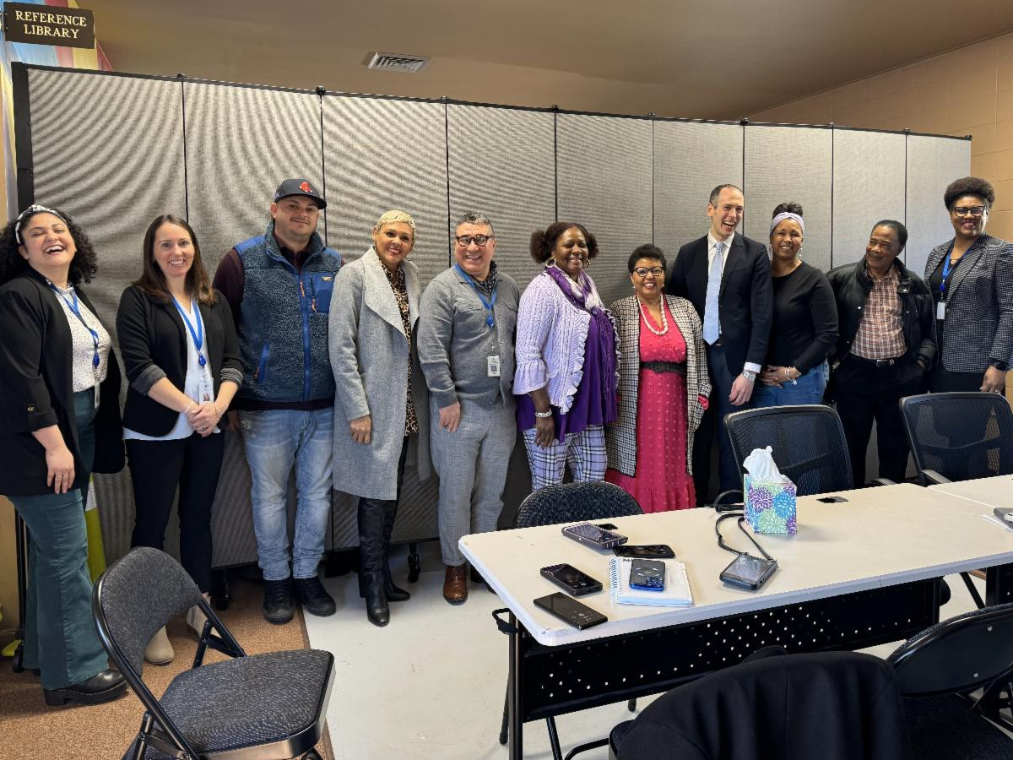
March 15, 2024
Here are the latest resources for promoting COVID-19 vaccination to share with your colleagues
and networks across Massachusetts. If you received this from a colleague, subscribe today.
View this email online.
What's New

DPH COMMISSIONER GOLDSTEIN VISITS VEI COVID VACCINE CLINIC
DPH Commissioner Robbie Goldstein visited the Latino Health Insurance Program’s flu and COVID clinic on March 1 and met with the many organizations providing wraparound services there. The conversations he had at the event are part of his commitment to engaging with community partners and ensuring their perspectives inform his decisions. He also met with VEI-funded community-based organizations, faith-based organizations, and organizations serving Tribal and Indigenous peoples during a large online meeting on March 15 as part of this ongoing commitment to communication.

ADULTS 65+ CAN NOW RECEIVE AN ADDITIONAL COVID-19 VACCINE DOSE
In February, the CDC voted to recommend an additional COVID-19 vaccine dose for adults ages 65 and older.
Looking for a COVID-19 vaccine? You can: Search vaccines.gov for appointments
Find a local mobile clinic near you Learn more about in-home

RESOURCES FROM ALL TOP DOC WEBINARS NOW AVAILABLE!
Thank you to everyone who joined in on VEI's Ask the Top Doc webinar series!
Slides, recordings, and other resources from all of the webinars are now available!

This includes:

Compilation of all Q&As
Webinar on respiratory illnesses: Presentation slides Presentation recording
Webinar on long COVID:

Presentation slides Presentation recording
Webinar on measles:

Presentation slides Presentation recording

Presentation recordings are currently available in English/ASL; other languages will be available soon!

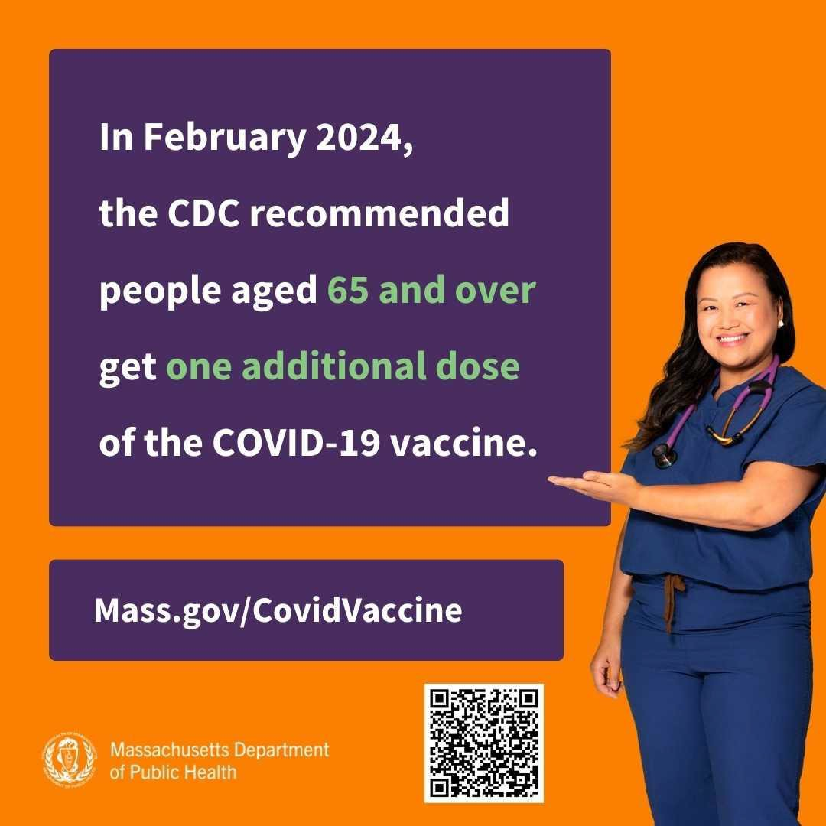
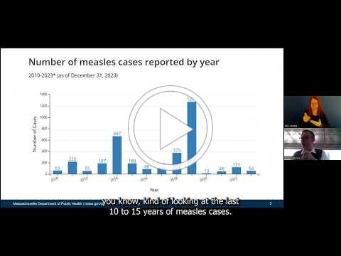
vaccination
If you have questions, please call 211 or (877) 211-6277 and press 1. Calls are answered Monday through Friday, 9 a.m. to 5 p.m.
Help spread the word! Click to download the shareable social media graphic pictured
above.
Reminders

NEW SOCIAL MEDIA GRAPHICS IN THE VAX PROMOTION TOOLKIT
These updated graphics give a quick overview of COVID vaccine basics and are easily shared on social media.
Now available in English, Haitian Creole, Portuguese, and Spanish.
Don't see the language you need? Let us know!

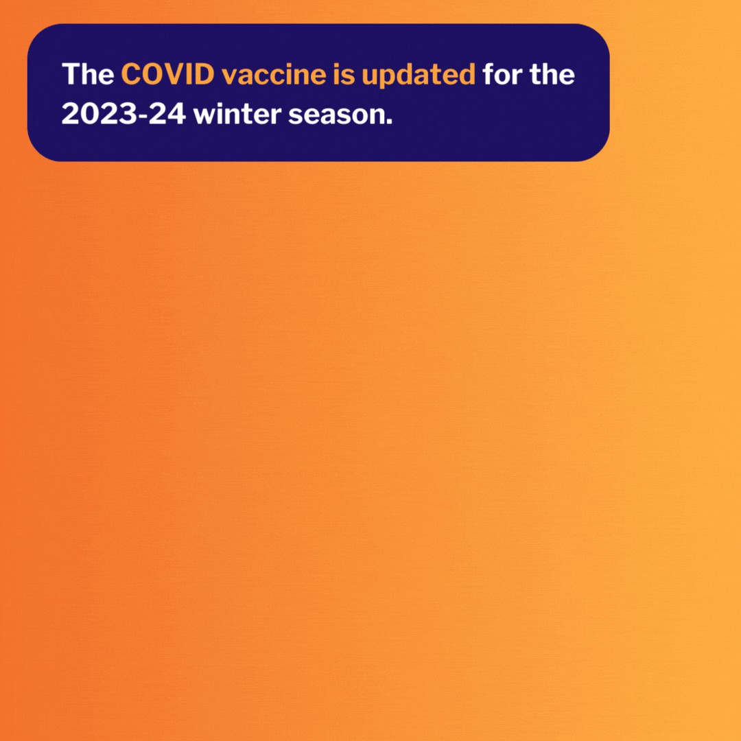
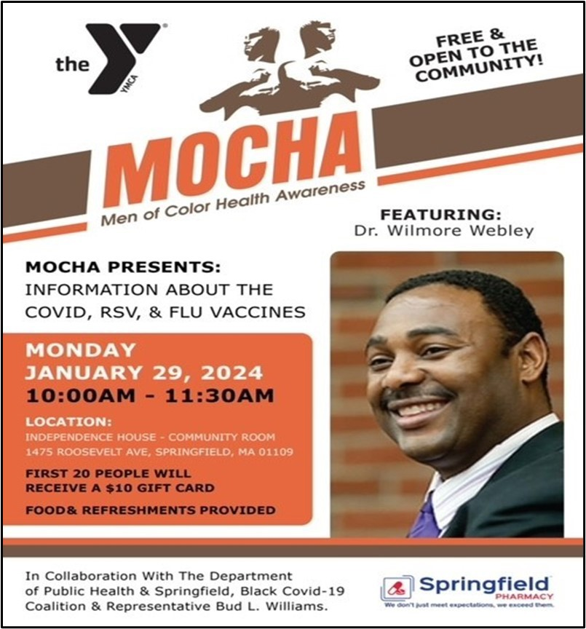

Men of Color Health Awareness (MOCHA) held several vaccine clinics and a presentation in January. In the presentation, delivered on January 29, Dr. Wilmore Webley covered COVID, flu, and RSV vaccines. MOCHA’s events emphasize their efforts to meet people where they are most comfortable. Vaccine clinics were held at low-income, affordable housing complexes and at a low-income senior housing center. These efforts have aided MOCHA in overcoming vaccine hesitancy and misinformation within their community by building trust and sharing resources directly.
Highlights
OUTREACH AND EDUCATION MATERIALS
COVID-19 Vaccine Information
COVID-19 Therapeutic Information (including telehealth)
Archive of COVID-19 Vaccine Communications Updates (past editions of VEI Roundup)
FIND A COVID-19 VACCINE DOSE
Use Vaccines.gov to sign up for a COVID-19 vaccine appointment Find a community COVID-19 vaccination clinic near you
Learn about the COVID-19 In-Home Vaccination Program and request a visit Request a copy of your vaccine card
Key Resources

Read More Highlights

Visit the VEI Website

Share This Email
Share This Email
Share This Email

Vaccine Equity Initiative | 250 Washington Street, Boston, MA 02108 Unsubscribe vaccineequityinitiative@mass.gov
Constant Contact Data Notice
Sent by vei@vaccineequityinitiative.ccsend.com powered by
Try email marketing for free today!

