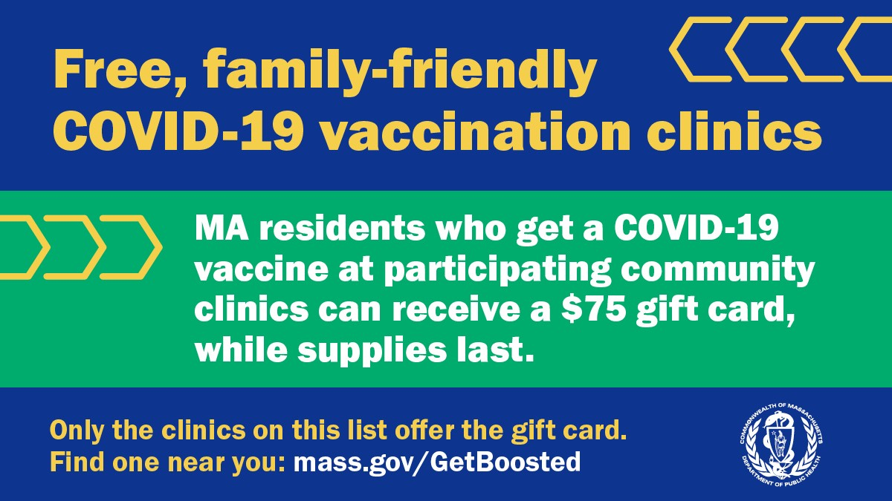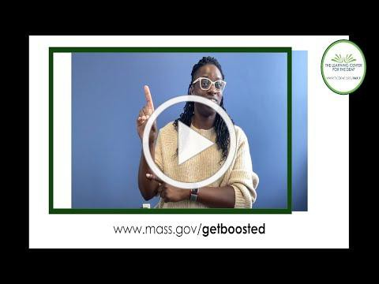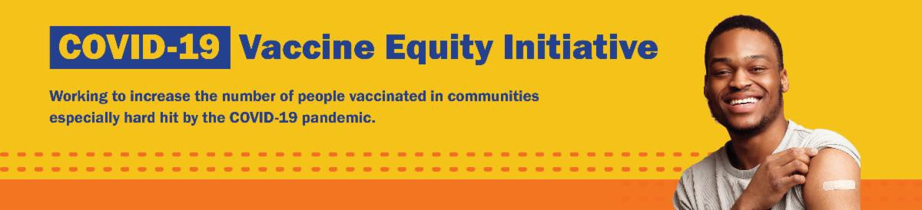
THERE'S STILL TIME: GET BOOSTED CAMPAIGN WILL END ON MARCH 31!

There's still time to get vaccinated and receive a $75 gift card! The Get Boosted campaign will end on March 31, 2023.

Over 72,000 vaccinations have been given since the campaign launched in October 2022.

Residents of all ages who get vaccinated (any dose) at participating clinics can receive a $75 gift card, while supplies last. Find participating clinics at mass.gov/GetBoosted.

Help spread the word: Flyers and other resources are available in multiple languages in our toolkit.

If you have questions about Get Boosted clinics, please call 2-1-1 (or 877-211-6277) and press 1. Calls are answered Monday through Friday, from 9 a.m. to 5 p.m.
With thanks to the Learning Center for the Deaf, info about Get Boosted clinics is also available in ASL.
March 17, 2023
Here are the latest resources for promoting COVID-19 vaccination to share with your colleagues
and networks across Massachusetts. If you received this from a colleague, subscribe today.

View this email online.
What's New

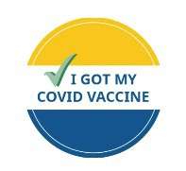
Get Boosted clinics were recently featured by WBZ News Radio and the Malden Patch.
Reminders

MASSHEALTH REDETERMINATION BEGINS IN APRIL: HELP MEMBERS KEEP THEIR HEALTH CARE COVERAGE

In 2023, all current MassHealth members will need to renew their health coverage to ensure they still qualify for their current benefit.

These renewals will take place over 12 months, starting in April 2023. MassHealth is working to help members maintain coverage and raise awareness about the renewal process and other coverage options, if needed.

Here's how you can help:

Remind members to update their addresses, report household changes, and read all mail from MassHealth
Share outreach materials from this toolkit (in multiple languages) Sign up for email notifications from MassHealth

LOST YOUR COVID-19 VACCINE CARD? HERE'S HOW TO GET A NEW ONE

There are a few ways to get a copy of your COVID-19 vaccine record:

If you were vaccinated at a health care center or by your primary care
provider: contact the location where you got vaccinated.

If you were vaccinated at a pop-up
clinic: contact your primary care provider, or explore the other options below.
If you were vaccinated at a retail pharmacy: you may be able to access your record online, or contact a pharmacist (varies by pharmacy).

If you were vaccinated at a state mass vaccination site: follow these instructions.

You can also:
Get a digital copy from My Vax Records .

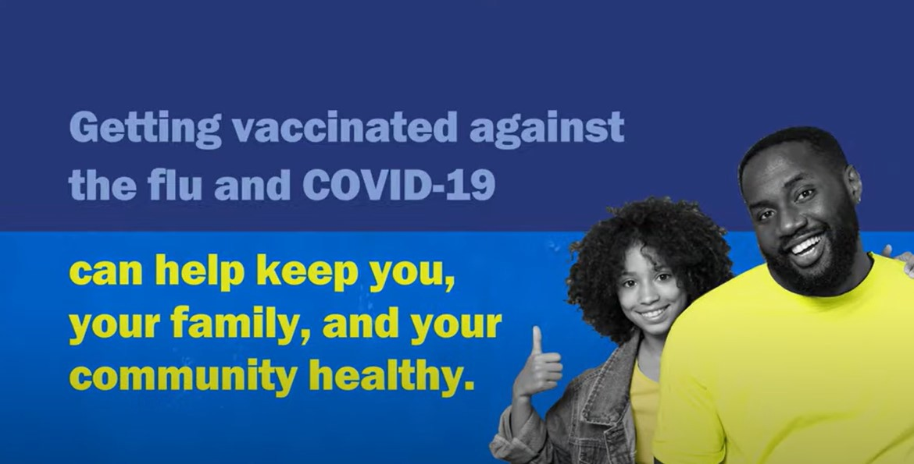
Find your record in v-safe (if you already enrolled).
Fill out a state immunization record request form. This will provide a record of all vaccines you've gotten. It may take several weeks to process.

Learn more, or call 2-1-1 with any questions.
IT'S NOT TOO LATE FOR A FLU SHOT! GET VACCINATED AGAINST COVID-19
AND THE FLU

It’s not too late to get a flu shot – and you can even get a flu shot and your COVID vaccine at the same time. Both vaccinations can help keep you, your family, and your community healthy. Learn more.
Key Resources

OUTREACH AND EDUCATION MATERIALS

COVID-19 Vaccine FAQs
COVID-19 Therapeutic Information (including telehealth) Weekly Provider Bulletin
Trust the Facts, Get the Vax Campaign Materials (organized by audience, including general, parents, youth, and young adults; available in 12 languages)
Multilingual COVID-19 Materials (videos and printables; organized by language)

COVID-19 Vaccination Tools for Employers
Archive of COVID-19 Vaccine Communications Updates (past editions of VEI Roundup)

FIND A COVID-19 VACCINE OR BOOSTER

Mass.gov/GetBoosted (family-friendly clinics through March 2023)
Vaccine Finder
Find, Schedule, or Sign Up for a Mobile COVID-19 Vaccination COVID-19 In-Home Vaccination Program
Request a Copy of Your Vaccine Card

Highlights

New Bedford
In late 2022, Centro Comunitario de Trabajadores held their end-of-the-year party, during which they also held their

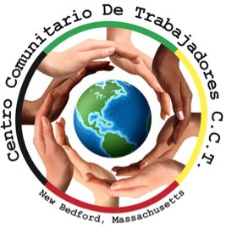
last COVID-19 vaccine clinic of the year.
In addition to the clinic, the party also included traditional Guatemalan food, a DJ and live music, gift cards, and raffles. While typically around 20 people get vaccinated at this party, this time, 73 individuals received vaccines.

Read More Highlights

Visit the VEI Website
Share This Email
Share This Email
Share This Email

Vaccine Equity Initiative | 250 Washington Street, Boston, MA 02108

Unsubscribe vaccineequityinitiative@mass.gov Constant Contact Data Notice
Sent by vaccineequityinitiative@mass.gov in collaboration with
Try email marketing for free today!

