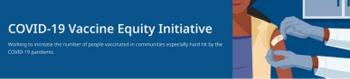March 18, 2022
See below for news and resources about COVID-19 vaccination. Please share this newsletter with colleagues including local social service agencies, community organizations, or colleagues working to increase vaccination across Massachusetts. To subscribe, click here.
What's New
BECOME A VACCINE CHAMPION: LEARN WAYS TO IMPROVE CONFIDENCE IN COVID-19 VACCINES
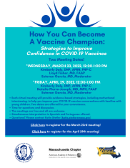
- DPH and other partners are
offering 2 upcoming trainings on
strategies to improve confidence
in COVID-19 vaccines. Meetings
are free and all are welcome.
Learn more, or register for
March 23 or April 29.
MA DPH UPDATES COVID-19 DEATH DEFINITION
- News Release (3/10) - This
revision captures more
accurately the acute impact of
COVID in MA and enables
comparison with other states.
Reminders
4 MORE AT-HOME COVID TESTS AVAILABLE FREE VIA US POSTAL SERVICE
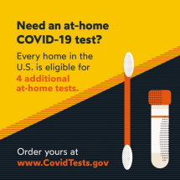
- Every U.S. household can order an
additional set of 4 at-home COVID-19
tests from the federal government.
This means every home is eligible to
receive a total of 8 free tests. Get Free
At-Home COVID Tests
- Additional info about COVID testing,
including what to do if you test
positive, is available at
mass.gov/GetTested.
UPDATES TO STOP THE SPREAD TESTING PROGRAM
- News Release (3/4) - Due to
significant decline in demand at
state sponsored Stop the Spread
testing sites and the wide
availability of rapid antigen
tests, the program will downsize
to 11 sites, effective April 1.
PHYSICIAN DESCRIBES NEW COVID-19 TREATMENT OPTIONS
- Patients recently diagnosed with
COVID-19 have options for treatment,
available at no cost at sites across MA.
Listen to Dr. Sandeep Jubbal, Medical
Director at UMass Memorial Medical
Center, describe treatment safety and
efficacy.

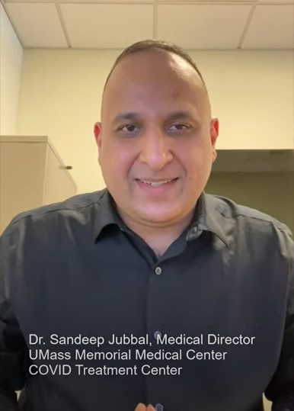
- Learn more about treatment options (info also available in 12 languages), or locate treatment near you.
Above: Dr. Jubbal discusses new COVID
treatment options.
MULTILINGUAL COVID-19 MATERIALS FROM DPH
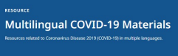
- Resources to support COVID-19 vaccine promotion and education, organized by language. Includes videos and printables on topics like vaccine safety, pregnancy and the vaccine, and FAQs.
IN-HOME VACCINATIONS AVAILABLE
- The COVID-19 In-Home Vaccination Program is a resource for anyone who has difficulty getting to or using a community vaccination location.
Key Resources
OUTREACH AND EDUCATION MATERIALS
- COVID-19 Vaccine FAQs
- COVID-19 Booster FAQs
- Weekly Provider Bulletin
- Trust the Facts, Get the Vax Campaign Materials (organized by audience, including general, parents and pregnant people, youth, young adults; available in 12 languages)
- Trust the Facts, Get the Vax Creative Materials Toolkit (updates ongoing, including
- pediatric eligibility)
- Additional Education and Outreach Materials (includes social media graphics, vaccine updates, guides to hosting a forum, and more)
- Multilingual COVID-19 Materials (videos and printables; organized by language)
- COVID-19 Funeral Assistance from FEMA (including 1-pager with key info available in multiple languages)
- COVID-19 Vaccination Tools for Employers
- Archive of COVID-19 Vaccine Communications Updates (past editions of VEI Roundup)
FIND A COVID-19 VACCINE OR BOOSTER
- Vaccine Finder
- Find, Schedule, or Sign Up for a Mobile COVID-19 Vaccination
- COVID-19 In-Home Vaccination Program
- Request a Copy of Your Vaccine Card
COVID-19 VACCINE STANDING ORDERS (FROM CDC)
- Pfizer
  - 5-11 (updated 2/7/22)
  - 12 + Gray Cap (updated 2/25/22)
  - 12 + Purple Cap (updated 2/25/22)
- Moderna (updated 2/28/22)
- Janssen (updated 2/22/22)
Recent Highlights
Fitchburg
Last week, Fitchburg offered a community outreach and education event to answer parents' questions about pediatric vaccination and share information. The event was held with partners including the YMCA, the Perinatal-Neonatal Quality Improvement Network of Massachusetts (PNQIN), the Fitchburg Local Board of Health, Fitchburg Vaccine Access and Administration providers, and the DPH Fitchburg/Leominster Community Liaison.
Read More Highlights
Visit the VEI Website
Vaccine Equity Initiative | 250 Washington Street, Boston, MA 02108
Unsubscribe vaccineequityinitiative@mass.gov About Constant Contact
Sent byvaccineequityinitiative@mass.govin collaboration with
Try email marketing for free today!

