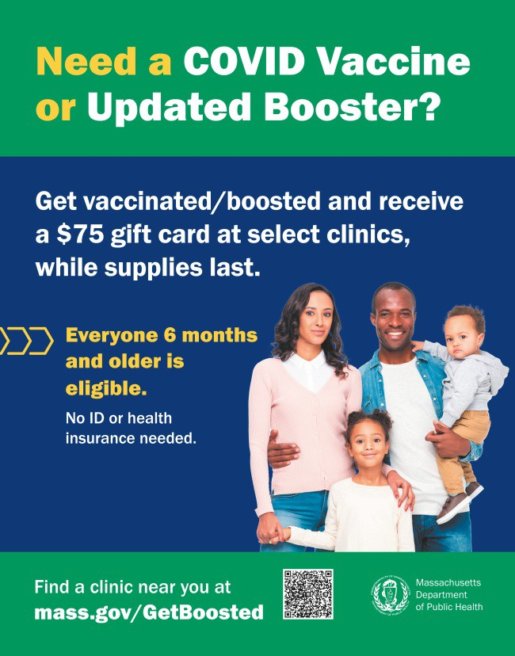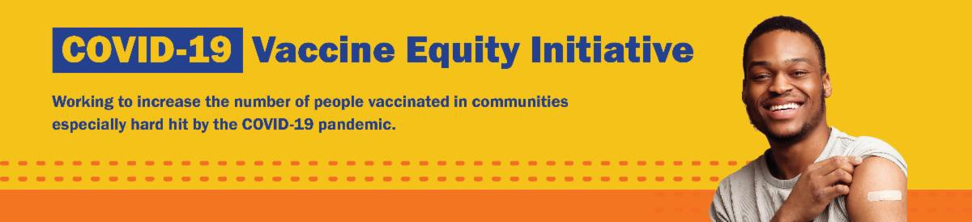
NOW IS THE TIME: GET BOOSTED CAMPAIGN WILL END ON MARCH 31!

There's still time to get vaccinated and receive a $75 gift card! The Get Boosted campaign will end on March 31, 2023.

Nearly 75,000 vaccinations have been given since the campaign launched in October 2022.

Residents of all ages who get vaccinated (any dose) at participating clinics can receive a $75 gift card, while supplies last. Find participating clinics at mass.gov/GetBoosted.

Help spread the word: Flyers and other resources are available in multiple languages in our toolkit.
If you have questions about Get
Boosted clinics, please call 2-1-1 (or 877-211-6277) and press 1. Calls are answered Monday through Friday, from 9 a.m. to 5 p.m.
With thanks to the Learning Center for the Deaf, info
about Get Boosted clinics is also available in ASL.
Get Boosted clinics were recently featured by the Eagle Tribune and Vineyard Gazette.
March 24, 2023
Here are the latest resources for promoting COVID-19 vaccination to share with your colleagues
and networks across Massachusetts. If you received this from a colleague, subscribe today.

View this email online.
What's New

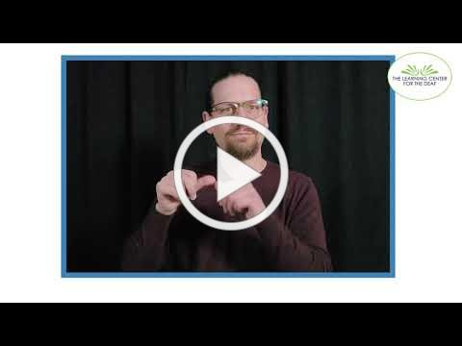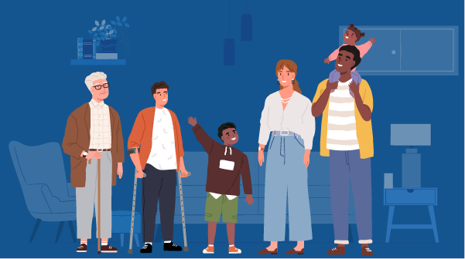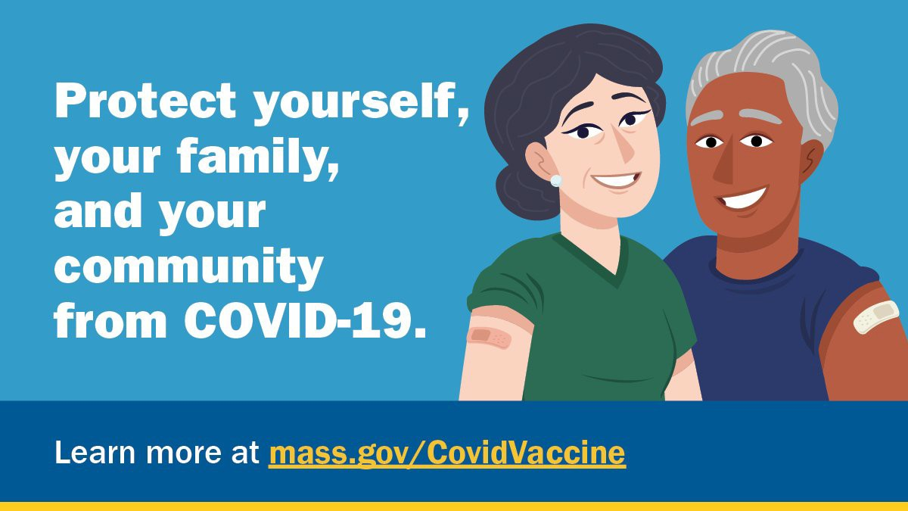
Reminders

MASSHEALTH REDETERMINATION BEGINS IN APRIL: HELP MEMBERS KEEP THEIR HEALTH CARE COVERAGE

In 2023, all current MassHealth members will need to renew their health coverage to ensure they still qualify for their current benefit.

These renewals will take place over 12 months, starting in April 2023. MassHealth is working to help members maintain coverage and raise awareness about the renewal process and other coverage options, if needed.

Info about MassHealth redetermination is available in ASL, courtesy of the Learning Center for the Deaf.

Here's how you can help:

Remind members to update their addresses, report household changes, and read all mail from MassHealth
Share outreach materials from this toolkit (in multiple languages) Sign up for email notifications from MassHealth

FREE IN-HOME COVID-19 VACCINATION AVAILABLE

Massachusetts offers in-home COVID-19 vaccinations for anyone who has difficulty getting to or using a community clinic, including young children. Learn more, or call 833-983-0485 to sign up for an in- home appointment.

Help spread the word with
this informational flyer (in 12 languages)!

FOLLOW THESE SEVEN STEPS TO HELP PROTECT AGAINST COVID-19

There are a number of steps that you can take to help protect yourself, your family, and your community from COVID-19.

Available in multiple languages, this flyer features a checklist with these
steps. Please share it with your networks.

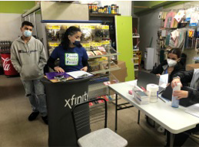
Springfield
On January 21, Pioneer Valley Project hosted a COVID-19 vaccine clinic at People’s Supermarket, a Springfield-based bodega in a Spanish-speaking neighborhood (see photo). For the clinic, Pioneer Valley Project had on-site bilingual/Spanish-speaking staff to attend to the community’s linguistic and cultural needs. In total, 27 individuals were vaccinated, including the owner of People’s Supermarket, who received a booster. Due to the clinic’s success, Pioneer Valley Project partnered with the bodega for a clinic on February 18, at which 25 people got vaccinated.
Read More Highlights
Highlights
Key Resources

OUTREACH AND EDUCATION MATERIALS

COVID-19 Vaccine FAQs
COVID-19 Therapeutic Information (including telehealth) Weekly Provider Bulletin
Trust the Facts, Get the Vax Campaign Materials (organized by audience, including general, parents, youth, and young adults; available in 12 languages)
Multilingual COVID-19 Materials (videos and printables; organized by language)
COVID-19 Vaccination Tools for Employers
Archive of COVID-19 Vaccine Communications Updates (past editions of VEI Roundup)

FIND A COVID-19 VACCINE OR BOOSTER

Mass.gov/GetBoosted (family-friendly clinics through March 2023)
Vaccine Finder
Find, Schedule, or Sign Up for a Mobile COVID-19 Vaccination COVID-19 In-Home Vaccination Program
Request a Copy of Your Vaccine Card

Share This Email
Share This Email
Share This Email

Visit the VEI Website

Vaccine Equity Initiative | 250 Washington Street, Boston, MA 02108

Unsubscribe vaccineequityinitiative@mass.gov Constant Contact Data Notice
Sent by vaccineequityinitiative@mass.gov in collaboration with
Try email marketing for free today!

