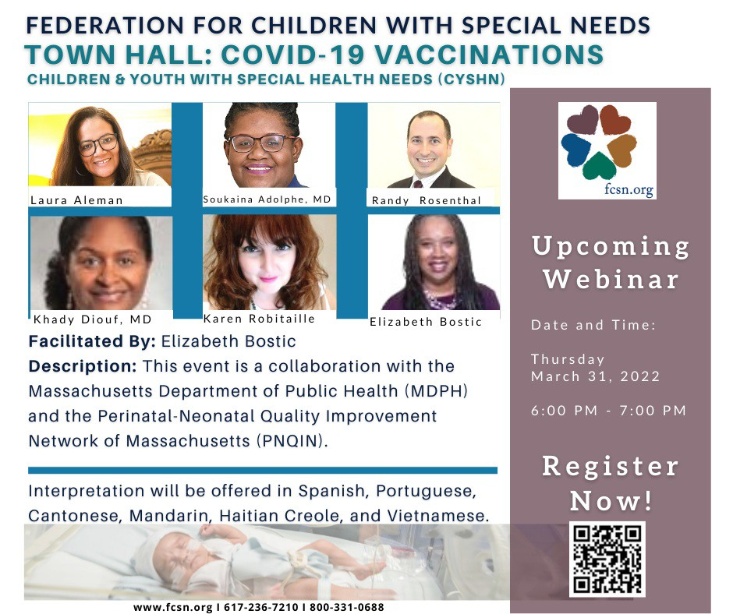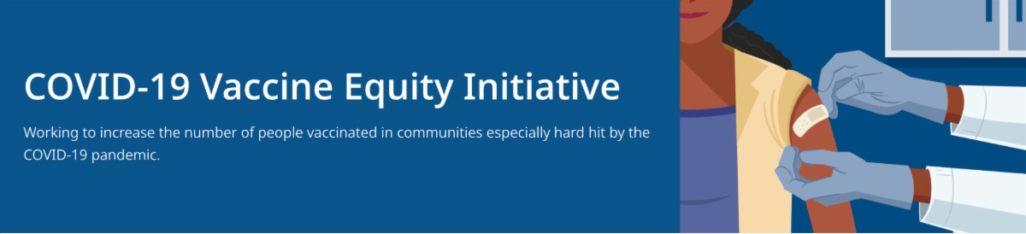
BECOME A VACCINE CHAMPION: LEARN WAYS TO IMPROVE CONFIDENCE IN COVID-19 VACCINES

DPH and other partners are offering trainings on strategies to improve confidence in COVID-19 vaccines. Meetings are free and all are welcome. Learn more, or register for April 29.
Reminders

MARCH 31 TOWN HALL: CHILDREN AND YOUTH WITH SPECIAL HEALTH NEEDS AND COVID-19 VACCINATIONS

All are invited to join a presentation and discussion about COVID-19 vaccination for children with special health needs on March 31 at 6:00 pm. Presented by DPH in collaboration with other partners, the event will have interpretation offered in multiple languages. Learn more or register here.
March 25, 2022
See below for news and resources about COVID-19 vaccination. Please share this newsletter with
colleagues including local social service agencies, community organizations, or colleagues working to increase vaccination across Massachusetts. To subscribe, click here.
What's New

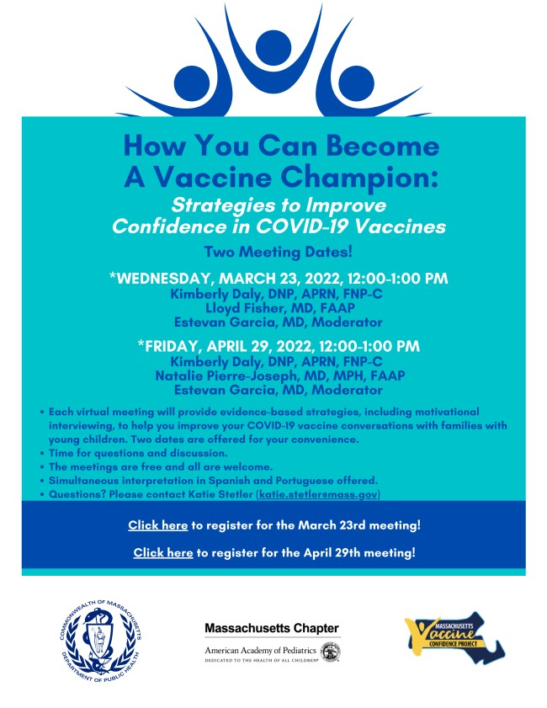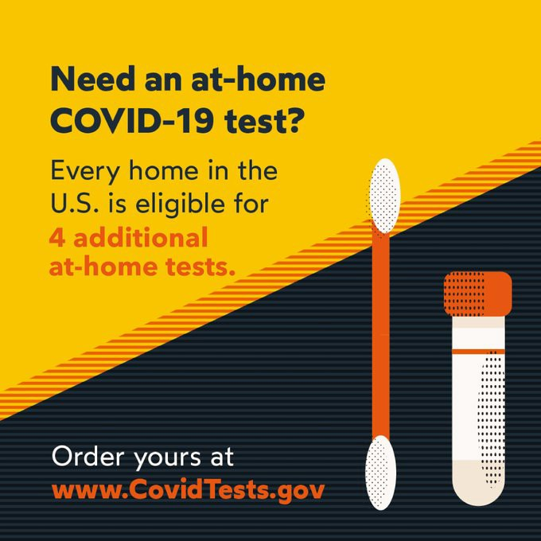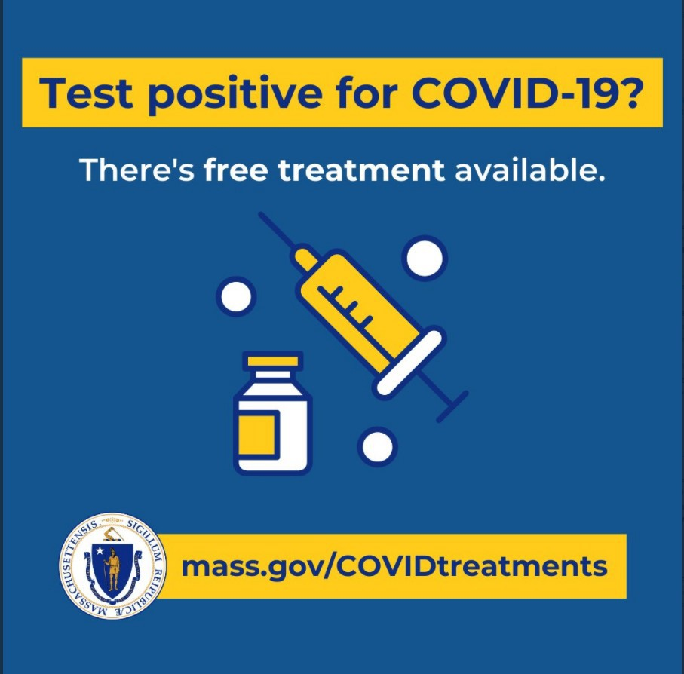

4 MORE AT-HOME COVID TESTS AVAILABLE FREE VIA US POSTAL SERVICE

Every U.S. household can order an additional set of 4 at-home COVID-19 tests from the federal government.
This means every home is eligible to receive a total of 8 free tests. Get Free At-Home COVID Tests

Additional info about COVID testing, including what to do if you test positive, is available at mass.gov/GetTested.

FREE COVID-19 TREATMENT OPTIONS

Patients recently diagnosed with COVID-19 have options for treatment, available at no cost at sites across MA. Learn more about treatment options (info also available in 12 languages), or locate treatment.

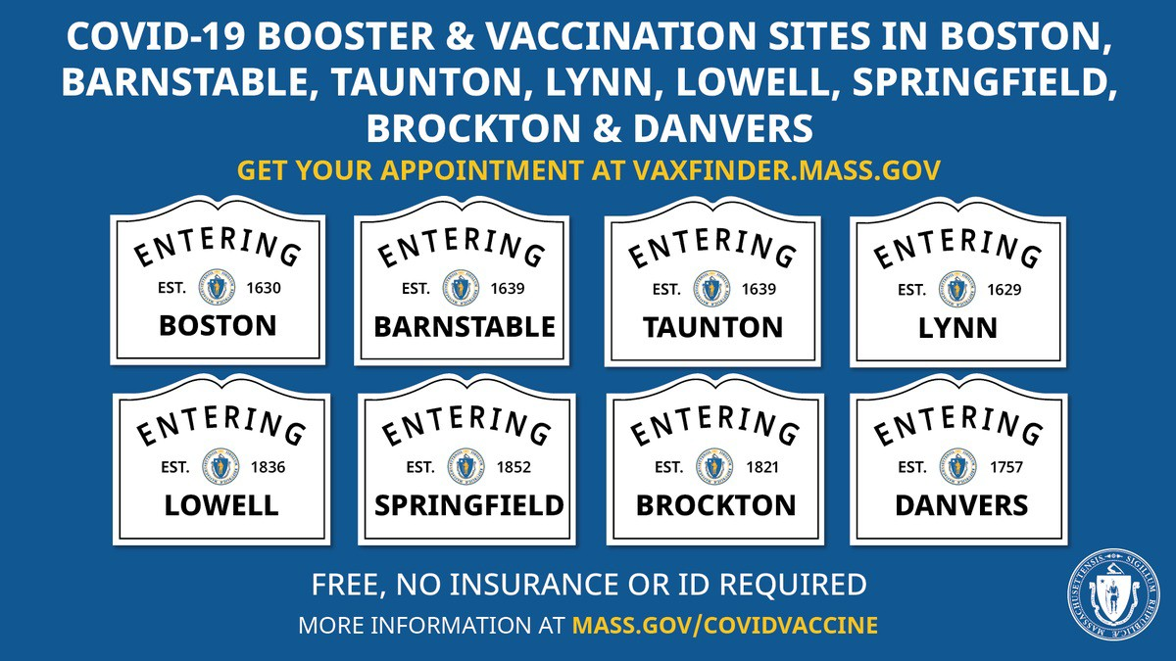
OUTREACH AND EDUCATION MATERIALS

COVID-19 Vaccine FAQs COVID-19 Booster FAQs
Weekly Provider Bulletin (published 3/22)
Trust the Facts, Get the Vax Campaign Materials(organized by audience, including general, parents and pregnant people, youth, young adults; available in 12 languages)
Trust the Facts, Get the Vax Creative Materials Toolkit(updates ongoing, including pediatric eligibility)
Key Resources

FIND A BOOSTER APPOINTMENT NEAR YOU

Booster shots provide an added layer of defense against the virus and its variants and can help keep you healthy and safe. Find your appointment or walk-in location.

Questions about boosters? Check out the COVID-19 booster FAQ (available in 12 languages).

TRUST THE FACTS. GET THE VAX. CAMPAIGN MATERIALS AVAILABLE FOR USE

Campaign materials include animations, videos, and flyers. Organized by audience, including general, parents and pregnant people, youth, young adults; available in 12 languages. Learn more.

MA DPH UPDATES COVID-19 DEATH DEFINITION

News Release (3/10) - This revision captures more accurately the acute impact of COVID in MA and enables comparison with other states.

Additional Education and Outreach Materials(includes social media graphics, vaccine
updates, guides to hosting a forum, and more)
Multilingual COVID-19 Materials (videos and printables; organized by language) COVID-19 Funeral Assistance from FEMA(including 1-pager with key info available in multiple languages)
COVID-19 Vaccination Tools for Employers
Archive of COVID-19 Vaccine Communications Updates (past editions of VEI Roundup)

FIND A COVID-19 VACCINE OR BOOSTER

Vaccine Finder
Find, Schedule, or Sign Up for a Mobile COVID-19 Vaccination COVID-19 In-Home Vaccination Program
Request a Copy of Your Vaccine Card

COVID-19 VACCINE STANDING ORDERS (FROM CDC)

Pfizer
5-11 (updated 2/7/22)
12 + Gray Cap(updated 2/25/22)
12 + Purple Cap (updated 2/25/22)
Moderna (updated 2/28/22)
Janssen (updated 2/22/22)

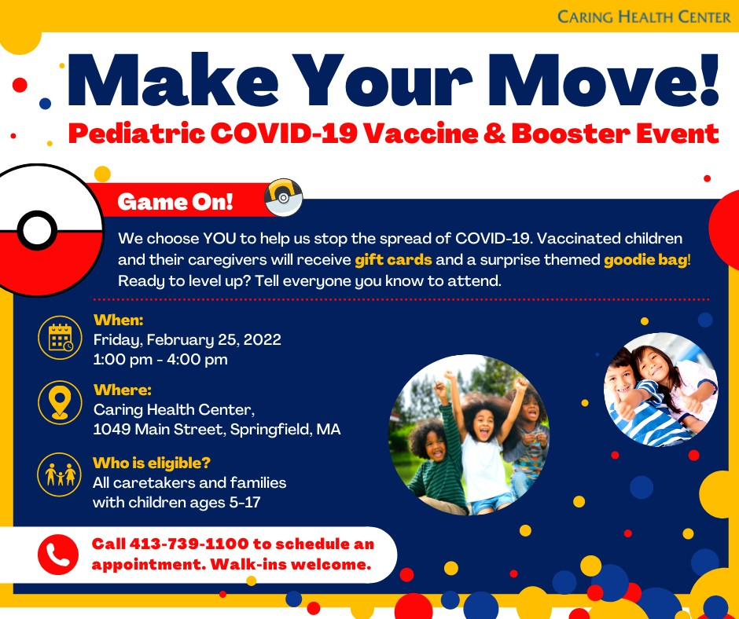
Springfield

In Springfield, Caring Health Center has been getting creative with vaccine clinic themes, including "Calling All Superheroes" (3/18), "Make Your Move!" (3/4, see flyer, right), and "Spread Love, Not COVID" (2/11). The family- friendly clinics offer primary series and booster doses, and staff, community health workers, and translators are on hand to answer any questions that parents may have about pediatric vaccination.
Read More Highlights
Visit the VEI Website
Share This Email
Share This Email
Share This Email
Recent Highlights

Vaccine Equity Initiative | 250 Washington Street, Boston, MA 02108 Unsubscribe vaccineequityinitiative@mass.gov
About Constant Contact
Sent byvaccineequityinitiative@mass.govin collaboration with
Try email marketing for free today!

