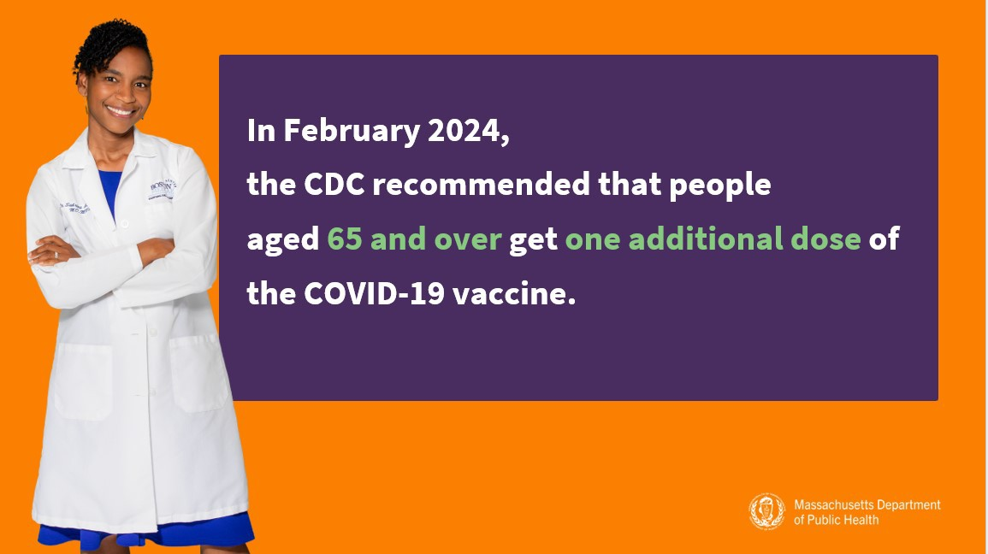
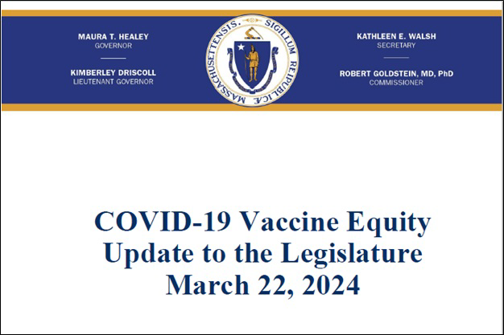
NEW IN THE VAX PROMOTION TOOLKIT: SLIDESHOWS AND SOCIAL MEDIA
GRAPHICS!
Adults ages 65 and older are now recommended to get an additional updated COVID-19 vaccine dose.
Help spread the word with a PowerPoint slideshow with the updated guidance (in English and Spanish) and social media graphics (also in English and Spanish).
COVID-19 VACCINE EQUITY PLAN: 60-DAY UPDATE
DPH submits a Vaccine Equity report to the Legislature every 60 days that outlines the progress and results made through the Vaccine Equity Initiative.
Read the most recent report, submitted on March 22.
Reminders
March 29, 2024
Here are the latest resources for promoting COVID-19 vaccination to share with your colleagues
and networks across Massachusetts. If you received this from a colleague, subscribe today.
View this email online.
What's New

DPH COMMISSIONER GOLDSTEIN VISITS VEI COVID VACCINE CLINIC

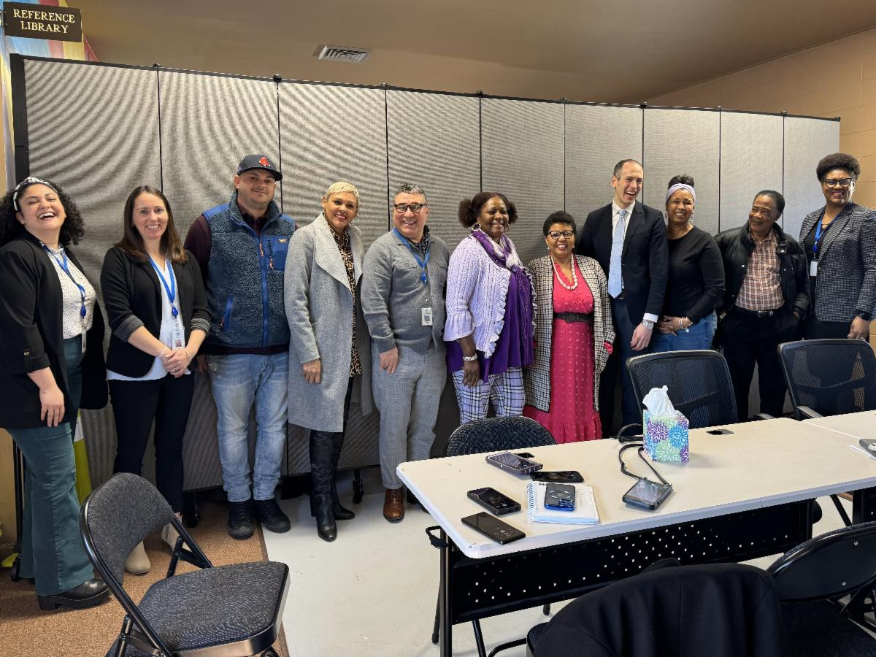
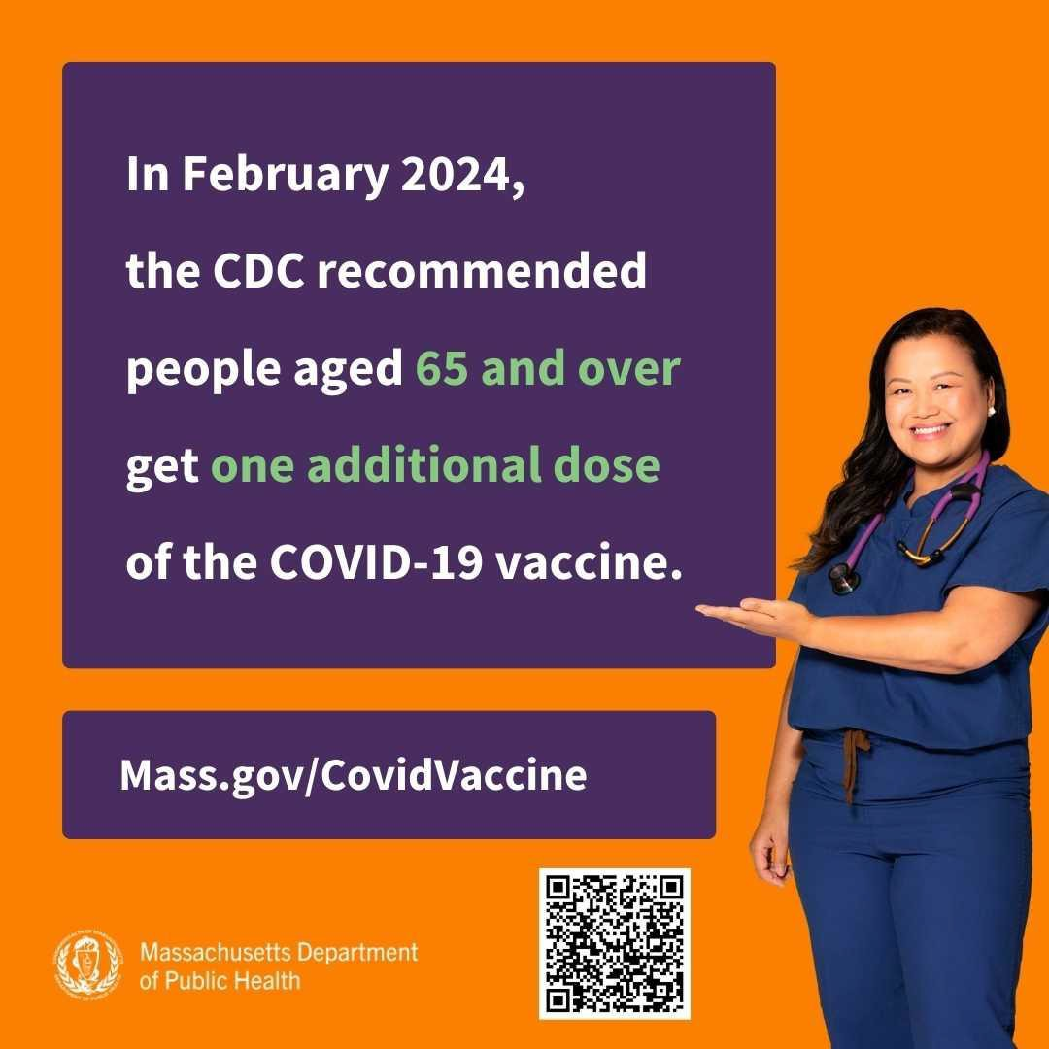
DPH Commissioner Robbie Goldstein
OUTREACH AND EDUCATION MATERIALS
COVID-19 Vaccine Information
COVID-19 Therapeutic Information (including telehealth)
Archive of COVID-19 Vaccine Communications Updates (past editions of VEI Roundup)
FIND A COVID-19 VACCINE DOSE
Use Vaccines.gov to sign up for a COVID-19 vaccine appointment Find a community COVID-19 vaccination clinic near you
Learn about the COVID-19 In-Home Vaccination Program and request a visit
Key Resources
visited the Latino Health Insurance Program’s flu and COVID clinic on March 1 and met with the many organizations providing wraparound services there. The conversations he had at the event are part of his commitment to engaging with community partners and ensuring their perspectives inform his decisions. He also met with VEI-funded community-based organizations, faith-based organizations, and organizations serving Tribal and Indigenous peoples during a large online meeting on March 15 as part of this ongoing commitment to communication.

ADULTS 65+ CAN NOW RECEIVE AN ADDITIONAL COVID-19 VACCINE DOSE
In February, the CDC voted to recommend an additional COVID-19 vaccine dose for adults ages 65 and older.
Looking for a COVID-19 vaccine? You can: Search vaccines.gov for appointments
Find a local mobile clinic near you Learn more about in-home vaccination
If you have questions, please call 211 or (877) 211-6277 and press 1. Calls are answered Monday through Friday, 9 a.m. to 5 p.m.

Help spread the word! Click to download the shareable social media graphic pictured above.

Request a copy of your vaccine card

Highlights
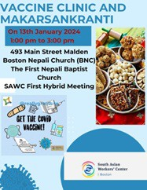
South Asian Workers’ Center (SAWC) has continued their strong focus on culturally responsive COVID vaccine education and clinics. During their January vaccine clinic and Makarsankranti (see flyer), 12 people were vaccinated. SAWC has also been helping individuals with navigating vaccine access barriers around IDs and insurance cards.

Read More Highlights

Share This Email
Share This Email
Share This Email

Visit the VEI Website

Vaccine Equity Initiative | 250 Washington Street, Boston, MA 02108 Unsubscribe vaccineequityinitiative@mass.gov
Constant Contact Data Notice
Sent by vei@vaccineequityinitiative.ccsend.com powered by

Try email marketing for free today!

