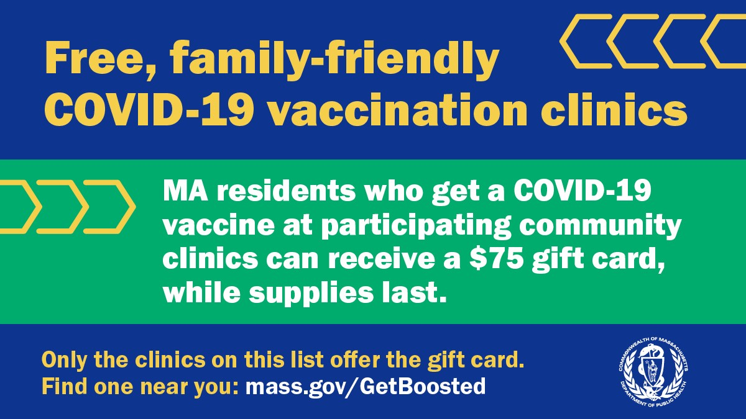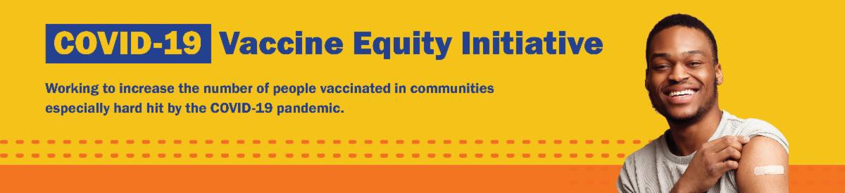
March 31, 2023
Here are the latest resources for promoting COVID-19 vaccination to share with your colleagues
and networks across Massachusetts. If you received this from a colleague, subscribe today.

View this email online.
What's New

GET BOOSTED ENDS MARCH 31: THANK YOU FOR YOUR SUPPORT!

The Get Boosted campaign is ending today, March 31, 2023.

As of March 26, over 77,000 vaccinations have been given since the campaign launched in October 2022. Thank you to everyone who helped make this possible!

Although Get Boosted's $75 gift card promotion is ending, other community clinics will continue. Find a local clinic here. Our COVID-19 vaccine promotion toolkit will also continue to be updated.

Questions? Please call 2-1-1 (or 877-211- 6277) and press 1. Calls are answered Monday through Friday, 9 a.m. to 5 p.m.

NEED A COVID-19 VACCINE OR BOOSTER? HERE'S HOW TO FIND ONE

Free COVID-19 vaccine clinics are still being held throughout Massachusetts!

To find COVID-19 vaccination opportunities, you can:
Search vaccines.gov for appointments

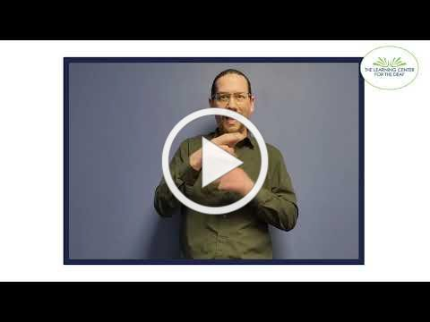
Fine a local mobile clinic near you
Learn more about in-home vaccination

If you have questions, please call 211 (or 877-211-6277) and press 1. Calls are answered Monday through Friday, 9 a.m. to 5 p.m.
Reminders

MASSHEALTH REDETERMINATION BEGINS IN APRIL: HELP MEMBERS KEEP THEIR HEALTH CARE COVERAGE

In 2023, all current MassHealth members will need to renew their health coverage to ensure they still qualify for their current benefit.

These renewals will take place over 12 months, starting in April 2023. MassHealth is working to help members maintain coverage and raise awareness about the renewal process and other coverage options, if needed.

Info about MassHealth redetermination (intro and key points) is available in ASL, courtesy of the Learning Center for the Deaf.

Here's how you can help:

Remind members to update their addresses, report household changes, and read all mail from MassHealth
Share informational and outreach materials from this toolkit
Sign up for email notifications from MassHealth

MY VAX RECORDS: A DIGITAL VACCINE CARD FOR MASSACHUSETTS RESIDENTS

Need a copy of your COVID-19 vaccination record? Massachusetts residents can use My Vax Records to get a digital vaccine

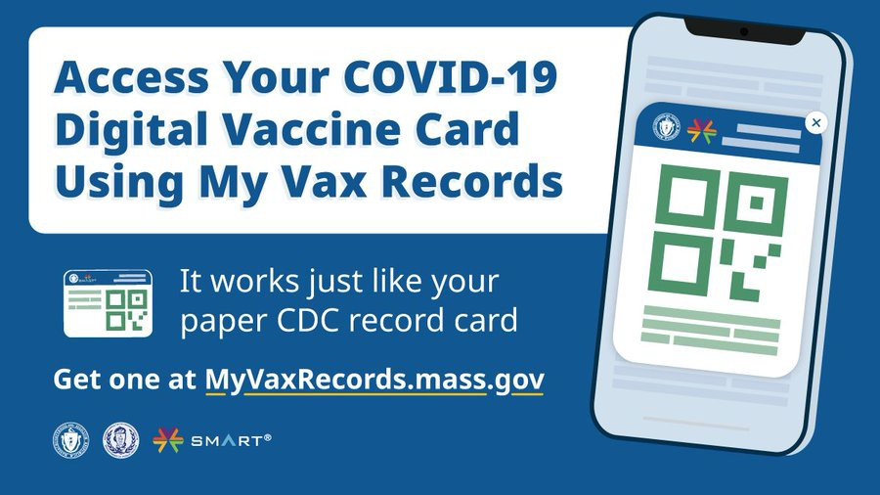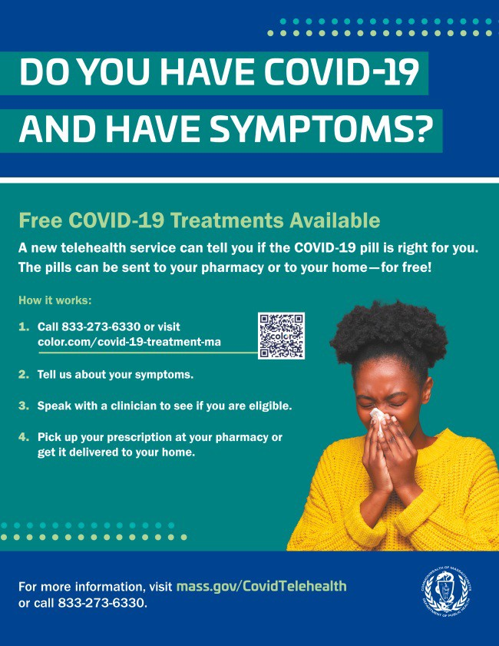card to show they’ve been vaccinated
OUTREACH AND EDUCATION MATERIALS

COVID-19 Vaccine FAQs
COVID-19 Therapeutic Information (including telehealth) Weekly Provider Bulletin
Trust the Facts, Get the Vax Campaign Materials (organized by audience, including general, parents, youth, and young adults; available in 12 languages)
Multilingual COVID-19 Materials (videos and printables; organized by language) Archive of COVID-19 Vaccine Communications Updates (past editions of VEI Roundup)
FIND A COVID-19 VACCINE OR BOOSTER

Find a COVID-19 Vaccine or Booster Appointment
Find, Schedule, or Sign Up for a Mobile COVID-19 Vaccination COVID-19 In-Home Vaccination Program
Request a Copy of Your Vaccine Card
Key Resources
against COVID-19, if they choose. Learn more.

Info about My Vax Records is available in ASL, courtesy of the Learning Center for the Deaf.

FREE COVID TREATMENT AVAILABLE VIA PHONE OR ONLINE

Free, safe, and effective treatments for COVID-19 are available across Massachusetts. They can help prevent hospitalizations and reduce the risk of severe disease.

Telehealth consultations are available via phone at 833-273-6330, in addition to online. Consultations can be accessed in 10+ languages.

Please share: Flyers are now available in 12 languages!

Highlights

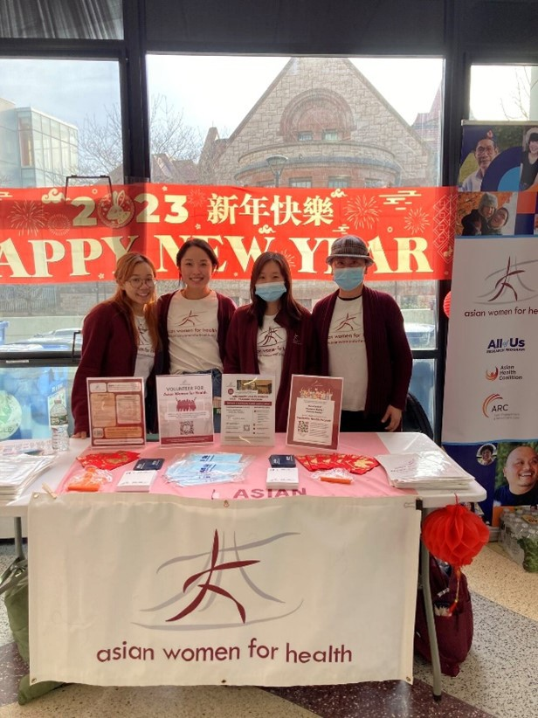Malden
Asian Women for Health is currently launching a college outreach program. As part of this program, they are choosing college liaisons who will work to educate and encourage college students to get vaccinated against COVID-19. Events will be scheduled at Northeastern University and Boston University.

Read More Highlights

Share This Email
Share This Email
Share This Email

Visit the VEI Website

Vaccine Equity Initiative | 250 Washington Street, Boston, MA 02108 Unsubscribe vaccineequityinitiative@mass.gov
Constant Contact Data Notice
Sent by vaccineequityinitiative@mass.gov in collaboration with
Try email marketing for free today!

