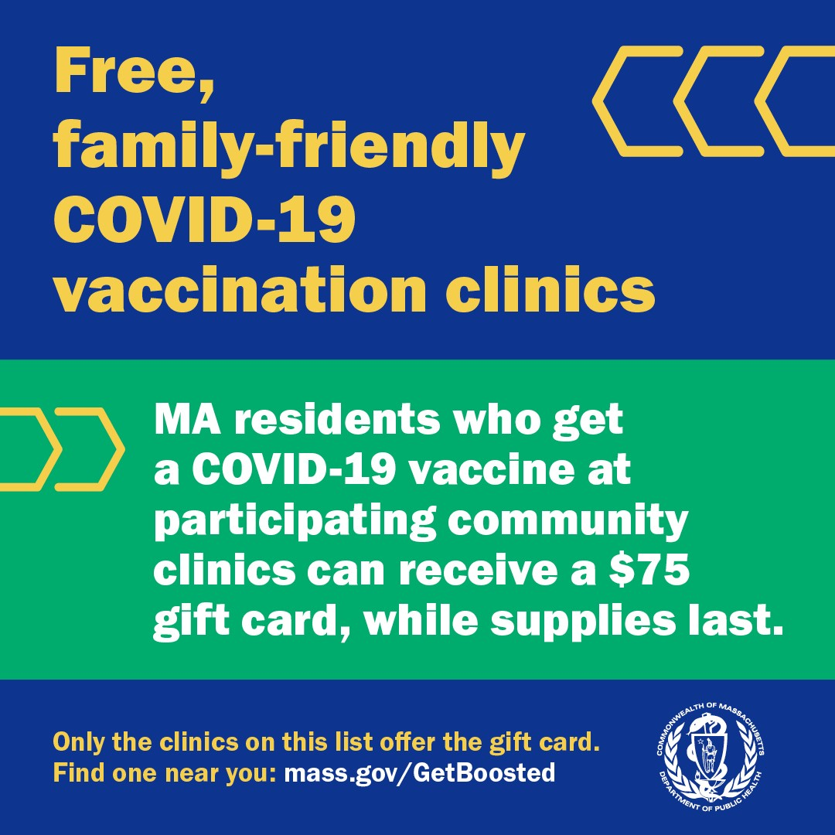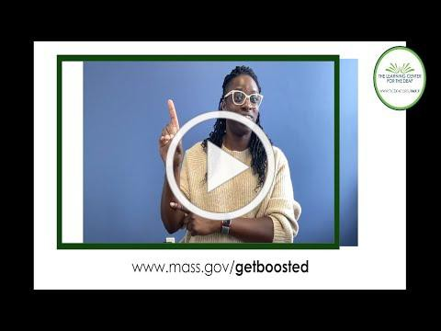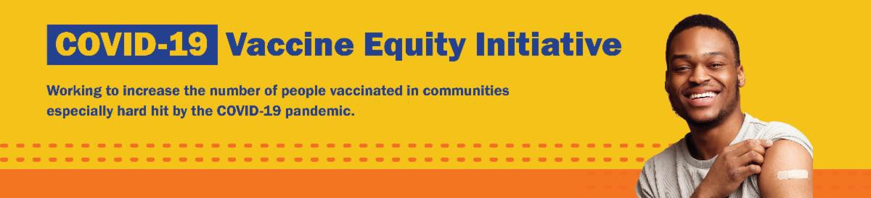
THERE'S STILL TIME: GET BOOSTED CLINICS RUN THROUGH MARCH 31!

There's still time to get vaccinated and receive a $75 gift card! Get Boosted clinics run through March 31, 2023.

Nearly 69,000 vaccinations have been given since the campaign launched in October 2022.

Residents of all ages who get vaccinated (any dose) at participating clinics can receive a $75 gift card, while supplies last. Find participating clinics at mass.gov/GetBoosted.

Help spread the word: Flyers and other resources are available in multiple languages in our toolkit.
If you have questions about Get
Boosted clinics, please call 2-1-1 (or 877-211-6277) and press 1. Calls are answered Monday through Friday, from 9 a.m. to 5 p.m.
With thanks to the Learning Center for the Deaf, info.
about Get Boosted clinics is also available in ASL.
Get Boosted clinics were recently featured in the media by WAMC and WWLP.
March 3, 2023
Here are the latest resources for promoting COVID-19 vaccination to share with your colleagues
and networks across Massachusetts. If you received this from a colleague, subscribe today.

View this email online.
What's New

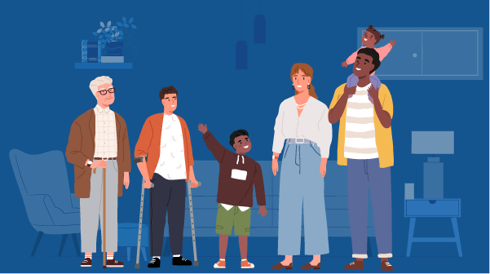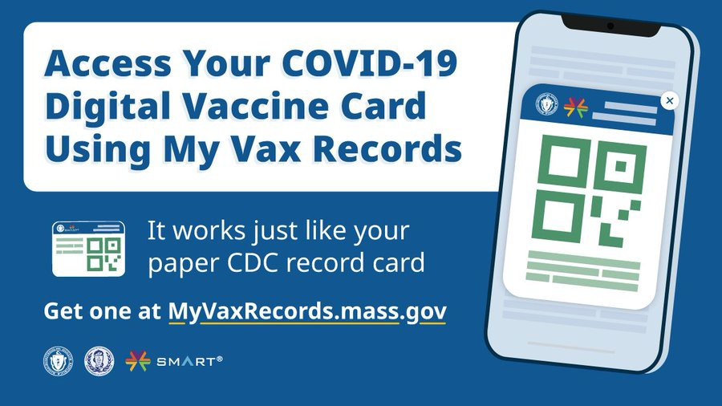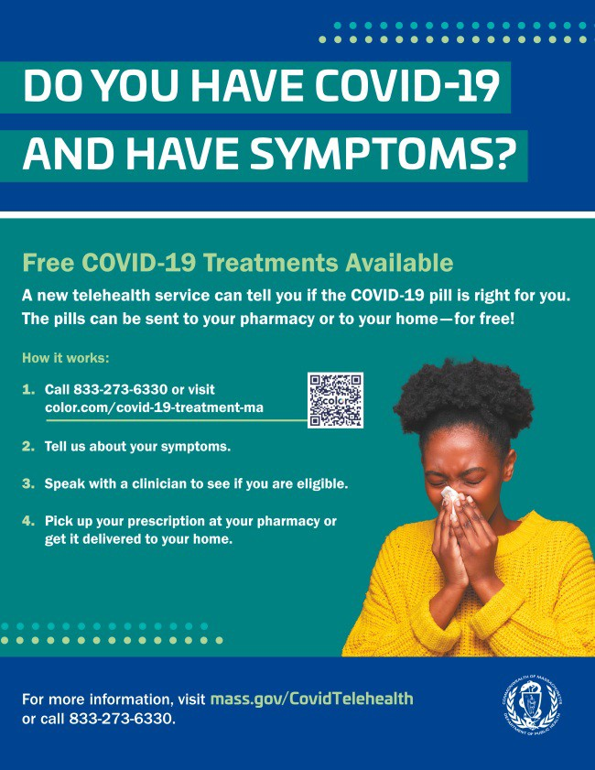
Reminders

FREE IN-HOME COVID-19 VACCINATION AVAILABLE

Massachusetts offers in-home COVID-19 vaccinations for anyone who has difficulty getting to or using a community clinic, including young children. Learn more, or call 833-983-0485 to sign up for an in- home appointment.

Help spread the word with
this informational flyer (in 12 languages)!

DO YOU USE MY VAX RECORDS? IT'S A DIGITAL VACCINE CARD FOR MASSACHUSETTS RESIDENTS

Need a copy of your COVID-19 vaccination record? Massachusetts residents can use My Vax Records to get a digital vaccine card to show they’ve been vaccinated against COVID-19, if they choose. Learn more.

FREE COVID TREATMENT AVAILABLE VIA PHONE OR ONLINE

Free, safe, and effective treatments for COVID-19 are available across Massachusetts. They can help prevent hospitalizations and reduce the risk of severe disease.

Telehealth consultations are available via phone, in addition to online. Consultations can be accessed in 10+ languages.

Please share: Flyers are now available in 12 languages!

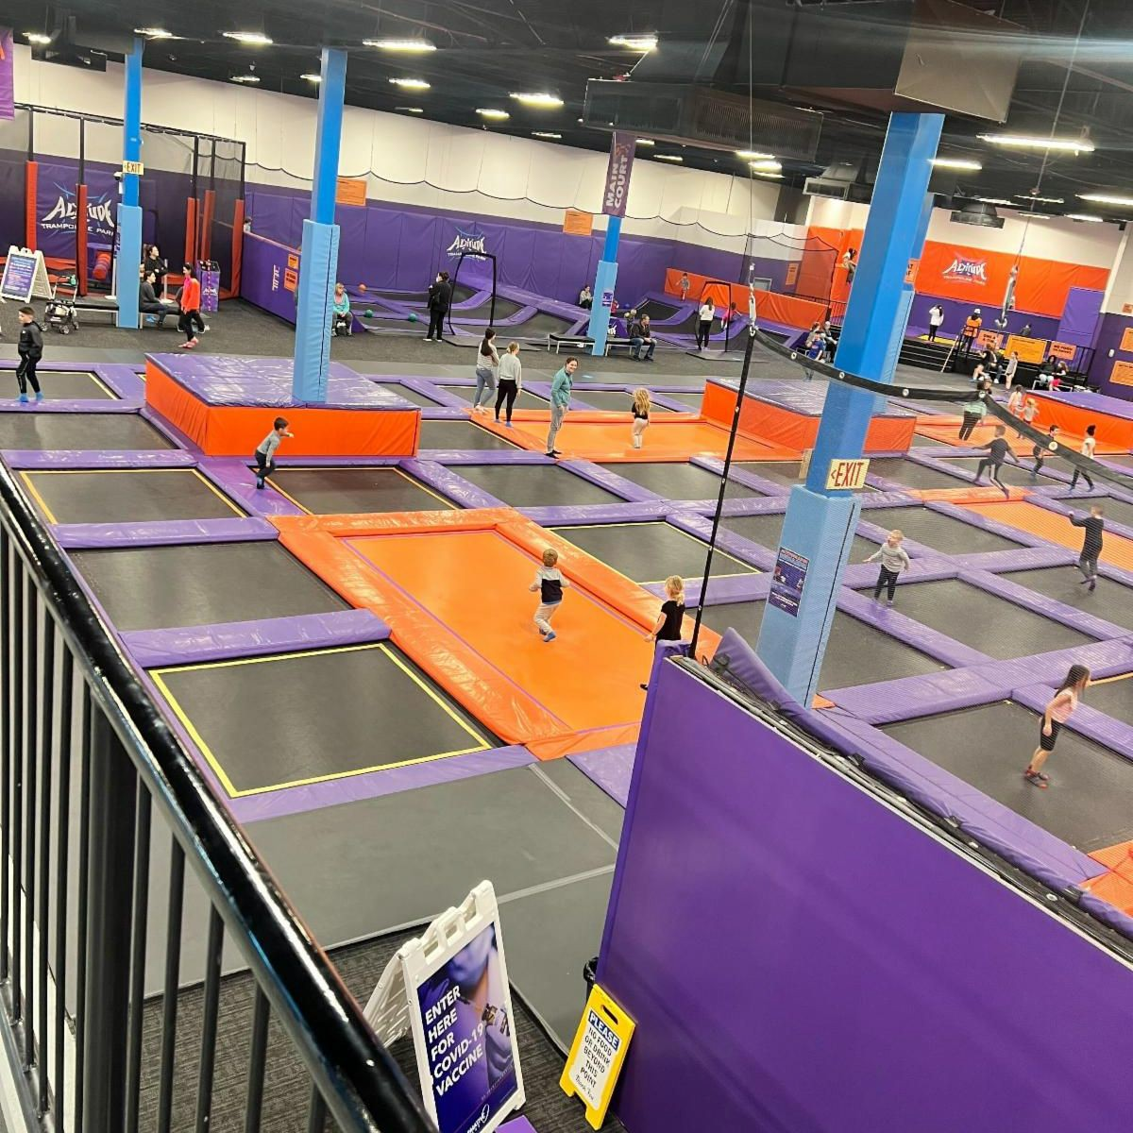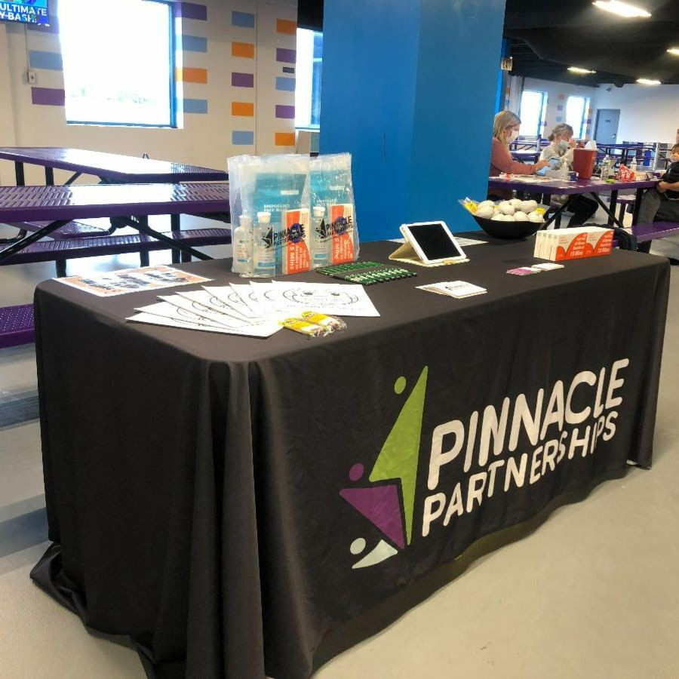
February School Vacation Week Clinics Vaccinate Over 3,000 People!

Last week, many of the Vaccine Equity Initiative communities held Get Boosted clinics for families to get their COVID-19 vaccines and boosters during February School Vacation.
Several of the clinics were held at trampoline parks (see photos) and other fun locations. In total, over 3,000 individuals got vaccinated. Thank you to all of our partners who made these events possible!
Above: Photos from one of three February Vacation Week clinics held at Altitude Trampoline Park in Avon
Recent Highlights
Key Resources

OUTREACH AND EDUCATION MATERIALS

COVID-19 Vaccine FAQs
COVID-19 Therapeutic Information (including telehealth) Weekly Provider Bulletin
Trust the Facts, Get the Vax Campaign Materials (organized by audience, including general, parents, youth, and young adults; available in 12 languages)
Multilingual COVID-19 Materials (videos and printables; organized by language)
COVID-19 Vaccination Tools for Employers
Archive of COVID-19 Vaccine Communications Updates (past editions of VEI Roundup)

FIND A COVID-19 VACCINE OR BOOSTER

Mass.gov/GetBoosted (family-friendly clinics through March 2023)
Vaccine Finder
Find, Schedule, or Sign Up for a Mobile COVID-19 Vaccination COVID-19 In-Home Vaccination Program
Request a Copy of Your Vaccine Card

in collaboration with Pinnacle Partnerships. Over 150 people were vaccinated at Altitude during the week.

Two more clinics are happening at Altitude in March! View the full list of Get Boosted clinics.

Read More Highlights

Visit the VEI Website

Share This Email
Share This Email
Share This Email

Vaccine Equity Initiative | 250 Washington Street, Boston, MA 02108

Unsubscribe vaccineequityinitiative@mass.gov Constant Contact Data Notice
Sent by vaccineequityinitiative@mass.gov in collaboration with
Try email marketing for free today!

