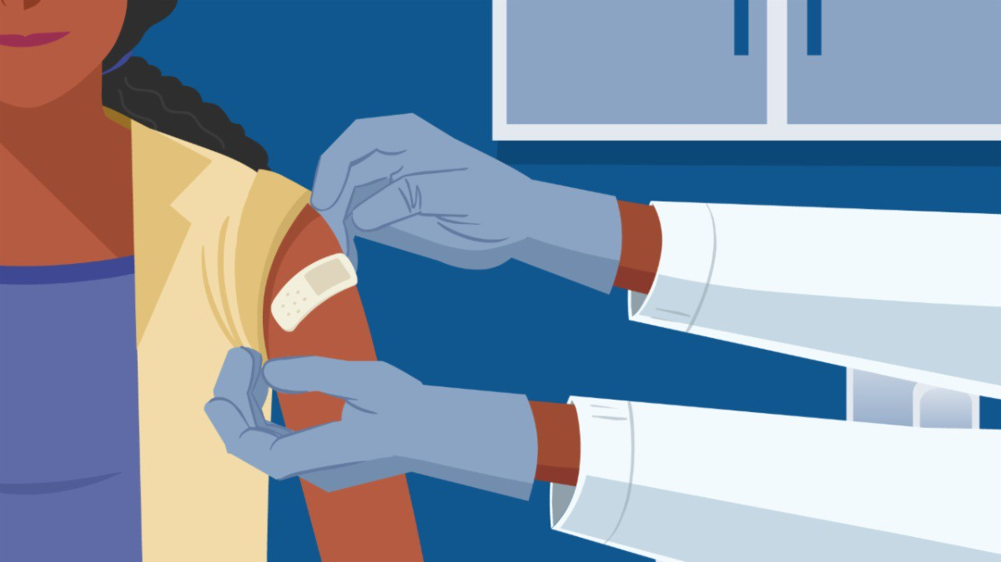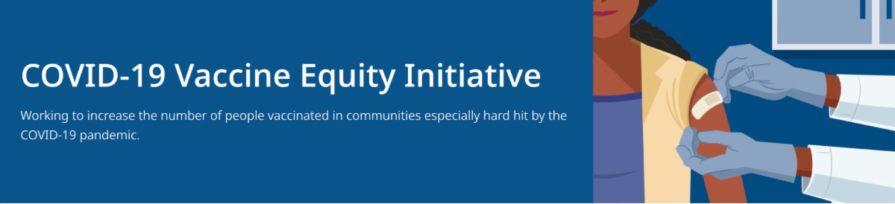
HOST A COVID-19 VACCINATION EVENT AT YOUR LOCAL LIBRARY

Read this conversation between MA DPH and the MA Library System to learn more about hosting a COVID-19 mobile clinic or community conversation at your local library.
FIND A BOOSTER APPOINTMENT NEAR YOU
March 4, 2022
This newsletter is your central source for COVID-19 vaccination updates. Materials are publicly
available and clickable for easy sharing. Others may subscribe by clicking here.

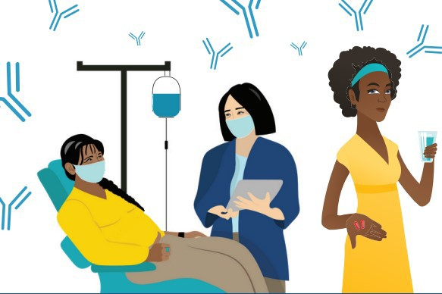

COVID-19 THERAPEUTICS FLYER - NOW IN 12 LANGUAGES

Free treatments for COVID-19 can help reduce your chance for severe disease, but they must be administered soon after diagnosis. Information for patients about these treatments is now in 12 languages.
Reminders
What's New

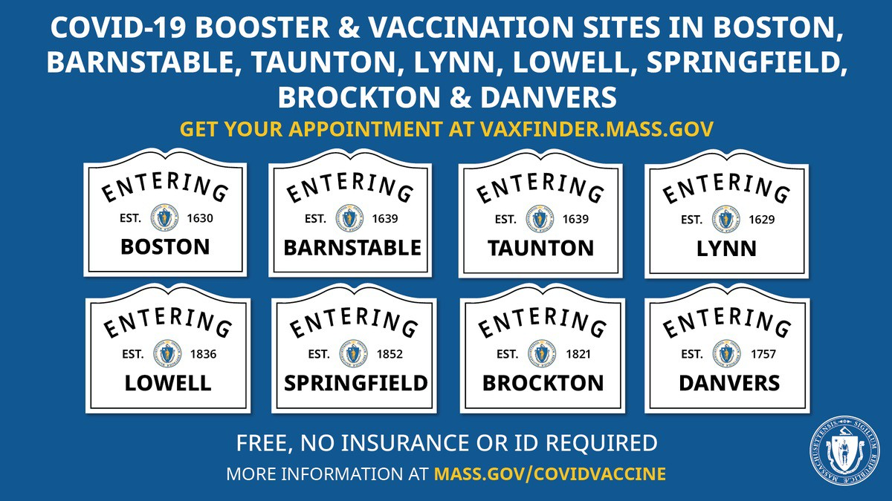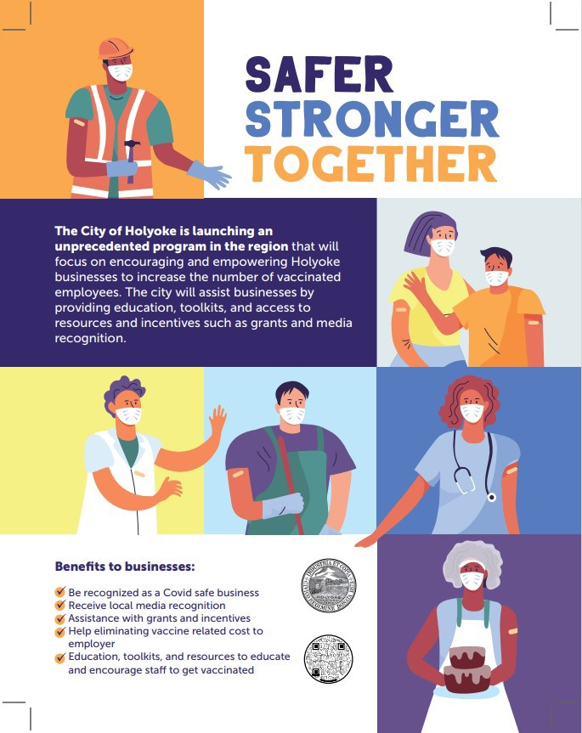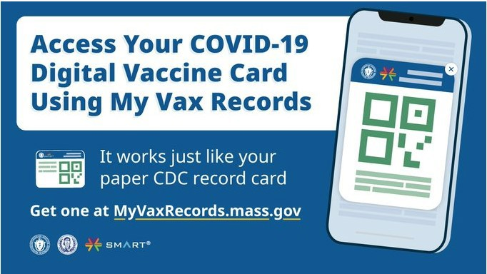Booster vaccines continue to be available at several state- managed sites and at hundreds of other locations in MA. Find your appointment or walk-in location.

Questions about boosters? Check out the COVID-19 booster FAQ (available in 12 languages).

EMPLOYERS: WAYS TO INCREASE COVID-19 VACCINATION AMONG EMPLOYEES

COVID-19 Vaccination Tools for Employers (includes info on hosting a free mobile clinic, helping employees locate a vaccine, offering paid sick leave for vaccination, and more)

The VEI team has worked with local businesses across the state and a new effort in Holyoke seeks to help local business owners support vaccination for their workers. “Educate to Vaccinate” offers awareness materials to business owners and employees about the benefits of vaccination and provides support for employees taking time from work to be vaccinated. Read more.

Above: A flyer from Holyoke's "Educate to Vaccinate" program.

MY VAX RECORDS - DIGITAL COVID-19 VACCINE CARD FOR MA RESIDENTS

Need a copy of your COVID-19 vaccination record? MA residents can now use My Vax Records to get a digital vaccine card to show they’ve been vaccinated against COVID-19, if they choose. Learn more.

ENABLE MASSNOTIFY ON YOUR SMARTPHONE

MassNotify is a tool that works through smartphones – with a focus on privacy – to alert users who may have

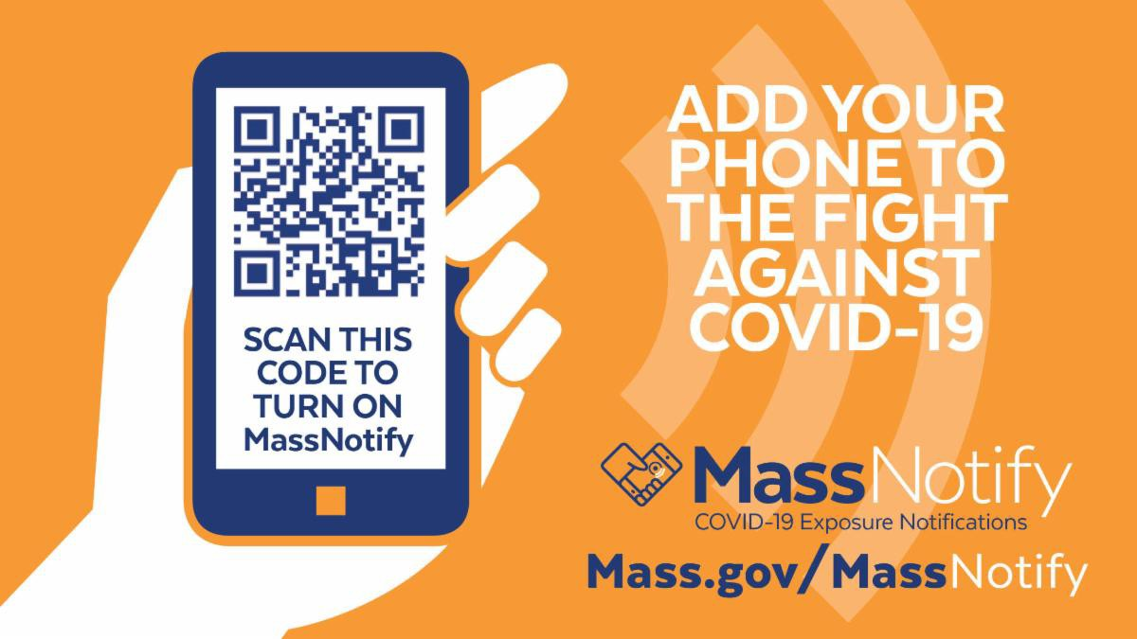
been exposed to COVID-19. Enable
MassNotify on your smartphone to add another tool in our fight against
COVID-19. Learn more.
IN-HOME VACCINATIONS AVAILABLE

The COVID-19 In-Home Vaccination Program is a resource for anyone who has difficulty getting to or using a community vaccination location.
Key Resources

OUTREACH AND EDUCATION MATERIALS

COVID-19 Vaccine FAQs COVID-19 Booster FAQs Weekly Provider Bulletin
Trust the Facts, Get the Vax Campaign Materials(organized by audience, including general, parents and pregnant people, youth, young adults; available in 12 languages)
Trust the Facts, Get the Vax Creative Materials Toolkit(updates ongoing, including pediatric eligibility)
Additional Education and Outreach Materials(includes social media graphics, vaccine updates, guides to hosting a forum, and more)
Multilingual COVID-19 Materials (videos and printables; organized by language) COVID-19 Funeral Assistance from FEMA(including 1-pager with key info available in multiple languages)
COVID-19 Vaccination Tools for Employers

FIND A COVID-19 VACCINE OR BOOSTER

Vaccine Finder
Find, Schedule, or Sign Up for a Mobile COVID-19 Vaccination COVID-19 In-Home Vaccination Program
Request a Copy of Your Vaccine Card

COVID-19 VACCINE STANDING ORDERS (FROM CDC)

Pfizer
5-11 (updated 2/7/22)
12 + Gray Cap(updated 2/25/22)
12 + Purple Cap (updated 2/25/22)
Moderna (updated 2/28/22)

Janssen (updated 2/22/22)
Recent Highlights

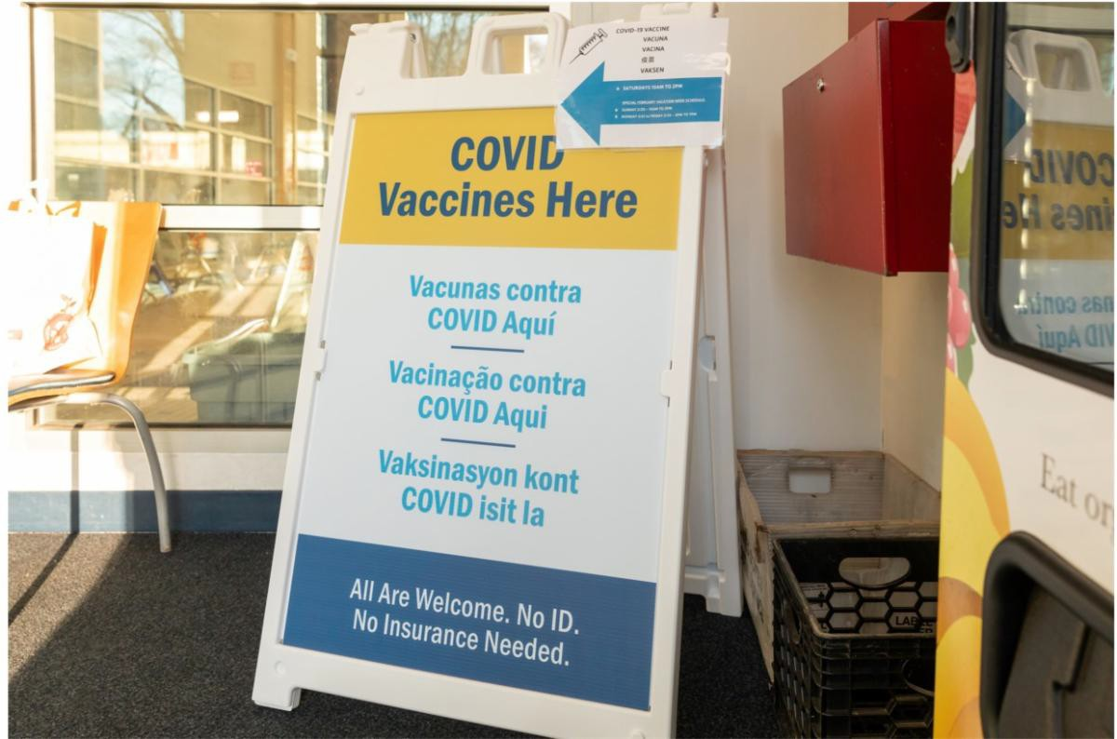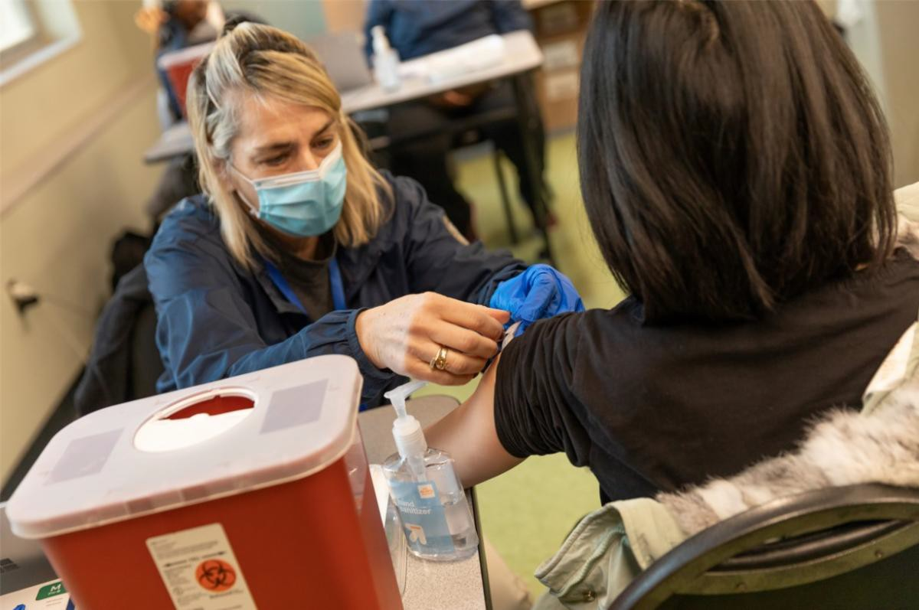February School Vacation Clinics Vaccinate over 2,000

Cities in our Vaccine Equity Initiative including Brockton, Chelsea, Everett, Fall River, Lawrence, Lowell, Malden, Methuen, New Bedford, Springfield, and Worcester held 59 clinics for youth and families to get vaccinated during February School Vacation week. In total, 2,212 were vaccinated, including 559 pediatric vaccinations, 336 youth vaccinations (153 boosters), and 1,317 adult vaccinations (998 boosters).

Thanks to our partners who made these events possible, including Blue Cross Blue Shield MA and United Way of MA Bay and Merrimack Valley, who provided funding for incentives and giveaways.

Above: Photos from a School Vacation Week clinic at the Malden YMCA.

Read More Highlights

Share This Email
Share This Email
Share This Email

Visit the VEI Website

Vaccine Equity Initiative | 250 Washington Street, Boston, MA 02108 Unsubscribe vaccineequityinitiative@mass.gov
About Constant Contact
Sent byvaccineequityinitiative@mass.govin collaboration with

Try email marketing for free today!

