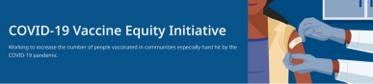April 1, 2022
See below for news and resources about COVID-19 vaccination. Please share this newsletter with colleagues including local social service agencies, community organizations, or colleagues working to increase vaccination across Massachusetts. To subscribe, click here.
What's New
SECOND COVID-19 BOOSTER AVAILABLE FOR INDIVIDUALS 50+ OR IMMUNOCOMPROMISED
- News Release (3/30) - A second
booster dose for individuals 50+
and those with certain health
conditions is now available.
- “Vaccines including boosters are
the most effective and widely
available tool we have to prevent
COVID infection, severe disease,
and death.”—DPH’s Dr. Larry
Madoff
- Questions? Our booster FAQ is
available in 12 languages.
PLEASE SHARE:
7 STEPS TO PROTECT YOURSELF & YOUR FAMILY FROM COVID-19
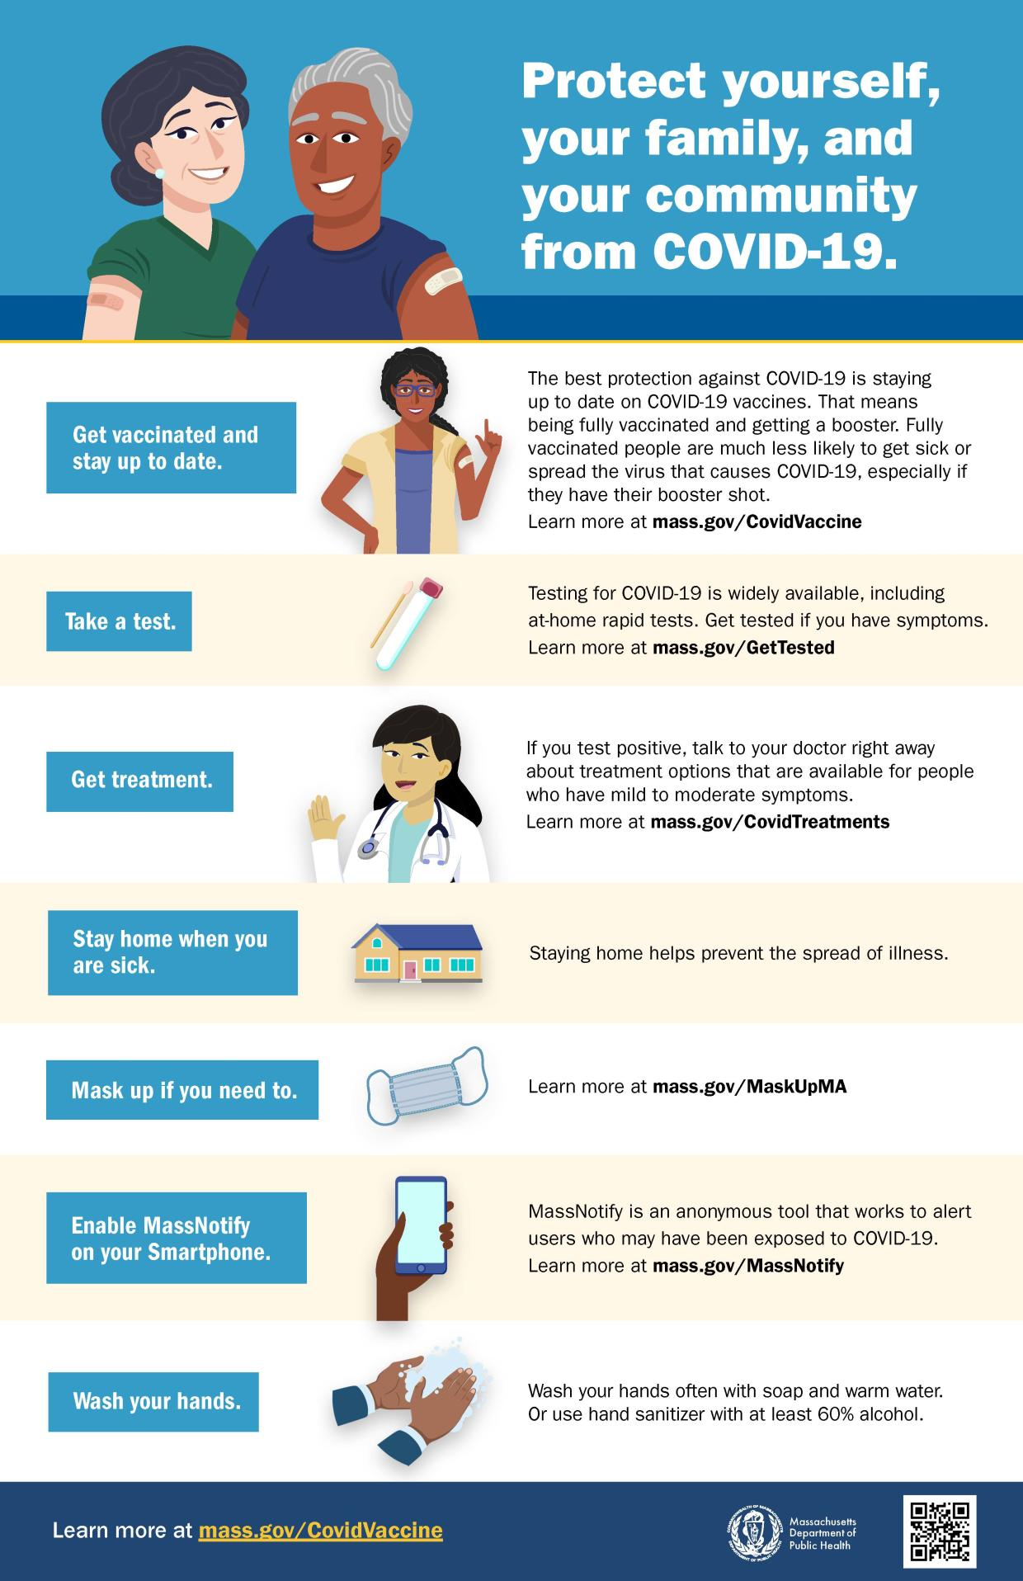
- This new flyer offers a checklist
to help protect yourself, your
family, and your community from
COVID-19. Available also in
Spanish with other languages
available soon.

FEDERAL COVID.GOV WEBSITE OFFERS "ONE-STOP SHOP" FOR COVID-19 RESOURCES
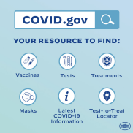
- COVID.gov is a new federal
website with info about how to
receive or locate free masks and
COVID tests, vaccines, and
treatment.
- The call line has 150+ languages
available: 1-800-232-0233
Reminders
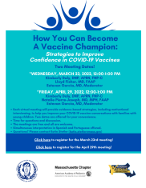
BECOME A VACCINE CHAMPION: LEARN WAYS TO IMPROVE CONFIDENCE IN COVID-19 VACCINES
- DPH and other partners are
offering trainings on strategies to
improve confidence in COVID-19
vaccines. Meetings are free and
all are welcome. Learn more, or
register for April 29.

IN-HOME VACCINATIONS AVAILABLE
- The COVID-19 In-Home Vaccination
Program is a resource for anyone who
has difficulty getting to or using a
community vaccination location.
MY VAX RECORDS - DIGITAL COVID-19 VACCINE CARD FOR MA RESIDENTS
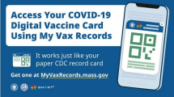
- Need a copy of your COVID-19
vaccination record? MA residents can
now use My Vax Records to get a
digital vaccine card to show they’ve
been vaccinated against COVID-19, if
they choose. Learn more.
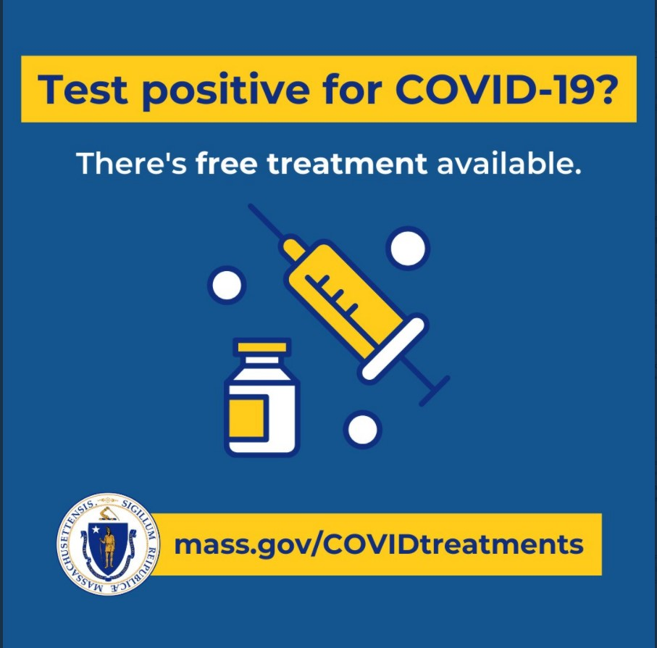
FREE COVID-19 TREATMENT OPTIONS
- Patients recently diagnosed with
COVID-19 have options for treatment,
available at no cost at sites across MA.
Learn more about treatment options
(info also available in 12 languages), or
locate treatment.

Key Resources
OUTREACH AND EDUCATION MATERIALS
- COVID-19 Vaccine FAQs
- COVID-19 Booster FAQs
- Weekly Provider Bulletin (published 3/30)
- Trust the Facts, Get the Vax Campaign Materials (organized by audience, including general, parents and pregnant people, youth, young adults; available in 12 languages)
- Trust the Facts, Get the Vax Creative Materials Toolkit (updates ongoing, including pediatric eligibility)
- Additional Education and Outreach Materials (includes social media graphics, vaccine updates, guides to hosting a forum, and more)
- Multilingual COVID-19 Materials (videos and printables; organized by language)
- COVID-19 Funeral Assistance from FEMA (including 1-pager with key info available in multiple languages)
- COVID-19 Vaccination Tools for Employers
- Archive of COVID-19 Vaccine Communications Updates (past editions of VEI Roundup)
FIND A COVID-19 VACCINE OR BOOSTER
- Vaccine Finder
- Find, Schedule, or Sign Up for a Mobile COVID-19 Vaccination
- COVID-19 In-Home Vaccination Program
- Request a Copy of Your Vaccine Card
COVID-19 VACCINE STANDING ORDERS (FROM CDC)
- Pfizer
  - 5-11 (updated 2/7/22)
  - 12 + Gray Cap (updated 2/25/22)
  - 12 + Purple Cap (updated 2/25/22)
- Moderna (updated 2/28/22)
- Janssen (updated 2/22/22)

Recent Highlights
Boston
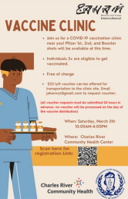
On March 5th, the first of a series of vaccine
clinics was hosted by JAHAN in partnership
with DPH and Charles River Community
Health (flyer, right). Prior to the clinic in
Brighton, JAHAN worked with mosques,
community organizations, and health centers
in the area to promote the clinic and hold
informational sessions on vaccination. More
than 175 people attended the family-friendly
clinic, with nearly 40% of people receiving
their first vaccines.
Worcester
In February, the Southeast Asian Coalition of MA (SEACMA) hosted a COVID vaccine clinic, vaccinating 38 people. Leading up to the clinic, the organization talked with over 100 parents about the vaccines and addressed any concerns. SEACMA centers the building of trust in all of their community outreach, especially among those who are refugees or who have limited English proficiency.
Read More Highlights
Visit the VEI Website
Vaccine Equity Initiative | 250 Washington Street, Boston, MA 02108
Unsubscribe vaccineequityinitiative@mass.gov
About Constant Contact
Sent byvaccineequityinitiative@mass.govin collaboration
with
Try email marketing for free today!

